RESEARCH, TESTING AND DEVELOPMENT

SUSTAINABILITY

CAMDEN AIR QUALITY REPORT

May 2014

EXECUTIVE SUMMARY
This monthly report covers the air quality monitoring data as monitored at Camden in May 2014.
There was one exceedance of the national ambient air quality SO₂ hourly limit and no exceedances of the daily FPM (PM10) and daily SO₂ limits. The ozone 8 hour moving average was also not exceeded. There were no exceedances of the NO2 hourly limit during the period under review.
The dominant wind directions during the daytime were from west-south-west, west and south-west. During the night, the most frequent directions were from east, north-west and north-north-west. Winds from all other directions were infrequent during day and night and wind speeds remained low.
The overall percentage data recovered from the monitoring station during the reporting period was 82.2% and the overall monitoring station availability during the reporting period was 82.3%.
DISCLAIMER
It is certified that the data presented is, to the best of our knowledge, a true copy of the specified record and for the times and places indicated thereon, as held on file at Research, Testing and Development (RT&D). The user assumes the entire risk related to the use of this data. In no event will RT&D be liable to the user or to any third party for any direct, indirect, incidental, consequential, special or exemplary damages or profit resulting from any use or misuse of this data.
1. INTRODUCTION
At the request of Environmental Management, the Research, Testing and Development (RT&D) air quality monitoring team commissioned an Ambient Air Quality Monitoring site at Camden Power Station to assess possible impacts of air pollution from Camden Power Station and other pollution sources in the area (Figure 1).

The Camden station is equipped for continuous monitoring of ambient concentrations of sulphur dioxide (SO₂), nitrogen dioxide (NO₂), ozone (O₃) and fine particulate matter (FPM) of particulate size <10μm in diameter. In addition, meteorological parameters of wind velocity (WVL), wind direction (WDR), ambient temperature (TMP), humidity (HUM) and ambient pressure (PRS) are also recorded.

Standard Specifications, Equipment/Techniques used for the measurement of SO₂, O₃ and NO_{x} conform to US-EPA equivalent method No EQSA-0486-060, EQOA-0880-047 and RFNA-1289-074 respectively.

2. SITE LOCATION
The monitoring station was located close to Camden Power Station at co-ordinates: (S26° 37’ 21.5”) (E30° 06’ 32.5”) in June 2003.
Figure 1. Camden Air / Quality Monitoring Station in relation to Camden Power Station and other pollution sources

3. DATA RECOVERY
The SANAS guideline figure of 80% per parameter monitored is used as a standard for representative data capture. This describes the required completeness of data set for the reporting of averages and is based on standard arithmetic calculations. The completeness calculations for data sets exclude zero and span data and times where service and/or maintenance is being conducted on the instruments in question.
Availability is a management definition related to system reliability. The availability target is not set in terms of data quality criteria and has no associated quality objectives. A target of 100% availability has been set for performance evaluation. Availability is reported as a measure of the percentage of time that electrical power was available to the monitoring station.
Table 1 shows the percentage data recovered, for each pollutant monitored, during the reporting period. The overall percentage data recovered from the monitoring station during the reporting period was 82.2% and the overall monitoring station availability during the reporting period was 82.3%.
Table 1. Percentage data recovered per parameter May 2014.
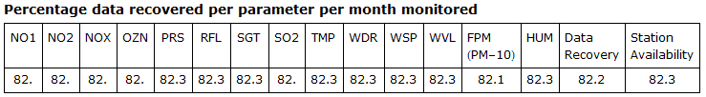

1. COMMENTS

In general the data losses that occurred during the monitoring period were due to routine site service, zero/span checks and power trips.

4. SUMMARY OF RESULTS FOR REPORTED PERIOD
Table 2 is a summary report presenting highest hourly and daily mean concentrations and the number of exceedances above the respective National Ambient Air Quality Standards limits as presented in Table 3.
Note: Where FPM is monitored, the following instrument methodologies may have been used.
TEOM (Tapered Element Oscillating Microbalance), Beta Gauge (Beta-attenuation using a C-14 source), DustTrak (Light scattering laser photometer). Where visibility is monitored, which can be converted to FPM <2.5 µg/m³, an Integrating Nephelometer measuring the scattering of light is used.
The results presented may vary depending on the instrumentation methodology used.
Table 2. Summary report
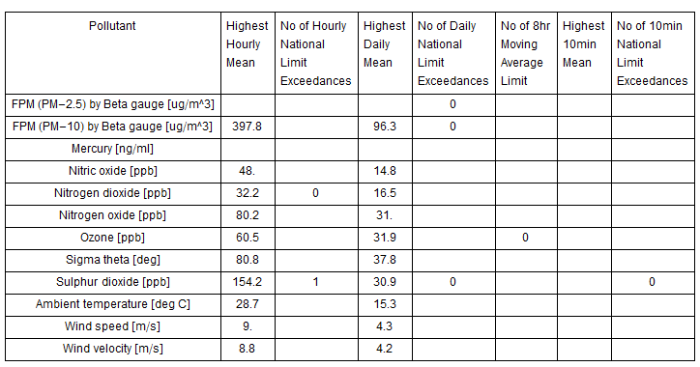

Table 3. Ambient air quality standards.

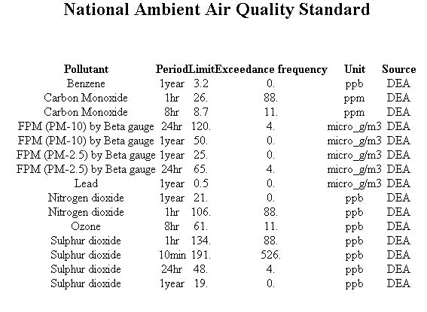

4.1 COMMENTS
The following exceedances of the National Ambient Air Quality Standards limits were reported during the monitoring period and indicate the day the exceedance occurred and the level of concentration, as reflected in Table 4.

Table 4. Exceedances above National Ambient Air Quality limits.

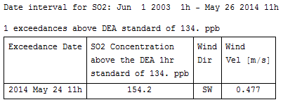

5. METEOROLOGICAL OBSERVATIONS
Figure 2 shows the daytime and night-time wind roses for the reporting period. The centre of the wind rose depicts the position of the air quality monitoring station. The position of the spokes in the polar diagram represents directions from which the wind was blowing. The length of the segment indicates the percentage of the time the wind blew from that direction and the speed in the various categories are denoted by colours and width.

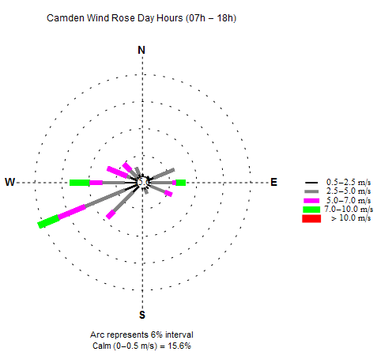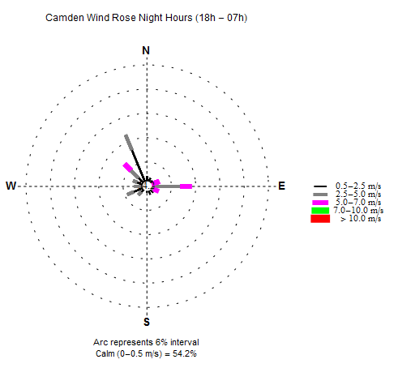

Figure 2. Wind roses.

5.1 COMMENTS
The dominant wind directions during the daytime were from west-south-west, west and south-west. During the night, the most frequent directions were from east, north-west and north-north-west. Winds from all other directions were infrequent during day and night and wind speeds remained low.
6. POLLUTANTS
Emissions of primary pollutants such as FPM, SO₂, and NO_{X} from low level sources such as domestic combustion, motor vehicles and smouldering dumps are expected to impact at ground level more significantly during the evening and early morning hours as a result of temperature inversion. Emissions of such pollutants from tall stacks (modern power stations and other industries), are expected to have more significant impact at ground level during the day, due to atmospheric turbulence influences. O₃ and other oxidants are formed in polluted atmospheres as a result of a rather wide variety of photochemical reactions. A gradual increase of O₃ throughout the day is expected, peaking at mid-afternoon and then decaying once more during the night.

6.1. FINE PARTICULATE MATTER (FPM-PM10)

6.1.1. Source identification by FPM-PM10 diurnal variations

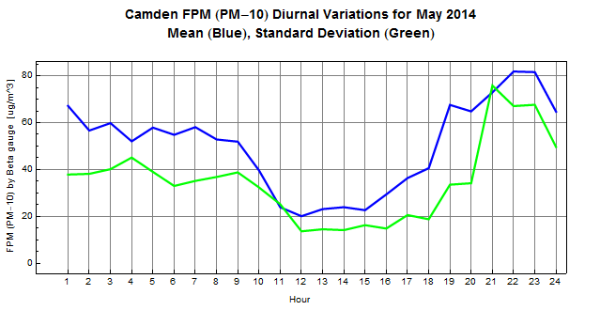

Figure 3. Diurnal variation by FPM-PM10

6.1.1.1 Comments
Figure 3 shows the FPM (PM10) hourly mean diurnal variation. Impacts from low level sources are evident with slight peaks at 03:00, 05:00 and 07:00 in the morning. A slight increase in concentration levels is shown from 12:00 peaking at 14:00 followed by a sharp increase at 15:00 in the afternoon with a peak at 19:00 which is indicative of high level sources such as Camden stacks and other industries. Low level sources are shown to be impacting once more from 20:00 in the evening with peaks at 22:00 and 23:00 at night. Concentration levels drop to background from 23:00 throughout the night.

6.1.2. FPM-PM10 hourly mean event roses and tables
As there are no National Ambient Air Quality hourly FPM-PM10 limits, the 98 percentile daytime and night-time event roses are presented in Figure 4 to identify the wind sectors from which the highest concentrations are derived.

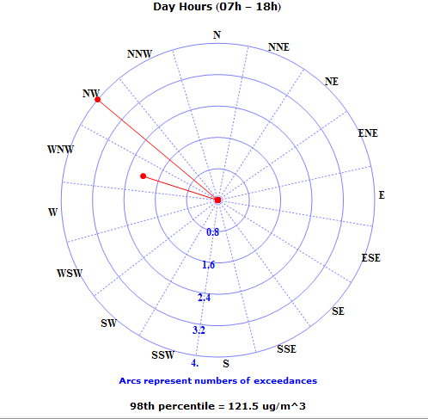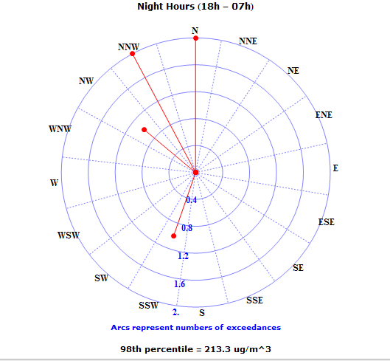

Figure 4. FPM-PM10 hourly mean 98th percentile event roses.

Table 5. FPM-PM10 daytime hourly mean 98th percentile event table.
Dir | N | NNE | NE | ENE | E | ESE | SE | SSE | S | SSW | SW | WSW | W | WNW | NW | NNW
Eve | 0 | 0 | 0 | 0 | 0 | 0 | 0 | 0 | 0 | 0 | 0 | 0 | 0 | 2 | 4 | 0
% | 0 | 0 | 0 | 0 | 0 | 0 | 0 | 0 | 0 | 0 | 0 | 0 | 0 | 33.33 | 66.67 | 0

Table 6. FPM-PM10 night-time hourly mean 98th percentile event table
Dir | N | NNE | NE | ENE | E | ESE | SE | SSE | S | SSW | SW | WSW | W | WNW | NW | NNW
Eve | 2 | 0 | 0 | 0 | 0 | 0 | 0 | 0 | 0 | 1 | 0 | 0 | 0 | 0 | 1 | 2
% | 33.3 | 0 | 0 | 0 | 0 | 0 | 0 | 0 | 0 | 16.6 | 0 | 0 | 0 |  | 16.6 | 33.3

There were no exceedances of the National Ambient Air Quality Standards FPM daily limit. The most dominant hourly mean concentrations above 121.5µg/m³ (98th percentile value) at Camden during daytime period were recorded from west-north-west to north-west. The most dominant hourly mean concentrations above 213.3µg/m³ (98th percentile) at Camden during night-time period were recorded from south-south-west and north-west to north sectors. Camden Power Station and Sasol Secunda are situated 1.9km and 91km west-north-west of the monitoring station respectively. Hendrina Power Station is situated 80km north-west of the monitoring station. Arnot Power Station is situated 80km north-north-west of the monitoring station. The ash dumps are located north-west of the monitoring station. There are mining activities to the north of the monitoring station. There is a continuous day and night movement of coal trucks to and from the power station coal stockpile. The coal stockpile is situated west-south-west of the monitoring station. The Mooiplaats open cast mine is located south-south-west of the monitoring station.

6.2.1. Source identification by FPM-PM2.5 diurnal variations

There is no PM2.5 monitoring at Camden.

6.3. SULPHUR DIOXIDE (SO₂)

6.3.1. Source identification by SO₂ diurnal variations

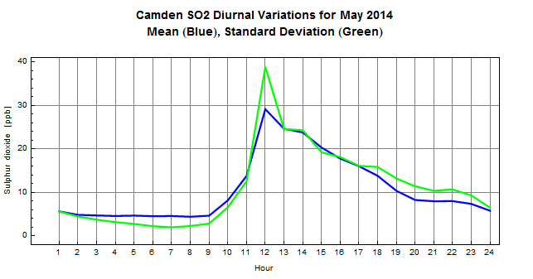

Figure 5. SO₂ diurnal variations

6.3.1.1. Comments
The SO₂ diurnal variation is presented in Figure 5. A sharp increase in concentration levels is noted from 09:00 peaking at 12:00 midday which is indicative of high level sources such as tall stacks where Camden Power Station may have directive impact. Concentration levels drop to background levels from 12:00 midday throughout the afternoon and the evening.

6.3.2. SO₂ hourly mean exceedance/event roses and tables

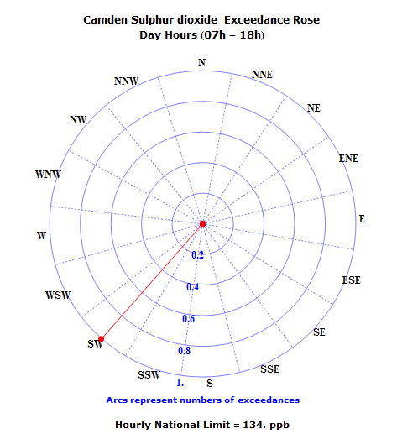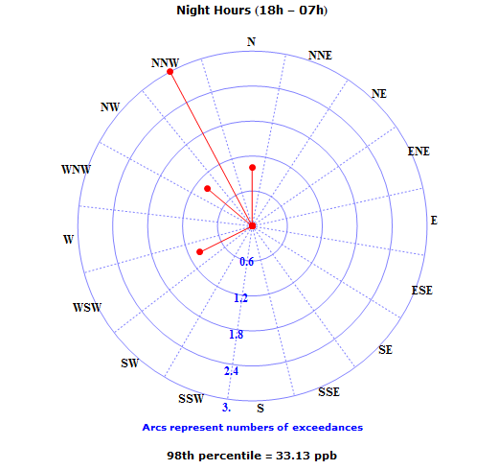

Figure 6 SO₂ hourly mean sector day time exceedance rose and night time 98th percentile event rose

Table 7. SO₂ daytime hourly mean exceedance table
Dir | N | NNE | NE | ENE | E | ESE | SE | SSE | S | SSW | SW | WSW | W | WNW | NW | NNW
Exc | 0 | 0 | 0 | 0 | 0 | 0 | 0 | 0 | 0 | 0 | 1 | 0 | 0 | 0 | 0 | 0
% | 0 | 0 | 0 | 0 | 0 | 0 | 0 | 0 | 0 | 0 | 100 | 0 | 0 | 0 | 0 | 0

Table 8. SO₂ night-time hourly mean 98th percentile event table.
Dir | N | NNE | NE | ENE | E | ESE | SE | SSE | S | SSW | SW | WSW | W | WNW | NW | NNW
Eve | 1 | 0 | 0 | 0 | 0 | 0 | 0 | 0 | 0 | 0 | 0 | 1 | 0 | 0 | 1 | 3
% | 16.6 | 0 | 0 | 0 | 0 | 0 | 0 | 0 | 0 | 0 | 0 | 16.6 | 0 | 0 | 16.6 | 50

6.3.2.1. Comments
The daytime exceedance rose and night-time 98th percentile rose are presented in Figure 6 to identify the wind sectors from which the highest concentrations are derived. There was one exceedance of the national ambient air quality SO₂ hourly limit and no exceedances of the SO₂ daily limits as detailed in Table 2. The most dominant hourly mean concentrations above 134ppb at Camden during daytime were recorded from south-west sector. The most dominant night-time concentrations above 33.13ppb (98th percentile) were recorded from west-south-west and north-west to north sectors. Majuba Power Station is situated 60km south-west of the monitoring station. Tutuka Power Station is approximately 78.3km west-south-west of the monitoring station. The Mooiplaats open cast mine is located south-south-west of the monitoring station. Hendrina Power Station is situated 80km north-west of the monitoring station. Arnot Power Station is situated 80km north-north-west of the monitoring station. There are mining activities to the north of the monitoring station.

6.4. NITROGEN DIOXIDE (NO₂)

6.4.1. Source identification by NO₂ diurnal variations

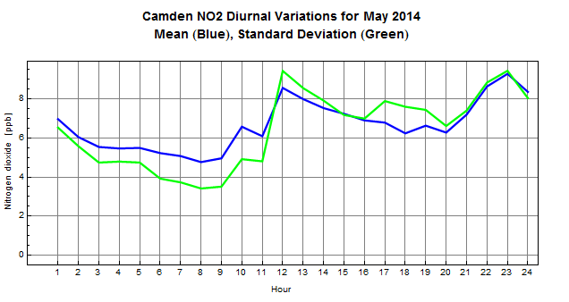

Figure 7. NO₂ diurnal variations

6.4.1.1. Comments
The NO₂ diurnal variation is presented in Figure 7. The levels of NO₂ are shown to be decreasing from 01:00 to 08:00 in the early morning followed by a slight to sharp increase in concentration levels from 08:00 with peaks at 10:00 and 12:00 which is an indication of high level sources such as tall stacks where Camden Power Station may have directive impact. Low level sources such as vehicle emissions are shown to be impacting at 18:00 with peaks at 19:00 and 23:00. Concentration levels drop to background from 23:00 throughout the night.

6.4.2. NO₂ hourly mean event roses and tables
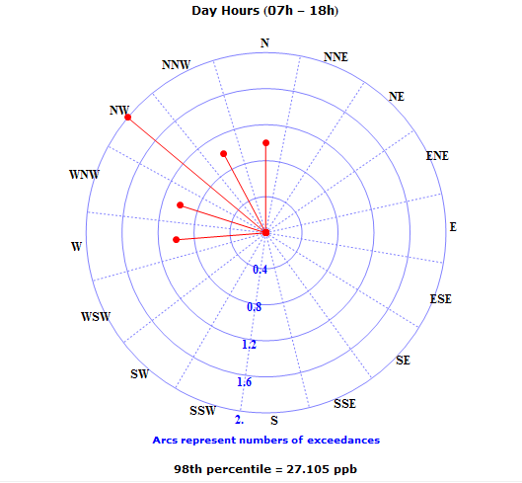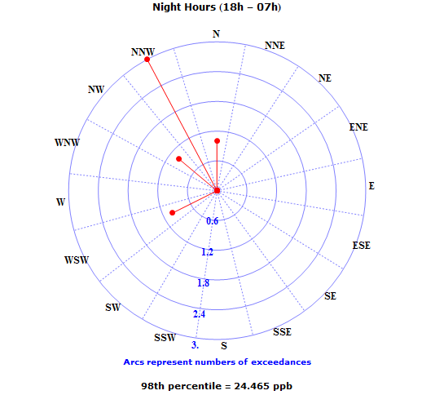

Figure 8. NO₂ hourly mean 98th percentile event roses.

Table 9. NO₂ daytime hourly mean 98th percentile event table.
Dir | N | NNE | NE | ENE | E | ESE | SE | SSE | S | SSW | SW | WSW | W | WNW | NW | NNW
Eve | 1 | 0 | 0 | 0 | 0 | 0 | 0 | 0 | 0 | 0 | 0 | 0 | 1 | 1 | 2 | 1
% | 16.6 | 0 | 0 | 0 | 0 | 0 | 0 | 0 | 0 | 0 | 0 | 0 | 16.6 | 16.6 | 33.3 | 16.6

Table 10. NO₂ night-time hourly mean 98th percentile event table.
Dir | N | NNE | NE | ENE | E | ESE | SE | SSE | S | SSW | SW | WSW | W | WNW | NW | NNW
Eve | 1 | 0 | 0 | 0 | 0 | 0 | 0 | 0 | 0 | 0 | 0 | 1 | 0 | 0 | 1 | 3
% | 16.6 | 0 | 0 | 0 | 0 | 0 | 0 | 0 | 0 | 0 | 0 | 16.6 | 0 | 0 | 16.6 | 50

6.4.2.1. Comments
The 98th percentile daytime and night-time event roses are presented in Figure 8 to identify the wind sectors from which the highest concentrations are derived. There were no exceedances of the National Ambient Air Quality Standards NO₂ hourly limits recorded during the period under review. The most dominant daytime concentrations above 27.105ppb (98th percentile value) were from the west to north sectors. The most dominant night-time concentrations above 24.465ppb (98th percentile) were from west-south-west and north-west to north sectors. Camden Power Station and Sasol Secunda are situated 1.9km and 91km west-north-west of the monitoring station respectively. There is a continuous day and night movement of coal trucks to and from the power station coal stockpile. The coal stockpile is situated west-south-west of the monitoring station. There are mining activities to the north of the monitoring station

6.5. OZONE (O₃)

6.5.1. Source identification by O₃ diurnal variations

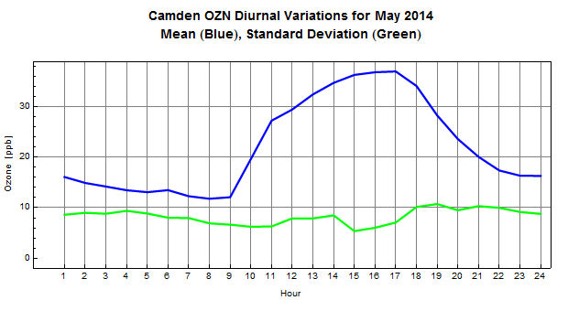

Figure 9. O₃ diurnal variations

6.5.1.1. Comments
Figure 9 shows the O₃ hourly mean diurnal variation with a slight decrease in the concentration levels occurring between 01:00 till 09:00. A sharp increase in O₃ concentration levels is noted from 09:00 peaking at 17:00 before decaying back to background levels throughout the night.

6.5.2 O₃ 8 hour Moving Average

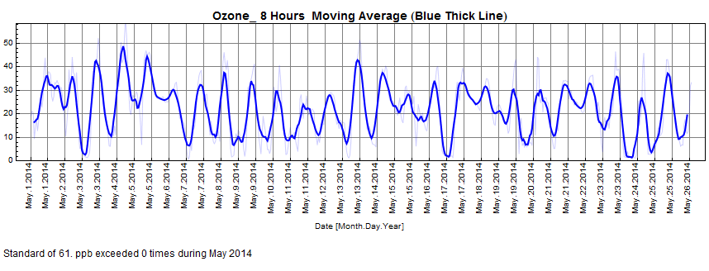

Figure 10. O₃ 8 hour Moving Average

6.5.2.1 Comments

The Ozone 8 hour moving average was not exceeded during the period under review.

6.5.3. O₃ hourly mean event roses and tables

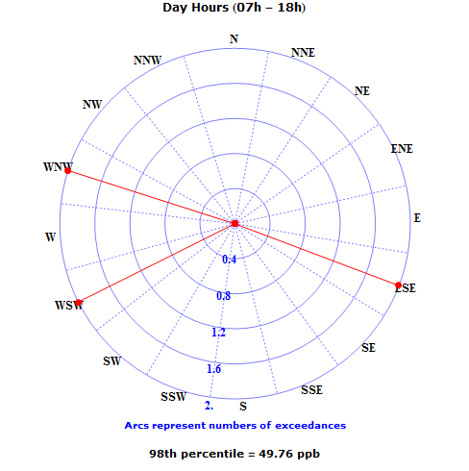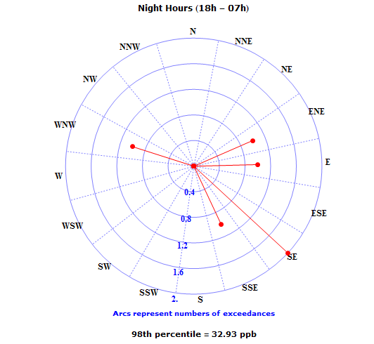

Figure 11. O₃ hourly mean sector 98th percentile event roses.

Table 11. O₃ daytime hourly mean 98th percentile event table.
Dir | N | NNE | NE | ENE | E | ESE | SE | SSE | S | SSW | SW | WSW | W | WNW | NW | NNW
Eve | 0 | 0 | 0 | 0 | 0 | 2 | 0 | 0 | 0 | 0 | 0 | 2 | 0 | 2 | 0 | 0
% | 0 | 0 | 0 | 0 | 0 | 33.3 | 0 | 0 | 0 | 0 | 0 | 33.3 | 0 | 33.3 | 0 | 0

Table 12. O₃ night-time hourly mean 98th percentile event table.
Dir | N | NNE | NE | ENE | E | ESE | SE | SSE | S | SSW | SW | WSW | W | WNW | NW | NNW
Eve | 0 | 0 | 0 | 1 | 1 | 0 | 2 | 1 | 0 | 0 | 0 | 0 | 0 | 1 | 0 | 0
% | 0 | 0 | 0 | 16.6 | 16.6 | 0 | 33.3 | 16.6 | 0 | 0 | 0 | 0 | 0 | 16.6 | 0 | 0

6.5.3.1. Comments
The 98 percentile event roses are presented in Figure 11 to indicate the wind directions from which highest concentrations are derived. The ozone 8 hour moving average was not exceeded during the month of May. The most dominant daytime concentrations above 49.76ppb (98th percentile value) were from east-south-east, west-south-west and west-north-west sectors. The most dominant night-time concentrations above 32.93ppb (98th percentile value) were from east-north-east to east, south- east to south-south-east and west-north-west sectors.
7. HISTORICAL CONCENTRATIONS

7.1. RECENT TRENDS
Time series graphs for each pollutant with respect to the National Ambient Air Quality Standards are represented from the beginning of the previous year until the end of the current reporting period or since inception of the monitors. The resultant period may vary for each analyser, depending on when it was installed.
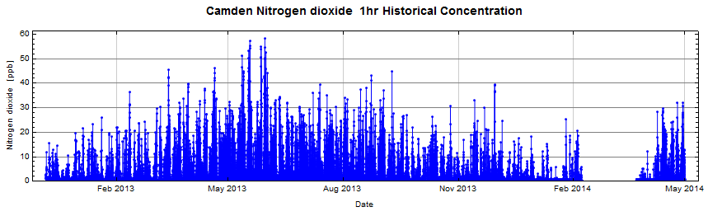

Figure12: NO₂ Hourly Means

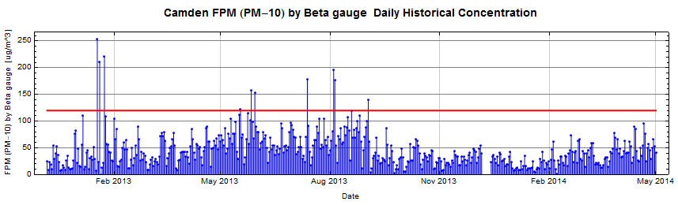
Figure 13: FPM Daily Means

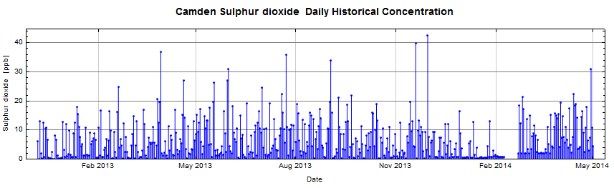
Figure 14: SO₂ Daily Means
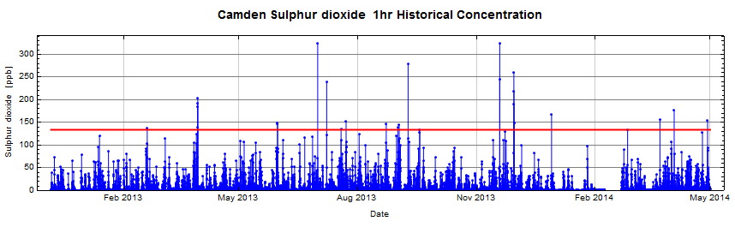
Figure 15: SO₂ Hourly Means
7.2. MONTHLY MEANS FOR THE CURRENT CALENDAR YEAR 2014
Table 13. Monthly Means for current calendar year 2014
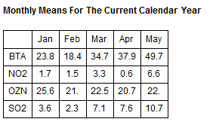
7.2.1. Comments

The monthly mean table shows concentrations of all the parameters monitored till May 2014.

7.3 ANNUAL MEANS AND NUMBER OF EXCEEDANCES FOR THE PRECEDING YEARS.

7.3.1. Comments

There has been only 1 exceedance of the NO₂ hourly mean concentration since the station was commissioned in July 2003. This happened in 2011. The SO₂ hourly limit was exceeded twice in 2005, once in 2006, 3 in 2007, 12 in 2008, 7 in 2009, 21 in 2010, 12 in 2011, 27 in 2012 and 22 times in 2013. The FPM daily limit had 1 exceedance in 2005, 2 in 2007, 4 in 2008, 9 in 2009, 5 in 2010, 5 in 2011, 6 in 2012 and 10 in 2013. The SO₂ daily limit had 1 exceedance in 2008 and 1 exceedance in 2009.

8. CONCLUSIONS
There was one exceedance of the national ambient air quality SO₂ hourly limit and no exceedances of the daily FPM (PM10) and daily SO₂ limits during the period under review. The ozone 8 hour moving average was also not exceeded. The above results show that stack emissions may have influence in the vicinity of Camden Power Station.

_________________________
Report compiled by: Abram Segopa
Date: 10 June 2014
Department: RT&D
9. ABBREVIATIONS
DEA | Department of Environmental Affairs
FPM | Fine particulate matter
HUM | Humidity
NO1 | Nitric oxide
NO2 | Nitrogen dioxide
NOX | Oxides of nitrogen
OZN / O₃ | Ozone
SGT | Sigma theta
TMP | Ambient temperature
WDR | Wind direction from true North
WSP | Wind speed
WVL | Wind velocity
N | North
NNE | North-north-east
NE | North-east
ENE | East-north-east
E | East
ESE | East-south-east
SE | South-east
SSE | South-south-east
S | South
SSW | South-south-west
SW | South-west
WSW | West-south-west
W | West
WNW | West-north-west
NW | North-west
NNW | North-north-west
deg | Degree
deg C | Degree Celsius
ug/m^3 | Microgram per cubic meter
m/s | Meters per second
PM-2.5 | Particulate matter < 2.5 microns in diameter
PM-10 | Particulate matter < 10 microns in diameter
ppb | Parts per billion
ppm | Parts per million
MWP | Megawatt Park

10. DISTRIBUTION LIST

AIR QUALITY CENTRE OF EXCELLENCE
ESKOM ENVIRONMENTAL MANAGEMENT MWP
Attention: K Langerman
Senior Consultant

AIR QUALITY CENTRE OF EXCELLENCE
ESKOM ENVIRONMENTAL MANAGEMENT MWP
Attention: B Monametsi
Senior Advisor

OFFICER ENVIRONMENTAL MANAGEMENT CAMDEN
Attention: Malekgoa Sejake
Officer Environmental Management

OFFICER ENVIRONMENTAL MANAGEMENT CAMDEN
Attention: Fikile Sithole
Officer Environmental Management

ENVIRONMENTAL MANAGER CAMDEN
Attention: Thabiso Mpongo
Manager Environmental

SYSTEM ENGINEER: FLUE GAS CLEANING CAMDEN
Attention: Charlene Naicker
Engineer Boiler Plant

Project File: Abram Segopa RT&D
Senior Technician

