

PURPOSE OF THE DRAFT ENVIRONMENTAL IMPACT REPORT

The purpose of the Environmental Impact Report Phase is to investigate and assess the potential positive and negative environmental impacts identified during the Scoping Phase (both biophysical and social) associated with the proposed project alternatives.

Please review this Executive Summary and preferably the full draft Environmental Impact Report, and submit your comments on the proposed project by 8 January 2007. Either complete a Response Form, write a letter, call or e-mail the public participation office. All EIA documents will also be available on the Eskom www.eskom.co.za/eia and the Ninham Shand website www.ninhamshand.co.za

Open houses and public meetings will be held as follows:

28 November 2006
16h00 – 18h00  Open House | El Toro Conf Centre
18h00 – 20h00  Public Meeting | El Toro Conf. Centre
29 November 2006
10h00 – 12h00  Open House | Mehlwana High School
16h00 – 18h00  Open House | Protea Hotel, Witbank
18h00 – 20h00  Public Meeting | Protea Hotel, Witbank

Public Participation office

Karen Shippey or Lindiwe Gaika
Ninham Shand Consulting Services
P O Box 1347. Cape Town, 8000
Tel: (021) 481 2501
Fax: (021) 424 5588
Email: karen.shippey@shands.co.za
lindiwe.gaika@shands.co.za

Technical enquiries about the EIA

Brett Lawson or Ashwin West
Ninham Shand Consulting Services
P O Box 509, George, 6530
Tel: (044) 874 2165
Fax: (044) 873 5843
Email: brett.lawson@shands.co.za
ashwin.west@shands.co.za

Background

Eskom Holdings Limited (hereinafter referred to as Eskom) is the primary supplier of electricity in South Africa, providing approximately 95% of the electricity consumed. Eskom applies an Integrated Strategic Electricity Planning (ISEP) process to identify long-term options regarding both the supply and demand sides of electricity provision in South Africa. The ISEP is informed by the White Paper on the Energy Policy of the Republic of South Africa (1998), the Integrated Energy Plan (2003) and the National Integrated Resource Plan (2003/ 2004).


The approved ISEP as at October 2005 has identified the need for increased base load electricity supply by the year 2010, while peaking generation is being attended to in the shorter term. The National Energy Regulator of South Africa (NERSA) is responsible for regulating electricity supply and in its National Integrated Resource Plan (NIRP), NERSA has determined that, while various alternative and renewable electricity generation options should be continually investigated, coal should still provide the main fuel source in South Africa. Accordingly, coal-fired power stations will be required for generation capacity expansion during the next 20 years.

As part of the increased electricity supply plan, Eskom proposes constructing a coal-fired power station in the Witbank area. The proposed power station is one of three similar coal-fired power stations being considered by Eskom, the others being located in the Lephalale area of Limpopo Province and in the northern Free State region. The three regions were selected primarily due to the availability of coal. These proposed projects are not alternatives.

Ninham Shand Consulting Services was appointed in January 2006 by Eskom to undertake an Environmental Impact Assessment (EIA) process, in terms of the Environment Conservation Act (No. 73 of 1989), for the activities relating to the proposed coal-fired power station and associated infrastructure in the Witbank area. The Scoping Phase of this EIA process has been completed and a Final Scoping Report was submitted to the responsible authority, namely the national Department of Environmental

Affairs and Tourism (DEAT), in October 2006. This has paved the way for the EIA Phase of the process and a draft Environmental Impact Report (EIR), of which this document is a summary, has been released for public comment.

Project Description

The project essentially comprises the construction and operation of a coal-fired power station comprising six generating units fuelled by pulverised fuel (coal) with a total nominal electricity generation capacity of approximately 5 400 MW. Apart from the power station buildings (including administration buildings, a medical centre, etc.), there would be various ancillary infrastructure which would include:

- A high voltage (HV) yard within the power station precinct;
- Water supply pipelines (temporary and permanent);
- Water and wastewater treatment facilities;
- Temporary electricity supply (during the construction phase);
- Ash disposal systems;
- Coal stockyard and handling facilities;
- General storage and handling facilities (for fuel oil, chemicals etc.);
- Conveying systems for ash and coal;
- Rail and/ or road transport of sorbent;
- Access roads; and
- Dams for the storage of “clean” and “dirty” water;

Coal would be supplied from a new colliery in the vicinity of the old New Largo coal mine and would be fed into pulverising mills to be crushed into fine powder. This would then be fed into the six boilers where it is burnt at high temperatures to heat water. The resultant superheated steam from the

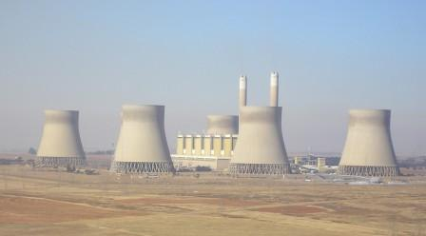
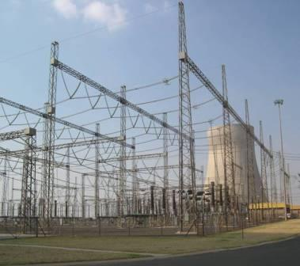
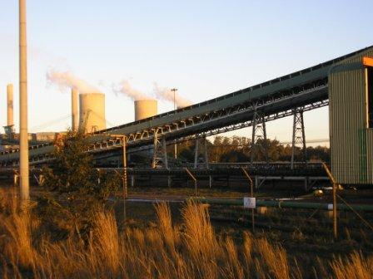

boilers would drive turbines coupled to generators, which convert mechanical energy into electrical energy. The generated electricity is stepped up via transformers in an HV yard and transported via transmission lines into the national grid. The coal mine and transmission lines do not form part of this project and will be the subject of separate EIA processes.

It is anticipated that the proposed power station would occupy an area of approximately 2 500 ha although the actual footprint (that part of the development that would actually modify the nature of the ground) would be approximately half this extent. The highest point would be two stacks, each approximately 250 m high.
Alternatives

It is a requirement of the EIA process that due consideration is given to reasonable alternatives, although not all alternatives need to be investigated at the same level of detail. The Scoping Report identified all the activity, location, process and layout alternatives with respect to the construction and operation of the proposed coal fired power station.

Activity alternatives:
Strategic-level alternatives, i.e. those alternatives related to the method of electricity generation and the selection of the Witbank geographical area for the proposed power station, fall outside of the scope of this project-level EIA process.

Location alternatives:
As mentioned above, three potential regions were identified for the development of new coal-fired power stations, the Witbank geographical area being one of those. Ninham Shand and Eskom undertook a process to define the boundaries of the Witbank geographical area, to delineate potential candidate sites within the identified area, and then to screen the candidate sites. This resulted in two preferred sites being recommended for further detailed investigation during the EIA process (refer to Figure 1). This process is described in detailed in the Scoping Report and location alternatives are therefore not considered further in this assessment.

Process alternatives:
During the Scoping phase, three combustion technology alternatives were discussed; namely pulverised fuel combustion, fluidised bed combustion and coal gasification technologies. Fluidised bed combustion boilers are only technologically proven for up to 400 MW capacity units and are not technologically proven for 900 MW units as proposed for this power station. Furthermore coal gasification technology has been investigated at a pilot plant scale, but is not technologically proven for a 5 400 MW power station. Consequently, pulverised fuel was chosen as the combustion alternative for further investigation.

Three cooling technology alternatives were considered during the Scoping Phase, including wet cooling, indirect dry cooling and direct dry cooling. Given its greater consumption of water than the other technologies, wet cooling was not assessed in the EIA, while indirect and direct dry cooling alternatives were investigated further. In direct dry cooling, the cooling occurs within the main water circuit, by means of forced draught fans and there is no need for cooling towers. In indirect dry cooling, the cooling is achieved via a secondary circuit, resulting in the need for cooling towers.

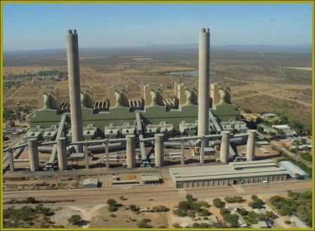
Power station with direct dry cooling

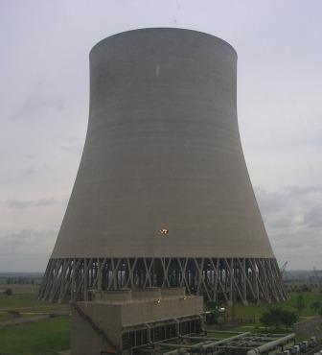
Cooling tower for indirect dry cooling

Atmospheric emission control technology alternatives address particulate matter, NO_{X} and SO₂ emissions. The two main technologies available to remove the fly ash or particulate matter from flue gasses are electrostatic precipitators and fabric filter bags. As the environmental consequences of these technologies do not differ substantively, they were not investigated in any further detail in the EIA. The minimisation of NO_{X} emissions to the atmosphere is by inherently designing the boilers for low NO_{X} production. This would be undertaken for the proposed project, and is not considered in any further detail. The removal of sulphur dioxide (SO₂) is principally undertaken through flue gas desulphurisation (FGD). Two FGD technologies exist, namely wet FGD and semi-dry FGD. Since each technology has a different life-cycle cost and achieves a different level of SO₂ removal efficiency, both wet and semi-dry FGD were further investigated. Wet FGD requires the use of limestone or dolomite as the source of sorbent for the SO₂ removal process. Semi-dry FGD utilises lime as the sorbent, the primary source of which is Lime Acres in the Northern Cape.

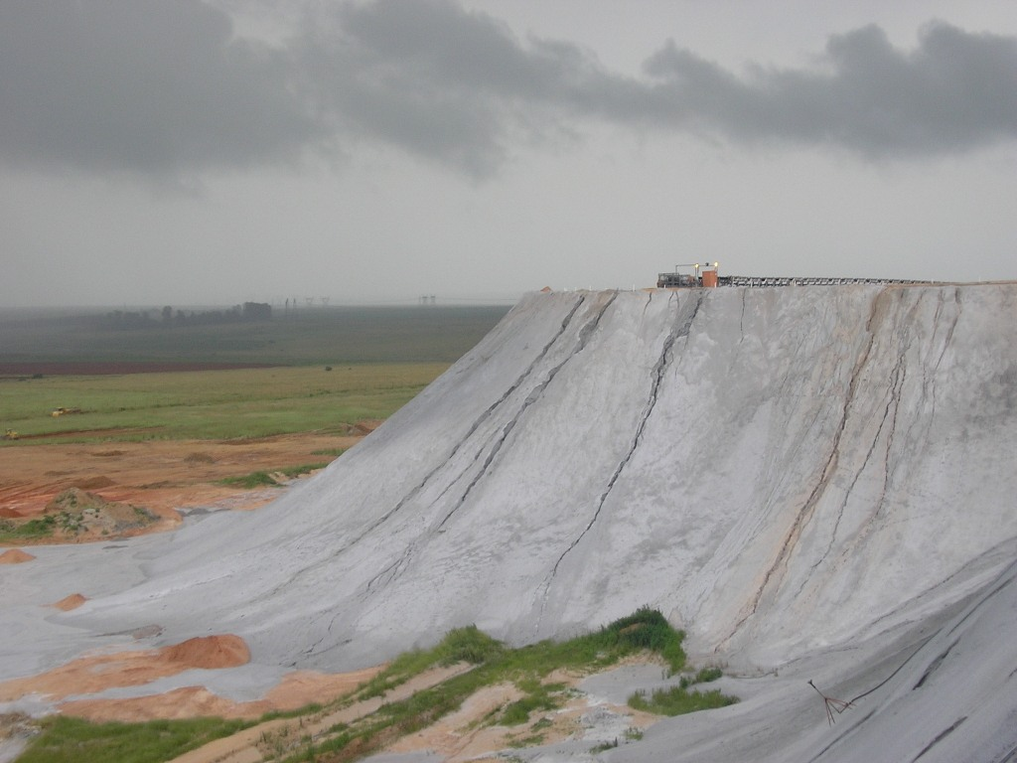
Active above-ground ash dump
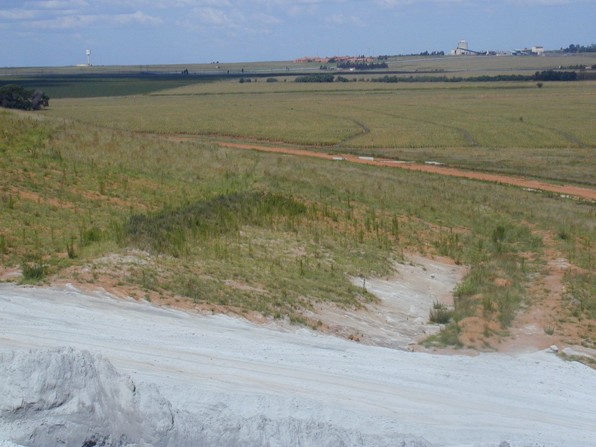

Partially rehabilitated above-ground ash dump

Three ash disposal alternatives were investigated during the Scoping Phase, namely above-ground ashing, in-pit ashing and back-ashing. In-pit ashing and back-ashing require an open cast mine and collaboration with a mining house, in order for these alternatives to be feasible. Above ground ash disposal is the primary method of ash disposal considered in this EIA process, as the other methods require collaboration between Eskom and the relevant mining house, and can not be agreed upon at this point. Consequently, in-pit and back-ashing will be considered in this EIA process at a conceptual level, and to compare these against above-ground ashing. Should Eskom wish to pursue either in-pit or back-ashing in the future, Eskom will need to discuss the legal requirements with the relevant authority(s) at the time.

Site layout alternatives
Broad site layout alternatives were identified for assessment during the EIA. One layout alternative was considered for each site with respect to the power station precinct, coal stockyard and ash dump orientation and it was these potential layouts that were assessed in the various specialist studies. A proposed water supply pipeline corridor from the existing Kendal power station as well as proposed corridors for the transport of sorbent by rail or haul road were also identified.

Alternatives related to the sourcing and mining of coal do not form part of this EIA process. However, the alignment of the overland coal conveyor required to transport the coal from the coal source to the proposed power station has been assessed at a generic level. Water supply to the area will be augmented via a regional supply augmentation scheme. The supply to the proposed power station would be via a pipeline from the existing Kendal power station. Alternative alignments of the water supply pipeline within an identified corridor, were assessed at a generic level. A railway line to provide for sorbent supply to the power station would be required, if FGD were to be implemented. The sorbent could either be railed directly to site, or railed to an existing railway siding and trucked to site, using a dedicated haul road. New road alignments have been investigated for an access road from the existing road network to the proposed sites.

Identified Impacts

The Scoping Phase of this process identified several potential impacts that were proposed to be assessed in the EIA Phase. Each of these impacts or issues was the subject of a specialist study and the following areas of specialisation were thus addressed:

- Air quality impacts;
- Noise impacts;
- Visual impacts;
- Impacts on terrestrial flora and fauna;
- Impacts on aquatic ecosystems;
- Groundwater impacts;
- Risk assessment;
- Heritage impacts;
- Impacts on agricultural potential;
- Socio-economic impacts;
- Planning impacts;
- Traffic impact assessment; and
- Geotechnical constraints.

The proposed terms of reference for the specialist studies are detailed in the Scoping Report and associated Plan of Study for EIA.

Public Participation Process

Engagement with Interested and Affected Parties (I&APs) forms an integral component of an EIA process and I&APs have an opportunity at various stages throughout the EIA process to be informed about the proposed project and to provide input into the consideration of a decision.

Public participation during the Scoping Phase was comprehensive and comprised advertising in national, regional and local newspapers, subsequent notifications in regional and local newspapers, holding several key stakeholder meetings, distributing a Background Information Document and two subsequent revisions, a series of information letters, holding two sessions of public forums at three venues in the area and capturing all the responses received in two Issues Trails. The Scoping Report reflects these actions in detail as well as the iteration in the public participation process necessitated by a revision to the site selection process.

The next stage of the public participation process involves the lodging of the draft EIR Report in public libraries, municipal offices and on the Internet, and hosting another round of public meetings. The purpose of the public meetings is to present the findings of the draft EIR and to provide an opportunity for I&APs to comment on these findings.

Letters were sent to all registered I&APs on 13 November 2006, informing them of the availability of the report for their review and comment and notifying them of the public meeting dates and times, as follows:

Tuesday, 28 November 2006
16h00 – 18h00 | Open House, El Toro Conference Centre
18h00 – 20h00 | Public Meeting, El Toro Conference Centre
Wednesday, 29 November 2006
10h00 – 14h00 | Open House, Mehlwana High School
16h00 – 18h00 | Open House, Protea Hotel, Witbank
18h00 – 20h00 | Public Meeting, Protea Hotel, Witbank

The public will have until 8 January 2007 to submit written comment on the draft EIR to Ninham Shand. Thereafter, the draft will be updated into a Final EIR for submission to DEAT. Cognisance will be taken of all comments when compiling the final report. Should DEAT believe that the final submission contains sufficient information, they will issue a Record of Decision (ROD). When an ROD is issued, I&APs will be informed accordingly and reminded of the 30 day appeal period, commencing on the day that the ROD is issued, in which appeals can be lodged against DEAT’s decision to the Minister of Environment Affairs in terms of the Environment Conservation Act.

Methodology & Assessment

The methodology applied during this EIA is broadly consistent with that described in DEAT’s Guideline Document on the EIA Regulations (1998). The methodology was outlined in the Plan of Study for EIA and in accepting the Final Scoping Report, DEAT has ratified this approach. Using a tabulated rating system, each impact is described according to its extent (spatial scale), magnitude (size or degree scale) and duration (time scale). These criteria are used to ascertain the significance of the impact, firstly in the case of no mitigation and then with the most effective mitigation measures in place. Once the significance of an impact has been determined, the probability of this impact occurring as well as the confidence in the assessment of the impact is determined. Lastly, the reversibility of the impact is estimated.

Challenges faced during the application of the methodology as described relate to the subjectivity in assigning significance to an impact, the consideration of cumulative impacts and the need for integration with other development proposals that impinge on the proposed power station.

Table 1 provides a summary of the significance of the environmental impacts associated with this proposed project. In recognising the extent of the information available at this stage of the project planning cycle, the confidence in the environmental assessment undertaken is regarded as acceptable for informed environmental decision making.

Conclusions & Recommendations

Based on the outcome of the EIA Phase of the proposed project, it is believed that the draft EIR provides a relatively comprehensive investigation and assessment of the environmental issues raised during the Scoping Phase by I&APs, National, Provincial and Local authorities, Eskom and the EIA project team.

Conclusions

None of the construction phase impacts were deemed to have a highly significant impact on the environment, given their relatively short duration and localised extent. The following potential impacts have been identified as relevant to the construction of this project:

- Disturbance of flora and fauna;
- Impacts on water resources (sedimentation and water quality);
- Increase in traffic volumes in the vicinity of the construction site;
- Noise pollution;
- Impact on existing infrastructure;
- Socio-economic impacts;
- Windblown dust;
- Litter/ waste pollution;
- Interruption of road services;
- Storage and utilisation of hazardous substances on site;
- Risk of fire;
- Disturbance to sense of place, visual aesthetics;
- Security risks;
- Health issues; and
- Light pollution.

However, many of the construction phase impacts are of medium significance and require a suite of mitigation interventions in order to avoid and minimise impacts on the biophysical and especially the human environment. A framework EMP (fEMP) has been developed to guide the construction and operational phases of the proposed project. The implementation of the fEMP would minimise possible negative impacts on construction and operation and assigns responsibility for environmental controls. A detailed construction and operational EMP would be developed based on the Conditions of Approval in the ROD, should the project be approved.

With reference to Table 1, the most significant operational phase impacts of the proposed power station and its associated infrastructure on the biophysical and social environment, without mitigation, include the following:

- Impact of air emissions on ambient air quality in the area-
The establishment of an approximately 5 400 MW power station in the Witbank area will lead to an increase in the ambient levels of SO_{X}, NO_{X}, CO₂, particulate matter and heavy metals in the region and potentially more broadly.

- Impact of SO₂ emitted on vegetation and metal corrosion
High concentrations of SO₂ over short periods of time may result in a visible effect on vegetation.

- Impact of CO₂ emissions on global climate change
The establishment of a new coal fired power station will result in an increase in the emission of greenhouse gasses to the atmosphere, adding to the greenhouse effect on a regional, national and international scale.

- Impact of air pollution on community health
The operation of a new coal-fired power station will result in increased emissions of SO₂, NO_{X}, particulate matter and mercury, which may have a detrimental impact on the health of communities in the surrounding areas.

- Impact of surface ash disposal on aquatic flora and fauna
The proposed above ground disposal of ash could have direct and indirect impacts on the aquatic environment and the ash dump would have a direct footprint impact on the aquatic environment. The proposed location of the ash dump on Site X is the middle of a high integrity wetland.

- Impact of surface ash disposal on Site X
The proposed location of the ash dump on Site X is the middle of a high integrity wetland.

- Visual impact of using FGD
The implementation of flue gas technology is likely to result in a visible plume arising from the emission stacks, as a consequence of the use of water in the FGD process. While the overall incremental difference in terms of the visual resource is likely to be minimal from a visual receptor point of view, the presence of a visible plume would slightly increase the severity of the impact.

- Noise impact as a result of direct dry cooling
The main source of noise that would emanate from the proposed power station would be the cooling fans, should direct dry cooling be chosen as the cooling technology alternative. Approximately 72 cooling fans would be required per generating unit, totalling 432 fans.

- Impact of the proposed site layout on aquatic fauna and flora at Site Y
The proposed power station and associated infrastructure/ processes may have impacts on the existing aquatic fauna and flora at either of the alternative sites. Site Y has a higher biodiversity and biotic integrity than at Site X.

- Impact of the proposed project on agricultural potential at Site Y
The establishment of a power station at either site would result in the loss of approximately 2 500 ha of agricultural land, which may have an impact on the economy of the region. The significance of the impact on Site Y is however deemed to be high due to the higher yield and production value of the soil per hectare than Site X, and because of the extensive irrigation infrastructure on the site and the access to water from the Wilge River.

Recommendations

With reference to the operational impacts described above, it can be noted that their significance levels could generally be reduced by implementing the identified mitigatory measures. Assuming that the identified suite of mitigatory measures are implemented, the following describes the various project alternatives in terms of their biophysical and socio-economic impact:

With reference to the alternative sites, there appears to be no clear distinction between Site X and Site Y, as their environmental impacts are similar. However, Site X appears to be marginally preferable to Site Y when issues related to groundwater, wetlands, noise and agriculture are considered. While the differences are marginal, the establishment of a coal fired power station on Site X is likely to have fewer negative impacts on the biophysical and socio-economic environments.

It is recommended that the proposed site layout for the power station precinct on Site Y be refined to avoid impacting on moderate- to high-integrity wetlands. Similarly, if an above-ground ash dump is created, the proposed location for the ash dumps on Sites X and Y would have to be refined slightly, to avoid impacting on high-integrity wetlands.

Insofar as cooling technologies are concerned, indirect dry cooling, which utilises cooling towers, greatly increases the disturbance footprint and visual prominence of the power station, making it a more imposing structure. However, direct dry cooling, utilising the bank of fans for each boiler unit, increases the ambient noise levels significantly. Given the potential mitigation measures for noise impacts, such as noise abatement technology, insulation and increasing the buffer zone between the power station and adjacent farmers, direct dry cooling is recommended as an environmentally acceptable option, despite the increased noise impact.

With reference to air emission abatement, Eskom has made a firm commitment to the implementation of Flue Gas Desulphurisation (FGD) with at least 90% removal efficiency for the proposed new coal-fired power station in the Witbank area. Without FGD in place, exceedances of the SO₂ standards increases significantly and a large number of additional people are likely to be exposed to SO₂ levels that are detrimental to human health. The implementation of FGD with at least 90% removal efficiency is recommended for the proposed project, and as mentioned above, Eskom has made a commitment to FGD implementation.

Above ground ash disposal will result in a larger footprint being disturbed than other forms of ash disposal. However, back-ashing and in-pit ashing require the ash to be conveyed to the mine and may result in groundwater contamination. Above-ground ashing is therefore recommended as the environmentally most acceptable ash disposal technique at this stage.

Way Forward

The next stage of this EIA process involves lodging the draft EIR at a suite of public venues and hosting two Open Houses and Public Meetings. The opportunities for public involvement are as follows:

- Commenting on the draft EIR, copies of which have been lodged at the Witbank public library, the Nelspruit public library, the Phola public library, the Johannesburg public library and the Kungwini and Delmas municipal offices, as well as on the Eskom (www.eskom.co.za/eia) and Ninham Shand (www.ninhamshand.co.za) websites. The public will have until 8 January 2007 to submit written comment on the draft EIR to Ninham Shand.
- All registered I&APs are being notified of the availability of the draft EIR by means of a letter which includes a copy of this draft EIR Executive Summary.
- Public notices are being placed in the Middleburg Observer, Witbank News, Streekbuus and The Highvelder on 17 November 2006 in order to notify I&APs of the availability of the draft EIR and will include an invitation to the Open Houses and Public Meetings.

Once the final EIR has been completed and all I&APs comments have been incorporated into the report, where appropriate, it will be presented to Eskom for their comment and review. Eskom will then motivate their selection of the project alternatives that it wishes to seek authorisation for. The final EIR and Eskom’s letter of motivation will be submitted to DEAT for review and decision making. Their decision will be documented in a Record of Decision and registered I&APs will be informed accordingly.

