Prepared for:
D van Heerden & M Potgieter
Enpro Industries
Environmental Consulting Auditing and Authorisation
PO Box 90159 Garsfontein 0042
Tel 0129913148
marnus@ecoprotect.co.za
dean@ecoprotect.co.za

A PHASE I HERITAGE IMPACT ASSESSMENT (HIA) STUDY FOR ESKOM’S PROPOSED NKWE PROJECT IN THE STEELPOORT VALLEY IN THE LIMPOPO PROVINCE

Prepared by:
Dr Julius CC Pistorius
Archaeologist & Heritage Consultant

352 Rosemary Street Lynnwood 0081
PO Box 1522 Bela Bela 0480

June 2015
Tel and fax: 014 7362115
Cell: 0825545449
Member ASAPA

EXECUTIVE SUMMARY

A Phase I Heritage Impact Assessment (HIA) study as required in terms of Section 38 of the National Heritage Resources Act (No 25 of 1999) was done for Eskom’s proposed Nkwe Project in the Steelpoort Valley in the Limpopo Province. The construction of the proposed Nkwe Project is hereafter referred to as the Eskom Project whilst the footprint for the proposed Eskom Project is referred to as the Eskom Project Area.

The aims of the Phase I HIA study were the following:
- To determine if any of the types and ranges of heritage resources (the ‘national estate’) as outlined in Section 3 of the National Heritage Resources Act (No 25 of 1999) do occur in the Eskom Project Area and, if so, to establish the significance of these heritage resources.
- To establish the level of significance of any possible impact on these heritage resources.
- To propose appropriate mitigation measures for those types and ranges of heritage resources that may be affected by the proposed Eskom Project.

The Phase I HIA study for the proposed Eskom Project revealed the following types and ranges of heritage resources as outlined in Section 3 of the National Heritage Resources Act (No 25 of 1999) in the Project Area, namely:
- Two graveyards in close proximity of the two alternatives for the power lines.

These graveyards were geo-referenced and mapped (Figure 11; Table 1). The significance of the graveyards is indicated as well as the significance of any impact on the graveyards (Table 2). No mitigation measures are outlined as the graveyards will not be affected by the proposed Eskom Project.

The significance of the graveyards
All graveyards and graves can be considered to be of high significance and are protected by various laws (Table 1). Legislation with regard to graves includes Section 36 of the National Heritage Resources Act (Act No 25 of 1999) whenever graves are older than sixty years. GY01 is older than sixty years. Other legislation with regard to graves includes those which apply when graves are exhumed and relocated, namely the Ordinance on Exhumations (No 12 of 1980) and the Human Tissues Act (No 65 of 1983 as amended).

Possible impact on the graveyards
Not one of the two graveyards will be affected by either Alternative 01 or Alternative 02 for the proposed new power line (Figure 11).

The significance of the impact on the graveyards
The significance of any possible impact on the graveyards is very low (Table 2).

Mitigating the graveyard impacts
The graveyards will not be affected by the Eskom Project. Consequently, the graveyards need no mitigation measures.

The Tsjate Provincial Heritage site will not be negatively influenced by Eskom’s proposed Nkwe Project considering the fact that Alternative 01 and Alternative 02 for the proposed new 132kV power lines merely cross the north-eastern tip of the Tsjate Provincial Heritage Site. The Tsjate Provincial Heritage Site collates with the historical Tsjate cultural landscape which is a contemporary living environment in which thousands of individuals with associated infrastructure with are constantly improved and upgraded are settled.

Summary
Both alternatives for the 132kV power lines as well as the two alternatives for the Nkwe Substation therefore are suitable from a heritage point of view for the implementation of the Eskom Nkwe Project.

General (disclaimer)
This Phase I HIA study may have missed heritage resources in the Project Area as heritage sites may occur in thick clumps of vegetation while others may lie below the surface of the earth and may only be exposed once development commences.

If any heritage resources of significance is exposed during the Project the South African Heritage Resources Authority (SAHRA) should be notified immediately, all development activities must be stopped and an archaeologist accredited with the Association for Southern African Professional Archaeologist (ASAPA) should be notify in order to determine appropriate mitigation measures for the discovered finds. This may include obtaining the necessary authorisation (permits) from SAHRA to conduct the mitigation measures.

CONTENTS

Executive summary 2

1 INTRODUCTION 6

2 PROJECT DESCRIPTION 9
2.1 Location 9
4.2 The nature of the Project Area 10
4.3 The nature of the Project 11
2.4 The heritage potential of the Project Area 12

3 LEGAL FRAMEWORK 15
3.1 Legislation relevant to heritage resources 15
3.2 The National Heritage Resources Act (NHRA) 16
3.3 Heritage Impact Assessment studies 16
3.4 Regulations with regard to heritage resources 17
3.4.1 Buildings and structures 17
3.4.2 Graves and burial grounds 17
3.4.3 Archaeology, palaeontology and meteorites 19

4 BASELINE ENVIRONMENT 20
4.1 Pre-historical context 20
4.2 Pre-historical and early Historical Period 20
4.3 The Historical Period 22
4.4 Historical beacons near the Project Area 24

5 STUDY APPROACH AND METHODOLOGY 26
5.1 Fieldwork survey 26
5.2 Databases, literature survey and maps 27
5.3 Assumptions and limitations 27
5.4 Some remarks on terminology 28

6 THE PHASE I HERITAGE IMPACT ASSESSMENT STUDY 32
6.1 The fieldwork survey 32
6.2 The proposed new power line 32
6.2.1 Alternative 01 32
6.2.2 Alternative 02 34
6.2.3 The Nkwe Substation 34
6.2 Types and ranges of heritage resources 36
6.2.1 Graveyards 38
6.2.1.1 Graveyard 01 39
6.2.1.2 Graveyard 02 49
6.3 Table 40
6.4 The significance of the graveyard s 40
6.5 Possible impact on the graveyards 41
6.6 The significance of the impact on the graveyards 41
6.7 Mitigating the graveyard impacts 43

7 CONCLUSION AND RECOMMENDATIONS 44

8 SELECT BIBLIOGRAPHY 46

9 BIBLIOGRAPHY RELATING TO EARLIER HERITAGE
STUDIES 48

APPENDIX A: DETAILS OF THE SPECIALIST 49
APPENDIX B: DECLARATION OF INDEPENDENCE 50

1 INTRODUCTION

Eskom intends to construct the Eskom Nkwe Project with associated 132kV power line and substation in the Steelpoort Valley in the Limpopo Province. The proposed Eskom Project may have an influence on any of the types and ranges of heritage resources which are listed in Section 3 of the National Heritage Resources Act (No 25 of 1999).

In order to comply with heritage legislation, Eskom requires knowledge of the presence, relevance and the significance of any heritage resources that may be affected by the Project. Eskom needs this knowledge in order to take pro-active measures with regard to any heritage resources that may be affected, damaged or destroyed when the Project is implemented. Enpro Industries, the environmental company responsible for compiling the Basic Assessment (BA) for the project, therefore commissioned the author to undertake a Phase I Heritage Impact Assessment (HIA) study for the Project Area.

The aims with the Phase I HIA were the following:
- To determine if any of the types and ranges of heritage resources (the ‘national estate’) as outlined in Section 3 of the National Heritage Resources Act (No 25 of 1999) do occur in the Eskom Project Area and, if so, to establish the significance of these heritage resources.
- To establish the level of significance of any possible impact on these heritage resources.
- To propose appropriate mitigation measures for those types and ranges of heritage resources that may be affected by the proposed Eskom Project.

This document contains the report on the results of the Phase I HIA study that was done for the proposed Eskom Nkwe Project in the Steelpoort in the Limpopo Province. The Limpopo Province has a rich heritage comprised of remains dating from the pre-historical and from the historical periods of South Africa. Pre-historical and historical remains in the Limpopo Province form a record of the heritage of most groups living in South Africa today. Heritage resources in the Limpopo Province therefore constitute a rich and wide diversified range, also known as the ‘national estate’ as outlined in Section 3 of the National Heritage Resources Act (Act 25 of 1999) (see Box 1, next page).

Box 1: Types and ranges of heritage resources (the national estate) as outlined in Section 3 of the National Heritage Resources Act, 1999 (No 25 of 1999).
The National Heritage Resources Act (Act No 25 of 1999, Art 3) outlines the following types and ranges of heritage resources that qualify as part of the National Estate, namely:
(a) places, buildings structures and equipment of cultural significance;
(b) places to which oral traditions are attached or which are associated with living heritage;
(c ) historical settlements and townscapes;
(d) landscapes and natural features of cultural significance;
(e) geological sites of scientific or cultural importance;
(f) archaeological and palaeontological sites;
(g) graves and burial grounds including-
(i) ancestral graves;
(ii) royal graves and graves of traditional leaders;
(iii) graves of victims of conflict;(iv) graves of individuals designated by the Minister by notice in the Gazette;
(v) historical graves and cemeteries; and
(vi) other human remains which are not covered by in terms of the Human Tissues Act, 1983 (Act No 65 of 1983);
(h) sites of significance relating to the history of slavery in South Africa;
(i) movable objects, including -
(i) objects recovered from the soil or waters of South Africa, including archaeological and palaeontological objects and material, meteorites and rare geological specimens;
(ii) objects to which oral traditions are attached or which are associated with living heritage;
(iii) ethnographic art and objects;
(iv) military objects;
(v) objects of decorative or fine art;
(vi) objects of scientific or technological interest; and
(vii) books, records, documents, photographs, positives and negatives, graphic, film or video material or sound recordings, excluding those that are public records as defined in section 1(xiv) of the National Archives of South Africa Act, 1996 (Act No 43 of 1996).
The National Heritage Resources Act (Act No 25 of 1999, Art 3) also distinguishes nine criteria for places and objects to qualify as ‘part of the national estate if they have cultural significance or other special value …‘. These criteria are the following:
(a) its importance in the community, or pattern of South Africa’s history;
- its possession of uncommon, rare or endangered aspects of South Africa’s natural or cultural heritage;
- its potential to yield information that will contribute to an understanding of South Africa’s natural or cultural heritage;
- its importance in demonstrating the principal characteristics of a particular class of South Africa’s natural or cultural places or objects;
- its importance in exhibiting particular aesthetic characteristics valued by a community or cultural group;
- its importance in demonstrating a high degree of creative or technical achievement at a particular period;
- its strong or special association with a particular community or cultural group for social, cultural or spiritual reasons; (h)
- its strong or special association with the life or work of a person, group or organisation of importance in the history of South Africa;
(i) sites of significance relating to the history of slavery in South Africa

2 PROJECT DESCRIPTION

2.1 Location

Eskom intends to construct the Nkwe Project in the Steelpoort Valley in the Limpopo Province. The Project Area is situated approximately forty-five kilometres to the north-west of Steelpoort and is located between the Leolo Mountain range (west) and Road 37 which runs between Lebowakgomo and Burgersfort, The Eskom Project Area runs from the north to the south whilst crossing the northern foothills of the Leolo mountain range as well as the farms Hackney 118KT, Forest Hill 117KT, Clapham 118KT, Driekop 253KT and Maandagshoek 234KT. This elongated area runs from the north to the south along a flat valley floor between the foothills of the Leolo Mountain range (2430CA Steelpoort & 2430AC Maroke 1:50 000 topographical maps; 2428 Modimolle 1: 250 000 map) (Figure 1).

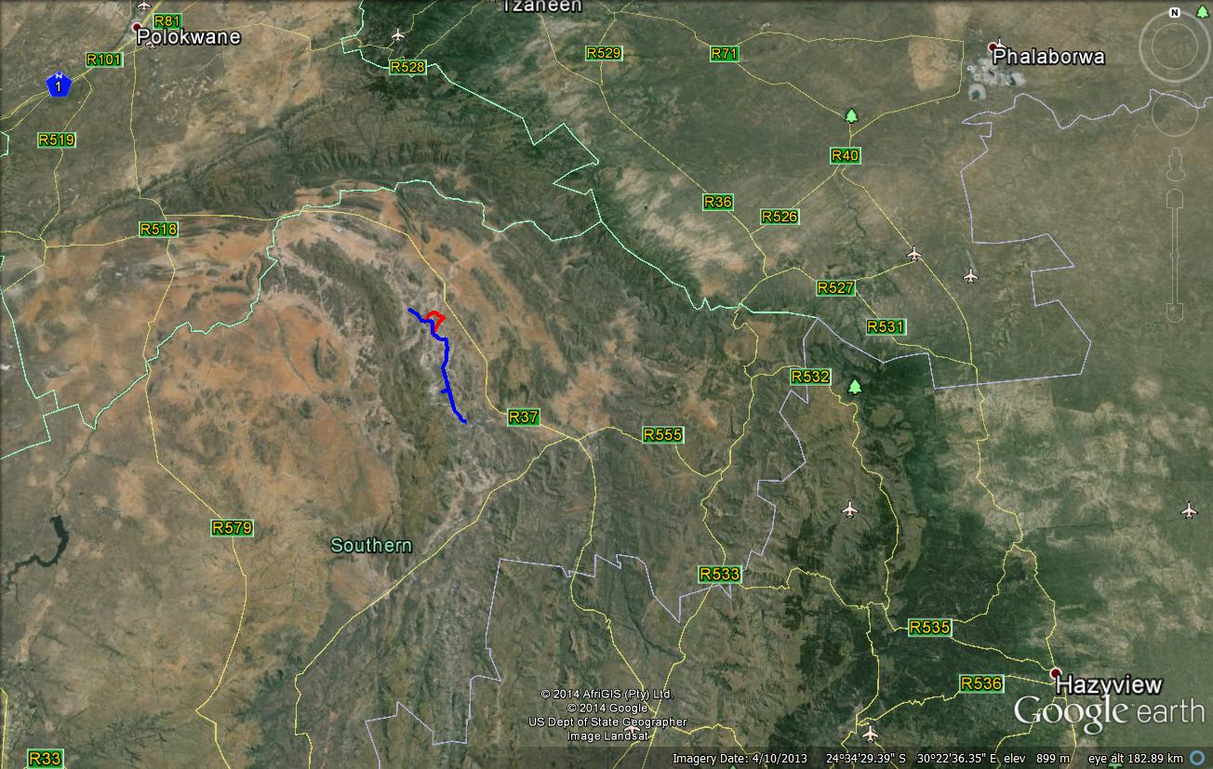

Figure 1- Regional location of the Eskom Nkwe Project in the Steelpoort Valley near the Tsjate Provincial Heritage Site in the Limpopo Province (above).
The Steelpoort Valley’s name is derived from the Steelpoort (Tubatse) River, one of the main geographical features in this valley. The Steelpoort River is a southern tributary of the Olifants River. It flows from an altitude higher than 1 800m on the Highveld near Wonderfontein in the Belfast district northwards and then north-eastwards to join the Olifants River before the latter cuts through the Drakensberg to enter the Lowveld. Other prominent beacons in the wider study area include the Chromite Hills to the north-east of the study area and the imposing Leolo Mountain range in the study area. The Leolo Mountain range is known as a beacon in the origin history of the Pedi.

2.2 The nature of the Project Area

The Project Area is not a pristine piece of land any longer as it follows Road D4169 which is an established road which winds its way through the villages of Mathipa, Moretha and Maroga. The nature and character of the Project Area is described in more detail and illuminated with a number of photographs (see Part 6.1 ‘The field Survey’).

The people of the Steelpoort Valley practised cultivating and stock farming for many centuries. This is definitely the case for historical villages such as Tsjate and others which occur along the foot of the Leolo Mountain range and some of its foothills in and near the Project Area. This part of the Steelpoort Valley used to be the home of numerous diverse clans who eventually were moulded into the nineteenth century Pedi chiefdom (see Part 4, ‘Baseline information’).

In the past, chiefs allocated pieces of land to the heads of wards. The heads of these dikgoro provided plots to married men. The sizes of plots were determined by the number of wives a man had, but each plot was usually 1 to 2 hectares, which is the maximum that a woman could cultivate using a hoe. The introduction of the plough allowed families to cultivate larger areas of land, up to about 4, 5 hectares.

Crops included sorghum (mabele) and millet (letsoa), which were later largely replaced by maize (mahea) as a staple food. Supplementary crops included pumpkins (marotse), various varieties of gourd (maraka), beans (dinawa) and a type of groundnut (ditloo). Tobacco and sugarcane were also planted.

Although each person usually possessed his own stock, pasturage was used on a communal basis. At a fixed time the tribal ruler declared the reaped grain fields open for use as winter grazing. Grazing cattle in particular disturbs heritage resources, as deposits on sites are churned under hoof and low stone foundations are broken and scattered.

The uninterrupted occupation of the Steelpoort Valley over a long period of time, an increase in population numbers as well as increasing development in the region however, are gradually changing an extraordinary cultural landscape with unique heritage characters and features.

2.3 The nature of the Project

The proposed Eskom Nkwe Project will entail the following developmental components:
- Construction of two ± 22 km of 132kV Kingbird power lines from the Leseding MTS station to the Nkwe substation. (The route will remain the same with these two power lines running parallel to one another).
- An access road ± 720m long to the substation.
- Construction of the proposed Nkwe 132kV substation 100m x 100m on the farm Maandagshoek 254 KT (area applied for is 200m x 200m to accommodate construction material etc.)
- A 46m high communication tower within Nkwe substation.

Two alternative power line routes for the 132kV power line as well as for the Nkwe Substation are proposed (Preferred and Alternative for each).

The purpose with the Eskom Nkwe Project is to provide electrification to the planned Nkwe Garatau Platinum Mine. The preferred site for the Nkwe Substation was provided by Nkwe Platinum. This site is the most viable with regards to its location within the mine complex entailing all mine infrastructure and tailings dam.

The construction of the proposed Nkwe Project is hereafter referred to as the Eskom Project whilst the footprint for the proposed Eskom Project is referred to as the Eskom Project Area.

2.4 The heritage potential of the Project Area

The Project Area is located near the heartland of the pre-historical and the historical Pedi chiefdom. A part of this landscape was declared a Provincial Heritage Site by the Limpopo Government on 23 February 2007 (Provincial Gazette No 1333 33). A small museum was also developed in the village of Tsjate. The archaeological and historical significance of this landscape is briefly described (see Part 4, ‘Baseline information’).
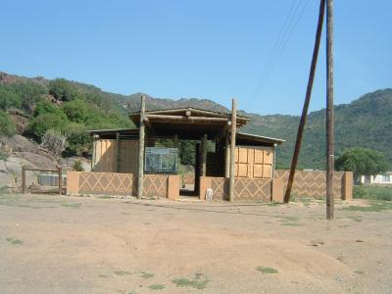

Figure 2 - The Tsjate museum in the village of Tsjate (above) is located next to the commemorative beacon that was erected for British soldiers who died in the Sekhukhune Wars (1879) (above).

The co-ordinates for the Tsjate Provincial Heritage site are as follows (see Figure 12):

S 24° 31’ 41.5”  S 24° 27’ 53”  S 24° 27’ 10”  S 24° 27’ 41”  S 24° 30’ 06”  S 24° 31’ 27.5” | E 29° 59’ 26”  E 29° 59’ 30”  E 30° 01’ 12.5”  E 30° 02’ 45”  E 30° 02’ 46”  E 30° 02’ 03”

Several heritage impact assessment studies have been done close to the Project Area, namely (see Part 8, ‘Select Bibliography’):
- Kusel, U. 2008. Assessment of the Cultural Heritage Resources on the provincial heritage site of Tsjate on the farm Djate 249KT in Sekhukhune Limpopo Province. Unpublished report. African Heritage Consultants.
- Pistorius, J.C.C. 2001. An Archaeological impact assessment report for the proposed Impala Platinum Mine at Steelpoort in the Northern Province of South Africa. Unpublished report prepared for Pulles, Howard and De Lange Incorporated.
- Pistorius, J.C.C. 2007. A Phase I Heritage Impact Assessment (HIA) study for the proposed Route D for the 400kV Duvha-Lesideng power line running across the Tsjate Valley in the Steelpoort in the Limpopo Province. Unpublished report prepared for Eskom Megawatt Park.
- Pistorius, J.C.C. 2007. A Phase I Heritage Impact Assessment (HIA) study for Marula Platinum’s proposed new shaft, corridor and extension to an existing waste dump in the Limpopo Province of South Africa. Unpublished report prepared for Metago Environmental Engineers.
- Pistorius, J.C.C. 2010. A Heritage Management Plan for Marula Platinum in the Steelpoort Valley in the Limpopo Province of South Africa. Unpublished report prepared for SRK Consulting.
- Pistorius, J.C.C. 2011. A Phase I Heritage Impact Assessment (HIA) study for Marula Platinum (Pty) Ltd’s (Marula) proposed new mine infrastructure, re-positioning of the approved Merensky Shafts and the incorporation of prospecting areas into the mining rights area in the Steelpoort Valley in the Limpopo Province. Unpublished report prepared for Metago Environmental Engineers.
- Pistorius, J.C.C. 2012. A Phase I Heritage Impact Assessment (HIA) study for Eskom’s 2x132kV power lines between the proposed Tshatane and Lesego Substations and between the proposed Tshatane and the existing Jane Furse Substation in the Limpopo Province. Unpublished report prepared for DIGES.

The most common types and ranges of heritage resources which do occur in the Project Area at large are the following (see Part 4, ‘Baseline information’):
- Stone tools which date from the MSA and the LSA. These are particularly common on the flat areas and in eroded dongas which occur near the foot slopes and between the foothills of the Leolo Mountain range.
- Early Iron Age sites which occur in more or less the same localities as tools from the Stone Age as well as near river and stream beds or at the junction of these water courses.
- Late Iron Age settlements which stretches well into the Historical Period such as Tsjate, Phiring, Thaba Mosega, Mofofolo, and others.
- Remains which date from the Historical Period and which are associated with the indigenous people who occupied the region.
- Graveyards which are associated with the indigenous people of the region and which date from the Historical Period into the present.

3 LEGAL FRAMEWORK

South Africa’s heritage resources (’national estate’) are protected by international, national and regional legislation which provides regulations, policies and guidelines for the protection, management, promotion and utilization of heritage resources. South Africa’s ‘national estate’ includes a wide range of various types of heritage resources as outlined in Section 3 of the National Heritage Resources Act (NHRA, Act No 25 of 1999) (see Box 1).

According to the NHRA (Act No 25 of 1999) heritage resources are categorised using a three-tier system, namely Grade I (national), Grade II (provincial) and Grade III (local) heritage resources.

At the provincial level, heritage legislation is implemented by Provincial Heritage Resources Agencies (PHRAs) which apply the National Heritage Resources Act (Act 25 of 1999) together with provincial government guidelines and strategic frameworks. Metropolitan or Municipal (local) policy regarding the protection of cultural heritage resources is also linked to national acts and is implemented by the South African Heritage Resources Agency (SAHRA) and the Provincial Heritage Resources Agencies.

At a national level heritage resources are dealt with by the National Heritage Council Act (Act No 11 of 1999) and the National Heritage Resources Act (Act No 25 of 1999).

3.1 Legislation relevant to heritage resources

The identification, evaluation and assessment of heritage resources in South Africa are regulated by the following legislation:
- National Environmental Management Act (NEMA) Act 107 of 1998
- National Heritage Resources Act (NHRA) Act 25 of 1999
- Minerals and Petroleum Resources Development Act (MPRDA) Act 28 of 2002
- Development Facilitation Act (DFA) Act 67 of 1995

3.2 The National Heritage Resources Act (NHRA)

According to the NHRA (Act No 25 of 1999) the ‘national estate’ comprises the following (see Box 1):
- Archaeological artefacts, structures and sites older than 100 years
- Ethnographic art objects (e.g. prehistoric rock art) and ethnography
- Objects of decorative and visual arts
- Military objects, structures and sites older than 75 years
- Historical objects, structures and sites older than 60 years
- Proclaimed heritage sites
- Graveyards, burial grounds and graves older than 60 years
- Meteorites and fossils
- Objects, structures and sites or scientific or technological value.

Elaborating on the above the ‘national estate’ also includes (Box 1):
- Places, buildings, structures and equipment of cultural significance
- Places to which oral traditions are attached or which are associated with living heritage
- Historical settlements and townscapes
- Landscapes and features of cultural significance
- Geological sites of scientific or cultural importance
- Archaeological and paleontological sites of importance
- Sites of significance relating to the history of slavery
- Movable objects (e.g. archaeological, paleontological, meteorites, geological specimens, military and ethnographic objects, books etc.)

3.3 Heritage Impact Assessment studies

According to Section 38 of the National Heritage Resources Act (Act No 25 of 1999) a Heritage Impact Assessment (HIA) process must be followed under the following circumstances:
- The construction of a linear development (road, wall, power line, canal etc.) exceeding 300m in length
- The construction of a bridge or similar structure exceeding 50m in length
- Any development or activity that will change the character of a site and which exceeds 5 000m² or which involve three or more existing erven or subdivisions thereof
- Re-zoning of a site exceeding 10 000 m²
- Any other category provided for in the regulations of SAHRA or a provincial heritage authority

3.4 Regulations with regard to heritage resources

The regulations outlined below are applicable to the types and ranges of heritage resources which are the most common in the region where the heritage study was conducted, namely:

3.4.1 Buildings and structures

According to Section 34(1) of the NHRA (Act No 25 of 1999) no person may alter (demolish) any structure or part thereof which is older than 60 years without a permit issued by the relevant provincial heritage resources authority.

A structure means any building, works, device or any other facility made by people and which is fixed to land and which includes fixtures, fittings and equipment associated with such structures.

Alter means any action which affects the structure, appearance or physical properties of a place or object, whether by way of structural or any other works such as painting, plastering, decorating, etc..

3.4.2 Graves and burial grounds

Graves and burial grounds are divided into the following:
- ancestral graves
- royal graves and graves of traditional leaders
- graves of victims of conflict
- graves designated by the Minister
- historical graves and cemeteries
- human remains

In terms of Section 36(3) of the NHRA (Act No 25 of 1999) no person, without a permit issued by the relevant heritage resources authority, may:
- destroy, damage, alter, exhume or remove from its original position or otherwise disturb the grave of a victim of conflict, or any burial ground or part thereof which contains such graves
- destroy, damage, alter, exhume or remove from its original position or otherwise disturb any grave or burial ground older than 60 years which is situated outside a formal cemetery administered by a local authority; or
- bring onto or use at a burial ground or grave referred to in paragraph (a) or (b) any excavation, or any equipment which assists in the detection or recovery of metals.

Unidentified graves are handled as if they are older than 60 years until proven otherwise.

Human remains that are less than 60 years old are subject to provisions of the Human Tissue Act (Act 65 of 1983) and to local regulations. Exhumation of graves must conform to the standards set out in the Ordinance on Excavations (Ordinance no. 12 of 1980) (replacing the old Transvaal Ordinance no. 7 of 1925).

Permission must also be gained from the descendants (where known), the National Department of Health, Provincial Department of Health, Premier of the Province and local police. Furthermore, permission must also be gained from the various landowners (i.e. where the graves are located and where they are to be relocated) before exhumation can take place. Human remains can only be handled by a registered undertaker or an institution declared under the Human Tissues Act (Act 65 of 1983 as amended).
3.4.3 Archaeology, palaeontology and meteorites

Section 35(4) of the NHRA (Act No 25 of 1999) deals with archaeology, palaeontology and meteorites and states that no person without a permit issued by the responsible heritage resources authority (national or provincial) may:
- destroy, damage, excavate, alter, deface or otherwise disturb any archaeological or paleontological site or any meteorite
- destroy, damage, excavate, remove from its original position, collect or own any archaeological or paleontological material or object or any meteorite
- trade in, sell for private gain, export or attempt to export from the Republic any category of archaeological or paleontological material or object, or any meteorite; or bring onto or use at an archaeological or paleontological site any excavation equipment or any equipment that assists in the detection or recovery of metals or archaeological and paleontological material or objects, or use such equipment for the recovery of meteorites
- alter or demolish any structure or part of a structure which is older than 60 years.

Heritage resources may only be disturbed or moved by an archaeologist after being issued with a permit received from the South African Heritage Resources Agency (SAHRA). In order to demolish heritage resources the developer has to acquire a destruction permit by from SAHRA.

4 BASELINE ENVIRONMENT

A brief overview of pre-historical and historical information below contextualises the Steelpoort Valley and the Project Area which is located in the Pedi heartland in Sekhukhune. This information is necessary to understand the meaning and significance of heritage resources which may exist in the Project Area.

4.1 Pre-historical context

Stone Age sites are scattered in the extensive network of dongas which occur across the wide valleys floors between the Leolo and other mountain ranges in the northern part of the Steelpoort Valley. Some sites have been observed by the author on farms such as Hendriksplaats 281, Derde Gelid 278, Onverwacht 292, Winterveld 293, Annex Grootboom 335 and Apiesboomen 295 (Pistorius 2005a, 2005b). These stone tools date from the Early Stone Age (500 000 to 200 000 years ago), the Middle Stone Age (200 000 to 40 000 years ago) and from the Late Stone Age (40 000 to 200 years ago).

However, no archaeological survey for Stone Age sites as part of any extensive or in-depth Stone Age research project has to the knowledge of this author been done in the Steelpoort River Valley as yet.

4.2 Pre-historical and early Historical Period

The origins of the first Bantu-Negroid farming communities who practised agriculture, live-stock herding and metal working can be traced to the Steelpoort Valley. These Early Iron Age farming communities whose settlements have been recorded on amongst others Hendriksplaats 281 and Derde Gelid 278 were related to Early Iron Age communities who, contemporaneously, AD500 to AD900, settled further towards the east in the Lydenburg Valley (Pistorius 2005a). One of the settlements belonging to the Early Iron Age Lydenburg culture won international acclaim as the Lydenburg clay masks were discovered at this site near the Sterkspruit, south of Lydenburg (Inskeep 1978, Whitelaw 1996).
The historical period in the Steelpoort Valley is associated with the second millennium AD when a predominantly Northern Sotho-speaking population occupied the Steelpoort. These people are part of a larger Northern Sotho-speaking community who occupy a vast area between the Limpopo River in the north, the Drakensberg in the east and the Sekhukhune Mountains in the west. Numerous divisions and groups or clans therefore occupy this vast region. The history of the people of this area can be divided into several periods (Mönnig 1978; Delius 1984, 2007):

The earliest period of settlement is characterized by small groups of Bantu people who started to drive the San and Khoi Khoi from the area and who are difficult to identify. From approximately AD1700 ancestral groupings of the present inhabitants of the land began to arrive in the area. Groups that can be distinguished include:
- A large group of Sotho who came from the north-eastern parts of the Lowveld and who settled on the plateau to the north and to the south of the Strydpoortberge.
- Small groups of Kgatla and Huruthshe-Kwena origin moved from the Tswana area (Brits and Rustenburg) into the territory. Amongst them were the present Pedi (or Rota) who moved into what is now Sekhukhuneland, where they subjected the Sotho already living there.
- During these times Sekhukhuneland was also penetrated by Sotho arriving from the south-east.
- After AD1600 the Northern Ndebele arrived from the south-east and settled in what is now the Mokerong district.

It is assumed that during the period from AD1700 to AD1826 the Pedi took political control over the territory previously known as Lebowa, but to the south of the Strydpoortberge. The Pedi chiefdom reached its zenith during the reign of Thulare who died in 1824.

During the disruption of the difaqane (AD1822 to AD1828) Mzilikazi attacked the Pedi from the south-east in 1826 and in 1827/1828. This caused large-scale depopulation of the southern part of the Northern-Sotho territory. The Pedi sought refuge in the Soutpansberg in 1822 and only returned in 1828.

After the wars with Mzilikazi there were wars with the Swazi. The Voortrekkers arrived in the Steelpoort area in the late 1840’s. Several armed struggles between the Voortrekkers and the Pedi ensued.

4.3 The Historical Period

After the British annexed the Transvaal (AD1877 to AD1881) the Pedi was subjugated by the British who were supported by the Swazi during the war of Sekhukhune in 1879 (see more detail below).

In 1842 Andries Hendrik Potgieter wished to move from the British sphere of influence and to establish trade relations with Delagoa Bay. He moved with his followers from Potchefstroom to the Eastern Transvaal and founded Andries Ohrigstad (named after himself and Gergios Gerhardus Ohrig, a merchant from Amsterdam who was well disposed towards the Voortrekkers). The name was later abbreviated to Ohrigstad. The town also served as the seat of the Volksraad (Erasmus 1995).

During 1848 to 1849 Ohrigstad was abandoned when many people died of malaria. The town of Lydenburg was founded further to the south near the confluence of the Sterkspruit and the Spekboom River. This area was located on higher ground and was therefore healthier than Ohrigstad.

The railway line between Steelpoort and Lydenburg was constructed in 1924 due to an increase in the mining of chrome and magnetite. The name Steelpoort is derived from a hunting expedition that took place either in the late 19th century or the early 20th century. When a group of Voortrekkers from Natal under Frans Joubert had settled there, a man called Scholtz shot an elephant at dusk and on returning next morning found that the tusks had been removed. When the wagons were searched, the tusks were found in the possession of a man called Botha, after which the farm Bothashoek was named. Because an elephant had been killed there, the poort was named Olifantspoort. The river flowing through the poort was called Steelpoort River (‘steel’ meaning steal).

The Pedi were governed by Thulware until his death in 1824. His main village was Monganeng on the banks of the Tubatse River. His son, Sekwati, fled to the Soutpansberg in the north during the raids of Mzilikazi in 1822. He returned in 1828 and occupied the mountain fortress Phiring, his capital from where he united the Pedi.

The Pedi initially maintained good relations with the Voortrekkers who arrived in Ohrigstad from 1845. However, after a clash with Andries Hendrik Potgieter in 1852 Sekwati moved his capital to Thaba ya Mosego. Border disputes with the Zuid-Afrikaansche Republiek (ZAR) were settled in 1857 with an accord that stated that the Steelpoort River served as the border between Pedi land and the Lydenburg Republic.

Sekwati gave the Berlin Missionary Society permission to establish the Maandagshoek missionary station in Pedi territory. After Sekwati’s death in 1861, his son Sekhukhune succeeded his father and also established his village at Thaba Mosego. He ordered the Berlin Missionary Society to discontinue their work and the mission station was burn down. Alexander Merensky, one of the missionaries, thereafter established the well-known Botšabelo missionary station at Middelburg.

The good relationship between the ZAR and the Pedi was gradually weakened. The period from 1876 to 1879 was one of conflict and war, first with the ZAR and then with the British who annexed the Transvaal in 1877. During the First Sekhukhune War in August 1876 the Voortrekkers attacked Thaba Mosego and partly destroyed the settlement.

The Second Sekhukhune War followed in November 1879 during which Sekhukhune was captured in the Mamatamageng cave and sent to prison in Pretoria. Two divisions attacked the Pedi. The main division, comprised of 3 000 whites and 2 500 black allies, attacked from the north-east. The Lydenburg division consist of 5 000 to 8 000 Swazi impi, 400 other black allies and 400 white soldiers who attacked from Burgersfort in the south. The Second Sekhukhune War is associated with the settlements of Thaba Mosego and Tšate, a new village established by Sekhukhune close to Thaba Mosego (Mönnig 1978; Delius 1984, 2007).

4.4 Historical beacons near the Project Area

Several outstanding significant historical beacons are located in or near the Leolo Mountain range and in the peripheral area outside the Project Area which deserves specific reference, namely:
- The mountain Thaba ya Mosego is part of the Leolo Mountain range. It was here that the British and their allies subjugated the Pedi of Sekhukhune in 1879 during the Battle of Sekhukhune. The Sekhukhune Wars of 1876 and 1879 were both fought near/on this mountain (and in the Leolo Mountain range) where the Pedi chiefs Sekwati and Sekhukhune also established their mountain fortresses. Sekwati is buried on Thaba ya Mosego.
- One of the main Pedi villages (mošate) during this war, namely Tsjatse, is also located along the foot of the Leolo Mountain range.
- The missionary station known as Maandagshoek (or Ratagou) was established in the middle of the 19th century on Maandagshoek, to the south of the Eskom Project Area.
- Two mountains in the Leolo Mountain chain are known as ‘Modimolle’. The name ‘modimolle’ implies that these mountains are sacred places. It is possible that Pedi chiefs (and possibly their wives as well) were buried near one or both of these mountains. (These mountains are probably still sacred places nowadays). The spirits of deceased chiefs (badimo) are venerated at these places and sacrifices are made annually at such places.
- The mountain Monganeng on Winterveld 293 may be where Thulare - one of the greatest Pedi chiefs of all time - lived during the early 19th century. The remains of his villages may be located near the Tubatse (Steelpoort) River.
- Names such as ‘Badimo’ and ‘Badimong’ are recorded on a mountain close to Monganeng. These names refer to forefathers (‘badimo’) and the place of the forefathers (‘badimong’) and therefore possibly to important settlements and graveyards that have important significance in the origin history of the Pedi.

5 STUDY APPROACH AND METHODOLOGY

This Phase I HIA study was conducted by means of the following:

5.1 Fieldwork

The Project Area was surveyed with a vehicle whilst short stretches of the power line corridors were subjected to pedestrian surveys where this deemed to be necessary, e.g. where sisal plants were growing or where possible stone or mud constructions such as house foundations were observed. Small streams and eroded dongas were also surveyed to establish the presence of any stone tools that may have been exposed by running water.

The alternatives for the proposed Nkwe Substation were not totally covered on foot as both the sites for the substation fall within the boundaries of agricultural fields.
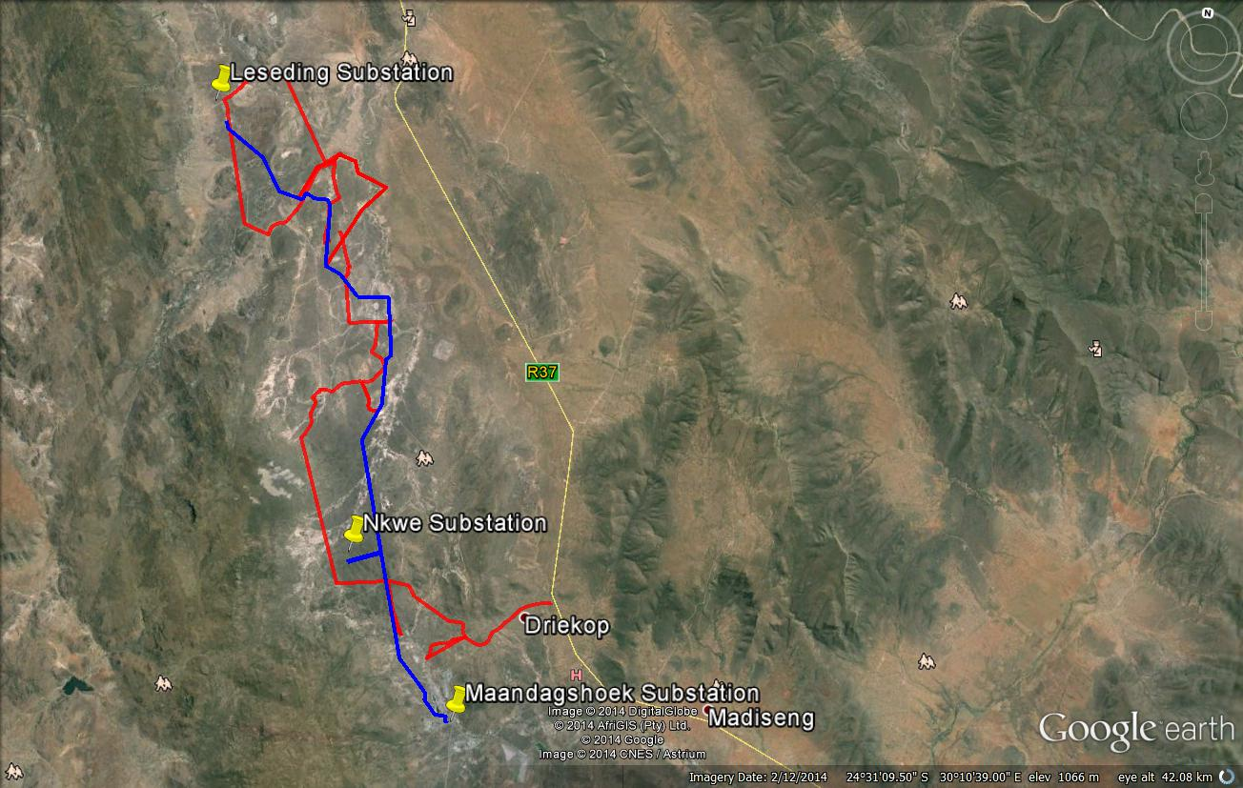

Figure 3- The main GPS track log which was registered with a fixed GPS instrument. Pedestrian surveys were conducted from the main track where this was deemed necessary. The Nkwe Project stretches between the proposed Nkwe Substations and the existing Leseding Substation (above).
All coordinates were recorded with a Garmin Etrex hand set Global Positioning System (instrument) with an accuracy of < 15m.

5.2 Databases, literature survey and maps

Literature relating to the pre-historical and the historical unfolding of the East Rand was reviewed. This review provides a broad chronological outline of the pre-historical as well as the historical context of the East Rand which contributes to a better understanding of the identity and meaning of heritage sites which occur in and near the Project Area.

The desktop study also involved consulting heritage data banks maintained at institutions such as the Gauteng Provincial Heritage Resources Agency, the Archaeological Data Recording Centre at the National Flagship Institute (Museum Africa) in Pretoria and the national heritage register at the South African Heritage Resources Agency (SAHRIS) in Cape Town.

In addition, the Eskom Project Area was also studied by means of maps on which it appears (2430CA Steelpoort & 2430AC Maroke 1:50 000 topographical maps; 2428 Modimolle 1: 250 000 map).

5.3 Assumptions and limitations

It is possible that this Phase I HIA study may have missed heritage resources in the Project Area as heritage sites may occur in thick clumps of vegetation while others may lie below the surface of the earth and may only be exposed once development commences.

If any heritage resources of significance is exposed during the Eskom Project the South African Heritage Resources Authority (SAHRA) should be notified immediately, all development activities must be stopped and an archaeologist accredited with the Association for Southern African Professional Archaeologist (ASAPA) should be notify in order to determine appropriate mitigation measures for the discovered finds. This may include obtaining the necessary authorization (permits) from SAHRA to conduct the mitigation measures.

5.4 Some remarks on terminology

Terms that may be used in this report are briefly outlined below:
- Conservation: The act of maintaining all or part of a resource (whether renewable or non-renewable) in its present condition in order to provide for its continued or future use. Conservation includes sustainable use, protection, maintenance, rehabilitation, restoration and enhancement of the natural and cultural environment.

- Cultural resource management: A process that consists of a range of interventions and provides a framework for informed and value-based decision-making. It integrates professional, technical and administrative functions and interventions that impact on cultural resources. Activities include planning, policy development, monitoring and assessment, auditing, implementation, maintenance, communication, and many others. All these activities are (or will be) based on sound research.

- Cultural resources: A broad, generic term covering any physical, natural and spiritual properties and features adapted, used and created by humans in the past and present. Cultural resources are the result of continuing human cultural activity and embody a range of community values and meanings. These resources are non-renewable and finite. Cultural resources include traditional systems of cultural practice, belief or social interaction. They can be, but are not necessarily identified with defined locations.

- Heritage resources: The various natural and cultural assets that collectively form the heritage. These assets are also known as cultural and natural resources. Heritage resources (cultural resources) include all human-made phenomena and intangible products that are the result of the human mind. Natural, technological or industrial features may also be part of heritage resources, as places that have made an outstanding contribution to the cultures, traditions and lifestyles of the people or groups of people of South Africa.

- In-Situ Conservation: The conservation and maintenance of ecosystems, natural habitats and cultural resources in their natural and original surroundings.

- Iron Age: Refers to the last two millennia and ‘Early Iron Age’ to the first thousand years AD. ‘Late Iron Age' refers to the period between the 16th century and the 19th century and can therefore include the Historical Period.

- Maintenance: Keeping something in good health or repair.

- Pre-historical: Refers to the time before any historical documents were written or any written language developed in a particular area or region of the world. The historical period and historical remains refer, for the Project Area, to the first appearance or use of ‘modern’ Western writing brought to the Eastern Highveld by the first Colonists who settled here from the 1840’s onwards.

- Preservation: Conservation activities that consolidate and maintain the existing form, material and integrity of a cultural resource.

- Recent past: Refers to the 20th century. Remains from this period are not necessarily older than sixty years and therefore may not qualify as archaeological or historical remains. Some of these remains, however, may be close to sixty years of age and may, in the near future, qualify as heritage resources.

- Protected area: A geographically defined area designated and managed to achieve specific conservation objectives. Protected areas are dedicated primarily to the protection and enjoyment of natural or cultural heritage, to the maintenance of biodiversity, and to the maintenance of life-support systems. Various types of protected areas occur in South Africa.

- Reconstruction: Re-erecting a structure on its original site using original components.

- Replication: The act or process of reproducing by new construction the exact form and detail of a vanished building, structure, object, or a part thereof, as it appeared at a specific period.

- Restoration: Returning the existing fabric of a place to a known earlier state by removing additions or by reassembling existing components.

- Stone Age: Refers to the prehistoric past, although Late Stone Age peoples lived in South Africa well into the Historical Period. The Stone Age is divided into an Earlier Stone Age (3 million years to 150 000 thousand years ago) the Middle Stone Age (150 000 years to 40 000 years ago) and the Late Stone Age (40 000 years to 200 years ago).

- Sustainability: The ability of an activity to continue indefinitely, at current and projected levels, without depleting social, financial, physical and other resources required to produce the expected benefits.

- Translocation: Dismantling a structure and re-erecting it on a new site using original components.

- Project Area: refers to the area (footprint) where the developer wants to focus its development activities (refer to Figure 3).

- Phase I studies refer to surveys using various sources of data in order to establish the presence of all possible types and ranges of heritage resources in any given Project Area (excluding paleontological remains as these studies are done by registered and accredited palaeontologists).

- Phase II studies include in-depth cultural heritage studies such as archaeological mapping, excavating and sometimes laboratory work. Phase II work may include the documenting of rock art, engraving or historical sites and dwellings; the sampling of archaeological sites or shipwrecks; extended excavations of archaeological sites; the exhumation of human remains and the relocation of graveyards, etc. Phase II work involve permitting processes, require the input of different specialists and the co-operation and approval of SAHRA.

6 THE PHASE I HERITAGE IMPACT ASSESSMENT STUDY

6.1 The fieldwork survey

The fieldwork survey covered the length of Alternative 01 as well as Alternative 02 for the proposed new power line whilst both alternatives for the Nkwe Substation were visited and surveyed. The following description and photographs illuminate the nature and character of the Project Area.

6.2 The proposed new power line

Two alternatives are proposed for the new power line, namely:

6.2.1 Alternative 01

Alternative 01 runs from the Nkwe Substation on the farm Maandagshoek 254KT north-westwards across Driekop 253KT and then north-eastwards skirting the perimeters of villages before joining some of Eskom’s existing power lines.
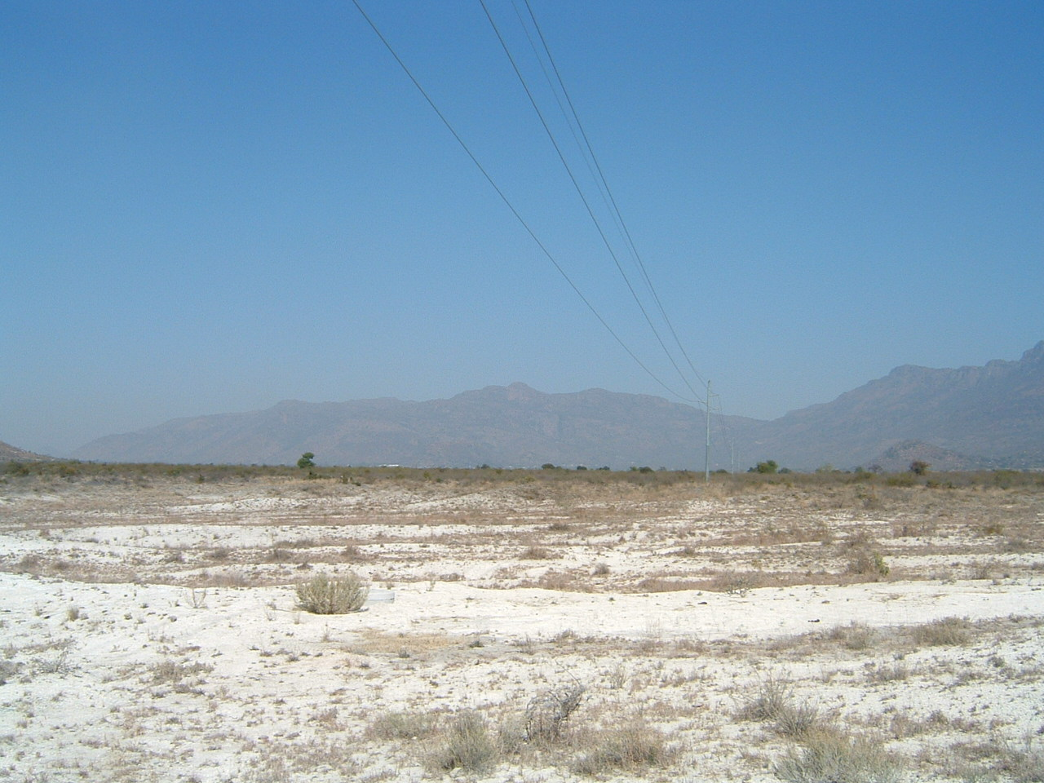

Figure 4– Alternative 01 bends to the north-east and then to the north skirting the eastern and western perimeters of the villages of Kalane and Legabeng where it joins one of Eskom’s existing 132kV power lines (above).
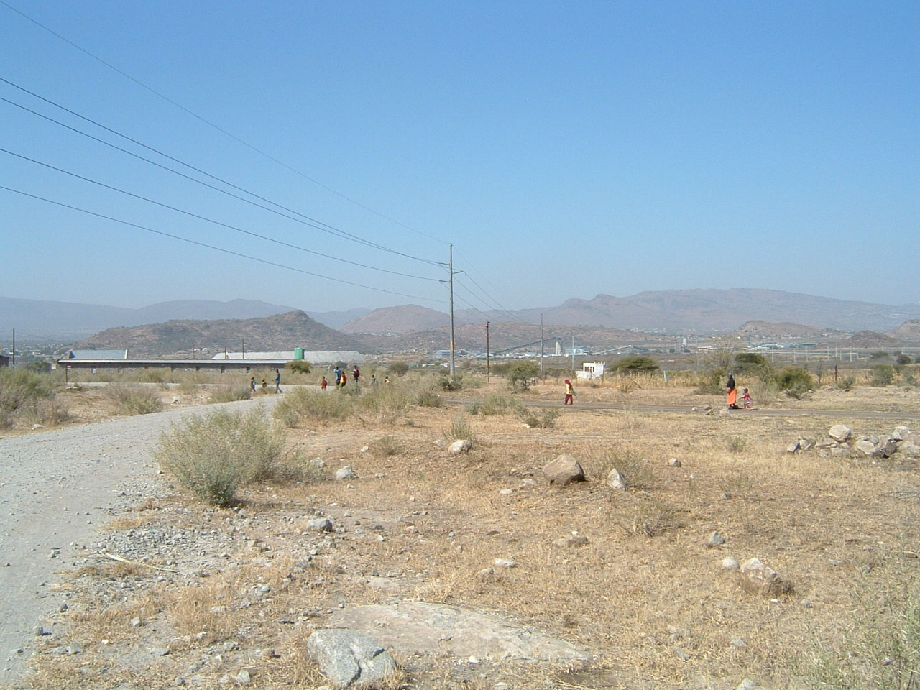

Figure 5- Alternative 01 bends to the west on Clapham 118KT where Marula Platinum Mine is located and then bends through three more consecutive bends in order to run northwards following Eskom’s existing 132kV power line (above).
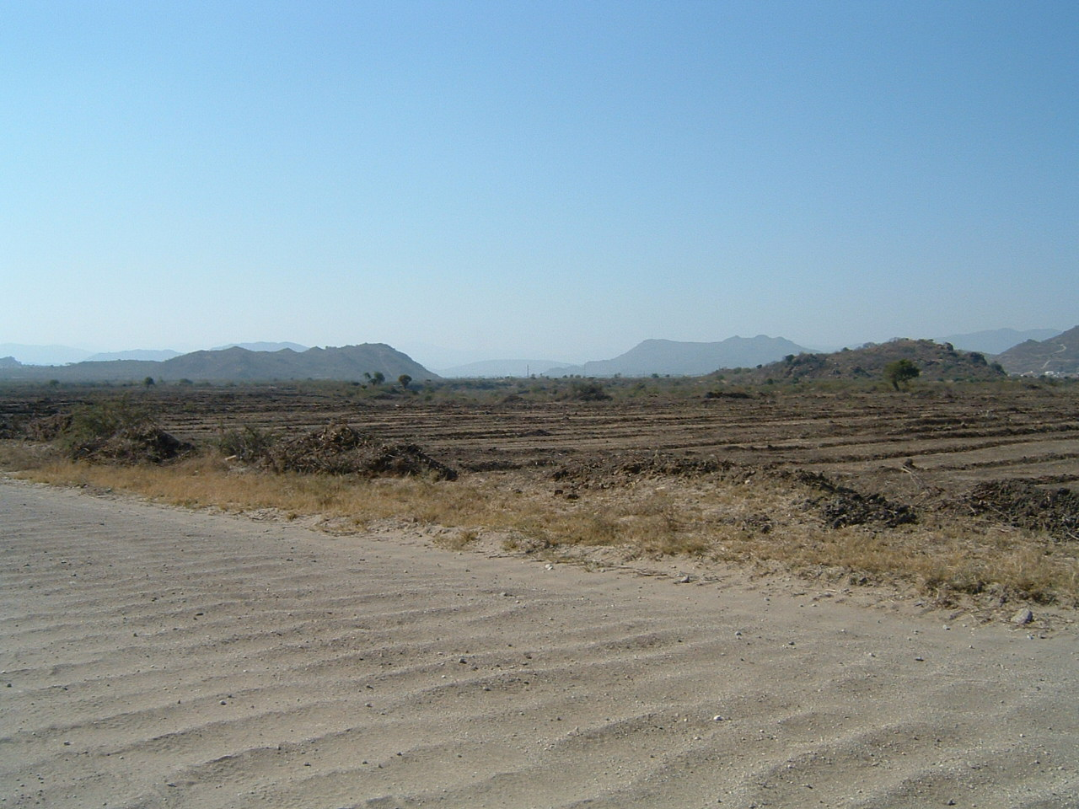

Figure 6 - Alternative 01 bends to the west on Forest Hill 117KT and crosses the mountain Maakuba and then follows the dirt road that runs to the Tsjate on Hackney 116KT where it bends to the west and the north-west in order to run to the Leseding Substation (above).
6.2.2 Alternative 02

The first and last stretch for Alternative 02 follows a similar corridor as Alternative 01. Alternative 02 only differs from Alternative 01 where it departs from Alternative 01 on the farm Forrest Hill 117KT in order to run to the north-east and then to the west before bending through three consecutive bends to the south-west in order to follow the western shoulder of the dirt road that runs to Tsjate.

The last stretch of Alternative 02 joins Alternative 01 on the farm Hackney 115KT in order to run to the Leseding Substation on the same farm.
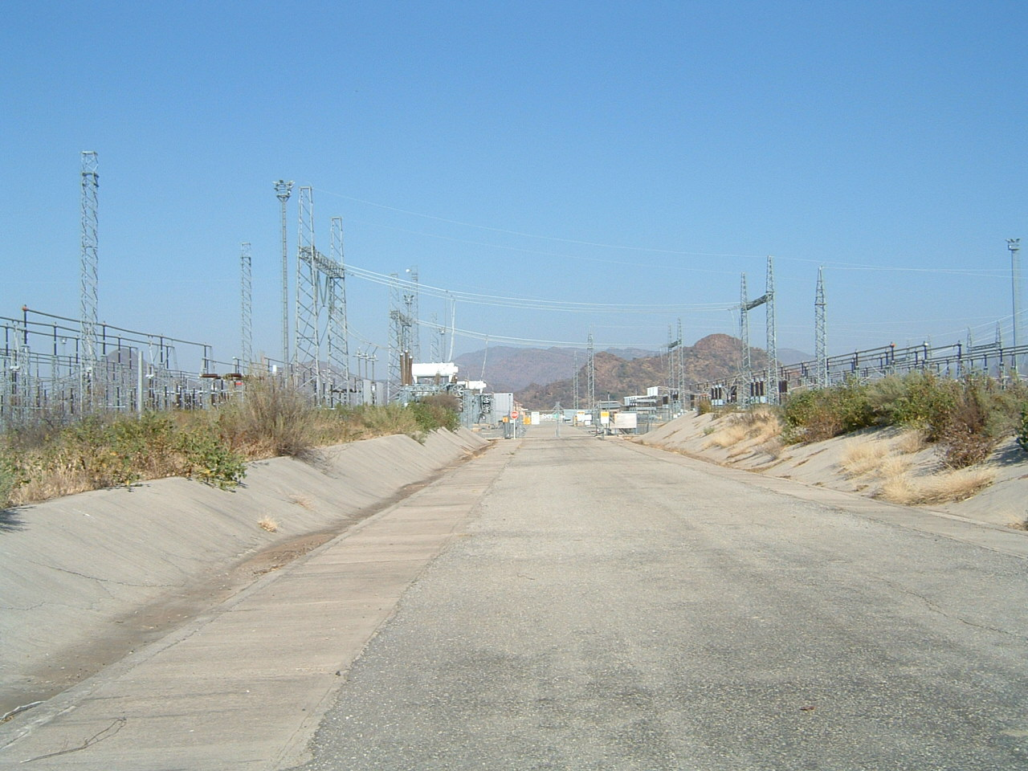

Figure 7 – Alternative 01 and Alternative 02 broadly follows the same power line corridor, except for a short stretch towards the end of the power line before entering the Leseding Substation on the farm Hackney 115KT (above).

6.2.3 The Nkwe Substation

The proposed Nkwe Substation is located on the farm Maandagshoek 254KT. Both Alternative 01 and Alternative 02 for the proposed Nkwe Substation, which are located approximately 300m from each other, are located in the midst of agricultural fields.

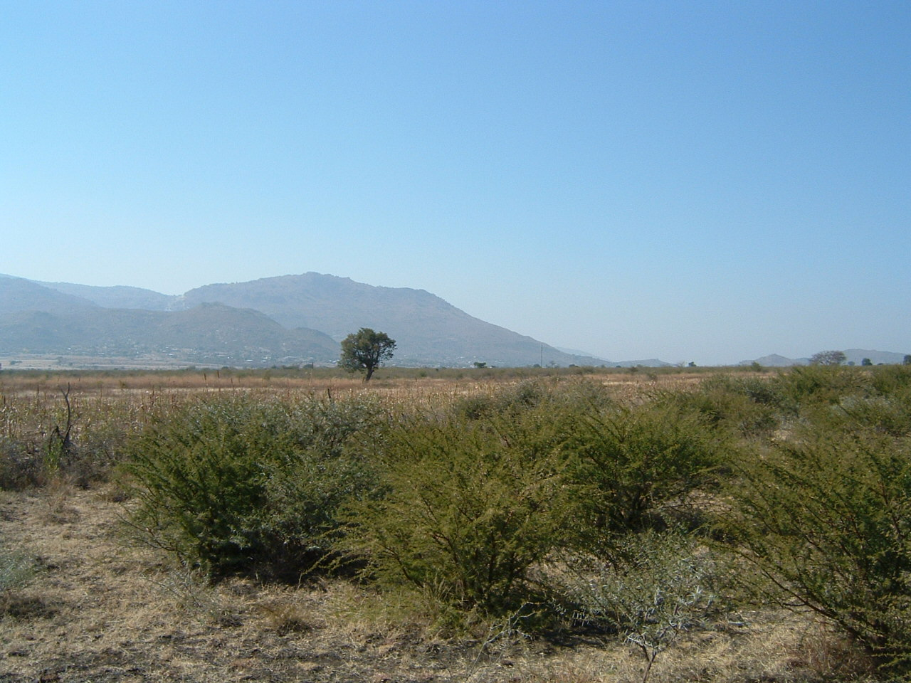

Figures 8 & 9– Alternative 01 and Alternative 02 for the proposed Nkwe Substations are located in close proximity on the farm Maandagshoek 254KT. Both stands for the new substation are located in agricultural fields which are currently lying foul (above and below).
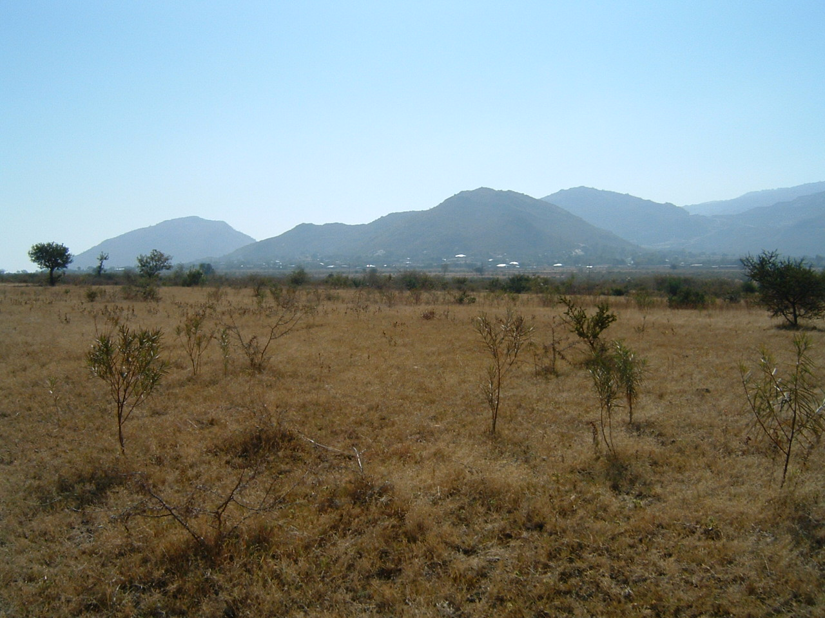

6.2 Types and ranges of heritage resources

The Phase I HIA study for the proposed Eskom Project revealed the following types and ranges of heritage resources as outlined in Section 3 of the National Heritage Resources Act (No 25 of 1999) in the Project Area, namely:
- Two graveyards in close proximity of the two alternatives for the power lines.

These graveyards were geo-referenced and mapped (Figure 11; Table 1). The significance of the graveyards is indicated as well as the significance of any impact on the graveyards (Table 2). No mitigation measures are outlined as the graveyards will not be affected by the proposed Eskom Project.

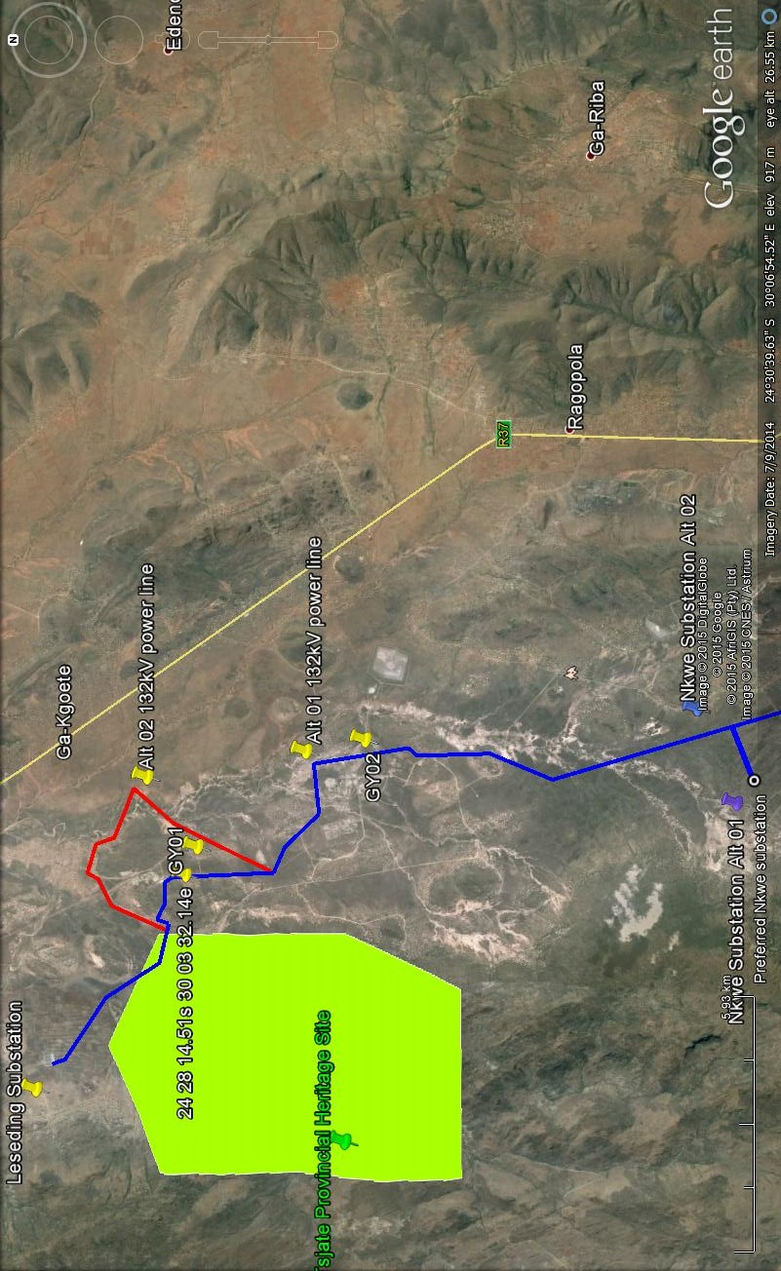

Figure 10– The Eskom Project Area which involves the construction of a 132kV power line between the existing Leseding Substation and the proposed Nkwe Substation in the Steelpoort Valley in the Limpopo Province. Two alternatives are proposed for the power line (Alternative 01 [blue] and Alternative 02 [red] as well as two alternatives for the proposed Nkwe Substation.
Note the Tsjate Provincial Heritage Site and the presence of two graveyards near the two alternatives for the power line. The graveyards will not be affected by the preferred or alternative power lines (above).
6.2.1 Graveyards

At least two graveyards occur in close proximity of the Eskom Project Area, namely:

6.2.1.1 Graveyard 01

GY01 is located in the village of Melao and holds approximately fifteen graves. The majority of the graves are fitted with granite headstones and trimmings.

It is likely that some of the undecorated graves in GY01 may be older than sixty years.

Some of the granite headstones bear the following inscriptions:
- ‘Maloke Mohlala Born 19150303 Died 20030201’
- ’Kgopane Mohlala Born 19100506 Died 19560708’
- Kweletsi Mohlala Born 19170313 Died 19690612’

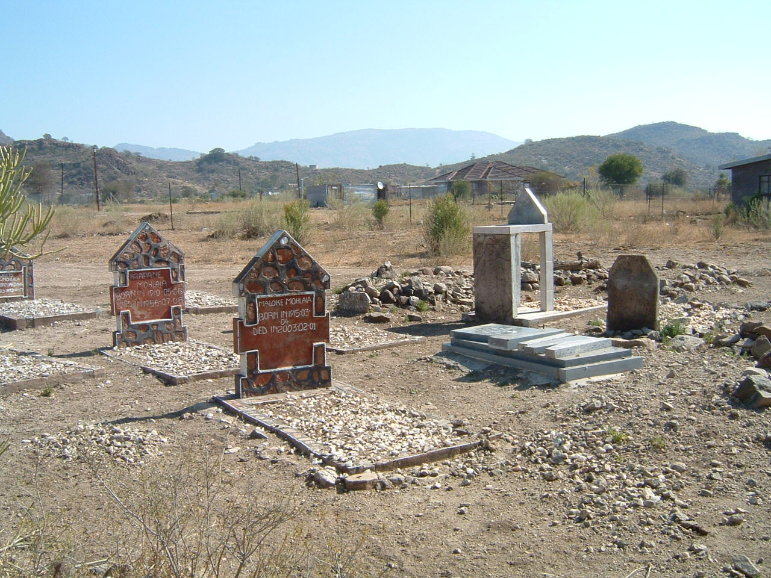

Figure 11 - GY01 is located in the village of Melao and holds approximately fifteen graves (above).
6.2.1.2 Graveyard 02

This graveyard (GY02) is situated near a booster pump and near a Late Iron Age site which was destroyed some time ago.

GY02 holds at least eleven graves of which the majority are fitted with granite headstones. Some of the graves are older than sixty years.

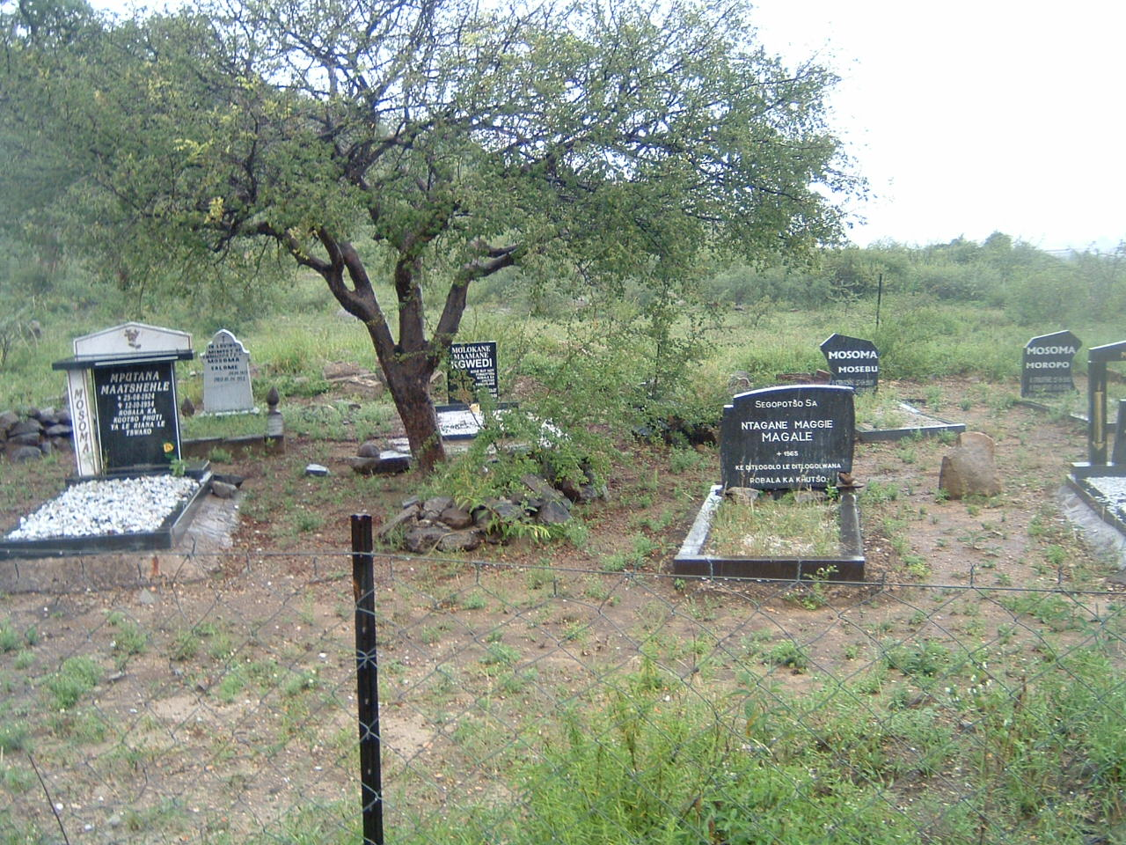

Figure 12- GY02 hold eleven graves and is located at the foot of a kopje near a booster pump and pipeline (above).

Inscriptions on some of the headstones read as follow:
- ‘Mputlana Naatshehle Robala ka khutso phuti’
- ‘Mosoma Moropa’
- ‘Mosoma Mosebu’
- ‘Molokane Mlamanye’
- ‘Ntagane Maggie Magale’

6.3 Table

The coordinates and level of significance of the graveyards are as follow:

Table 1 - Coordinates and significance rating for the graveyards in the Eskom Project Area (below).

Graveyards | Coordinates | Significance
In close proximity of Alternative 01 and 02 for the power line
GY01. Graveyard in the village of Melao. Holds 15 graves some of which are possibly older than sixty years. Close to Alternative 02 for the new power line. | 24º 28 14.51'S  30º 03 32.14'E | HIGH
GY02. Located near booster pump and railway line. Holds eleven graves some of which are possibly older than sixty years. Close to Alternative 01 for the new power line. | 24º 30.504'S  30º 05.399'E | HIGH

6.4 The significance of the graveyards

All graveyards and graves can be considered to be of high significance and are protected by various laws (Table 1). Legislation with regard to graves includes Section 36 of the National Heritage Resources Act (Act No 25 of 1999) whenever graves are older than sixty years. GY01 is older than sixty years. Other legislation with regard to graves includes those which apply when graves are exhumed and relocated, namely the Ordinance on Exhumations (No 12 of 1980) and the Human Tissues Act (No 65 of 1983 as amended).

6.5 Possible impact on the graveyards

Not one of the two graveyards will be affected by either Alternative 01 or Alternative 02 for the proposed new power line (Figure 11).

6.6 The significance of the impact on the graveyards

The significance of possible impacts on the graveyard was determined using a ranking scale, based on the following:

- Occurrence
- Probability of occurrence (how likely is it that the impact may/will occur?), and
- Duration of occurrence (how long may/will it last?)
- Severity
- Magnitude (severity) of impact (will the impact be of high, moderate or low severity?), and
- Scale/extent of impact (will the impact affect the national, regional or local environment, or only that of the site?).

Each of these factors has been assessed for each potential impact using the following ranking scales:

Probability:  5 – Definite/don’t know  4 – Highly probable  3 – Medium probability  2 – Low probability  1 – Improbable  0 – None | Duration:  5 – Permanent  4 - Long-term (ceases with the operational life)  3 - Medium-term (5-15 years)  2 - Short-term (0-5 years)  1 – Immediate
Scale:  5 – International  4 – National  3 – Regional  2 – Local  1 – Site only  0 – None | Magnitude:  10 - Very high/don’t know  8 – High  6 – Moderate  4 – Low  2 – Minor

The environmental significance of each potential impact was assessed using the following formula:
Significance Points (SP) = (Magnitude + Duration + Scale) x Probability
The maximum value is 100 Significance Points (SP). Potential environmental impacts are rated as very high, high, moderate, low or very low significance on the following basis:
- More than 80 significance points indicates VERY HIGH environmental significance.
- Between 60 and 80 significance points indicates HIGH environmental significance.
- Between 40 and 60 significance points indicates MODERATE environmental significance.
- Between 20 and 40 significance points indicates LOW environmental significance.
- Less than 20 significance points indicates VERY LOW environmental significance.

The significance of any possible impact on the graveyards is very low (Table 2).

Table 2: The significance of potential impacts on the graveyards before and after mitigation (below).

Grave- yard | Probability of impact | Magnitude of impact | Duration of impact | Scale | Significance points | Significance of impact | Significance after mitigation
GY01 | 1 | 2 | 1 | 1 | 2 | Very low | Not applicable
GY02 | 1 | 2 | 1 | 1 | 2 | Very low | Not applicable

6.7 Mitigating the graveyard impacts

The graveyards will not be affected by the Eskom Project. Consequently, the graveyards need no mitigation measures.

7 CONCLUSION AND RECOMMENDATIONS

The Phase I HIA study for the proposed Eskom Project revealed the following types and ranges of heritage resources as outlined in Section 3 of the National Heritage Resources Act (No 25 of 1999) in the Project Area, namely:
- Two graveyards in close proximity of the two alternatives for the power lines.

These graveyards were geo-referenced and mapped (Figure 11; Table 1). The significance of the graveyards is indicated as well as the significance of any impact on the graveyards (Table 2). No mitigation measures are outlined as the graveyards will not be affected by the proposed Eskom Project.

The significance of the graveyards
All graveyards and graves can be considered to be of high significance and are protected by various laws (Table 1). Legislation with regard to graves includes Section 36 of the National Heritage Resources Act (Act No 25 of 1999) whenever graves are older than sixty years. GY01 is older than sixty years. Other legislation with regard to graves includes those which apply when graves are exhumed and relocated, namely the Ordinance on Exhumations (No 12 of 1980) and the Human Tissues Act (No 65 of 1983 as amended).

Possible impact on the graveyards
Not one of the two graveyards will be affected by either Alternative 01 or Alternative 02 for the proposed new power line (Figure 11).

The significance of the impact on the graveyards
The significance of any possible impact on the graveyards is very low (Table 2).

Mitigating the graveyard impacts
The graveyards will not be affected by the Eskom Project. Consequently, the graveyards need no mitigation measures.

The Tsjate Provincial Heritage site will not be negatively influenced by Eskom’s proposed Nkwe Project considering the fact that Alternative 01 and Alternative 02 for the proposed new 132kV power lines merely crosses the north-eastern tip of the Tsjate Provincial Heritage Site. The Tsjate Provincial Heritage site collates with the historical Tsjate cultural landscape which is a contemporary living environment in which thousands of individuals with associated infrastructure with are constantly improved and upgraded are settled.

Summary
Both alternatives for the 132kV power lines as well as the two alternatives for the Nkwe Substation therefore are suitable from a heritage point of view for the implementation of the Eskom Nkwe Project.

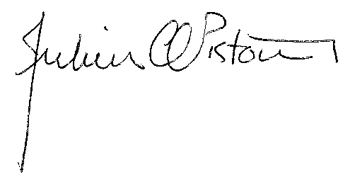

Dr Julius CC Pistorius
Archaeologist & Heritage Consultant
Member ASAPA

8 SELECT BIBLIOGRAPHY

Berg, J.S. 1989. Geskiedenisatlas van Suid Afrika. Die vier noordelike provinsies. Van Schaik: Pretoria.

Botha, S.J. 1983. ‘n Voorgestelde nasionale ontwikkelingsplan vir Lebowa. Universiteit van Pretoria: Pretoria.

Bothma, C.V. 1969. Pedi origins. Ethnological publications no 52. Government Printer: Pretoria.

Bothma, C. V. 1976. The political structure of the Pedi of Sekhukhuneland. African Studies. 35(3).

Cawthorn, R.G. 1999. The discovery of the platiniferous Merensky Reef in 1924. South African Journal of Geology. 10 (3): 178-183.

Delius, P. 1984. The land belongs to us. Raven Press: Johannesburg.

Delius, P. 2007. Mpumalanga. History and Heritage. C.T.P. Book Printers: Cape Town.

De Beer, F.C. 1996. Berge is nie net berge nie: Swart mense se persepsies oor Modimolle. South African Journal of Ethnology. 19(1).

Erasmus, B.P.J. 1995. Oppad in Suid-Afrika. Jonathan Ball: Johannesburg.

Inskeep, R.R. 1978. The peopling of Southern Africa. David Philip: Cape Town.

Kusel, U. 2008. Assessment of the Cultural Heritage Resources on the provincial heritage site of Tsjate on the farm Djate 249KT in Sekhukhune Limpopo Province. Unpublished report. African Heritage Consultants.

Lombaard, B. V. 1945. Die ontdekkers van platina in die Transvaal. Historical Studies. University of Pretoria, South Africa. 6(1):32-40.

Mönnig, H.O. 1978. The Pedi. National Book Printers: Cape Town.

Pistorius, J.C.C. 1993. 'n Ondersoek van Historiese en Argeologiese Oorblyfsels op die plase Hendriksplaats (281KT) en Derde Gelid (278KT) in die Steelpoortdistrik van Mpumalanga. (Mede-outeur H. P. Prinsloo). Verslag voorberei vir Samancor, Eastern Chrome Mines: Steelpoort.

Pistorius, J.C.C. 2005a. A Heritage Impact Assessment (HIA) study for a proposed new power line between the Merensky Substation and the Burgersfort Substation in the Limpopo (Northern) Province of South Africa. Unpublished report prepared for PBA International and Eskom.

Pistorius, J.C.C. 2005b. Results of a Phase II Heritage Impact Assessment Study: An investigation of Late Iron Age (including initiation cairns) and mining heritage remains on the farm Onverwacht 292KT in the Mpumalanga and Limpopo Provinces of South Africa. Unpublished report for SAHRA and Modikwa Platinum.

Standard Encyclopaedia of Southern Africa. Volumes 8-10. 1970. Nasionale Opvoedkundige Uitgewery Ltd, Bpk: Kaapstad.

Viljoen, M.J. & Reimold, W.U. 1999. An introduction to South Africa’s geological and mining heritage. The Geological Society of South Africa. Mintek. Randburg.

Wagner, P.A. 1973. The platinum deposits and mines of South Africa. Struik: Cape Town.

Wilson, M.G.C. & Anhausser, C.R. 1998 (eds). The Mineral Resources of South Africa. Council for Geoscience 16: Silverton, South Africa.

Whitelaw, G. 1996. Lydenburg revisited. Another look at the Mpumalanga Early Iron Age sequence. South African Archaeological Bulletin. 51.

9 BIBLIOGRAPHY RELATING TO EARLIER HERITAGE STUDIES

Kusel, U. 2008. Assessment of the Cultural Heritage Resources on the provincial heritage site of Tsjate on the farm Djate 249KT in Sekhukhune Limpopo Province. Unpublished report. African Heritage Consultants.

Pistorius, J.C.C. 2001. An Archaeological impact assessment report for the proposed Impala Platinum Mine at Steelpoort in the Northern Province of South Africa. Unpublished report prepared for Pulles, Howard and De Lange Incorporated.

Pistorius, J.C.C. 2007. A Phase I Heritage Impact Assessment (HIA) study for the proposed Route D for the 400kV Duvha-Lesideng power line running across the Tsjate Valley in the Steelpoort in the Limpopo Province. Unpublished report prepared for Eskom Megawatt Park.

Pistorius, J.C.C. 2007. A Phase I Heritage Impact Assessment (HIA) study for Marula Platinum’s proposed new shaft, corridor and extension to an existing waste dump in the Limpopo Province of South Africa. Unpublished report prepared for Metago Environmental Engineers.

Pistorius, J.C.C. 2010. A Heritage Management Plan for Marula Platinum in the Steelpoort Valley in the Limpopo Province of South Africa. Unpublished report prepared for SRK Consulting.

Pistorius, J.C.C. 2011. A Phase I Heritage Impact Assessment (HIA) study for Marula Platinum (Pty) Ltd’s (Marula) proposed new mine infrastructure, re-positioning of the approved Merensky Shafts and the incorporation of prospecting areas into the mining rights area in the Steelpoort Valley in the Limpopo Province. Unpublished report prepared for Metago Environmental Engineers.

Pistorius, J.C.C. 2012. A Phase I Heritage Impact Assessment (HIA) study for Eskom’s 2x132kV power lines between the proposed Tshatane and Lesego Substations and between the proposed Tshatane and the existing Jane Furse Substation in the Limpopo Province. Unpublished report prepared for DIGES.
APPENDIX A: DETAILS OF THE SPECIALIST
Profession: Archaeologist, Museologist (Museum Scientists), Lecturer, Heritage Guide Trainer and Heritage Consultant
Qualifications:
BA (Archaeology, Anthropology and Psychology) (UP, 1976)
BA (Hons) Archaeology (distinction) (UP, 1979)
MA Archaeology (distinction) (UP, 1985)
D Phil Archaeology (UP, 1989)
Post Graduate Diploma in Museology (Museum Sciences) (UP, 1981)
Work experience:
Museum curator and archaeologist for the Rustenburg and Phalaborwa Town Councils (1980-1984)
Head of the Department of Archaeology, National Cultural History Museum in Pretoria (1988-1989)
Lecturer and Senior lecturer Department of Anthropology and Archaeology, University of Pretoria (1990-2003)
Independent Archaeologist and Heritage Consultant (2003-)
Accreditation: Member of the Association for Southern African Professional Archaeologists. (ASAPA)
Summary: Julius Pistorius is a qualified archaeologist and heritage specialist with extensive experience as a university lecturer, museum scientist, researcher and heritage consultant. His research focussed on the Late Iron Age Tswana and Lowveld-Sotho (particularly the Bamalatji of Phalaborwa). He has published a book on early Tswana settlement in the North-West Province and has completed an unpublished manuscript on the rise of Bamalatji metal workings spheres in Phalaborwa during the last 1 200 years. He has written a guide for Eskom’s field personnel on heritage management. He has published twenty scientific papers in academic journals and several popular articles on archaeology and heritage matters. He collaborated with environmental companies in compiling State of the Environmental Reports for Ekhurhuleni, Hartebeespoort and heritage management plans for the Magaliesberg and Waterberg. Since acting as an independent consultant he has done approximately 800 large to small heritage impact assessment reports. He has a longstanding working relationship with Eskom, Rio Tinto (PMC), Rio Tinto (EXP), Impala Platinum, Angloplats (Rustenburg), Lonmin, Sasol, PMC, Foskor, Kudu and Kelgran Granite, Bafokeng Royal Resources etc. as well as with several environmental companies.

APPENDIX B: DECLARATION OF INDEPENDENCE

I, Julius CC Pistorius, declare that:
•I act as the independent environmental practitioner in this application
•I will perform the work relating to the application in an objective manner, even if this results in views and findings that are not favourable to the applicant
•I declare that there are no circumstances that may compromise my objectivity in performing such work;
•I have expertise in conducting environmental impact assessments, including knowledge of the National Heritage Resources Act (No 25 of 1999) and any guidelines that have relevance to the proposed activity;
•I will comply with the Act, regulations and all other applicable legislation;
•I will take into account, to the extent possible, the matters listed in regulation 8 of the regulations when preparing the application and any report relating to the application;
•I have no, and will not engage in, conflicting interests in the undertaking of the activity;
•I undertake to disclose to the applicant and the competent authority all material information in my possession that reasonably has or may have the potential of influencing - any decision to be taken with respect to the application by the competent authority; and - the objectivity of any report, plan or document to be prepared by myself for submission to the competent authority;
•I will ensure that information containing all relevant facts in respect of the application is distributed or made available to interested and affected parties and the public and that participation by interested and affected parties is facilitated in such a manner that all interested and affected parties will be provided with a reasonable opportunity to participate and to provide comments on documents that are produced to support the application;
•I will ensure that the comments of all interested and affected parties are considered and recorded in reports that are submitted to the competent authority in respect of the application, provided that comments that are made by interested and affected parties in respect of a final report that will be submitted to the competent authority may be attached to the report without further amendment to the report;
•I will keep a register of all interested and affected parties that participated in a public participation process; and
•I will provide the competent authority with access to all information at my disposal regarding the application, whether such information is favourable to the applicant or not
•all the particulars furnished by me in this form are true and correct;
•will perform all other obligations as expected from an environmental assessment practitioner in terms of the Regulations; and
•I realise that a false declaration is an offence in terms of regulation 71 and is punishable in terms of section 24F of the Act.
Disclosure of Vested Interest
I do not have and will not have any vested interest (either business, financial, personal or other) in the proposed activity proceeding other than remuneration for work performed in terms of the Environmental Impact Assessment Regulations, 2010.
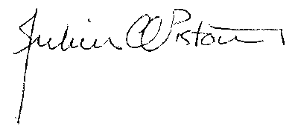
____________________________________
Signature of the environmental practitioner:
Private Consultant
____________________________________
Name of company:
1 July 2014
____________________________________
Date:
____________________________________
Signature of the Commissioner of Oaths:

____________________________________
Date:

____________________________________
Designation:

