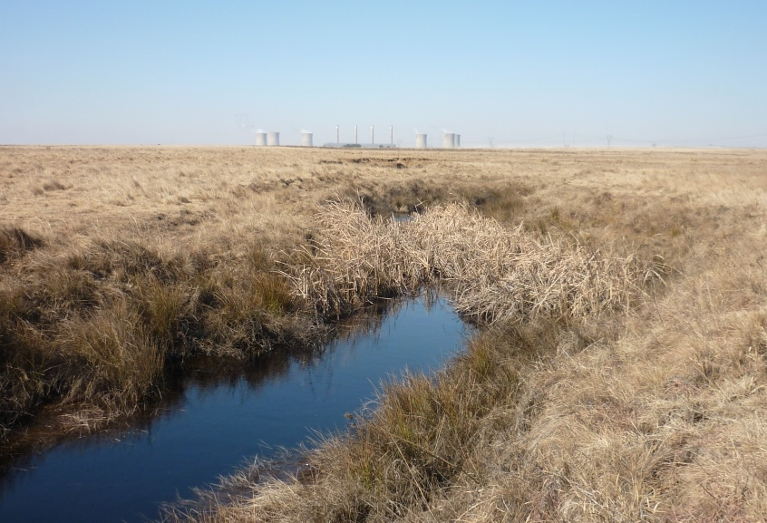
August 2014
Submitted to:
Zitholele Consulting (Pty) Ltd.
Building 1, Magwa Crescent,
Maxwell Office Park,
Cnr Allandale & Maxwell Drive,
Waterfall City,
Midrand

Report Number: | 1407683-13024-1
Distribution:
1 Copy - Client
1 Copy - GAA Library
1 Copy - Project file 1407683

Report
Zitholele Consulting (Pty) Ltd.

Camden Power Station Ash Disposal Facility - Wetland and Aquatic Assessment

Table of Contents
1.0 Introduction 1
2.0 Approach and methods 2
2.1 Limitations 3
2.2 Aquatic Assessment 3
2.3 Wetland Delineation and Classification 4
2.4 Wetland Assessment 5
2.4.1 Present Ecological State (PES) and Ecological Importance and Sensitivity (EIS) 5
2.4.2 Functional Assessment 6
3.0 Results 7
3.1 Aquatic Assessment 7
3.1.1 Review of Previous Studies 7
3.1.2 Golder site visit, July 2014 7
3.2 Wetland Delineation and Classification 8
3.2.1 Channelled Valley Bottom (VBA) 11
3.2.2 Unchannelled Valley Bottom (VBB) 12
3.2.3 De Jager’s Pan 12
3.2.4 Hillslope Seep 12
3.2.5 Modified wetland 12
3.3 Wetland Assessment 13
3.3.1 PES 13
3.3.2 EIS 14
3.3.3 Wetland Functioning 14
4.0 Potential impacts 16
4.1 Aquatic Ecosystems 16
4.1.1 Degradation of biotic integrity due to modification of water quality 16
4.1.2 Degradation of aquatic ecosystems due to increased sedimentation 16
4.2 Wetlands 16
4.2.1 Interruption in hydrology 17
4.2.2 Erosion of catchment soils & increased sediment input to wetlands 17
4.2.3 Water quality deterioration 17
5.0 Recommendations 17
6.0 Closing 20

TABLES
Table 1: Description of the PES categories 5
Table 2: Description of the EIS categories 6
Table 3: In situ water quality measured in July 2014 8
Table 5: Proposed aquatic monitoring points 19

figures
Figure 1: Location of infrastructure in Preferred Site 1 – the Study Area for wetland and aquatic assessment 1
Figure 2: Previously mapped wetlands (Zitholele, 2013) 2
Figure 3: Historical imagery (1955 predating construction of the power station, indicating De Jagers Pan and wetland areas to the East in proximity to the current ash facility 3
Figure 4: Aquatic sampling sites sampled in January 2012, March 2014 and July 2014 4
Figure 5: Crystalline deposits along river banks 7
Figure 6: Bubbles and foaming 7
Figure 7: Excessive algal build-up 8
Figure 8: Discoloured water 8
Figure 9: Wetlands in relation to preferred Site 1 ash disposal facility footprint 10
Figure 10: Historic (A) and current (B) aerial imagery of wetland area to the east of De Jagers Pan 11
Figure 11: Seasonal wetland soil 12
Figure 12: Temporary wetland soil 12
Figure 13: Heavily modified wetland area 13
Figure 14: Spider diagram showing scores for ecosystem services supplied by channelled valley bottom wetland (VBA) 15
Figure 15: Spider diagram showing scores for ecosystem services supplied by unchannelled valley bottom wetland (VBB) 15
Figure 16: Proposed Aquatic Monitoring Sites 19

appendices
APPENDIX A
Document Limitations

User Note: This Table of Contents section acts as a reference point for the Record of Issue, Executive Summary and Study Limitations sections as and when they might be required. Therefore, the structure of this section must not be altered in any way.
This “Hidden” text will not print.

Introduction
Camden Power Station is located approximately 15 km south east of the town of Ermelo in the Mpumalanga province. Eskom proposes to construct a new ash disposal facility (ADF) at Camden Power Station, to extend the life of the power station (the Project). The preferred site is Site 1 (Figure 1 - ‘Ash Facility’ and ‘Return Water Dam’) as it can accommodate the full ash production for the planned 17 years ash production, whilst keeping within the 40 metres allowable height.
Golder Associates Africa (Pty) Ltd. was appointed by Zitholele Consulting (Pty) Ltd. to ground-truth and update (where necessary) previously-delineated wetland boundaries, assess the status and level of functioning of delineated wetlands, and conduct an aquatic assessment of the Humanspruit in the vicinity of the preferred Site 1 and its associated infrastructure (Figure 1 - ‘Ash Facility’ and ‘Return Water Dam’). The baseline wetland and aquatic information was used to inform the conceptual design of the Project.
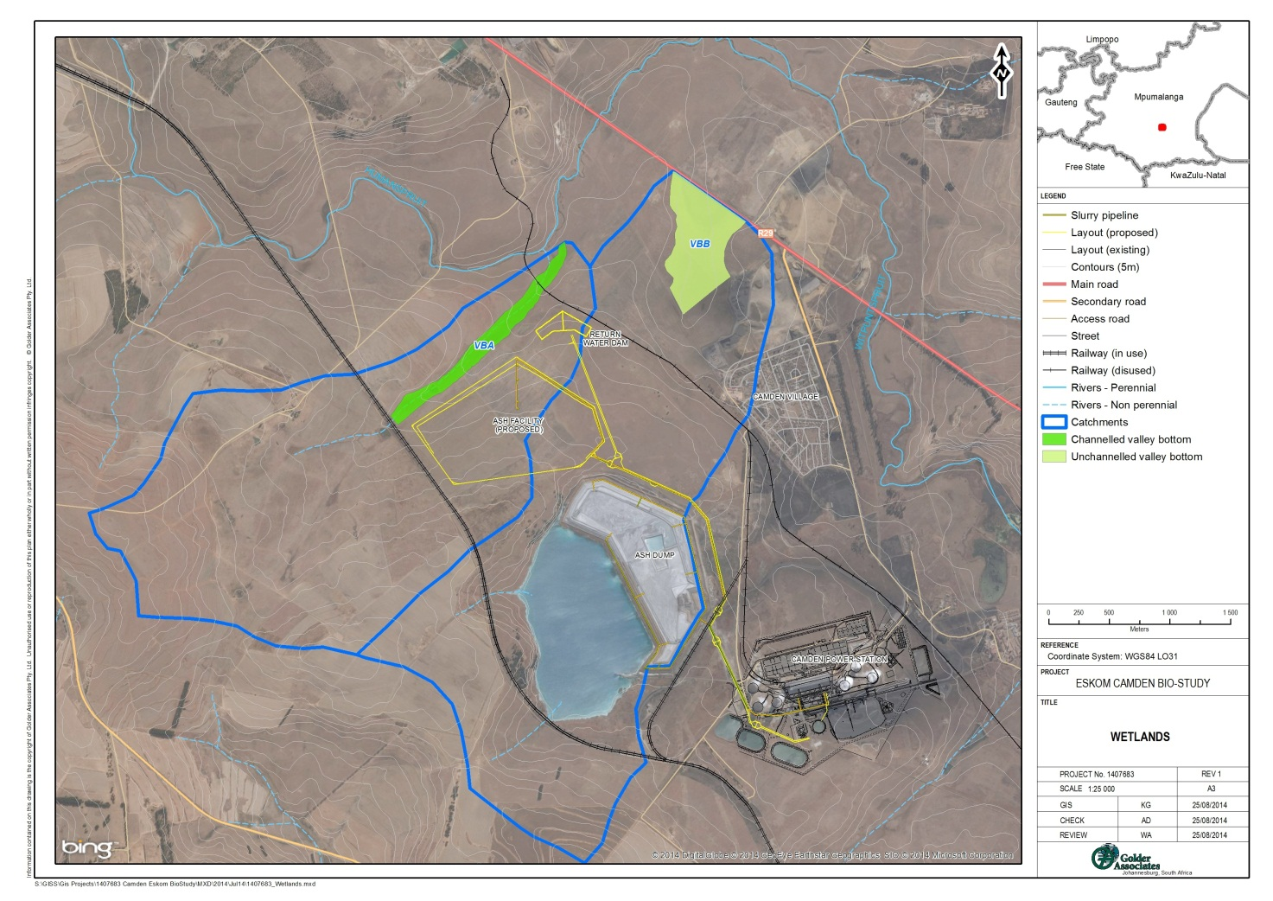
Figure 1: Location of infrastructure in Preferred Site 1 – the Study Area for wetland and aquatic assessment
This report focuses on potential impacts on wetlands ‘channelled valley bottom’ (VBA) and ‘unchannelled valley bottom’ (VBB) (Figure 1) as the proposed ash facility is located in their respective catchments. Some limitations influenced the survey results and these are outlined in Section 2.1.

Approach and methods
The Study Area was visited on 16 and 17 July 2014. Ground-truthing and assessment were focused on the area previously mapped as wetland (Zitholele Consulting, 2013) that lies adjacent to the boundary of preferred Site 1, and the wetland area indicated in Figure 2 by the red arrow to the northeast of preferred Site 1 (Figure 2). As stated in Section 2.1 below, the former De Jagers Pan and its associated hillslope seeps were not surveyed.
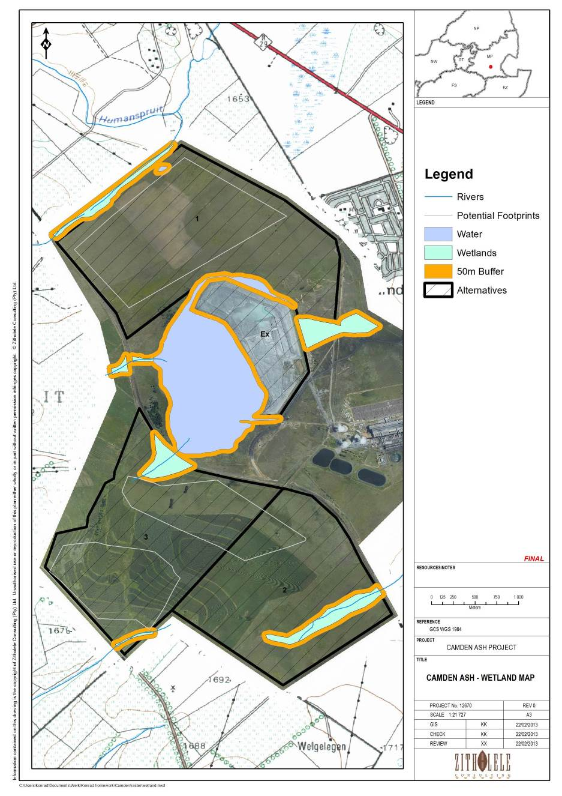
Figure 2: Previously mapped wetlands (Zitholele, 2013)
Wetlands that were surveyed on 16 and 17 July 2014 were ground-truthed and assessed using the methods outlined in Section 2.3.

Limitations
The fieldwork took place during the peak dry season (16-17 July 2014) due to Project scheduling constraints. Most flowering plants, grasses and sedges that are normally indicative of wetland conditions were dormant at the time of the Site visit; furthermore much of the area had been burnt. This posed a significant limitation in terms of accurate delineation of some of the wetland areas, in particular the highly-modified areas west and east of the existing ash disposal facility facility.
Fieldwork was therefore focussed on delineation of the wetlands ‘VBA’ and ‘VBB’, which were located within 500m northwest and northeast of the preferred Site 1 (Figure 1). These wetlands were concentrated on because they are not directly impacted by the ongoing existing activities at Camden Power station.
De Jagers Pan and its associated hillslope seeps were not surveyed in the field; these are shown on Figure 9 as tentative delineations derived from aerial imagery and the previous wetland assessment report (see Zitholele Consulting, 2013). De Jagers Pan is operated as a return water facility for the current ash disposal facility and consequently is extensively modified.
The heavily modified wetland area to the east of the existing ash disposal facility is shown on Figure 9 as a tentative delineation, largely derived from historical imagery (see Figure 3). This area was almost completely burnt at the time of survey.
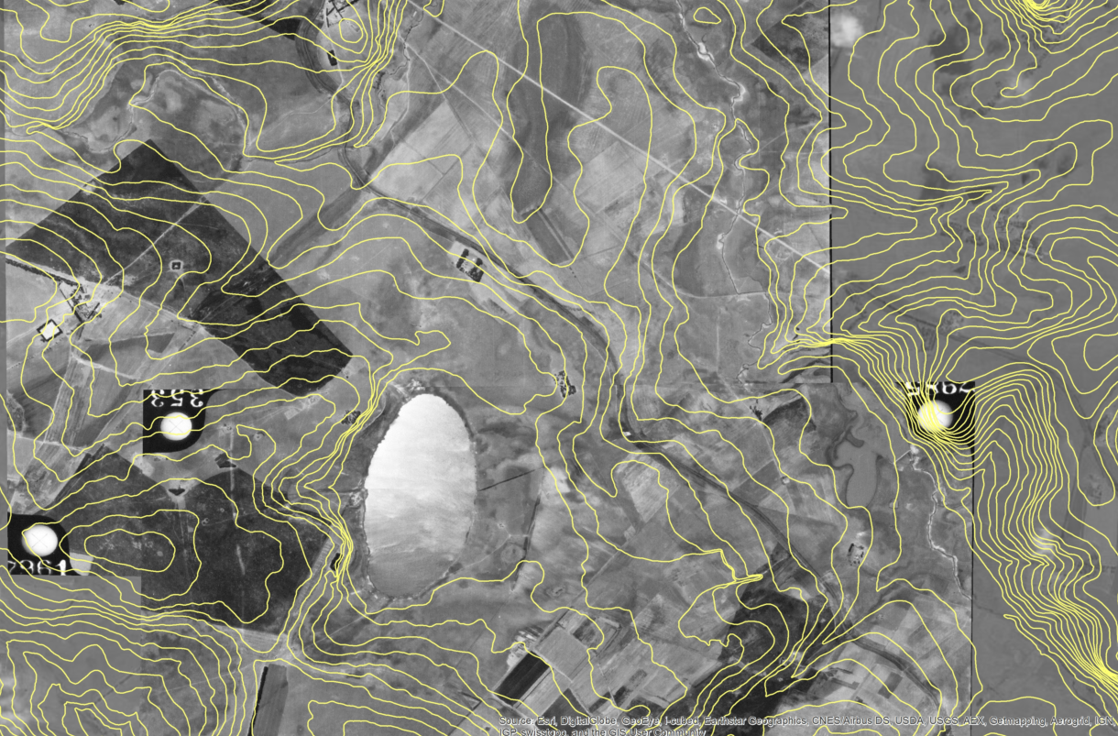
Figure 3: Historical imagery (1955 predating construction of the power station, indicating De Jagers Pan and wetland areas to the East in proximity to the current ash facility
It is recommended that tentatively delineated wetlands (Figure 9 – hillslope seep, pan and modified wetland) are re-visited during the early wet season when flowering hydrophilic plants are present so that these indicators can be used to accurately determine the exact boundaries of wetland areas.

Aquatic Assessment
A site visit to Camden Power Station to assess the rivers was done during July 2014. The purpose of the site visit was to ground-truth the existing data (Scientific Aquatic Services (SAS), 2012; Clean Stream Biological Services, 2014), and consider any additional impacts that the proposed ash disposal facility facility may have on the receiving waterbodies.
Figure 4 shows the location of aquatic sampling sites. Yellow points indicate the SAS (2012) survey locations; while blue points indicate the Clean Stream (2014) survey locations. The green point indicates the additional point assessed by Golder during July 2014.
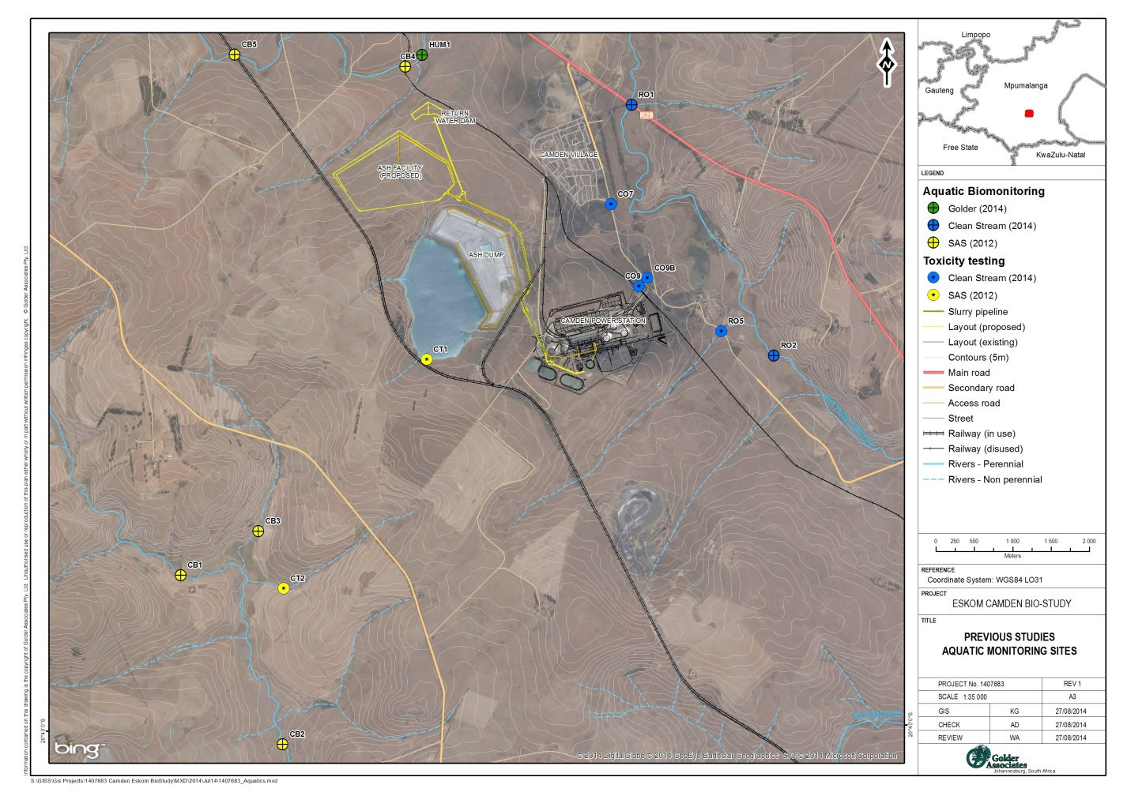
Figure 4: Aquatic sampling sites sampled in January 2012, March 2014 and July 2014

Wetland Delineation and Classification
Use was made of 1:50 000 topographic maps, Google Earth images and geo-referenced historical imagery to generate digital base maps of the study area. A preliminary, desktop delineation of suspected wetlands was done by identifying wetness signatures from the digital base maps and drawing boundaries around these. All suspected wetland areas identified during the desktop assessment were then further investigated in the field in July 2014.
Wetlands were delineated in the field according to the delineation procedure as set out by the “A Practical Field Procedure for the Identification and Delineation of Wetlands and Riparian Areas” document (DWAF, 2005). The study area was sub-divided into transects and the soil profile was examined for signs of wetness within 50 cm of the surface, using a hand augur along each transect. The wetland boundaries were then determined based on the positions of augured holes that showed signs of wetness as well as the presence or absence of hydrophilic vegetation. In accordance with the above methodology, the following key indicators were used to identify and classify the wetlands:
- Soil hydromorphy: the presence of grey and orange mottles indicating periods of alternating anaerobic and aerobic conditions. Wetlands are considered to be the result of an interaction between soil, water and vegetation, and the 50cm depth limit represents the rooting zone of herbaceous wetland vegetation. Hydromorphic characteristics within the top 50cm of the soil profile therefore indicate the presence of wetland habitat.
- Vegetation: Certain plant species are good indicators of the temporary, seasonal and permanent wetland zone and terrestrial habitat; however the delineation fieldwork took place during the peak dry season (16-17 July 2014) due to Project scheduling constraints. Most flowering plants, grasses and sedges that are normally indicative of wetland conditions were dead at the time of the Site visit; furthermore much of the area had been burnt. This posed a significant limitation in terms of accurate delineation of some of the wetland areas, in particular the highly-modified area adjacent to the existing ash disposal facility.
- Topography is a good wetland indicator, particularly when delineating floodplain and channelled valley-bottom systems where the shape of the land indicates the likely extent of peak-flows.
The wetlands were subsequently classified according to their hydro-geomorphic determinants based on the most recent system as described by SANBI (2009). Notes were made on the levels of degradation in the wetlands, based on field experience and a general understanding of the types of systems present.

Wetland Assessment

Present Ecological State (PES) and Ecological Importance and Sensitivity (EIS)
A PES and EIS analysis was conducted for each hydro-geomorphic (HGM) wetland unit identified and delineated within the study area. This was done in order to establish a baseline of the current state of the wetlands, and to provide an indication of the conservation value and sensitivity of the wetlands.
The scoring system described in (DWAF, 1999a) was applied for the determination of EIS. (The rapid DWAF PES determination technique was applied due to the budget and time constraints of the project). The technique outlined in WET-Health (Macfarlane, et al., 2008) was used for determination of PES. The results of these assessments categorise the status of each wetland unit; descriptions of these categories are provided in Table 1 and Table 2.
Table 1: Description of the PES categories
Mean* | Category | Explanation
Within generally acceptable range
>4 | A | Unmodified, or approximates natural condition
>3 and ≤4 | B | Largely natural with few modifications, but with some loss of natural habitats
>2.5 and ≤3 | C | Moderately modified, but with some loss of natural habitats
≤2.5 and >1.5 | D | Largely modified. A large loss of natural habitat and basic ecosystem function has occurred.
Outside generally acceptable range
>0 and ≤1.5 | E | Seriously modified. The losses of natural habitat and ecosystem functions are extensive.
0 | F | Critically modified. Modification has reached a critical level and the system has been modified completely with almost complete loss of natural habitat.

Table 2: Description of the EIS categories
Ecological Importance and Sensitivity categories | Range of Median | Recommended Ecological Management Class
Very high
Wetlands that are considered ecologically important and sensitive on a national or even international level. The biodiversity of these floodplains is usually very sensitive to flow and habitat modifications. They play a major role in moderating the quantity and quality of water of major rivers. | >3 and ≤4 | A
High
Floodplains that are considered to be ecologically important and sensitive. The biodiversity of these floodplains may be sensitive to flow and habitat modifications. They play a role in moderating the quantity and quality of water of major rivers. | >2 and ≤3 | B
Moderate
Floodplains that are considered to be ecologically important and sensitive on a provincial or local scale. The biodiversity of these floodplains is not usually sensitive to flow and habitat modifications. They play a small role in moderating the quantity and quality of water of major rivers. | >1 and ≤2 | C
Low/marginal
Floodplains that are not ecologically important and sensitive at any scale. The biodiversity of these floodplains is ubiquitous and not sensitive to flow and habitat modifications. They play an insignificant role in moderating the quantity and quality of water of major rivers. | >0 and ≤1 | D

Functional Assessment
A functional assessment of the delineated wetlands was undertaken using the Wet-EcoServices Level 2 Assessment (Kotze, et al., 2009). This method provides a scoring system for wetland ecosystem services.

Results

Aquatic Assessment

Review of Previous Studies
An assessment of the aquatic ecosystems surrounding the proposed ash disposal facility, as well as an impact assessment thereof was conducted in 2012 (Scientific Aquatic Services, 2012). The study was conducted in the wet season (January) and considered five biomonitoring and two toxicological sites (Figure 4). The Humanspruit (which is located north of preferred Site 1) showed elevated salt levels as well as low pH values. The electrical conductivity (EC) measured 74.7 mS/m and 100.7 mS/m, while the pH values measured were 5.55 and 6.30 respectively. These findings were consistent with measurements taken in the field during the July 2014 site visit. Sampling of the biota in 2012 indicated that the Humanspruit is seriously impaired, with only four aquatic macroinvertebrate taxa identified and no fish being captured during the study (Scientific Aquatic Services, 2012).
In a survey conducted in March 2014 (Clean Stream Biological Services, 2014), similarly poor water quality was observed in the Witpuntspruit with two sites recording pH values below the South African Water Quality Guidelines (DWAF, 1996 – Vol. 7) (Figure 4). The pH values measured were 4.92 and 6.56 respectively. In addition, a further three on-site toxicological sites were sampled, both of which showed no acute toxicity. A combined total of 24 aquatic macroinvertebrate taxa were sampled, with six having a moderate requirement for unmodified water quality.

Golder site visit, July 2014
The site visit conducted in July 2014 focused on two sites located on the Humanspruit. One of the sites was located at a previous monitoring point (CB4), while the second was located downstream at a new point HUM1 (Figure 4).
During the July 2014 site visit, salt precipitation and uncharacteristic bubbles/foam were observed in the Humanspruit (Figure 6). Additionally, there were large quantities of algae and the water was discoloured (Figure 8). These are further indications that there are substantial upstream impacts. Potential upstream impacts include Ermelo Town and the Ermelo Yard associated with the Heavy-haul Coal Line. In addition to this there are extensive opencast mining operations within the area, with likely occurrences of sinkholes and decant.
Aquatic assessment - site photographs
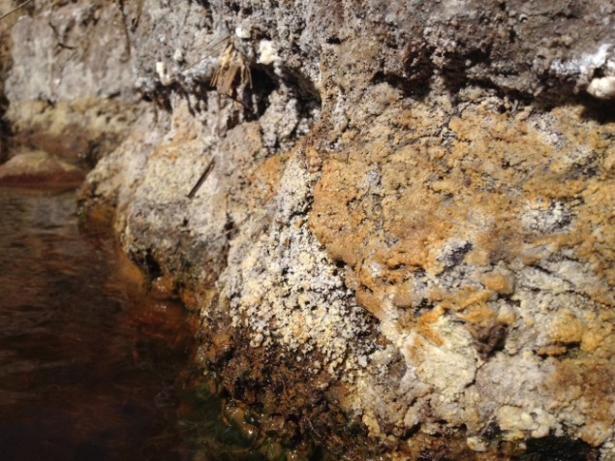  Figure 5: Crystalline deposits along river banks | 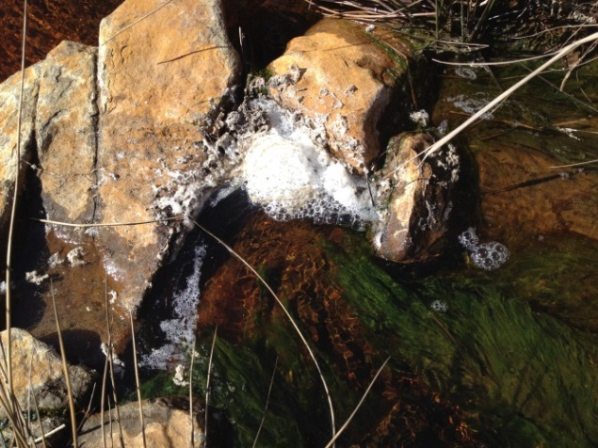  Figure 6: Bubbles and foaming
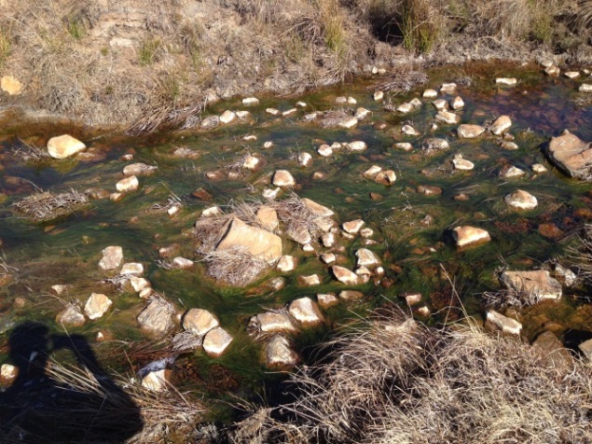  Figure 7: Excessive algal build-up | 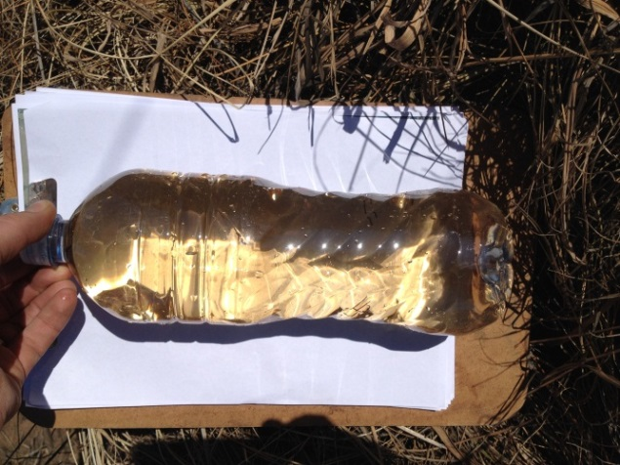  Figure 8: Discoloured water
Sampling during the July 2014 site visit indicated that the aquatic macroinvertebrate community was critically impaired and the water quality was poor (Table 3). Only two aquatic macroinvertebrate taxa were sampled indicating that the system is unlikely to host ant sensitive taxa. The pH and TDS values measured exceeded the South African Water Quality Guidelines (DWAF, 1996)
Table 3: In situ water quality measured in July 2014
Site | pH | EC (mS/m) | TDS | DO (mg/l) | DO Saturation (%) | Temperature
TWQR | 6.5 – 9.0 | <154 | <1000 | >5.00 | 80 - 120 | 5-30
CB4 | 6.0 | 410.0 | 2665.0 | 10.6 | 107.3 | 16.0
HUM1 | 6.1 | 410.0 | 2665.0 | 10.0 | 100.5 | 16.4
^{(a)} | Total Dissolved Salts | ^{mS/cm} | Millisiemens per centimetre | % | Percent
^{(b)} | Dissolved Oxygen | ^{mg/ℓ} | Milligrams per litre | ^{˚C} | Degrees Celsius
^{TWQR} | Target Water Quality Range

Wetland Delineation and Classification
Wetland types are differentiated based on their hydro-geomorphic (HGM) characteristics i.e. on the position of the wetland in the landscape, as well as the way in which water moves into, through and out of the wetland systems. Four wetland types were identified within the Study Area (Figure 9);
- Channelled valley bottom (‘VBA’)
- Unchannelled valley bottom (‘VBB’)
- Pan (‘De Jager’s Pan’)
- Hillslope seep (west of De Jager’s Pan)
- Heavily-modified wetland conditions exist to the east of the existing ash disposal facility, which is located along the eastern edge of De Jager’s Pan (‘modified wetland’). The presence of the existing ash disposal facility, and site roads that intersect the former wetland area at a number of junctures have almost completely modified this wetland (Figure 10.

The different HGM types, as currently defined (SANBI, 2009), are described in Table 4.
Table 4: Wetland hydrogeomorphic (HGM) types
Hydrogeomorphic type | Description
Channelled valley bottom | Valley bottom areas with a well-defined stream channel but lacking characteristic floodplain features. May be gently sloped and characterised by the net accumulation of alluvial deposits or may have steeper slopes and be characterized by the net loss of sediment. Water inputs from main channel (when channel banks overspill) and from adjacent slopes.
Unchannelled valley bottom | Valley bottom areas without a major channel running through it, characterised by an absence of distinct channel banks and the prevalence of diffuse flows, even during and after high rainfall events. Water inputs are typically from an upstream channel, as the flow becomes dispersed, and from adjacent slopes (if present) or groundwater.
Depression (includes pans) | A basin shaped area with a closed elevation contour that allows for the accumulation of surface water (i.e. it is inward draining). It may also receive sub-surface water. An outlet is usually absent, and therefore this type is usually isolated from the stream channel network.
Hillslope seep | A wetland area located on (gently to steeply) sloping land, which is dominated by gravity-driven, unidirectional movement of material down-slope. Water inputs are primarily from groundwater or precipitation that enters the wetland from an up-slope direction in the form of subsurface flow.

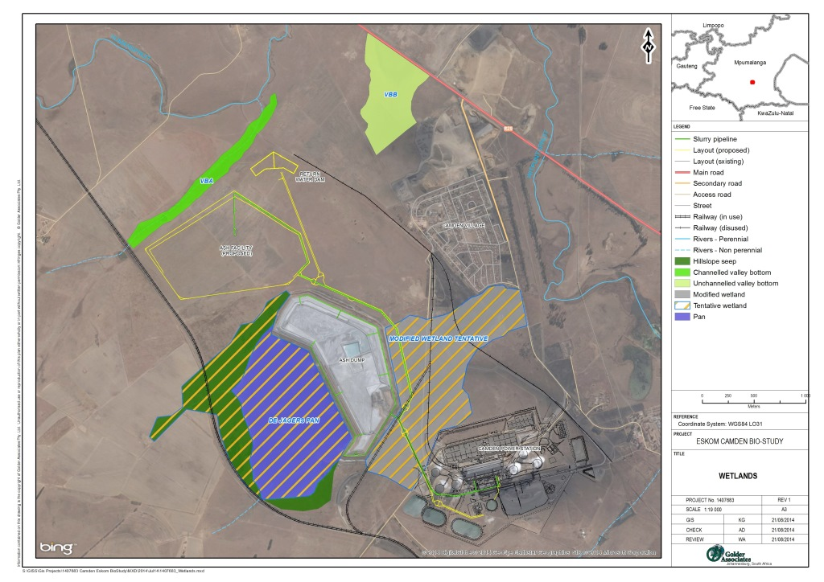
Figure 9: Wetlands in relation to preferred Site 1 ash disposal facility footprint

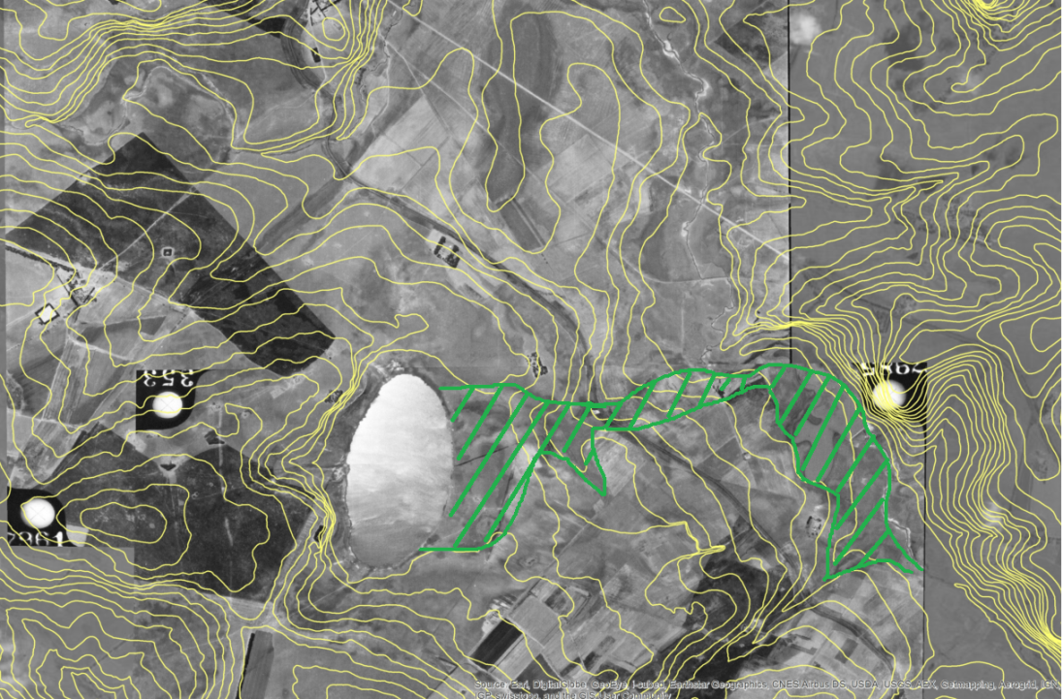
Wetland
De Jager’s Pan
- Historic aerial imagery showing wetland area east of De Jager’s pan prior to construction of power plant and ash facility
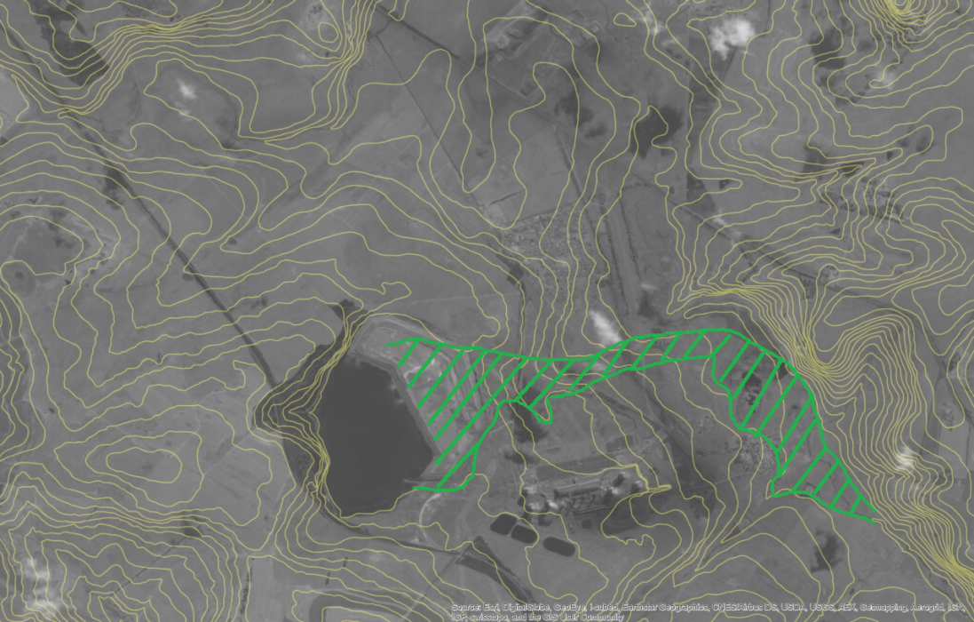
Ash disposal facility
Roads intersecting
- Recent aerial imagery showing power station infrastructure in relation to historic wetland
Figure 10: Historic (A) and current (B) aerial imagery of wetland area to the east of De Jagers Pan

Channelled Valley Bottom (VBA)
A channelled valley bottom wetland is located approximately 100 m northwest of the boundary of the proposed ash facility and return water dam (Figure 9). Hydrophilic vegetation observed in this wetland included Imperata cylindrica grass and Juncus sp., with the exotic species Verbena sp. also recorded. At the time of survey (during the dry season), flow was limited and open water was restricted to areas where water had pooled. This channelled valley bottom system flows into the nearby Humanspruit (Figure 9).

Unchannelled Valley Bottom (VBB)
An unchannelled valley bottom wetland is located approximately 600 metres northeast of the proposed return water dam (Figure 9). Imperata grass is abundant in this area, and dead flower heads of a diversity of sedges (Cyperus sp., Pycreus sp., inter alia) were observed during the dry season survey. The wetland soils augured here showed wetness signatures indicating permanent, seasonal (Figure 11) and temporary (Figure 12) wetland zones; however these zones could not be clearly established as vegetation types could not be easily identified at the time of survey.
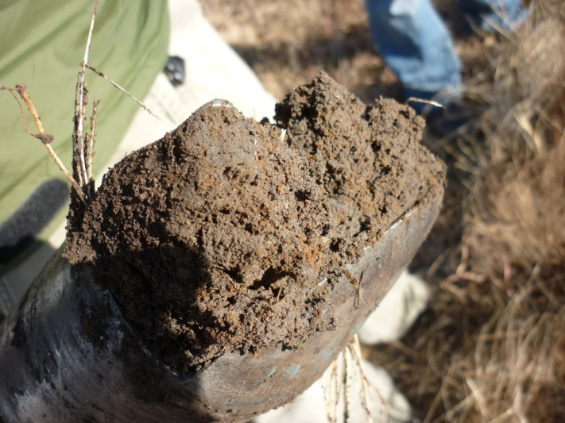 | 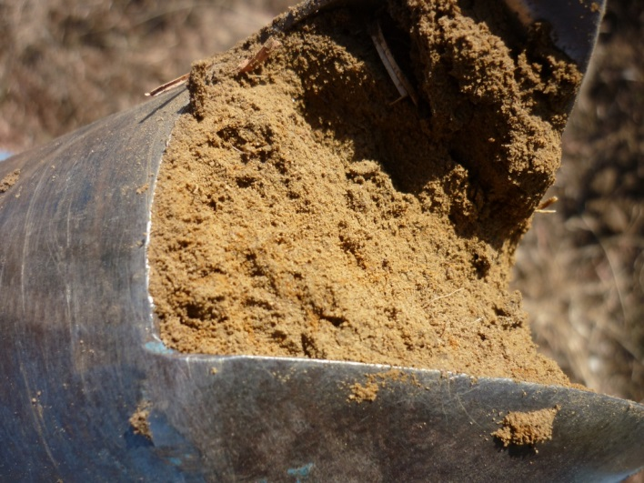
Figure 11: Seasonal wetland soil | Figure 12: Temporary wetland soil
The southern extent of the wetland boundary is defined by the edges of cultivated fields. The wetland is intercepted by the main R29 road at its north-eastern extent, which has impounded it. The area that previously formed part of this wetland to the north of the intersecting R29 has now been disturbed by cultivation.

De Jager’s Pan
A heavily-modified pan exists in the shape of the former De Jager’s Pan, which has been utilised as a return water dam for the existing ash facility and has been integrated into the dirty water management circuit of the power plant for over 40 years (Zitholele Consulting, 2013). This area was not surveyed during the field visit; the boundary shown on Figure 4 was derived from recent aerial imagery and delineated from desktop only.

Hillslope Seep
Inflow to De Jager’s Pan comes from hillslope seep areas to the west of the pan. This area was not surveyed during the field visit; the boundary shown on Figure 9 was derived from recent aerial imagery and delineated from desktop only.

Modified wetland
Heavily-modified wetland conditions exist to the east of the existing ash disposal facility (see Figure 5 - Figure 8 and photographs in Figure 13).
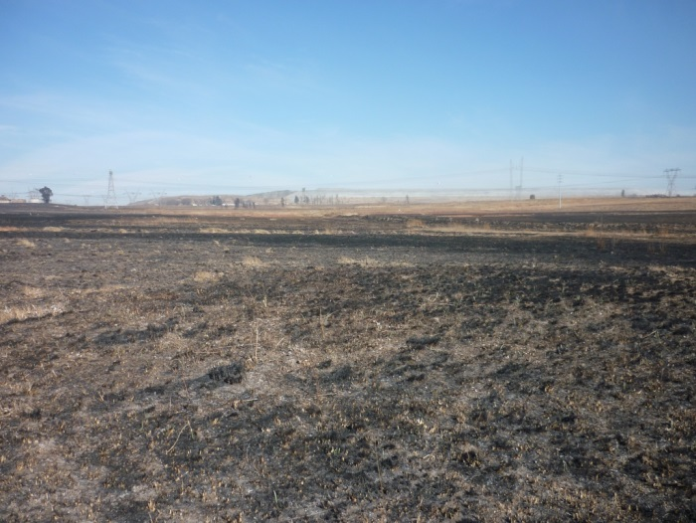 | 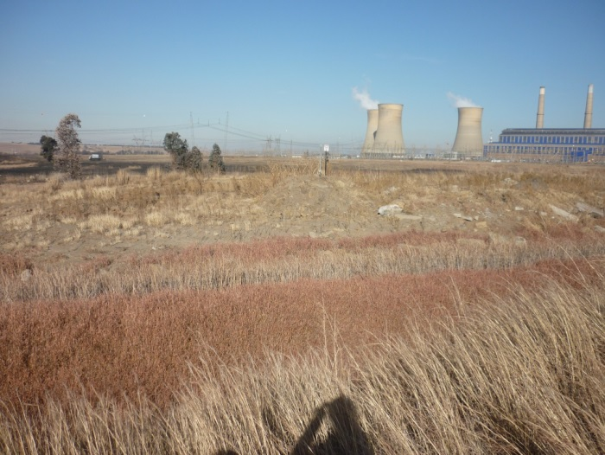
Figure 13: Heavily modified wetland area
Originally, this system was likely a hillslope seep without channelled outflow and fed by seepage from De Jager’s Pan (Figure 10). The system is now almost completely modified by the presence of the existing ash disposal facility, and site roads that intersect the former wetland area at a number of junctures (Figure 10), channelling surface run-off through culverts. At the time of survey, the area was completely burnt and could not be accurately delineated in the field; however patches of Imperata grass are prevalent throughout, and Phragmites was evident adjacent to the channelled outflow from this area. Delineation of this system presented in this report is consequently derived from aerial imagery.

Wetland Assessment
PES and EIS assessments and wetland functioning assessments were done for the channelled valley bottom wetland VBA and unchannelled valley bottom VBB only (ref. Section 2.1 Limitations).

PES
The wetlands and wetland catchments within the study area exist within a landscape dominated by Camden Power Station and associated infrastructure, and agricultural cultivation. In particular, linear infrastructure such as the railway lines and the R29 road (Figure 9) have had a substantial influence on the current extent and condition of the wetlands VBA and VBB, as a result of their influence on the hydrological and geomorphological characteristics of the wetlands in question.
VBA – Channelled valley bottom
The PES of the channelled valley bottom is C or Moderately Modified i.e. a moderate change in ecosystem processes and loss of natural habitats has taken place but the natural habitat remains predominantly intact. The change in ecosystem processes is largely attributable to the two railway lines (operational and disused) that intersect this wetland. Although culverts beneath are present, the embankments form a barrier to surface and sub-surface water supply to the wetland and as such has modified the hydrological integrity of the system. The presence of dams at intervals along the valley bottom cause flow impoundment and reduce the supply of water to the wetland downstream, particularly during the dry season.
VBB – Unchannelled valley bottom
The PES of this wetland is D or Largely modified, i.e. a large change in ecosystem processes and loss of natural habitat and biota and has occurred. Again, the PES classification of this wetland is mainly due to the presence of the embankment on which the R29 road is built. The embankment is a barrier to both surface and sub-surface water flow in the wetland; comparison of historic and current aerial imagery clearly illustrates that a large part of this wetland to the north of the R29 has become desiccated and is now cultivated (Figure 10). Nonetheless, although the survey was done in the dry season the indications are that a relatively diverse wetland flora remains in this wetland.

EIS
The ‘Ecological Importance’ of a wetland resource refers to its importance in the maintenance of ecological diversity and functioning on local and wider scales; while the ‘Ecological Sensitivity’ relates to the system’s ability to resist disturbance and its capability to recover from disturbance once it has occurred (DWAF, 1999a). Considered together, the EIS determinant methodology is used to evaluate wetlands in terms of:
- Ecological Importance;
- Hydrological Functions; and
- Direct Human Benefits.
According to the findings of a terrestrial ecology survey done at the site (Zitholele Consulting, 2013) the plant Boophone disticha was observed in the Study Area. This species is listed as ‘Declining’ by the Red List of South African Plants (SANBI, 2014), due to habitat loss and unsustainable harvesting. No other species of conservation concern were reported in that study.
During the site visit of July 2014, no species of conservation concern were observed; however the survey was done in the dry season so flowering plants of interest would have been overlooked. Both wetlands have the potential to support Grass Owl Tyto capensis which is regionally Vulnerable (BirdLife South Africa, 2014), due to the presence of suitable habitat in the form of extensive stands of Imperata cylindrica grass; however no evidence of the presence of this species was observed.
In summary, in terms of the support of important biodiversity provided by wetlands within the Study Area, both the channelled valley bottom (VBA) and the unchannelled valley bottom (VBB) in proximity to the footprint of preferred Site 1 were both ranked D or of Low/Marginal ecological importance and sensitivity. This is because their biodiversity features are largely ubiquitous, being prevalent in other similar wetland systems in the local area, and the wetlands themselves play a relatively insignificant role in moderating the quantity and quality of surface and ground water systems in the locality. The primary value of the wetlands is their contribution to erosion control and regulation of soil and water nutrients in their respective catchments; this is discussed further under the Wetland Functioning Section 3.3.3.

Wetland Functioning
The nature of the functions that the wetlands perform and the services they provide were assessed using the Wet Ecoservices tool. Each wetland was assessed separately. The assessment considers each HGM unit in the context of unit type and the land-use setting in which it occurs (i.e. power station and ancillary infrastructure, agricultural cultivation) as these factors determine the potential functions provided by the wetlands and the opportunities available to perform certain functions and services.
VBA – Channelled valley bottom wetland
The findings of the assessment of VBA (channelled valley bottom wetland) adjacent to the infrastructure of preferred Site 1 (Figure 9) indicate that it principally controls exacerbation of erosion that could potentially arise as a result of tilled agricultural fields in its catchment (Figure 1), and increased levels of surface water runoff. Phosphate trapping and stream flow regulation are regulated in tandem with erosion control. The wetland has a more limited role in flood attenuation and maintenance of biodiversity, as a function of its size and apparently limited biological diversity.
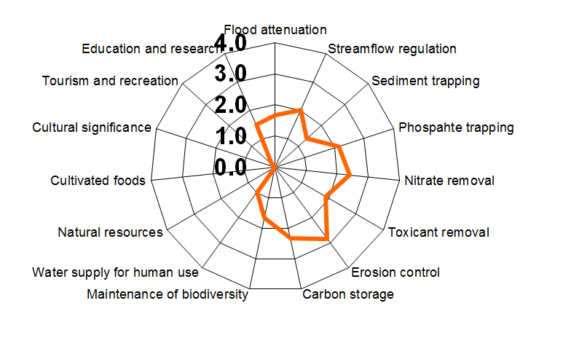
Figure 14: Spider diagram showing scores for ecosystem services supplied by channelled valley bottom wetland (VBA)
VBB – Unchannelled valley bottom wetland
Although the unchannelled valley bottom (VBB) northeast of the infrastructure of preferred Site 1 (Figure 1) provides a number of ecosystem services, the value of these services is low, due to the impacted extent and ecological integrity of this wetland. It contributes to regulation of soil nutrients and may have an influence on toxicant removal; such toxicants may enter the wetland in the form of contaminants and sediments transported in surface water run-off from the adjacent roadway, or from dust blown off the ash disposal facility.
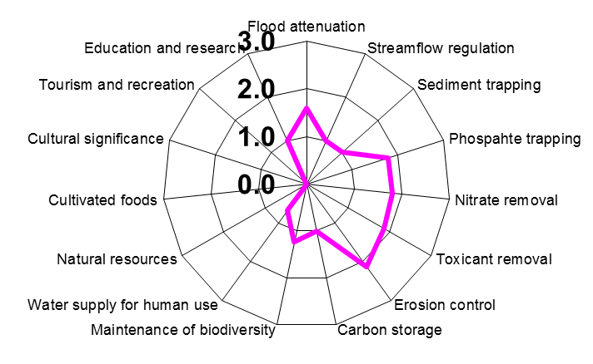
Figure 15: Spider diagram showing scores for ecosystem services supplied by unchannelled valley bottom wetland (VBB)

Potential impacts
Potential impacts on the Humanspruit and wetlands ‘VBA’ and ‘VBB’ that may arise as a result of the construction and operation of the proposed infrastructure of preferred Site 1 are discussed in the following sections.

Aquatic Ecosystems
It is evident that the Humanspruit is highly impacted as is the larger area surrounding the Camden Power Station. For this reason, the cumulative impact of the proposed ash disposal facility in relation to the larger catchment and not just the site footprint should be considered. Potential upstream impacts could include effects associated with municipal discharges from Ermelo town, and the Ermelo Yard associated with the Heavy-haul Coal Line. In addition to this there are extensive opencast mining operations within the catchment.
Based on the review of the existing studies and the site visit, the following potential impacts were identified:

Degradation of biotic integrity due to modification of water quality
Changes to the water quality could result in changes to ecosystem structure and function as well as a potential loss of biodiversity. Water quality deterioration often leads to modification of species composition, with loss of sensitive species and their replacement by organisms more tolerant to environmental changes, which tend to dominate the community structure within the degraded system.
The proposed new Ash facilities are designed to be lined facilities (Zitholele Consulting, 2014). Furthermore, these facilities contain contaminated run-off and storm water systems and an associated pollution control dam sized to accommodate run-off from a one in 50 year rainfall event. The design of the new Ash facility does mitigate risk of contaminated surface run-off reporting directly to the aquatic environment. The effectiveness of this mitigation will however be influenced by the operational practices employed, particularly ensuring that the pollution control dam is regularly de-silted to ensure that the surge capacity inherent in the design is retained. Through good surface/storm water management, no polluted water should be allowed to leave the site as this water is often of poor quality due to exposure to various processes and chemicals. There is also risk that contaminated water may enter the Humanspruit through failure of pipes transporting water back from the return water system. Such events could have significant impacts on aquatic ecosystems, dependent on concentration and volume of pollutants accidentally released, especially in a system that is already under stress.

Degradation of aquatic ecosystems due to increased sedimentation
Habitat availability and habitat quality are major determinants of the aquatic community structure. Changes in the biological community of a river may be linked to changes in water quality, habitat or both. When naturally vegetated landscapes are transformed, physical and biological relationships with adjacent streams are affected, usually resulting in stream bank erosion, increased sedimentation and a change in biotic community structure.
Clearance of existing vegetation during construction will expose the upper layers of the soil horizon to soil erosion. Runoff after rain can give rise to erosion and sedimentation. The disturbed areas of land and the ash disposal facility itself will be susceptible to erosion if not managed correctly. In addition to surface water runoff, dust fallout must also be considered. Severe fallout could potentially impact habitat and water quality, depending on the molecular composition.
Uncontrolled surface water runoff from the construction site should be implemented to reduce the risk of sediment being transported into the adjacent wetland and river system. Appropriate silt traps should be installed to reduce velocities and prevent erosion. This will assist in settling out particulates before they enter the receiving systems.

Wetlands
The footprint of the preferred Site 1 does not overlap with the boundaries of wetlands within the Study Area, and as such no impacts on wetlands through direct habitat loss, disturbance or fragmentation are anticipated. Similarly, the Project incorporates measures to address stormwater management and separation of clean and dirty water systems, therefore no direct impacts on water quality of the wetlands are anticipated. However, indirect effects on wetland water quality could arise due to potential dust loading into the wetland systems – ref. Section 4.2.3.
Impacts on the quantity of water supplied to the wetlands could occur due to the location of the infrastructure of preferred Site 1 in the catchments of wetlands VBA and VBB; these are further discussed below.
Activities that occur within a wetland’s catchment, but which do not directly impact upon the wetland can still have significantly negative impacts on the hydrology supporting these systems. It is now a legislative requirement that any activity within 500 meters of a wetland is subject to authorisation under Section 21 of the National Water Act (Act 36, 1998), and will require submission of a Water Use License Application (DWAF, 2007).

Interruption in hydrology
The hydrological properties of both the channelled valley bottom (VBA) and the unchannelled valley bottom (VBB) are currently impacted by the impounding effects of the embankments on which the rail lines and the R29 are built. The proposed ash disposal facility will be situated in the catchments of both of these wetlands (Figure 1). Vegetation clearance works during construction, and the physical presence of the ash disposal facility during operation will interrupt the hydrology of the wetland systems through alteration of the soil profile and subsequent changes in sub-surface water supply to the wetlands.
The physical positioning of the ash disposal facility and return water dam in the catchment of the wetlands during operation will result in reduced quantities of surface water run-off being supplied to the wetlands. The presence of the ash disposal facility is also likely to impede or alter the natural subsurface flow in the catchment’s soils and this could have indirect but potentially significant desiccating effects on the wetlands.

Erosion of catchment soils & increased sediment input to wetlands
Erosion may occur on exposed soils in the immediate catchment of the channelled valley bottom wetland (VBA) in particular, as a consequence of vegetation clearing during construction. Erosion of the catchment soils could lead to channelisation of surface water runoff in the catchment and subsequently the wetland unit itself, and associated changes in the natural wetland hydrology, concentration of flows, lowering of the water table within the wetland and possible desiccation of areas of the wetland.
During construction, excavations in the catchment of the channelled valley bottom wetland VBA) may cause increased sediment deposition in this wetland downstream of the works, particularly during rainfall events. Excavations may also cause changes in the soil profile and soil permeability, which could increase the sediment load in surface water runoff. Dust fallout from the ash facility once it is in operation may occur; this may also contribute to increased sedimentation of the wetlands in question. These factors will affect the geomorphological integrity of the wetlands.

Water quality deterioration
During construction, standard site management practices for handling hazardous and potentially polluting goods during construction need to be built into the contractor plans.
During operation, dust fallout from the proposed ash disposal facility could contain toxicants that may contaminate surface water systems, contributing to water quality deterioration. Such deterioration may affect the composition of the wetland vegetation community and result in loss of diversity of plant species, reducing the (already compromised) ecological integrity and functioning of the wetlands in the Study Area. Potential dust loading into wetland systems should be quantified through air quality modelling.

Recommendations
The impact assessment previously conducted for the Site indicates that once appropriate mitigation measures are applied, residual impacts on aquatic and wetland ecosystems will be of moderate-low significance (Zitholele Consulting, 2013). Specific mitigation recommendations additional to those proposed in Zitholele Consulting (2013) are provided in the following paragraphs.
It is imperative that the appropriate mitigation measures concerning aquatic and wetland ecosystems be implemented. It is important that rehabilitation and re-vegetation of the exposed areas be undertaken on a continual basis and should not be left until the closure phase. If erosion has taken place, rehabilitation should be implemented as soon as possible.
Recommendations specific to the aquatic and wetland ecosystems within the Study Area and the potential impacts on them that may arise as a result of the Project include:
- The wetland field survey was done in the dry season. A comprehensive wet season survey of all wetlands in the Study Area is recommended:
  - to accurately define the boundaries of wetlands that have been delineated from desk study only
  - to record the floristic diversity at the wetlands and update the EIS scores accordingly
- Appropriate stormwater management at the Project is vital due to the proposed location of Site 1 in the catchments of wetlands VBA and VBB, and the catchment of the Humanspruit. An additional ash water return dam will be constructed as part of the Project, and this together with the dirty water containment at De Jager’s Pan will be used to manage dirty stormwater at the Site. A clean water diversion channel forms part of the conceptual design, this will divert clean water around the proposed facility and discharge into the natural environment:
  - The clean water diversion channel should be routinely monitored for acidity/alkalinity and EC as an early warning for potential contamination by ash dust;
  - The discharge of clean water to the natural environment must not result in erosion or channelization of wetland areas – where necessary, engineered measures should be put in place to ensure diffuse discharge of water across wetland areas;
  - Silt traps should be placed down-slope of where vegetation stripping will take place to minimise siltation in rivers and wetlands. These silt traps need to be regularly maintained to ensure effective drainage;
  - The pollution control dam must be regularly de-silted to ensure that the surge capacity inherent in the design is retained; and
  - To our knowledge there is currently no monitoring program in place. Therefore it is recommended that a monitoring program of the adjacent wetland and aquatic ecosystem be implemented. These studies must consider results from the surface water monitoring, which must take cognisance of the pH and TDS. Monitoring of the receiving environment should consider sites on the Humanspruit and Witpuntspruit. In situ water quality measurements should not exceed the South African Water Quality Guidelines and ecological integrity should not differ from background values. Monitoring should be conducted bi-annually during the wet and dry season. Proposed monitoring pints are shown in Figure 16 and Table 5.
- Potential dust loading into wetland and aquatic systems should be quantified through air quality modelling, and dust load predictions established.
- No construction activities should take place within the macro-channel, riparian zones, or wetland areas, to prevent disturbance of vegetation and limit the effects of soil compaction on hydrology and geomorphology of wetland catchments. The boundaries of these features should be clearly demarcated and no construction machinery or activities should pass beyond them.
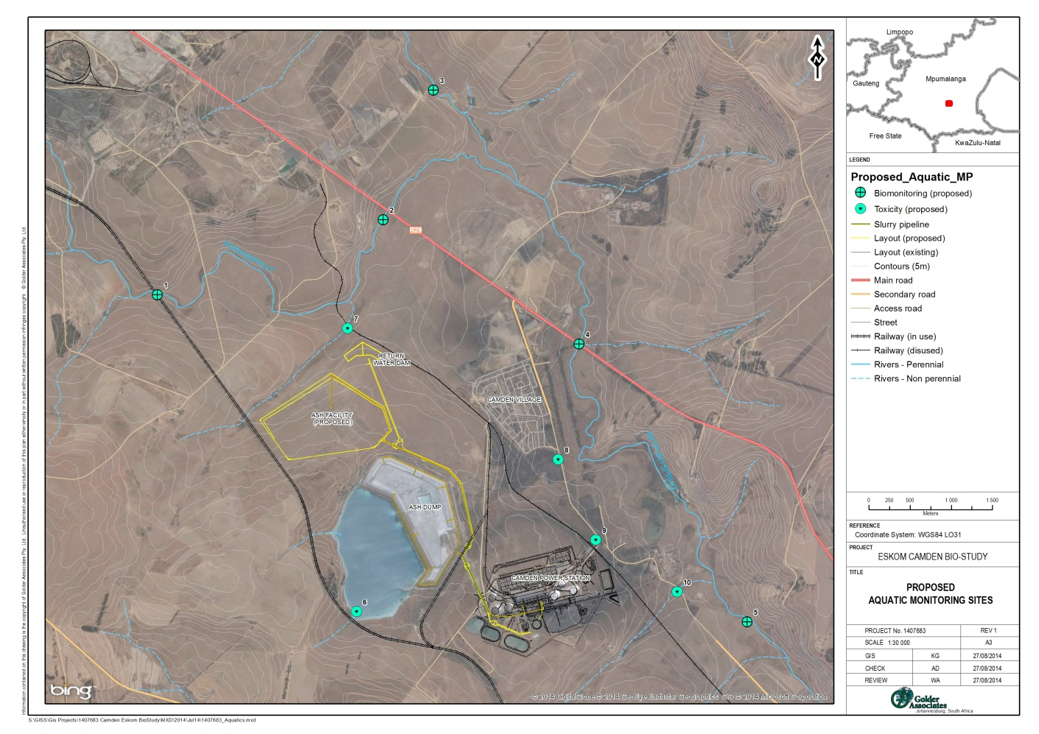
Figure 16: Proposed Aquatic Monitoring Sites
Table 5: Proposed aquatic monitoring points
Site | Sample | Latitude | Longitude
1 | Biomonitoring | -26.587410 | 30.044781
2 | Biomonitoring | -26.579381 | 30.072338
3 | Biomonitoring | -26.565223 | 30.078569
4 | Biomonitoring | -26.593176 | 30.096100
5 | Biomonitoring | -26.623751 | 30.116330
6 | Toxicity Testing | -26.622337 | 30.068748
7 | Toxicity Testing | -26.591264 | 30.067908
8 | Toxicity Testing | -26.605816 | 30.093452
9 | Toxicity Testing | -26.614652 | 30.097960
10 | Toxicity Testing | -26.620406 | 30.107813

Closing
We trust that this report meets your current requirements. If you have any questions, please contact the undersigned Golder staff members.
Golder Associates Africa (Pty) Ltd.

Aisling Dower Brent Baxter
Ecologist Reviewer

AD/BB/ad

Reg. No. 2002/007104/07
Directors: SAP Brown, L Greyling, RGM Heath

Golder, Golder Associates and the GA globe design are trademarks of Golder Associates Corporation.

g:\projects\1407683 - zitholele eskomcamdenbiostdy ermelo\6.1 deliverables\1407683-13024-1_camden_wetlands_aquatics_final_270814.docx

Document Limitations

DOCUMENT LIMITATIONS
This Document has been provided by Golder Associates Africa Pty Ltd (“Golder”) subject to the following limitations:

- This Document has been prepared for the particular purpose outlined in Golder’s proposal and no responsibility is accepted for the use of this Document, in whole or in part, in other contexts or for any other purpose.
- The scope and the period of Golder’s Services are as described in Golder’s proposal, and are subject to restrictions and limitations. Golder did not perform a complete assessment of all possible conditions or circumstances that may exist at the site referenced in the Document. If a service is not expressly indicated, do not assume it has been provided. If a matter is not addressed, do not assume that any determination has been made by Golder in regards to it.
- Conditions may exist which were undetectable given the limited nature of the enquiry Golder was retained to undertake with respect to the site. Variations in conditions may occur between investigatory locations, and there may be special conditions pertaining to the site which have not been revealed by the investigation and which have not therefore been taken into account in the Document. Accordingly, additional studies and actions may be required.
- In addition, it is recognised that the passage of time affects the information and assessment provided in this Document. Golder’s opinions are based upon information that existed at the time of the production of the Document. It is understood that the Services provided allowed Golder to form no more than an opinion of the actual conditions of the site at the time the site was visited and cannot be used to assess the effect of any subsequent changes in the quality of the site, or its surroundings, or any laws or regulations.
- Any assessments made in this Document are based on the conditions indicated from published sources and the investigation described. No warranty is included, either express or implied, that the actual conditions will conform exactly to the assessments contained in this Document.
- Where data supplied by the client or other external sources, including previous site investigation data, have been used, it has been assumed that the information is correct unless otherwise stated. No responsibility is accepted by Golder for incomplete or inaccurate data supplied by others.
- The Client acknowledges that Golder may have retained sub-consultants affiliated with Golder to provide Services for the benefit of Golder. Golder will be fully responsible to the Client for the Services and work done by all of its sub-consultants and subcontractors. The Client agrees that it will only assert claims against and seek to recover losses, damages or other liabilities from Golder and not Golder’s affiliated companies. To the maximum extent allowed by law, the Client acknowledges and agrees it will not have any legal recourse, and waives any expense, loss, claim, demand, or cause of action, against Golder’s affiliated companies, and their employees, officers and directors.
- This Document is provided for sole use by the Client and is confidential to it and its professional advisers. No responsibility whatsoever for the contents of this Document will be accepted to any person other than the Client. Any use which a third party makes of this Document, or any reliance on or decisions to be made based on it, is the responsibility of such third parties. Golder accepts no responsibility for damages, if any, suffered by any third party as a result of decisions made or actions based on this Document.

GOLDER ASSOCIATES AFRICA (PTY) LTD

Golder Associates Africa (Pty) Ltd.
PO Box 6001
Halfway House, 1685
Building 1 , Golder House, Magwa Crescent West
Maxwell Office Park, Waterfall City
Cnr Allandale Road and Maxwell Drive
Midrand
South Africa
T: [+27] (11) 254 4800

