APPENDIX 6
PHOTOGRAPHS

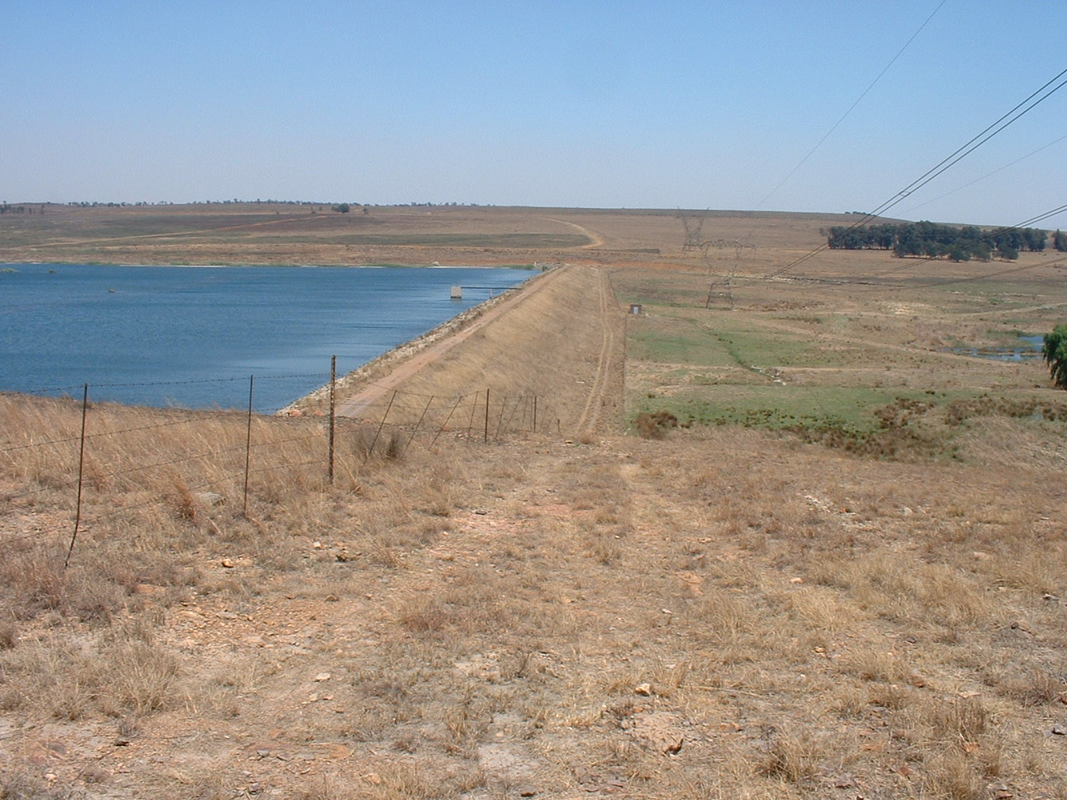
Approximate position of the pumping station
Photo 1: View of the Driefontein Dam wall looking south

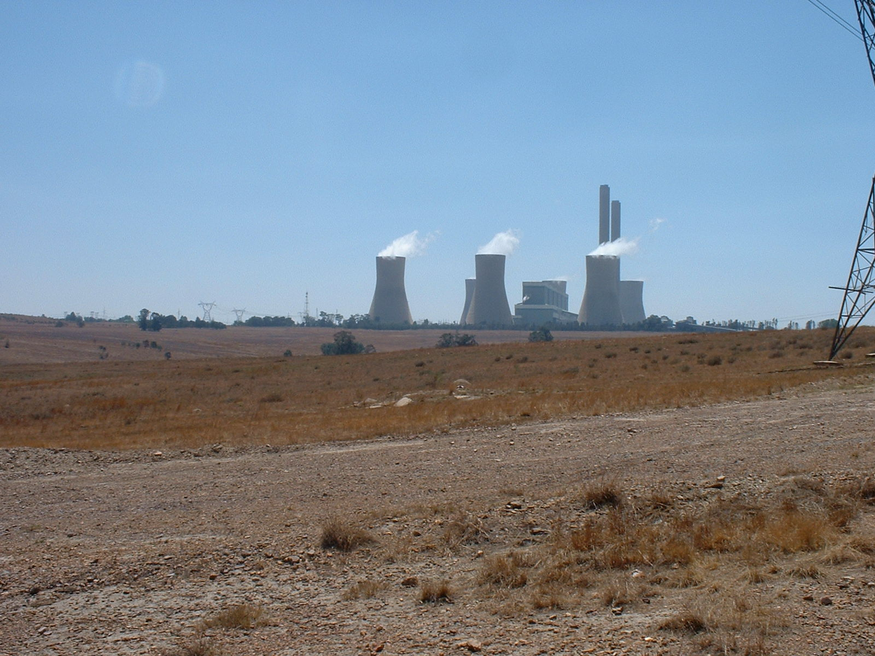
Photo 2: View from the start of the pipeline to Duvha power station

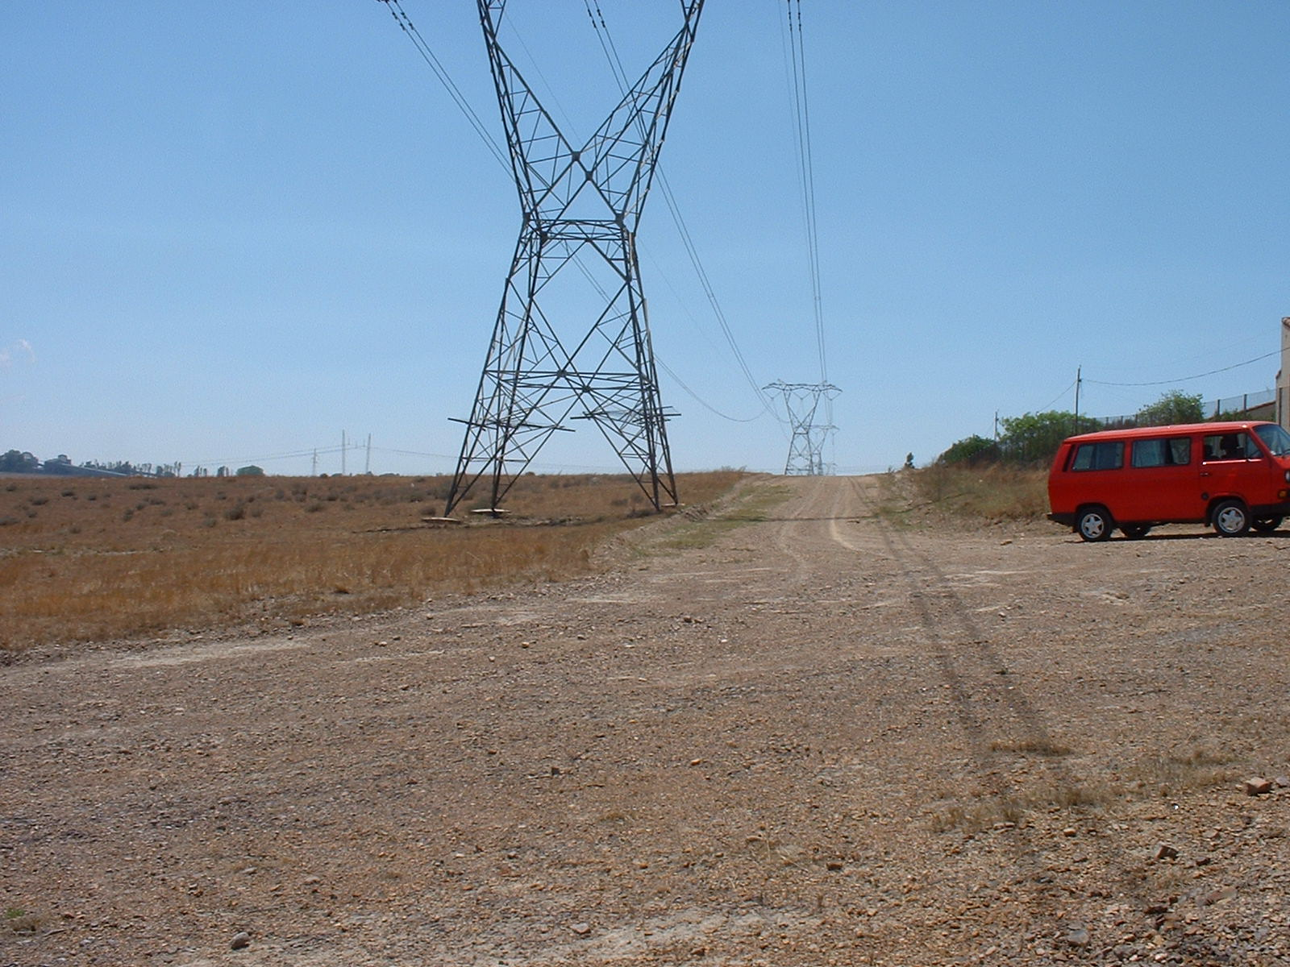
Photo 3: View looking north of the power line servitude past the west side of
Lesedi. The pipeline and power line for the pump will be laid to the west (left)
of the existing power line.

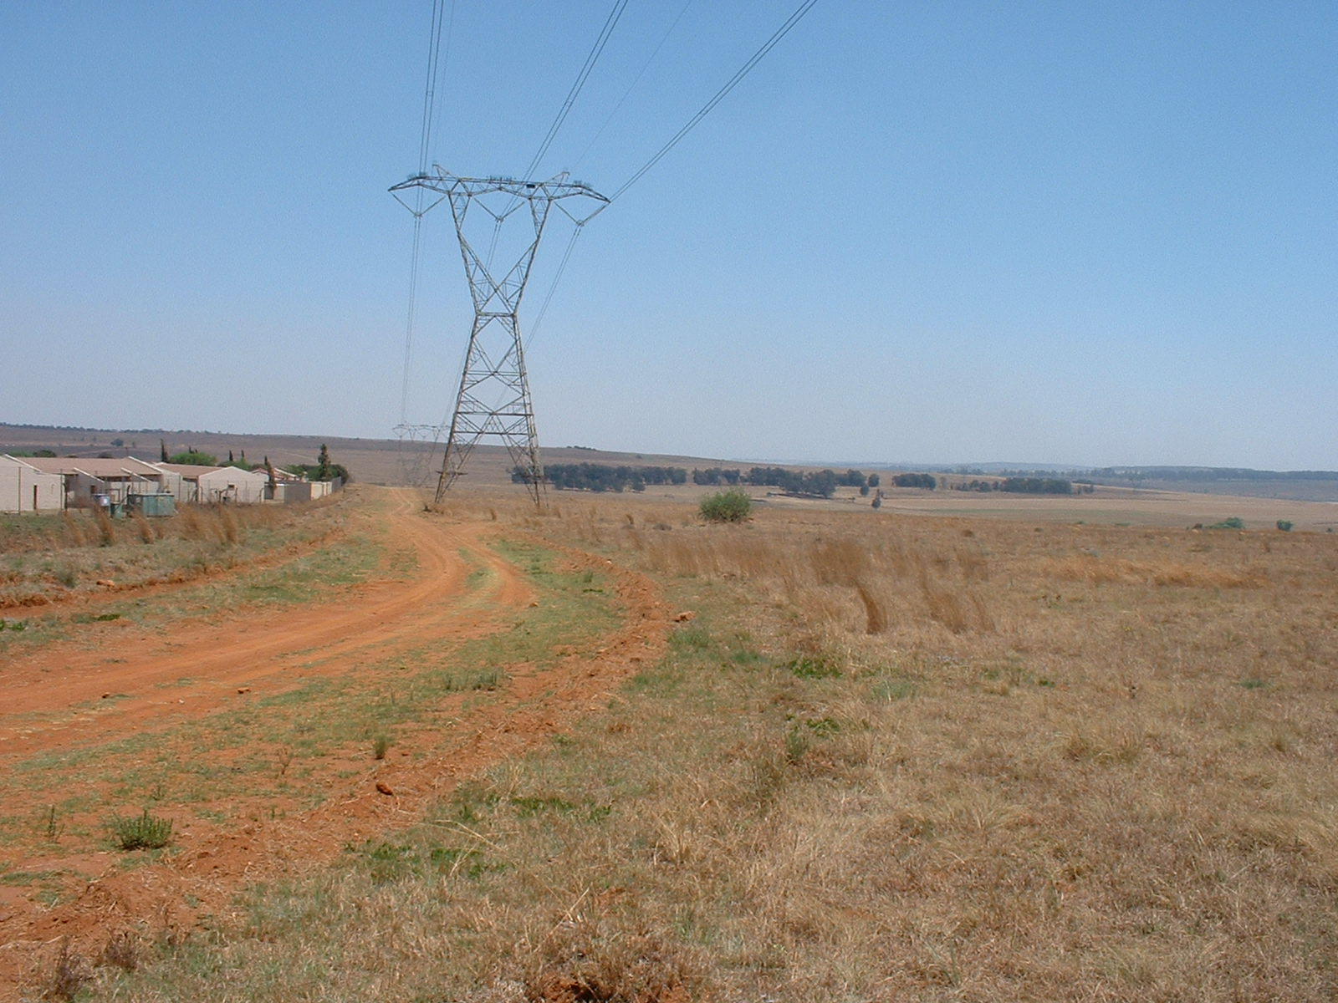
Photo 4: View looking south of the power line servitude past the west side
of Lesedi, showing Lesedi on the left hand (eastern) side.
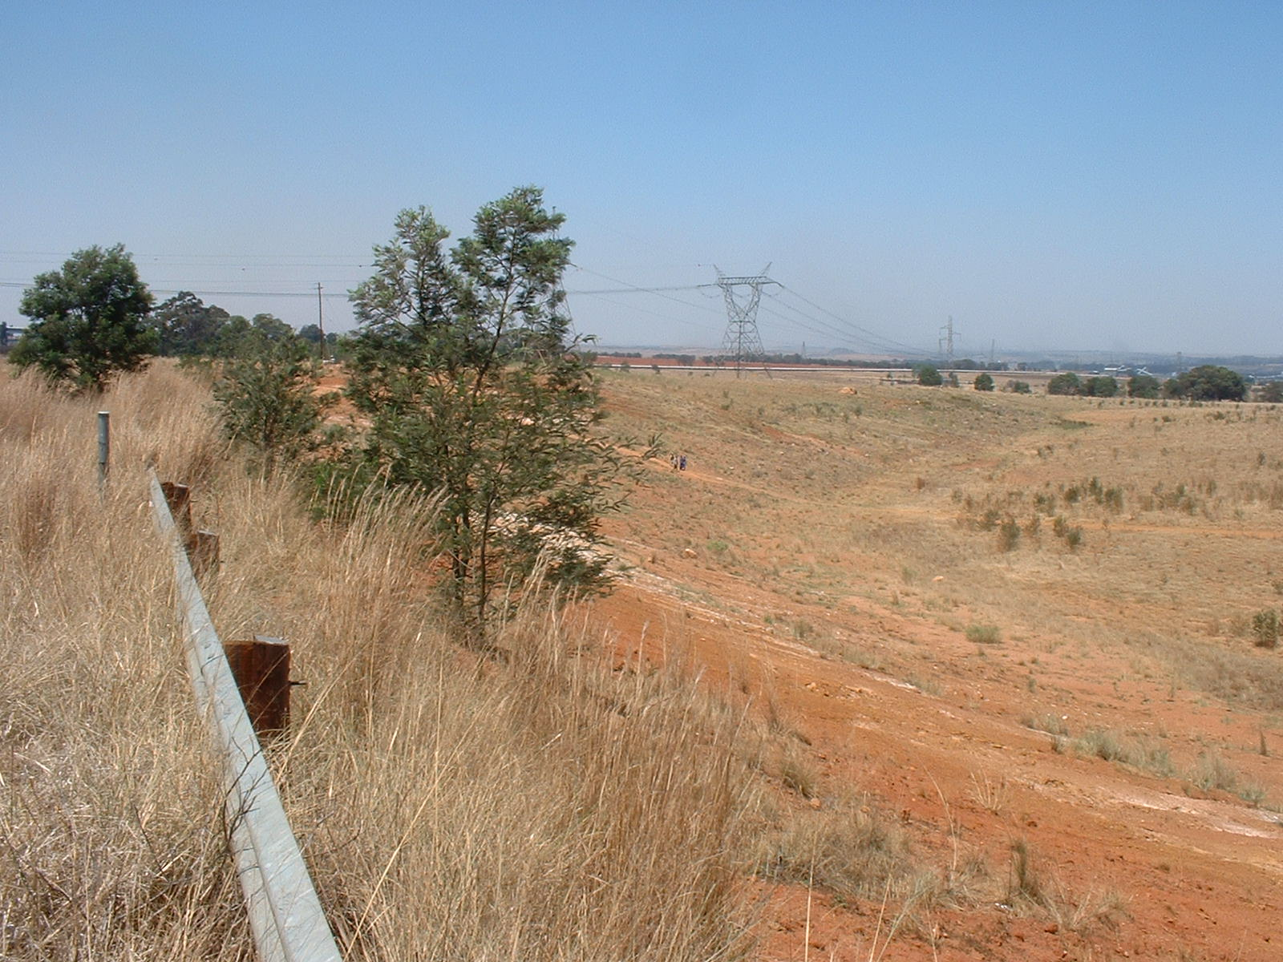
Photo 5: View looking southeast from the approximate point where the pipeline
Rehabilitated mining land
Power line
will cross the road. The power line servitude in which the pipeline will be laid
is visible in the background.

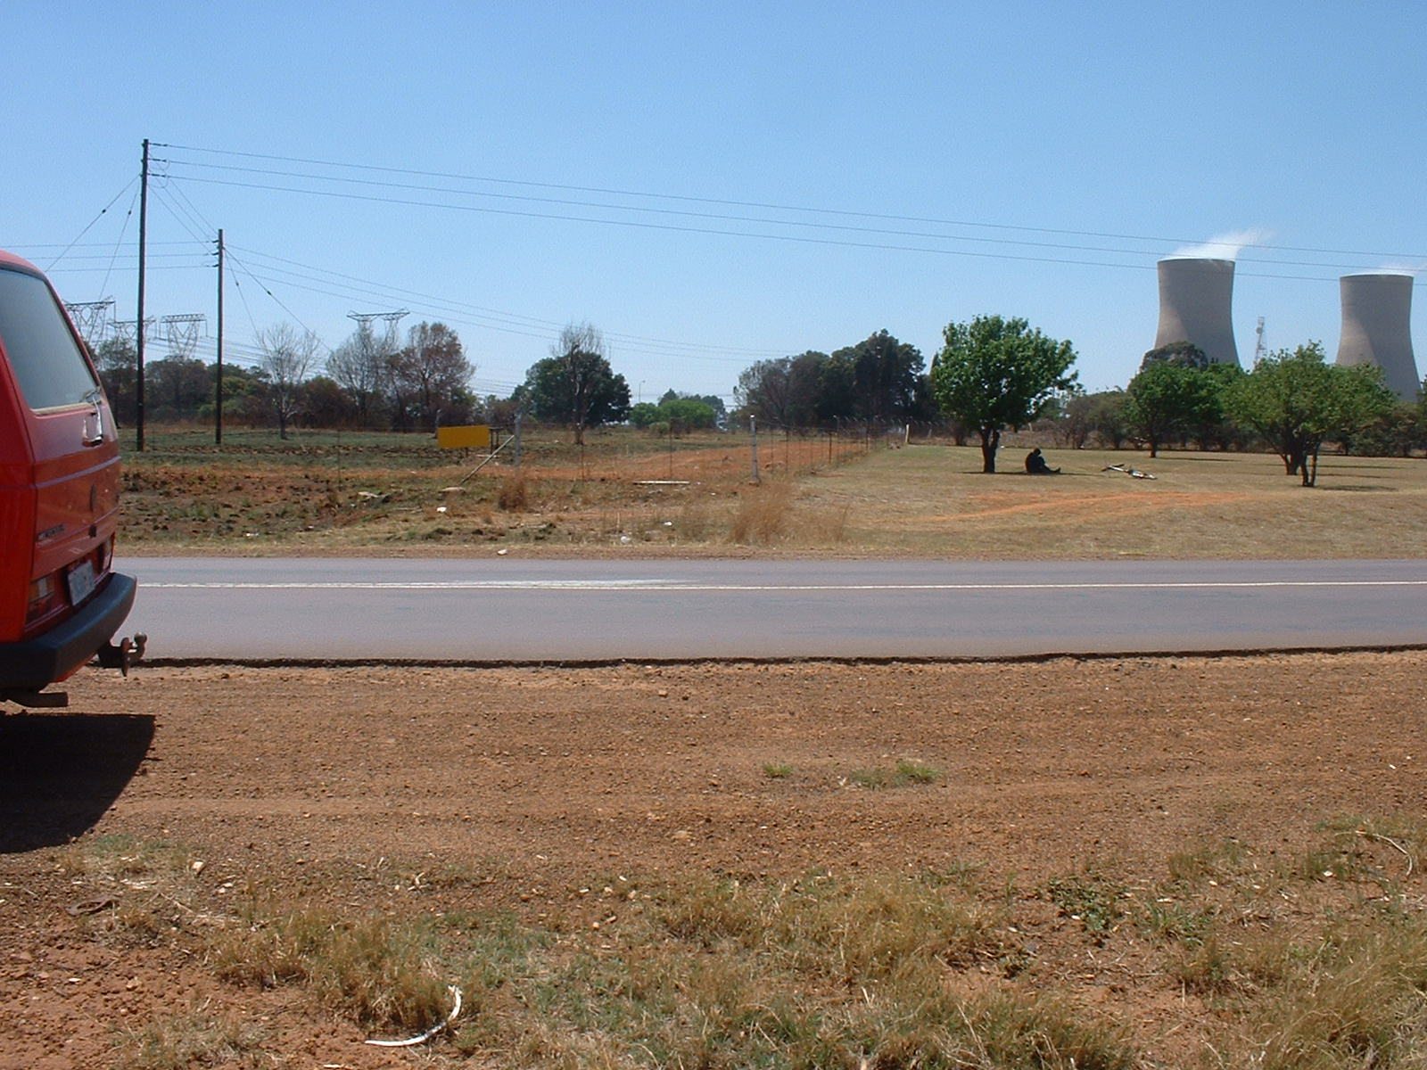
Photo 6: View looking north from the approximate point where the pipeline
will cross the road.

