ENVIRONMENTAL IMPACT ASSESSMENT (EIA) FOR A PROPOSED 400kV TRANSMISSION LINE BETWEEN PERSEUS SUB-STATION (DEALESVILLE) AND MERCURY SUB-STATION (VIERFONTEIN), FREE STATE PROVINCE
FOCUS GROUP MEETING MINUTES
15 APRIL 2003 AT 10:00
MILITARY MUSEUM AUDITORIUM, BLOEMFONTEIN
1. OPENING AND WELCOME
The Chairperson (Marita Oosthuizen) welcomed all present and introduced the various persons from Eskom as well as the consultants.
2. PURPOSE OF THE MEETING
The Chairperson stated that the purpose of the meeting was to:
- Provide background to the proposed project;
- Introduce the EIA process;
- Give Eskom the opportunity to explain the rationale behind the project and give an overview of their construction practices;
- Indicate the potential environmental impacts identified;
- Discuss the proposed project and answer questions raised by the public; and
- Identify issues and concerns.

3. PRESENTATIONS
The Chairperson asked Messrs. Vollmer and Streaton to make their presentations. Ms. Vollmer’s presentation was structured around the Environmental Impact Assessment (EIA) process with an emphasis on this proposed transmission line, while Ms. Streaton explained the rationale for the proposed project as well as Eskom’s construction practices. She also outlined the basic negotiation process.
3.1 BACKGROUND TO THE STUDY AND THE ENVIRONMENTAL IMPACT ASSESSMENT PROCESS
A summary of Ms. Vollmer’s presentation follows:
OVERVIEW OF THE PRESENTATION
Ms. Vollmer thanked everybody for the opportunity to make her presentation. She began an overview of her presentation:
- Introduction and need for this study;
- Background to the project;
- Study area;
- The process
- The Public participation process;
- Preliminary issues identified;
- Potential impacts identified to date; and the
- Way forward.
BACKGROUND TO THE PROJECT
Ms. Vollmer noted that a full explanation of the need for the project is part of Eskom’s presentation. In brief, Eskom proposed to develop a 400kV transmission line to provide additional capacity to support the network supplying the Greater Cape Region south of Bloemfontein. The proposed transmission line would be 300 – 350km in length.
Ms. Vollmer showed a map depicting the study area (figure 1 – on the following page).

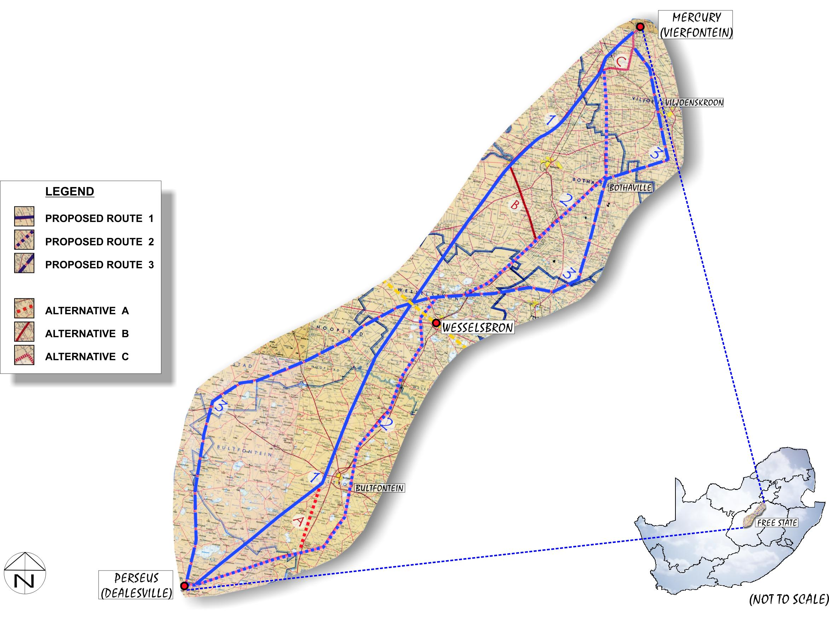
FIGURE 1

NEED FOR THE ENVIRONMENTAL IMPACT ASSESSMENT (EIA)
Ms. Vollmer explained that in terms of Section 26 of the Environmental Conservation Act (Act 73 of 1989), the development falls within the ambit of listed activities (Section 1 of Government Notice R. 1183 of 05 September 1997) and is therefore subject to an Environmental Impact Assessment (EIA).
In terms of Government Notice R 1183, Schedule 1 clause 1a, states that EIAs need to be conducted for “the construction or upgrading of facilities for commercial electricity generation and supply.”

THE LEGAL ENVIRONMENTAL PROCESS
Ms. Vollmer showed a slide depicting the EIA process (figure 2- following page). She noted that it was a two-tiered process that entails a Scoping Phase (Phase I), followed by an Environmental Impact Assessment Phase (EIA Phase or Phase II). The Scoping phase entails the identification of the possible impacts that the development may have on the environment, and makes a recommendation as to the preferred alignment. The EIA phase then investigates in greater depth the environmental impact that the preferred alignment will have on the environment and proposes a series of mitigation measures.
Ms. Vollmer indicated to attendants that the study was currently in the Scoping Phase. She also highlighted the parts during these phases that Public Participation will take place.
Ms. Vollmer indicated that, during the Scoping Phase, the environmental team had the following objectives:
- Introduce the project;
- Provide information on the status of the project;
- Register and obtain comments from Interested & Affected Parties (I&APs);
- Proactively identify areas of concern; and
- Achieve a synergistic relationship between development, environment and I&APs.
In order to achieve these objectives, Ms. Vollmer explained, public involvement was of paramount importance.

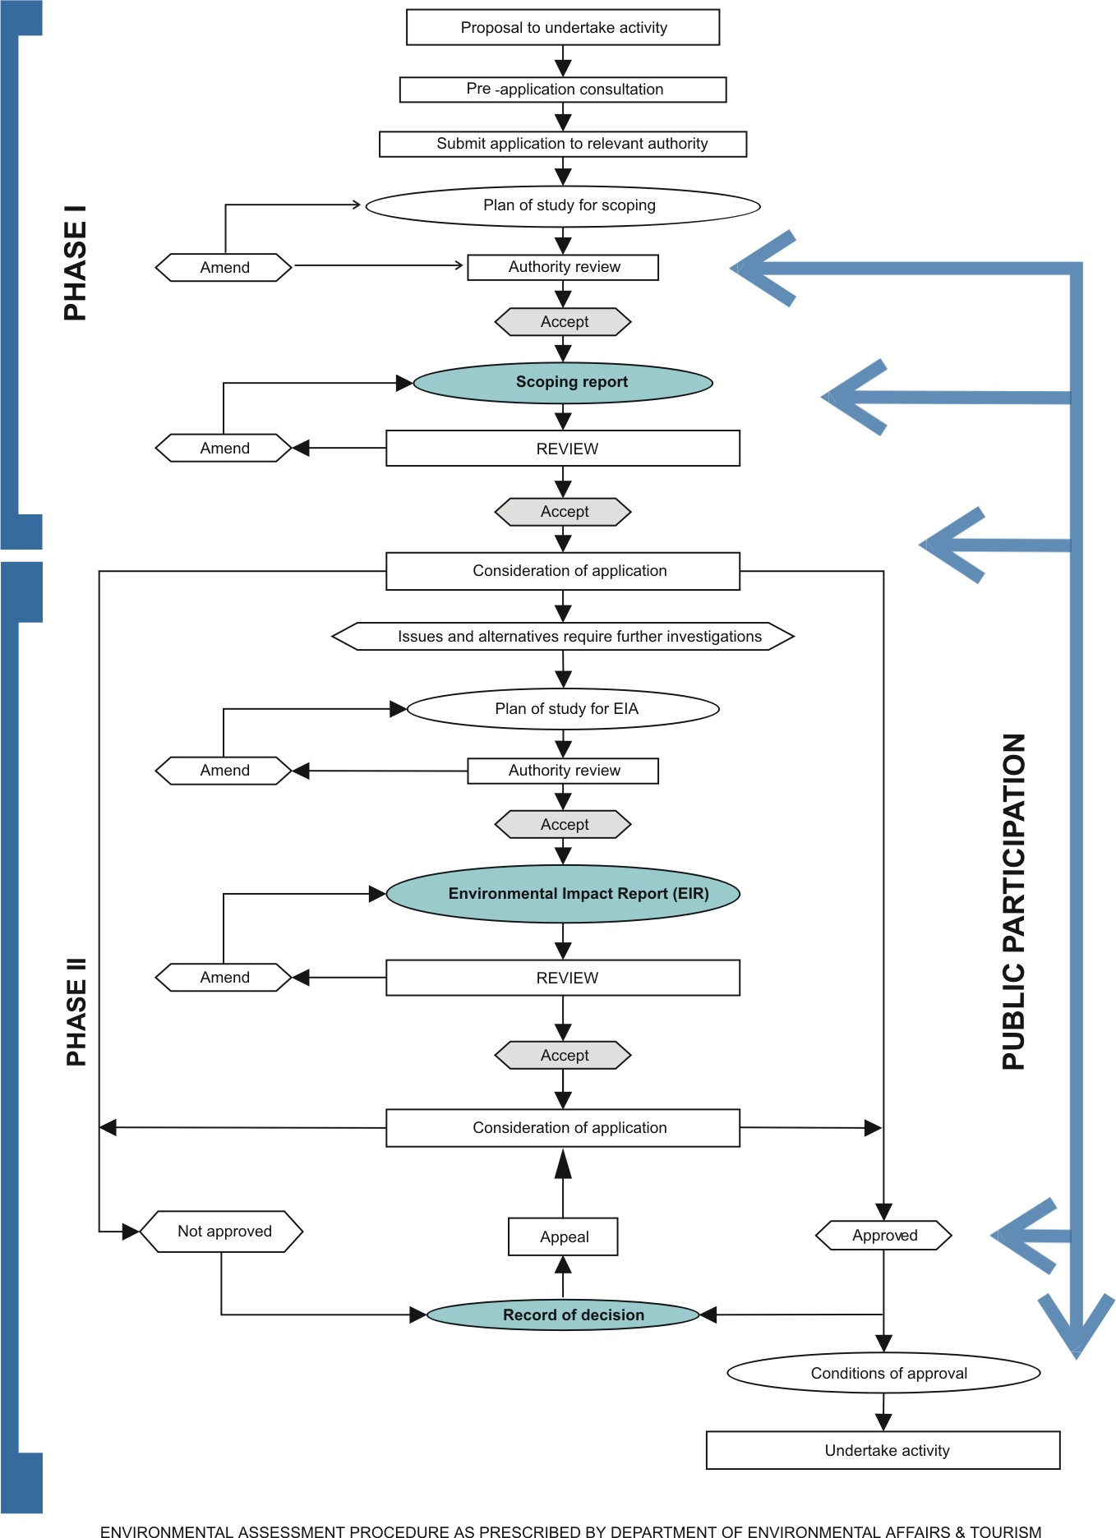

FIGURE 2: THE ENVIRONMENTAL IMPACT ASSESSMENT PROCESS
PUBLIC PARTICIPATION
In order to actively participate, I&APs need to understand the nature and objectives of Public Participation. Ms. Vollmer touched on the following:

WHAT IS PUBLIC PARTICIPATION?
A process leading to informed decision-making through the joint effort of:
- Interested and Affected Parties (I&APs);
- The proponent;
- Technical experts; and
- Authorities.
…who work together to produce better decisions than if they had acted independently (Greyling, 1999).
OBJECTIVES OF PUBLIC PARTICIPATION:
To provide stakeholders with information on:
- The purpose of the proposed project;
- Technical and participatory processes to be followed;
- The way in which the contributions of the I&APs will be incorporated;
- Environmental impacts of the proposed project; and
- for stakeholders to assist in determining issues that should receive attention in the report.

THE PROJECT SPECIFIC PROCESS
THE ESKOM PROCESS:
Ms. Vollmer indicated that Eskom had taken the following actions prior to appointing an independent EIA Consultant:
- The first step in the process was to identify various alternatives to accomplish the said objective; and
- This lead to the creation of a study area
- The appointment of independent Environmental Consultants, whose task it is to assess the feasibility of each alternative in terms of the physical, biological and social environment (the current study), which will result in a decision on which is the most feasible alternative.
- The most feasible alternative will be investigated in greater detail during the EIA phase.
- Finally, Eskom would secure a servitude for the transmission line.
THE ENVIRONMENTAL PROCESS:
Ms. Vollmer explained that PD Naidoo (consultants), in association with Strategic Environmental Focus (SEF) won the tender to conduct the EIA and appointed Afrosearch (Pty) Ltd. to conduct the Public Participation Process for the EIA. To date, the following actions have been taken by the EIA Consultants:
- Project registration with Department of Environmental Affairs and Tourism (DEAT) and the Free State Department of Tourism, Environment and Economic Affairs (DTEEA):
  - 27 February 2003;
- Approval of Plan of Study for Scoping:
  - 12 March 2003; and
- Public participation process:
  - April 2003
    - Focus Group Meetings – 15 and 16 April 2003
    - Open Days and Public Meetings – 23 and 24 April 2003
    - Availability of Draft Scoping Reports for public comment – May 2003
  - BID, newspaper advertisement and letters to I&APs
    - Continual
Before finalising the Scoping Phase, Focus Group Meetings, and a series of Open Days with Public Meetings must still be completed. Thereafter, the Draft Scoping Report would be circulated in the public domain for a period of two weeks for comment. After finalising the Scoping Report, it will be submitted to the relevant authorities for decision-making.
THE ENVIRONMENTAL IMPACT ASSESSMENT (EIA)
Ms. Vollmer informed attendants that a team of specialists were appointed to assist the environmental consultants in conducting the EIA. For this project, the following specialist have been appointed:
- Geo-Technical;
- Soils (Pedologist);
- Bird Specialist (Ornithologist);
- Aquatic;
- Visual Impact;
- Heritage;
- Tourism; and
- Social Impact.
The following issues were to be investigated by the specialists:
- Physical & biological environment:
  - Soils, Geo-Technical Aspects,Topography etc.;
  - Hydrology; and
  - Fauna & Flora.
- Social environment:
  - Social assessment;
  - Tourism; and
  - Heritage Resources.

Ms. Vollmer noted that the following potential impacts have already been identified to date:
- Contamination of surface water;
- Disturbance of riverine habitats;
- Impacts on bird life;
- Increased surface water run-off;
- Increased erosion along river banks;
- Floral disturbance;
- Faunal displacement and disturbance;
- Visual intrusion;
- Health, safety and security risks;
- Impact on land with a historical value and heritage resources; and
- Increased ambient noise levels (during construction only).

She said that the natural pans were highlighted as being particularly sensitive. The pans were unique and had an ecological integrity that needed to be maintained due to:
- Their unique biodiversity brought about by the physical environmental conditions;
- Habitat for a variety of fauna and flora (important for breeding and feeding); and
- The fact that pans are sensitive ecological systems (symbiotic relationships).

3.2 ESKOM CONSTRUCTION PRACTICES
A summary of Ms. Streaton’s presentation follows:
CAPACITY NEEDS
Eskom: Transmission has an existing power line backbone that runs from the ALPHA sub-station (near Standerton) to the BETA sub-station (near Bloemfontein).
Currently the Port Elizabeth area is experiencing rapid growth due to the Coega development. There is 650MW of electricity currently available to the area, but it is anticipated that a further 1 500MW will be needed (1 000MW for the proposed smelter and a further 500MW due to expected new industrial developments). Eskom forecasts a 1.5% natural load growth in the PE region.
The construction of the 400 kV line from Mercury to Persues is part of Eskom’s network strengthening programme. Eskom investigated several options to provide the necessary electricity to the PE region. FIGURE 1 shows the proposed alternative transmission lines, of which one alternative needs to be selected to meet the requirements if the desired development in the PE region took place.

OVERHEAD VS. UNDERGROUND
To construct a 400kV transmission line underground, would require a 60m wide piece of land. Within this servitude, all trees, bushes, buildings and structures would have to be removed and remain so even after construction. This would mean that the land would be sterile as no developments can be undertaken in the servitude.
One of the main problems of an underground power line is cooling. Conductors would have to be either air cooled (with air conditioners) or oil cooled. Cooling of the conductors does not present a problem when power lines are constructed overhead, as they are cooled by the natural flow of air.
An underground power line costs in the region of 20 times more than an overhead power line (R 20 million as opposed to R 1 million per kilometer.)
SERVITUDE RESTRICTIONS
Eskom does not allow people to live within the servitude and tall trees would be removed. Eskom prefer not to have centre pivot irrigation systems within the servitude, although a strategy could be established to accommodate this type of irrigation.
Activities such as grazing and crop planting can continue as before.
GATES
Eskom would identify all places where gates were needed in terms of accessing the servitude. A-grade gates are erected. Eskom does take cognizance of the type of gate required, for instance, if there is a jackal proof fence, a jackal proof gate would be erected.
ACCESS ROADS
Construction activities do not require that an actual road be built adjacent to the power line. The road ‘develops’ as a result of the construction vehicles moving up and down this strip over the construction period.
Access roads are only erected under special circumstances to gain access to the servitude for construction and maintenance purposes. Such instances would be discussed with the landowner.

BUSH CLEARING
The whole servitude area (55m) will not be cleared of vegetation. Construction activities require that a 4m wide strip be cleared in the middle of the servitude for stringing purposes and the area where the foundation for the tower needs to be constructed will be cleared.
In sensitive areas such as valleys, endemic vegetation or by special agreement between a landowner and Eskom vegetation would not be removed. Plants such as Sekelbos, Lantana and Port Jacksons were removed and treated with herbicide.

CAMPS
For a power line of this length (300 – 350 km) it is anticipated that two construction camps would be necessary. Each camp could house about 300 or more construction workers at a given point in time.
The camps are controlled and monitored by the Environmental Officer according to the requirements set out in the Environmental Management Plan (EMP). The EMP typically makes the following recommendations: construction camps have to be fenced, no live animals may be kept, and fires are only allowed in designated areas. Rehabilitation measures that need to be carried out once construction is complete are stated.

ENVIRONMENTAL MANAGEMENT PLANS (EMP) AND THE ENVIRONMENTAL OFFICER
The EMP covered a number of generic aspects with regard to the general conditions relating to the protection of the environment during the construction phase. It may include specific stipulations as requested by each landowner during the negotiation phase. The EMP forms part of the legal contract that Eskom has with the contractor and is therefore enforceable.
An environmental officer would be available throughout the construction phase and all affected landowners would have his/her contact details. In the case of any irregularities, the environmental officer is to be contacted to resolve the matter.
TOWER TYPES
Eskom uses a variety of tower types for the construction of transmission lines. On this line, cross-rope suspension towers would be used for the straight stretches, while self-supporting towers (so-called bend or strain towers) would be used on bends. Eskom tries to keep bends to a minimum, because the strain towers use more steel are therefore far more expensive and are visually more intrusive.
CONSTRUCTION
It is anticipated that construction could take approximately 2 years. Construction is a cyclical process, all the gates are erected first, followed by bush clearing, the digging of foundations, the erection of the towers and finally stringing. The implication of this is that over the two-year construction period landowners would have construction workers on their property intermittently.
Construction equipment is very large. Towers were assembled on site, except in cases where there was not enough space. In sensitive areas construction activities are undertaken mostly by hand (digging of foundations) and helicopters are used to place the towers.
Foundation holes were covered to prevent humans and animals from falling into the holes.
Crop planting can go on as normal. If crops were destroyed during construction, Eskom compensates the farmer according to the market value of the crop.
Vegetation usually re-establishes once construction has been completed, however, additional rehabilitation will be done where necessary.
STRINGING
Stringing is a specialized activity. The conductors need to be kept under tension during the stringing process because they get damaged when they touch the ground. Stringing is usually done by a machine, but could also be done by hand or helicopter.
Storage camps will be established in areas negotiated with the land owners to store various materials such as cable. All construction waste will be removed once the construction of the transmission line is complete.
LABOUR
The construction activities relating to the construction of transmission lines is specialized and therefore skilled labour is required. For this reason very few local labour opportunities exist.
IMPACTS GO BOTH WAYS
The environment also has an impact on the transmission lines. Examples are veld fires, lightning, bird streamers (excretion) and birds flying into the earth wires.
Eskom has done a lot of work on managing the impact of birds on power lines. Bird guards are erected in areas where there are insulator strings and conductors. “Bird flappers” are placed on the line where the ornithologist anticipates that the power lines cross flight paths.
ARCHAEOLOGICAL AND HISTORIC SITES
Once the final alignment for the transmission line has been decided on, the archaeologist and botanist walked the entire area to identify sites of historical importance or ecological sensitivity.

SUB-STATION CONSTRUCTION
Both sub-stations will be upgraded. It should be noted that the property on which the substation occurs is big enough and will not need to be extended.
NEGOTIATION
Eskom does not buy the land, only the rights to convey electricity across the land within the agreed servitude.
An individual contract is negotiated between Eskom and each affected landowner and this results in the signing of an option. Eskom has one year to exercise the option.
An independent valuator assists in the valuation process to ensure that a fair price is obtained by the land owner.
Once Eskom decided to exercise the option, the servitude is registered against the title deeds attached to the property at the deeds office. At that stage the compensation is paid out with interest (the interest will be paid from the time the option contract was entered into, until the servitude is registered.)

4. DISCUSSION
Ms. Ramabima wanted to know if the consultants had received any resistance from the public to date. Ms. Streaton explained that resistance to a transmission line was usual. She stated that the issues mentioned most often were visual impacts (especially in eco-tourism areas); impacts with regard to the construction phase (influx of workers, noise, dust, etc.) and impacts on the birdlife. Construction impacts and the impacts on bird life are usually mitigated (e.g. conditions in the EMP to govern construction, the use of bird flappers and bird guards). For this specific transmission line the public resistance could only be gauged after the first public open days and meetings that were be held on 23 and 24 April 2003.
Ms. Briedenhann noted that salt gathering took place at a number of the pans in the south. She wanted to know what the impact would be on this industry should the line cross a pan(s). Ms. Vollmer stated that the pans would be avoided when selecting the preferred alignment as the pans are sensitive environments.
Ms. Briedenhann noted that heritage sites had to be mapped and suggested that the applicable specialist have a meeting with her department. Ms. Briedenhann emphasized the importance of consulting traditional leaders in the study.
Ms. Mdi wanted to know how many state conservation areas there were within the study area. Ms. Vollmer said that one had been identified in the Boshoff district. Ms. Mdi stated that a lot of research was currently being conducted with regard to certain species. Also, species such as rhinoceros were introduced recently. Ms. Mdi advised that this be followed up and taken note of during the process of further investigations.
Mr. Chinner noted that state land was an intricate matter and that state land had to be identified as soon as possible in order for discussions between Eskom and the Department to start. Mr. Van der Merwe agreed.
Mr. Chinner wanted to know what the Social Impact Assessment (SIA) entailed. Ms. Vollmer explained briefly noting that issues such as the influx of workers from outside the area, the possible spread of STDs, etc. were being investigated. Mr. Chinner noted that the southern Free State area had been identified as being very poor. Poverty alleviation and job creation were therefore extremely important and he urged Eskom to revisit the possibility of local job creation.
Ms. Mdi wanted to know what the projected time frames were that Eskom is planning for this project. Ms. Streaton explained that the construction period for a transmission line of this nature is approximately two years.
Ms. Mdi wanted to know if it was not possible to construct a larger transmission line (765kV) now (while Eskom is constructing anyway) to avoid having to go through this process again. Ms. Streaton explained that this would not be possible since the grid always had to be balanced. Therefore the 765kV lines were only used as ‘backbone’ to the grid, while the 400kV lines were used for the rest.
Ms. Ramabima wanted to know if it was possible to reduce the visual impact by painting the towers green. Ms. Streaton explained that this had been done in areas in Europe where the plants did not change colour. This would however not be practical in South Africa. She noted that the towers and electricity lines dulled over time and became less visible than the towers and lines in the presentation.
Ms. Ramabima wanted to know how Eskom ensures that the contractor complies with the Health and Safety Standards. Ms. Streaton explained that the EMP was strictly enforced by Eskom, but that the contractor was responsible for its own safety standards.

5. THE WAY FORWARD
Ms. Vollmer explained the way forward to be as follows:
- The meeting would be minuted and concerns raised addressed in the Scoping Report;
- The Scoping Report would be made available for public comment in May 2003 for 14 days at libraries, on the internet, and on CD by request;
- Once all I&APs comments have been received within the timeframe, the report will be submitted to the national and provincial environmental departments;
- DEAT (national) issues a Record of Decision for the EIA process to begin;
- The EIA phase will be advertised in the newspaper;
- Further public meetings will be held on 10 – 11 September 2003 to give feedback to I&APs;
- Meetings will be minuted and concerns raised addressed in the EIR;
- The draft EIR will be made available for public comment in September 2003 for 14 days at libraries, on the internet and on CD by request;
- Once all I&AP comments have been received within the timeframe, the report will be submitted to the national and provincial Departments of Environmental Affairs and Tourism;
- A final record of decision will be obtained from DEAT (national). and
- The record of decision will be advertised (anticipated to be in January 2004).

Ms. Vollmer highlighted the following important dates:
Open Days and Public Meetings during the Scoping Phase:
- BULTFONTEIN: 23 April 2003
- BOTHAVILLE: 24 April 2003

Open Days and Public Meetings during the EIA Phase:
- BULTFONTEIN: 10 September 2003
- BOTHAVILLE: 11 September 2003
Ms Vollmer emphasized that any further questions that the I&Aps may have can be forwarded to Marita Oosthuisen before the 30th of April 2003 to:

AFROSEARCH
Marita Oosthuisen
Tel: (+27 12) 362 2908
Fax: (+27 12) 362 2463
E-mail: marita@afrosearch.co.za
Web site: http://www.eskom.co.za/eia
6. CLOSURE
The Chairperson thanked everybody present and said that they could expect a set of minutes for comment within a week.
The meeting adjourned at approximately 15:00.
7. ATTENDANCE REGISTER
The attendance register for the meeting is attached.

NAAM EN VAN  NAME AND SURNAME | ORGANISASIE EN POSISIE  ORGANISATION AND POSITION | TELEFOONNOMMER  TELEPHONE NO. | FAKSIMILE  FAXIMILEE |  | POSADRES  POSTAL ADDRESS | E-POS  E-MAIL
Streaton, Carol (Ms.) | Eskom: Transmission (Public Participation Advisor) | (011) 800-5411 (W)  083 633 1545 (C) |  |  | P. O. Box 1091  JOHANNESBURG, 2000 | carol.streaton@eskom.co.za
Selepe, Patience (Ms.) | Eskom: Transmission (Property Rights Officer) | (011) 800-6172 (W)  082 805 7371 |  |  | P. O. Box 1091  JOHANNESBURG, 2000 | µPatience.Selepe@eskom.co.za§
Van der Merwe, Koos (Mr.) | Eskom: Transmiossion (Land and Rights) | 082 805 7605 (C) |  |  | P. O. Box 1091  JOHANNESBURG, 2000 | µjjvdm@reskom.co.za§  koma@global.co.za
Vollmer, Bernadette (Ms.) | Strategic Environmental Focus | (012) 349-13078 (W) | (012) 349-1229 | A |  | bernadette@sefsa.co.za
Oosthuizen, Marita (Ms.) | Afrosearch | (012) 362-2908 (W)  082 378 4903 (C) | (012) 362-2463 | A | P. O. Box 13540  HATFIELD, 0028 | marita@afrosearch.co.za
Mdi, Nomazizi (Ms.) | DTEEA | (051) 403-3772 (W)  082 717 8877 (H)  082 570 4366 (C) | (051) 403-3412 | A | Private Bag X20801  BLOEMFONTEIN, 9300 | mokoenmj@dteea.fs.gov.za
Ramabima, Grace (Ms.) | DTEEA | (051) 405-5404 (W) | (051) 403-3412 | A | Private Bag X20801  BLOEMFONTEIN, 9300 | N/a
Fourie, Nico (Mr.) | Provincial Museum Service | (051) 447-5478 (W) | (051) 447-7755 | A | Private Bag X 20543  BLOEMFONTEIN, 9300 | wardengun@yahoo.co.uk

NAAM EN VAN  NAME AND SURNAME | ORGANISASIE EN POSISIE  ORGANISATION AND POSITION | TELEFOONNOMMER  TELEPHONE NO. | FAKSIMILE  FAXIMILEE |  | POSADRES  POSTAL ADDRESS | E-POS  E-MAIL
Briedenhann, Myra (Ms.) | Provincial Museum Service: Deputy Director | (051) 447-5478 (W)  082 760 1044 (C) | (051) 447-7755 | A | Private Bag X 20543  BLOEMFONTEIN, 9300 | N/a
Van Zijl, Johan (Mr.) | Curator: Military Museum | (051) 525-2354 (h)  (051) 447-5478 (W) | (051) 447-7755 | A | Private Bag X 20543  BLOEMFONTEIN, 9300 | N/a
Chinner, R. (Mr.) | Department of Public Works, Roads and Transport: Director | (051) 405-4122 (W)  083 455 1399 (C) | (051) 405-5417 | A | Room 1428,  CR Swart Building  Elizabeth Street  Bloemfontein | Ronnie@freetrans.gov.za

