BIRD IMPACT ASSESSMENT REPORT

SYFERKUIL - RAMPHERI 132kV POWER LINE AND ASSOCIATED INFRASTRUCTURE

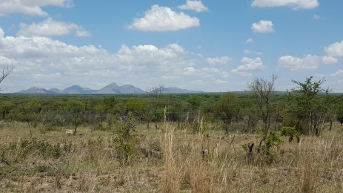
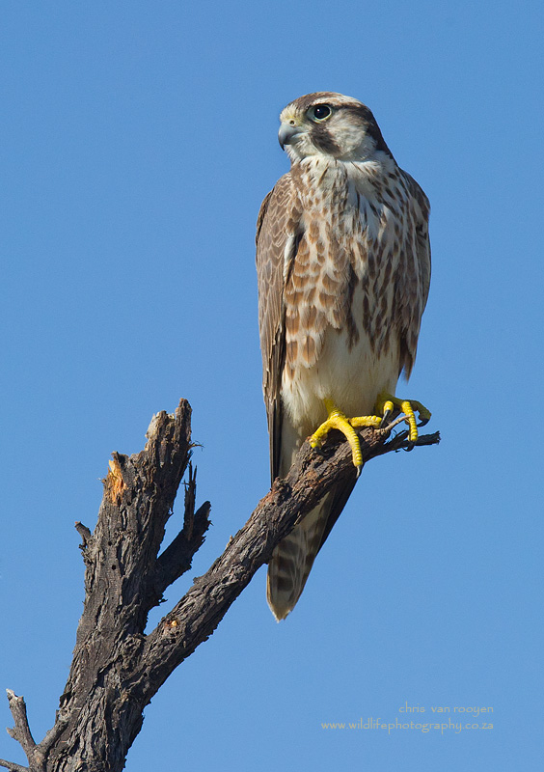
June 2016

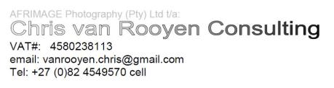

PROFESSIONAL EXPERIENCE

Chris van Rooyen
Chris has 20 years’ experience in the management of wildlife interactions with electricity infrastructure. He was head of the Eskom-Endangered Wildlife Trust (EWT) Strategic Partnership from 1996 to 2007, which has received international acclaim as a model of co-operative management between industry and natural resource conservation. He is an acknowledged global expert in this field and has worked in South Africa, Namibia, Botswana, Lesotho, New Zealand, Texas, New Mexico and Florida. Chris also has extensive project management experience and has received several management awards from Eskom for his work in the Eskom-EWT Strategic Partnership. He is the author of 15 academic papers (some with co-authors), co-author of two book chapters and several research reports. He has been involved as ornithological consultant in numerous power line and wind generation projects. Chris is also co-author of the Best Practice for Avian Monitoring and Impact Mitigation at Wind Development Sites in Southern Africa, which is currently (2016) accepted as the industry standard. Chris also works outside the electricity industry and had done a wide range of bird impact assessment studies associated with various residential and industrial developments.

DECLARATION OF INDEPENDENCE

I, Chris van Rooyen as duly authorised representative of Chris van Rooyen Consulting, and working under the supervision of and in association with Albert Froneman (SACNASP Zoological Science Registration number 400177/09) as stipulated by the Natural Scientific Professions Act 27 of 2003, hereby confirm my independence (as well as that of Chris van Rooyen Consulting) as a specialist and declare that neither I nor Chris van Rooyen Consulting have any interest, be it business, financial, personal or other, in any proposed activity, application or appeal in respect of which Landscape Dynamics Environmental Consultants was appointed as environmental assessment practitioner in terms of the National Environmental Management Act, 1998 (Act No. 107 of 1998), other than fair remuneration for worked performed, specifically in connection with the Environmental Impact Assessment for the proposed Syferkuil-Rampheri 132kV power line and associated infrastructure.

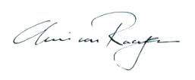

___________________________
Full Name: Chris van Rooyen
Title / Position: Director

EXECUTIVE SUMMARY

Landscape Dynamics Environmental Consultants (Landscape Dymanics) has been appointed by Eskom to undertake an Environmental Impact Assessment for the proposed Syferkuil – Rampheri 132kV power line development.

The project entails the following:

- A 132kV Powerline of approximately 22km from the approved Rampheri Substation to the proposed new Syferkuil Substation, situated next to the existing Syferkuil Substation;
- A Customer Network Centre next to the proposed Rampheri Substation;
- A Customer Network Centre next to the proposed Syferkuil Substation;
- Upgrade of a 2km 33kV Chikadee Thabamoopo - Syferkuil line to a Kingbird Line; and
- Decommissioning of the existing Syferkuil Substation

This project is located within the Polokwane Local Municipality in the Limpopo Province.

In general, the habitat through which the proposed Syferkuil-Rampheri 132kV alignments run is low to moderately sensitive from a potential bird impact perspective. The remaining natural habitat is woodland and is likely to attract a number of Red Data power line sensitive species, but there are also evidence of anthropogenic impacts, which is visible in the disturbed state of the majority of the woodland. This has had a negative impact on avifaunal diversity and abundance and is reflected in the low reporting rates for power line sensitive Red Data species, which may also indicate that levels of disturbance are high. The construction of the proposed power lines will result in various potential impacts on the birds occurring in the vicinity of the new infrastructure, with impacts ranging from low to moderate. The proposed power line poses a moderate collision risk which can be reduced to low through the application of mitigation measures. The electrocution risk is assessed as low, due to the proposed structure type, and can be reduced to very low with appropriate mitigation. The habitat transformation and disturbance associated with the construction and decommissioning of the power line, Syferkuil substation and CNC, and the Rampheri CNC should have a moderate impact, which could be reduced to low with appropriate mitigation.

The project can proceed subject to the implementation of the following recommendations:

- An avifaunal walk through of the final power line route should be conducted prior to construction, to identify any Red Data species that may be breeding on the site or within the immediate surrounds and to ensure that any impacts likely to affect Red Data breeding species (if any) are adequately managed. In addition, the walk-through should be used to identify the exact sections of power line requiring collision mitigation.
- The correct bird-friendly pole structure must be utilized to avoid electrocution (APPENDIX 2).
- In addition to this, the normal suite of environmental good practices should be applied, such as ensuring strict control of staff, vehicles and machinery on site and limiting the creation of new roads as far as possible.

The three powerline alternatives are very similar in terms of envisaged impacts on avifauna. All of them cross through essentially the same mosaic of relic areas of savanna, large areas of fallow lands, subsistence agriculture and urban development. No preferred alternative can therefore be identified, as all three alternatives are acceptable options from a bird impact assessment perspective.

------------------------------------------------------

Table of Contents
1 INTRODUCTION 6
2 BACKGROUND AND BRIEF 9
3 STUDY APPROACH 9
3.1 Sources of information 9
3.2 Limitations & assumptions 11
4. STUDY AREA 11
4.1 Important Bird Areas 11
4.2 Primary vegetation divisions (biomes) 11
4.3 Description of bird habitat classes 11
4.3.1 Savanna 11
4.3.2 Rivers 12
4.3.3 Dams 12
4.3.4 Agricultural clearings and old lands 12
4.3.6 Mountains and koppies 13
4.4 Power line sensitive species occurring in the study area 13
5. DESCRIPTION OF EXPECTED IMPACTS 17
5.1 Electrocutions 17
5.2 Collisions 17
5.3 Displacement due to habitat destruction and disturbance 20
6 ASSESSMENT OF EXPECTED IMPACTS 21
6.1 Assessment criteria 21
6.2 Assessment tables 24
6.2.1 Construction phase 24
6.2.2 Operational phase 25
7.2.3 De-commissioning phase 27
7 SELECTION OF PREFERRED ALTERNATIVE 27
8 CONCLUSIONS 27
9 REFERENCES 28
APPENDIX 1: BIRD HABITATS 31
APPENDIX 2: STRUCTURE TYPES 35

INTRODUCTION
Landscape Dynamics Environmental Consultants (Landscape Dynamics) has been appointed by Eskom to undertake an Environmental Impact Assessment for the proposed Syferkuil – Rampheri 132kV power line development.
The project entails the following:
  - A 132kV Powerline of approximately 22km from the approved Rampheri Substation to the proposed new Syferkuil Substation, situated next to the existing Syferkuil Substation;
- A Customer Network Centre next to the proposed Rampheri Substation;
- A Customer Network Centre next to the proposed Syferkuil Substation;
- Upgrade of a 2km 33kV Chikadee Thabamoopo - Syferkuil line to a Kingbird Line; and
- Decommissioning of the existing Syferkuil Substation
This project is located within the Polokwane Local Municipality in the Limpopo Province.
Landscape Dynamics has appointed Chris van Rooyen Consulting to compile a specialist avifaunal assessment report (based on a desktop review and a one-day site visit, conducted on 11 May 2016) detailing the sensitive bird habitats within the study area and the potential bird related impacts associated with the proposed new sub-transmission line and associated infrastructure.

See Figures 1 and 2 below for maps showing the location of the project, the two corridor alternatives and habitat assessment survey points.

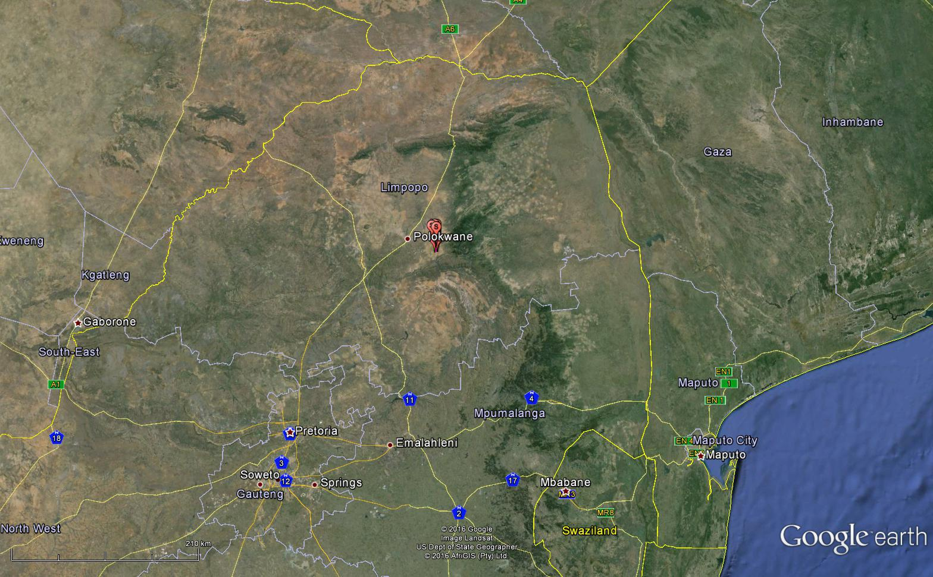
Figure 1: Regional map showing the approximate location of the study area

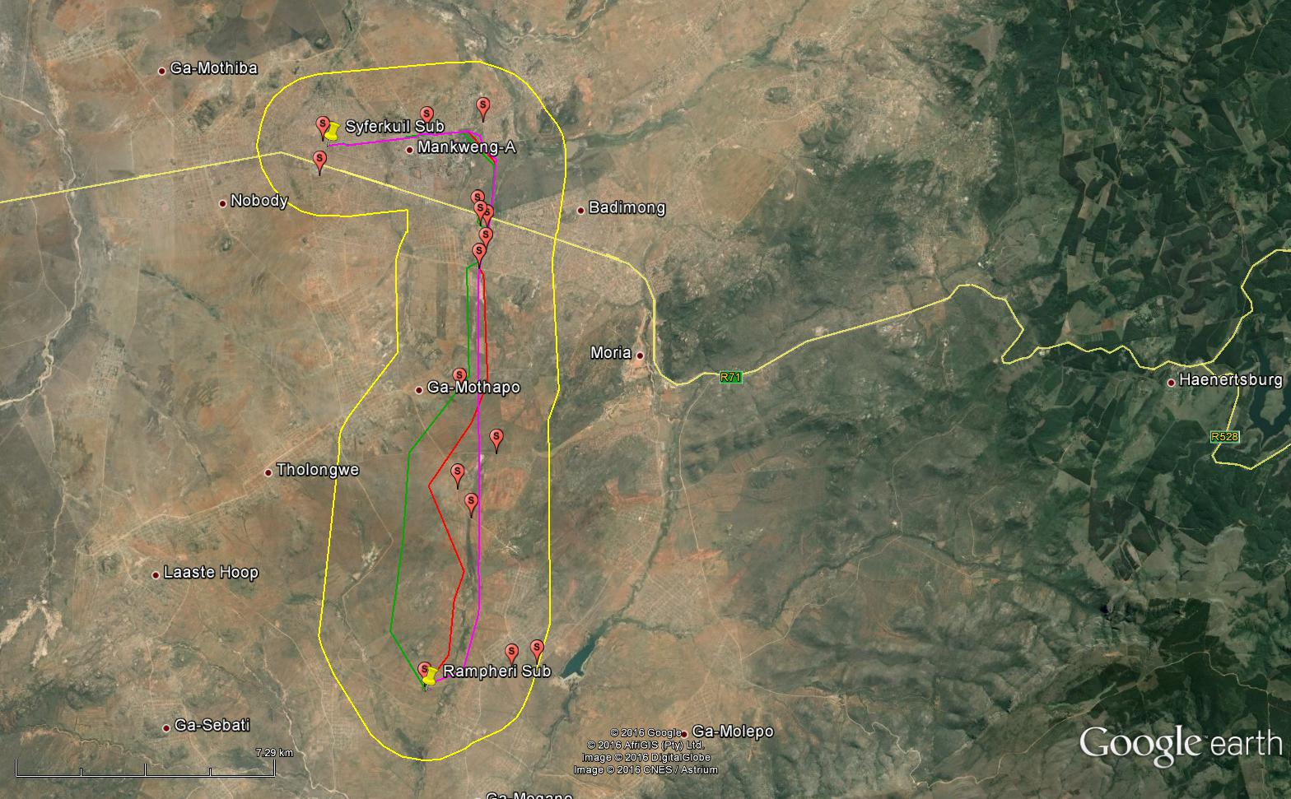

Figure 2: Close-up view of the study area and proposed alignments.
Alternative 1 = purple line. Alternative 2 = green line. Preferred alternative = red line. 2km buffer (study area) = yellow line. Habitat Assessment Survey Points = red placemarks

BACKGROUND AND BRIEF

The terms of reference for this bird impact assessment study are as follows:

- Describe the affected environment;
- Indicate how birdlife will be affected;
- Discuss gaps in baseline data;
- Data and assess the expected impacts; and
- Provide recommendations for mitigating measures.

STUDY APPROACH

3.1 Sources of information

The study made use of the following data sources:

- Bird distribution data of the South African Bird Atlas 2 (SABAP 2) was obtained from the Animal Demography Unit of the University of Cape Town, as a means to ascertain which species occur within the broader area i.e. within a block consisting of nine pentad grid cells within which the study area is situated. A pentad grid cell covers 5 minutes of latitude by 5 minutes of longitude (5'× 5'). Each pentad is approximately 8 × 7.6 km. Between 2007 and 2015, a total of 35 full protocol cards (i.e. 35 bird surveys lasting a minimum of two hours each, or longer) have been completed for the study area and its immediate surrounds (see Figure 3 below).
- The Important Bird Areas project data was consulted to get an overview of important bird areas (IBAs) and species diversity in the study area (Marnewick et al. 2015).
- The power line bird mortality incident database of the Endangered Wildlife Trust (1996 to 2007) was consulted to determine which of the species occurring in the study area are typically impacted upon by power lines (Jenkins et al. 2010).
- Data on vegetation types in the study area was obtained from the Vegetation Map of South Africa, (Mucina & Rutherford 2006).
- The conservation status of all species considered likely to occur in the area was determined as per the most recent iteration of the South African Red Data for birds (Taylor 2015), and the most recent and comprehensive summary of southern African bird biology (Hockey et al. 2005).
- Personal observations, especially experience from other projects which the author worked on in the Limpopo Province since 1996, have also been used to supplement the data that is available from SABAP2, and has been used extensively in forming a professional opinion of likely bird/habitat associations.
- The location of Cape Vulture colonies and vulture restaurants in Limpopo was obtained from Kerri Wolter at Vulpro (Wolter 2015 pers. comm).
- A field visit to the study area was conducted on 11 May 2015 to form a first-hand impression of the micro-habitat on site. This information, together with the SABAP2 data was used to compile a comprehensive Data of species that could occur in the study area.

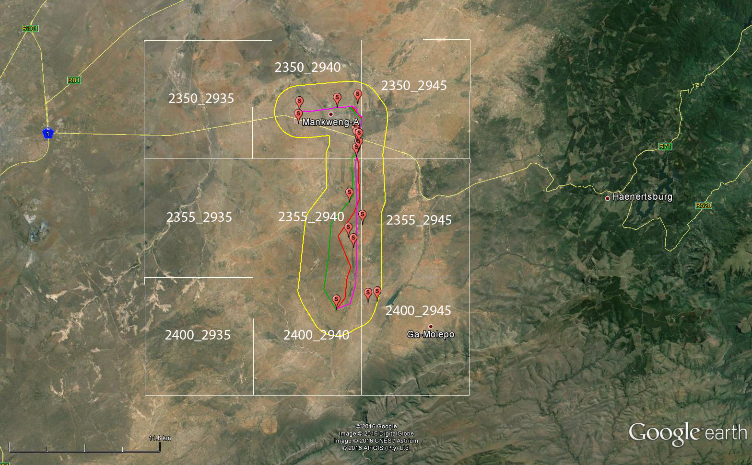

Figure 3: The SABAP2 pentads within which the study area is located.

3.2 Limitations & assumptions

This study made the following assumptions:

- The SABAP2 data is regarded as a fairly comprehensive record of the avifauna due to the substantial number of full protocol data cards (n = 35) which have been completed to date for the area.
- Predictions in this study are based on experience of these and similar species in different parts of South Africa. Bird behaviour can never be entirely reduced to formulas that will hold true under all circumstances; therefore, professional judgment played an important role in this assessment. It should also be noted that the impact of power lines on birds has been well researched with a robust body of published research stretching over thirty years.
- The study area was defined as a 2km buffer around the proposed alignments (see Figure 2).

4. STUDY AREA

4.1 Important Bird Areas

The study area does not overlap with any Important Bird Areas (IBAs). The closest IBA is the Wolkberg Forest Belt IBA (SA SA005) which is located 4km to the east of the proposed Rampheri substation (Marnewick et al. 2015). Although this IBA is located within close proximity (in bird terms – particularly for wide ranging species) to the study area, the proposed development should not have any direct impact on the Wolkberg Forest Belt IBA or the species that this area supports.
SA023

4.2 Primary vegetation divisions (biomes)

The study area extends over a single primary vegetation division, namely savanna (woodland) (Mucina & Rutherford 2006). It is generally accepted that vegetation structure, rather than the actual plant species, influences bird species distribution and abundance (Harrison et al. 1997). From an avifaunal perspective, the Atlas of southern African Birds (SABAP1) recognises six primary vegetation divisions or biomes within South Africa, namely (1) Fynbos (2) Succulent Karoo (3) Nama Karoo (4) Grassland (5) Savanna and (6) Forest (Harrison et al. 1997). These vegetation descriptions do not focus on lists of plant species, but rather on factors which are relevant to bird distribution. The criteria used by the SABAP 1 authors to amalgamate botanically defined vegetation units, or to keep them separate were (1) the existence of clear differences in vegetation structure, likely to be relevant to birds, and (2) the results of published community studies on bird/vegetation associations.

4.3 Description of bird habitat classes

The following bird habitat classes were recorded in the study area (vegetation descriptions based largely on Harrison et al. 1997 and Mucina & Rutherford 2006):

4.3.1 Savanna
The study area is situated in the savanna biome and the natural woodland consists of mainly of Polokwane Plateau Bushveld (Muchina & Rutherford 2006). Polokwane Plateau Bushveld is characterised by open savannah dominated by Themeda grass and scattered Vachellia tortilis and Vachellia rehmanniana trees, and is perched on an elevated plateau at an average height of 1300m above sea level. The natural woodland in the study area has been disturbed. Evidence of bush clearing and removal of trees is clearly visible in some areas, and evidence of grazing pressure is evident in the depleted state of the grass layer and dense bush encroachment in places, especially in the immediate vicinity of towns and settlements. Large sections of the study area have been completely transformed by human settlement. Very little undisturbed woodland remains, but a few relic patches of good quality woodland exist in some areas, particularly on koppies. The woodland areas are utilised for live-stock grazing.

SABAP 2 reporting rates for large power line sensitive Red Data avifauna potentially occurring in woodland habitat in the study area are low (see Table 4-1). Many species which would be expected to occur in undisturbed woodland of this nature, especially large raptors, is entirely absent from the SABAP 2 dataset, indicating that human activity has impacted on the habitat and that levels of disturbance are high. Red Data species that could potentially be found in this habitat in the study area are Lanner Falcon, European Roller, White-bellied Korhaan, Cape Vulture, White-backed Vulture, Secretarybird, Martial Eagle and Short-clawed Lark.

4.3.2 Rivers
The study area does not contain any major rivers, only a few ephemeral drainage lines, of which the Pourivier in the north-east is the largest. Drainage lines are important habitat for birds in that they act as corridors of microhabitat for waterbirds and woodland species. These ephemeral rivers generally only flow for short periods in the rainy season, but pools of water can persist for many months and aquatic organisms that occur in those pools could provide potential sources of food for various species, including the Red Data Yellow-billed Stork and Marabou Stork. The pools in the drainage lines could attract Red Data Greater Painted-snipe as well as many other non-threatened waterbirds, and the surrounding riverine woodland, which often contain some of the last remaining large trees, could support many non-Red Data woodland species.

Dams
Many thousands of earthen and other dams exist in the southern African landscape. Whilst dams have altered flow patterns of streams and rivers, and affected many bird species detrimentally, a number of species have benefited from their construction. The construction of these dams has probably resulted in a range expansion for many water bird species that were formerly restricted to areas of higher rainfall. Man-made impoundments, although artificial in nature, can be very important for a variety of birds, particularly water birds. Apart from the water quality, the structure of the dam, and specifically the margins and the associated shoreline and vegetation, plays a big role in determining the species that will be attracted to the dam. Non-Red Data species in the study area that could use dams and dam edges include Red-knobbed Coot Fulica cristata, Black-headed Heron Ardea melanocephala, Red-billed Teal Anas erythrorhyncha White-faced Duck Dendrocygna viduata, Yellow-billed Duck Anas undulata, Blacksmith Lapwing Vanellus armatus, African Sacred Ibis Threskiornis aethiopicus and Egyptian Goose Alopochen aegyptiaca. Red Data species recorded in the study area by SABAP 2 that could potentially be attracted to dams include Yellow-billed Stork, Maccoa Duck, Marabou Stork, Greater Flamingo and Abdim’s Stork. A couple of small to medium sized dams were observed are located in the study areas.

4.3.4 Agricultural clearings and old lands
The tilling of soil is one of the most drastic and irrevocable transformations brought on the environment. It completely destroys the structure and species composition of the natural vegetation, either temporarily or permanently. However, arable or cultivated land may represent a significant feeding area for many bird species in any landscape for the following reasons: through opening up the soil surface, land preparation makes many insects, seeds, bulbs and other food sources suddenly accessible to birds and other predators; the crop or pasture plants cultivated are often themselves fed on by birds, or attract insects which are in turn fed on by birds; during the dry season arable lands often represent the only green or attractive food sources in an otherwise dry landscape. The southern part of the study area contains many subsistence agricultural lands and old agricultural clearings.

In general, agricultural areas are of lesser importance for the majority of Red Data species recorded in the study area, compared to the other avifaunal habitats (i.e. woodland, rivers and dams). The Red Data species that are most likely to utilise agricultural lands and old clearings in the study area are the Abdim’s Stork, White-bellied Korhaan, Short-clawed Lark and occasionally Southern Bald Ibis. The clearings, including those areas of abandoned old lands could also be utilised by Secretarybird but the species has been reduced to almost vagrant status in the study area. Other large, non-threatened power line sensitive species such as Spur-winged Goose Plectropteris gabensis, Egyptian Goose and Hadeda Ibis Bostrychia hagedash may also use freshly agricultural areas in the study area to feed in.

4.3.5 Mountains and koppies
The Wolkberg Mountains are located just outside the study area, to the south and east. The Wolkberg Mountains provides foraging, roosting and breeding habitat to a number of Red Data species, including the Red Data Southern Bald Ibis, Martial Eagle and the nationally Vulnerable African Crowned Eagle Stephanoaetus coronatus. While it is unlikely that the latter two Red Data species would be regularly attracted to the study area, given the highly disturbed state of the natural habitat, occasional forays into the study area by Martial Eagle and Southern Bald Ibis may well happen.

There are several koppies in the study area. The koppies are potentially suitable roosting and breeding habitat for the Red Data Lanner Falcon. Lanner Falcon could also be attracted to poultry in the settlements.

See APPENDIX 1 for a photographic record of the bird habitats in the study area.

4.4 Power line sensitive species occurring in the study area
A total of fifteen Red Data species could potentially occur in the study area (Table 4-1). For each species, the potential for occurring in a specific habitat class is indicated, as well as the type of impact that could potentially affect the species in the study area.

Table 4-1: Red Data species that could potentially occur in the study area.

CR = Critically endangered EN = Endangered VU = Vulnerable NT = Near-threatened

Name | Conservation status  (Taylor et al., 2015) | Consolidated reporting rate in the 9 pentads % | Rivers and dams | Koppies | Savanna | Agricultural clearings | Collisions | Electrocutions | Displacement through disturbance | Displacement through habitat destruction
Duck, Maccoa  Oxyura maccoa | NT | 2.86 | x | - | - | - | x | - | - | -
Eagle, Martial  Polemaetus bellicosus | EN | 0 | - | - | x | - | x | - | - | -
Falcon, Lanner  Falco biarmicus | VU | 11.43 | - | x | x | x | x | - | - | -
Korhaan, White-bellied  Eupodotis senegalensis | VU | 11.43 | - | - | x | x | x | - | - | -
Lark, Short-clawed  Certhilauda chuana | NT | 42.86 | - | - | x | x | - | - | - | -
Roller, European  Coracias garrulus | NT | 2.86 | - | - | x | x | - | - | - | -
Name | Conservation status  (Taylor et al., 2015) | Consolidated reporting rate in the 9 pentads % | Rivers and dams | Koppies | Savanna | Agricultural clearings | Collisions | Electrocutions | Displacement through disturbance | Displacement through habitat destruction
Secretarybird  Sagittarius serpentarius | VU | 2.86 | - | - | x | x | x | - | - | -
Stork, Abdim’s  Ciconia abdimii | NT | 8.57 | x | - | x | x | x | - | - | -
Stork, Yellow-billed  Mycteria ibis | EN | 2.86 | x | - | - | - | x | - | - | -
Ibis, Southern Bald  Geronticus calvus | VU | 0 | - | - | - | x | x | - | - | -
Painted-snipe, Greater  Rostratula benghalensis | NT | 2.86 | x | - | - | - | - | - | - | -
Marabou Stork  Leptoptilos crumeniferus | NT | 2.86 | x | - | x | - | x | - | - | -
Name | Conservation status  (Taylor et al. 2015) | Consolidated reporting rate in the 9 pentads % | Rivers and dams | Koppies | Savanna | Agricultural clearings | Collisions | Electrocutions | Displacement through disturbance | Displacement through habitat destruction
Greater Flamingo  Phoenicopterus ruber | NT | 2.86 | x | -- |  | - | x | - | - | -
Vulture, Cape  Gyps coprotheres | EN | 14.29 | - | - | x | - | x | x | - | -
Vulture, White-backed  Gyps africanus | CR | 11.43 | - | - | x | - | x | x | - | -

5. DESCRIPTION OF EXPECTED IMPACTS

Because of their size and prominence, electrical infrastructure constitutes an important interface between wildlife and man. Negative interactions between wildlife and electricity structures take many forms, but two common problems in southern Africa are electrocution of birds (and other animals) and birds colliding with power lines. (Ledger and Annegarn 1981; Ledger 1983; Ledger 1984; Hobbs and Ledger 1986a; Hobbs and Ledger 1986b; Ledger, Hobbs and Smith, 1992; Verdoorn 1996; Kruger and Van Rooyen 1998; Van Rooyen 1998; Kruger 1999; Van Rooyen 1999; Van Rooyen 2000; Anderson 2001; Shaw 2013).

5.1 Electrocutions

Electrocution refers to the scenario where a bird is perched or attempts to perch on the electrical structure and causes an electrical short circuit by physically bridging the air gap between live components and/or live and earthed components (van Rooyen 2004). The electrocution risk is largely determined by the pole/tower design. The tower design that has been proposed for this project is the steel monopole (see APPENDIX 2).

Clearance between phases on the same side of the 132kV pole structure is approximately 2.2m for this type of design, and the clearance on strain structures is 1.8m. The length of the stand-off insulators is approximately 1.6m. This clearance should be sufficient to reduce the risk of phase – phase electrocutions of birds on the towers to negligible for all species except vultures. If vultures attempt to perch on the stand-off insulators, they are potentially able to touch both the conductor and the earthed pole simultaneously potentially resulting in a phase – earth electrocution. This is particularly likely when more than one bird attempts to sit on the same pole, which may happen with vultures. Vultures are unlikely to occur regularly within the study area, but sporadic occurrence cannot be ruled out. The closest Cape Vulture colony (Moletje) is approximately 40km away, and the closest vulture restaurant (Polokwane Nature Reserve) is about 25km away. The average foraging radius for Cape Vultures around colonies is approximately 40km, but birds may on occasion forage far wider (Boshoff & Minnie 2011). The only envisaged high risk scenario would be when a carcass becomes available within a few hundred metres of the line, attracting White-backed Vultures and Cape Vultures which may cluster on a few poles. This is likely to be an irregular event in the study area.

In summary it is concluded that the risk of electrocution posed to avifauna by the steel monopole design is likely to be LOW and restricted to vultures, but it cannot be ruled out entirely.

Electrocutions in the proposed Syferkuil substation yard is possible, but should not affect the more sensitive Red Data bird species as these species are unlikely to use the infrastructure within the substation yard for perching or roosting, given the location of the proposed substation in a densely populated urban area. The highly disturbed woodland at the Rampheri Substation is also unlikely to attract Red Data species on a regular basis. The risk of electrocution within the substation yards is therefore evaluated to be LOW.

5.2 Collisions

Collisions are probably the biggest single threat posed by transmission lines to birds in southern Africa (van Rooyen 2004; Shaw 2013). Most heavily impacted upon are bustards, storks, cranes and various species of waterbirds. These species are mostly heavy-bodied birds with limited manoeuvrability, which makes it difficult for them to take the necessary evasive action to avoid colliding with power lines (van Rooyen 2004; Anderson 2001; Shaw 2013).

In a recent PhD study, Shaw (2013) provides a concise summary of the phenomenon of avian collisions with power lines:

“The collision risk posed by power lines is complex and problems are often localised. While any bird flying near a power line is at risk of collision, this risk varies greatly between different groups of birds, and depends on the interplay of a wide range of factors (APLIC 1994). Bevanger (1994) described these factors in four main groups – biological, topographical, meteorological and technical. Birds at highest risk are those that are both susceptible to collisions and frequently exposed to power lines, with waterbirds, gamebirds, rails, cranes and bustards usually the most numerous reported victims (Bevanger 1998, Rubolini et al. 2005, Jenkins et al. 2010).

The proliferation of man-made structures in the landscape is relatively recent, and birds are not evolved to avoid them. Body size and morphology are key predictive factors of collision risk, with large-bodied birds with high wing loadings (the ratio of body weight to wing area) most at risk (Bevanger 1998, Janss 2000). These birds must fly fast to remain airborne, and do not have sufficient manoeuvrability to avoid unexpected obstacles. Vision is another key biological factor, with many collision-prone birds principally using lateral vision to navigate in flight, when it is the low-resolution and often restricted, forward vision that is useful to detect obstacles (Martin & Shaw 2010, Martin 2011, Martin et al. 2012). Behaviour is important, with birds flying in flocks, at low levels and in crepuscular or nocturnal conditions at higher risk of collision (Bevanger 1994). Experience affects risk, with migratory and nomadic species that spend much of their time in unfamiliar locations also expected to collide more often (Anderson 1978, Anderson 2002). Juvenile birds have often been reported as being more collision-prone than adults (e.g. Brown et al. 1987, Henderson et al. 1996).

Topography and weather conditions affect how birds use the landscape. Power lines in sensitive bird areas (e.g. those that separate feeding and roosting areas, or cross flyways) can be very dangerous (APLIC 1994, Bevanger 1994). Lines crossing the prevailing wind conditions can pose a problem for large birds that use the wind to aid take-off and landing (Bevanger 1994). Inclement weather can disorient birds and reduce their flight altitude, and strong winds can result in birds colliding with power lines that they can see but do not have enough flight control to avoid (Brown et al. 1987, APLIC 1994).

The technical aspects of power line design and siting also play a big part in collision risk. Grouping similar power lines on a common servitude, or locating them along other features such as tree lines, are both approaches thought to reduce risk (Bevanger 1994). In general, low lines with short span lengths (i.e. the distance between two adjacent pylons) and flat conductor configurations are thought to be the least dangerous (Bevanger 1994, Jenkins et al. 2010). On many higher voltage lines, there is a thin earth (or ground) wire above the conductors, protecting the system from lightning strikes. Earth wires are widely accepted to cause the majority of collisions on power lines with this configuration because they are difficult to see, and birds flaring to avoid hitting the conductors often put themselves directly in the path of these wires (Brown et al. 1987, Faanes 1987, Bevanger 1994).”

As mentioned by Shaw (2013) in the extract above, several factors are thought to influence avian collisions, including the manoeuvrability of the bird, topography, weather conditions and power line configuration. An important additional factor that previously has received little attention is the visual capacity of birds; i.e. whether they are able to see obstacles such as power lines, and whether they are looking ahead to see obstacles with enough time to avoid a collision. In addition to helping explain the susceptibility of some species to collision, this factor is essential to planning effective mitigation measures. Recent research provides the first evidence that birds can render themselves blind in the direction of travel during flight through voluntary head movements (Martin & Shaw 2010). Visual fields were determined in three bird species representative of families known to be subject to high levels of mortality associated with power lines i.e. Kori Bustards, Blue Cranes and White Storks. In all species the frontal visual fields showed narrow and vertically long binocular fields typical of birds that take food items directly in the bill under visual guidance. However, these species differed markedly in the vertical extent of their binocular fields and in the extent of the blind areas which project above and below the binocular fields in the forward facing hemisphere. The importance of these blind areas is that when in flight, head movements in the vertical plane (pitching the head to look downwards) will render the bird blind in the direction of travel. Such movements may frequently occur when birds are scanning below them (for foraging or roost sites, or for conspecifics). In bustards and cranes pitch movements of only 25° and 35° respectively are sufficient to render the birds blind in the direction of travel; in storks head movements of 55° are necessary. That flying birds can render themselves blind in the direction of travel has not been previously recognised and has important implications for the effective mitigation of collisions with human artefacts including wind turbines and power lines. These findings have applicability to species outside of these families especially raptors (Accipitridae) which are known to have small binocular fields and large blind areas similar to those of bustards and cranes, and are also known to be vulnerable to power line collisions.

Thus visual field topographies which have evolved primarily to meet visual challenges associated with foraging may render certain bird species particularly vulnerable to collisions with human artefacts, such as power lines and wind turbines that extend into the otherwise open airspace above their preferred habitats. For these species placing devices upon power lines to render them more visible may have limited success since no matter what the device the birds may not see them. It may be that in certain situations it may be necessary to distract birds away from the obstacles, or encourage them to land nearby (for example by the use of decoy models of conspecifics, or the provision of sites attractive for roosting) since increased marking of the obstacle cannot be guaranteed to render it visible if the visual field configuration prevents it being detected. Perhaps most importantly, the results indicate that collision mitigation may need to vary substantially for different collision prone species, taking account of species specific behaviours, habitat and foraging preferences, since an effective all-purpose marking device is probably not reaDataic if some birds do not see the obstacle at all (Martin & Shaw 2010).

Despite speculation that line marking might be ineffective for some species due to differences in visual fields and behaviour, or have only a small reduction in mortality in certain situations for certain species, particularly bustards (Martin & Shaw 2010; Barrientos et al. 2012; Shaw 2013), it is generally accepted that marking a line with PVC spiral type Bird Flight Diverters (BFDs) can reduce the collision mortality rates (Sporer et al. 2013; Barrientos et al. 2012, Alonso & Alonso 1999; Koops & De Jong 1982). Regardless of statistical significance, a slight mortality reduction may be very biologically relevant in areas, species or populations of high conservation concern (e.g. Ludwig’s Bustard) (Barrientos et al. 2012). Beaulaurier (1981) summarised the results of 17 studies that involved the marking of earth wires and found an average reduction in mortality of 45%. A recent study reviewed the results of 15 wire marking experiments in which transmission or distribution wires were marked to examine the effectiveness of flight diverters in reducing bird mortality. The presence of flight diverters was associated with a decrease in bird collisions. At unmarked lines, there were 0.21 deaths/1000 birds (n = 339,830) that flew among lines or over lines. At marked lines, the mortality rate was 78% lower (n = 1,060,746) (Barrientos et al. 2011). Koops and De Jong (1982) found that the spacing of the BFDs were critical in reducing the mortality rates - mortality rates are reduced up to 86% with a spacing of 5 metres, whereas using the same devices at 10 metre intervals only reduces the mortality by 57%. Line markers should be as large as possible, and highly contrasting with the background. Colour is probably less important, as during the day the background will be brighter than the obstacle with the reverse true at lower light levels (e.g. at twilight, or during overcast conditions). Black and white interspersed patterns are likely to maximise the probability of detection (Martin et al. 2010).

A potential impact of the proposed 132kV sub-transmission line is collisions with the earth wire of the proposed lines. Quantifying this impact in terms of the likely number of birds that will be impacted, is very difficult because such a huge number of variables play a role in determining the risk, for example weather, rainfall, wind, age, flocking behaviour, power line height, light conditions, topography, population density and so forth. However, from incidental record keeping by the Endangered Wildlife Trust, it is possible to give a measure of what species are likely to be impacted upon (see Figure 5 below - Jenkins et al. 2010). This only gives a measure of the general susceptibility of the species to power line collisions, and not an absolute measurement for any specific line.

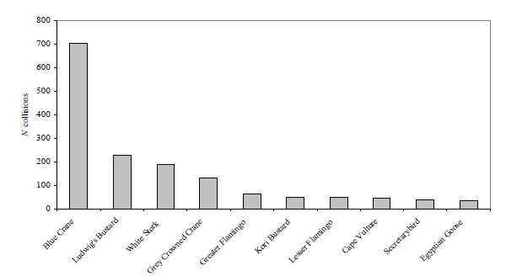
Figure 5: The top ten collision prone bird species in South Africa, in terms of reported incidents contained in the Eskom/EWT Strategic Partnership central incident register 1996 - 2008 (Jenkins et al. 2010)

In the present instance, potential candidates for collision mortality in the woodland habitat on the proposed power line are White-bellied Korhaan, Lanner Falcon, Secretarybird, Cape Vulture, White-backed Vulture, Marabou Stork, Abdim’s Stork and Martial Eagle. Collisions are likely to be few and far between, as there are no specific areas where one would expect a concentration of birds in the remaining woodland habitat. Vultures would be most at risk of collision if they descend to a carcass near the line. This is not likely to be a regular event, given the fact that the occurrence of vultures is likely to be the exception rather than the rule.

Abdim’s Stork will be at risk in agricultural clearings, especially on freshly ploughed fields. White-bellied Korhaan, Secretarybird and Southern Bald Ibis could also forage in old agricultural clearings, where they might be exposed to collision risk.

There is a potential collision risk associated with ephemeral drainage lines where it is expected that waterbirds could commute up and down the drainage line when it is flowing or when it contains large pools of standing water. Red Data species that could be impacted in this manner are Yellow-billed Stork and Marabou Stork as well as many other non-threatened waterbirds. Dams likewise could attract many non-Red Data waterbird species, and Red Data species such as Yellow-billed Stork, Marabou Stork, Greater Flamingo, Maccoa Duck and Abdim’s Stork. However, there are relatively few ephemeral drainage lines and dams in the study area, therefore the risk is likely to be limited.

In summary, the risk of collision posed to Red Data avifauna by the proposed power line is likely to be of MEDIUM significance. With mitigation, this risk could be reduced to LOW.

5.3 Displacement due to habitat destruction and disturbance

During the construction phase and maintenance of power lines and associated infrastructure, some habitat destruction and transformation inevitably takes place. Servitudes have to be cleared of excess vegetation at regular intervals in order to allow access to the line for maintenance, to prevent vegetation from intruding into the legally prescribed clearance gap between the ground and the conductors and to minimize the risk of fire under the line, which can result in electrical flashovers. These activities have an impact on birds breeding, foraging and roosting in or in close proximity of the servitude through transformation of habitat, which could result in temporary or permanent displacement.

In the present instance, the risk of displacement of Red Data species due to habitat transformation is likely to be fairly limited given the low reporting rate for Red Data species in the study area. The biggest potential impact would be the removal of large trees that could potentially serve as nesting substrate for large Red Data raptors such as Martial Eagle (and many other non-threatened avifauna), although again it is noted that reporting rates for large raptors are very low, and that most large trees in the study area have been removed long ago for firewood. Furthermore, the high levels of disturbance and significant habitat transformation make it unlikely that large raptors will breed in the study area. The biggest potential impact is likely to be where riparian vegetation needs to be cleared, as the majority of remaining large trees are found in riparian woodland along drainage lines, and on koppies. Depending on how many large trees would need to be removed, the proposed construction of the new power line should have a LOW-MEDIUM habitat transformation impact from an avifaunal perspective. If the removal of large trees can be avoided, the impact of habitat transformation risk is judged to be LOW.

The urban habitat at the proposed Syferfontein substation and CNC does not contain unique features that will make it critically important for avifauna, particularly the Red Data species mentioned in the previous paragraphs (see APPENDIX 1). The same can be said of the disturbed woodland at the proposed Rampheri CNC. It is therefore not envisaged that any Red Data species will be displaced by the habitat transformation that will take place as a result of the construction of the proposed Syferfontein substation and the two CNCs, therefore this impact is rated to be LOW.

Apart from direct habitat destruction, the above mentioned construction and maintenance activities also impact on birds through disturbance; this could lead to breeding failure if the disturbance happens during a critical part of the breeding cycle. Construction activities in close proximity could be a source of disturbance and could lead to temporary breeding failure or even permanent abandonment of nests. The low reporting rates for Red Data species in the study area are an indication that they are not regularly utilising the area for breeding. The impact of disturbance is therefore likely to be LOW and temporary as far as Red Data species are concerned. However, once the alignment is authorised, a detailed inspection would be required to establish if there are any breeding Red Data species that could be disturbed. In such an event, appropriate mitigation measures would need to be implemented (such as postponing the construction of the line to avoid peak breeding season).

6 ASSESSMENT OF EXPECTED IMPACTS

6.1 Assessment criteria

Impacts are described and then evaluated in terms of the criteria given below.

Criteria | Rating Scales | Notes
Nature | Positive | This is an evaluation of the type of effect the construction, operation and management of the proposed development would have on the affected environment. Would it be positive, negative or neutral?
 | Negative
 | Neutral
Extent | Footprint | Site-specific, affects only the development footprint
 | Site | The impact could affect the whole or a significant portion of the site.
 | Regional | The impact could affect the area including the neighbouring farms, the transport routes and adjoining towns or cities.
Duration | Short | The impact will be relevant through to the end of the  construction phase.
 | Medium | The impact will last up to the end of the  development phases, where after it will be entirely negated.
 | Long term | The impact will continue or last for the entire  operational lifetime of the development
Severity | Low | Where the impact affects the environment in such a way that natural, cultural and social functions and processes are minimally affected
 | Medium | Where the affected environment is altered but natural, cultural and social functions and processes continue albeit in a modified way; and valued, important, sensitive or vulnerable systems or communities are negatively affected
 | High | Where natural, cultural or social functions and processes are altered to the extent that the impact will temporarily or permanently cease; and valued, important, sensitive or vulnerable systems or communities are substantially affected.
Potential for impact on irreplaceable resources | No | No irreplaceable resources will be impacted.
 | Yes | Irreplaceable resources will be impacted.
Consequence | Extremely detrimental | A combination of extent, duration, intensity and the potential for impact on irreplaceable resources.
 | Highly detrimental
Moderately
detrimental
 | Slightly detrimental
 | Negligible
 | Slightly beneficial
Moderately
beneficial
Probability | Improbable | Improbable. It is highly unlikely or less than 50 % likely that an impact will occur.
 | Probable | Distinct possibility. It is between 50 and 70 % certain that the impact will occur.
 | Definite | Most likely. It is more than 75 % certain that the impact will occur or it is definite that the impact will occur.
Significance | Very high - negative | A function of Consequence and Probability
 | High - negative
 | Moderate - negative
 | Low - negative
 | Very low
 | Low - positive
 | Moderate - positive
 | High - positive
 | Very high - positive

- Nature: This is an evaluation of the type of effect the construction, operation and management of the proposed development would have on the affected environment. Will the impact change in the environment be positive, negative or neutral?

- Extent or scale: This refers to the spatial scale at which the impact will occur. Extent of the impact is described as: footprint (affecting only the footprint of the development), site (limited to the site) and regional (limited to the immediate surroundings and closest towns to the site).

- Duration: The lifespan of the impact is indicated as short, medium and long term.

- Severity: This is a relative evaluation within the context of all the activities and the other impacts within the framework of the project. Does the activity destroy the impacted environment, alter its functioning, or render it slightly altered?

- Impact on irreplaceable resources: This refers to the potential for an environmental resource to be replaced, should it be impacted. A resource could possibly be replaced by natural processes (e.g. by natural colonisation from surrounding areas), through artificial means (e.g. by reseeding disturbed areas or replanting rescued species) or by providing a substitute resource, in certain cases. In natural systems, providing substitute resources is usually not possible, but in social systems substitutes are often possible (e.g. by constructing new social facilities for those that are lost). Should it not be possible to replace a resource, the resource is essentially irreplaceable e.g. Red Data species that are restricted to a particular site or habitat of very limited extent.

- Consequence: The consequence of the potential impacts is a summation of above criteria, namely the extent, duration, intensity and impact on irreplaceable resources.

- Probability of occurrence: The probability of the impact actually occurring based on professional experience of the specialist with environments of a similar nature to the site and/or with similar projects. It is important to distinguish between probability of the impact occurring and probability that the activity causing a potential impact will occur. Probability is defined as the probability of the impact occurring, not as the probability of the activities that may result in the impact. The fact that an activity will occur does not necessarily imply that an impact will occur. For instance, the fact that a road will be built does not necessarily imply that it will impact on a wetland. If the road is properly routed to avoid the wetland, the impact may not occur at all, or the probability of the impact will be low, even though it is certain that the activity will occur.
- Significance: Impact significance is defined to be a combination of the consequence (as described below) and probability of the impact occurring. The relationship between consequence and probability highlights that the risk (or impact significance) must be evaluated in terms of the seriousness (consequence) of the impact, weighted by the probability of the impact actually occurring. The following analogy provides an illustration of the relationship between consequence and probability. The use of a vehicle may result in an accident (an impact) with multiple fatalities, not only for the driver of the vehicle, but also for passengers and other road users. There are certain mitigation measures (e.g. the use of seatbelts, adhering to speed limits, airbags, anti-lock braking, etc.) that may reduce the consequence or probability or both. The probability of the impact is low enough that millions of vehicle users are prepared to accept the risk of driving a vehicle on a daily basis. Similarly, the consequence of an aircraft crashing is very high, but the risk is low enough that thousands of passengers happily accept this risk to travel by air on a daily basis. In simple terms, if the consequence and probability of an impact is high, then the impact will have a high significance. The significance defines the level to which the impact will influence the proposed development and/or environment. It determines whether mitigation measures need to be identified and implemented and whether the impact is important for decision-making.

- Degree of confidence in predictions: The specialist must provide an indication of the degree of confidence (low, medium or high) that there is in the predictions made for each impact, based on the available information and their level of knowledge and expertise. Degree of confidence is not taken into account in the determination of consequence or probability.

- Mitigation measures: Mitigation measures are designed to reduce the consequence or probability of an impact, or to reduce both consequence and probability. The significance of impacts has been assessed both with mitigation and without mitigation.

6.2 Assessment tables

The assessment of each impact is discussed and presented in tabular format as shown below for both “pre” and “post” mitigation. The different phases (Construction, Operation, and Decommissioning) are treated separately:

6.2.1 Construction phase

Impact | Nature | Extent | Duration | Severity | Impact on Irreplaceable Resources | Consequence | Probability | Significance | Confidence
Impact: Displacement of Red Data species due to habitat destruction and disturbance associated with the construction of the power line, substation and CNC
Impact Description: Displacement of Red Data species may occur during the construction phase of the power lines, substation and CNC, and may be caused by the noise and movement associated with the construction activities.
Without Mitigation | Negative | Site | Short | Medium | No | Moderately detrimental | Probable | Moderate - negative | Medium
Mitigation Description:
- The primary means of mitigating this impact is through the selection of the optimal route for the lines through this area, explained in Section 7 below. This will ensure that sensitive habitats (e.g. riparian vegetation and water bodies) are avoided as far as possible.
- Construction activity should be restricted to the immediate footprint of the infrastructure.
- Access to the remainder of the site should be strictly controlled to prevent unnecessary disturbance of Red Data species.
- Measures to control noise should be applied according to current best practice in the industry.
- Maximum use should be made of existing access roads and the construction of new roads should be kept to a minimum.
- The recommendations of the ecological and botanical specialist studies must be strictly implemented, especially as far as limitation of the construction footprint and rehabilitation of disturbed areas is concerned.
- The final powerline alignment must be inspected on foot by the avifaunal specialist prior to construction to ascertain if any Red Data species nests are present. All relevant detail must be recorded i.e. species, coordinates and nest status. Should any nests be recorded, it would require management of the potential impacts on the breeding birds once construction commences, which would necessitate the involvement of the avifaunal specialist and the Environmental Control Officer. An effective communication strategy should be implemented whereby the avifaunal specialist is provided with a construction schedule which will enable him/her to ascertain when and where such breeding Red Data species could be impacted by the construction activities. This could then be addressed through the timing of construction activities during critical periods of the breeding cycle, once it has been established that a particular nest is active.
Impact | Nature | Extent | Duration | Severity | Impact on Irreplaceable Resources | Consequence | Probability | Significance | Confidence
With Mitigation | Negative | Site | Short | Low | No | Slightly detrimental | Improbable | Low -Negative | High
Cumulative Impact:

Although each power line probably affects a relatively small proportion of the landscape, there are already several existing activities and infrastructure in this area that has resulted in significant habitat transformation, and additional infrastructure in the form of power lines and substations will add further cumulative impact. It is important therefore to try to limit the effects of the new power lines as much as possible, by applying the mitigations described above.

6.2.2 Operational phase

Impact | Nature | Extent | Duration | Severity | Impact on Irreplaceable Resources | Consequence | Probability | Significance | Confidence
Impact: Electrocution of Red Data species on the 132kV line and in the proposed substation

Impact Description: Electrocution of Red Data species on the steel monopole structure.

Without Mitigation | Negative | Regional | Long term | Low | Yes | Slightly detrimental | Improbable | Low- negative | High
Mitigation Description:
An Eskom approved bird friendly pole design must be used (APPENDIX 2). The Distribution Technical Bulletin must be used in this regard. In addition, if a monopole structure is used, as this report has assumed, a Bird Perch must be installed on top of all poles, to provide safe perching substrate for birds well above the dangerous hardware.

With regards to the infrastructure within the substation yard, the hardware is too complex to warrant any mitigation for electrocution at this stage. It is rather recommended that if on-going impacts are recorded once operational, site specific mitigation be applied reactively. This is an acceptable approach because Red Data bird species are unlikely to frequent the substation and be electrocuted.

Impact | Nature | Extent | Duration | Severity | Impact on Irreplaceable Resources | Consequence | Probability | Significance | Confidence
With Mitigation | Negative | Regional | Long term | Low | No | Negligible | Improbable | Very Low-Negative | High
Cumulative Impact:

The cumulative impacts of power lines on birds through electrocution are significant nationally. No effort should be spared to ensure that the new power lines are built bird friendly and results in no additional impact on birds in the area. Due to the low risk of electrocution, the envisaged cumulative impact is also likely to be low.

Impact | Nature | Extent | Duration | Severity | Impact on Irreplaceable Resources | Consequence | Probability |  | Significance | Confidence
Impact: Collision of Red Data species with the earthwire of the 132kV line

Impact Description: Red Data species mortality due to collisions with the earthwire of the power lines.

Without Mitigation | Negative | Regional | Long term | Medium | Yes | Moderately detrimental | Probable | Moderate- negative |  | Medium
Mitigation:

Every effort must be made to select a route that poses the least risk to birds. High risk sections of power line must be identified by a qualified avifaunal specialist during the walk through phase of the project, once the alignment has been finalized. If power line marking is required (i.e. in areas that contain drainage lines, open savanna habitat and water bodies) bird flight diverters must be installed on the full span length on each of the conductors (according to Eskom guidelines - five metres apart). Light and dark colour devices must be alternated so as to provide contrast against both dark and light backgrounds respectively. These devices must be installed as soon as the conductors are strung.

Impact | Nature | Extent | Duration | Severity | Impact on Irreplaceable Resources | Consequence | Probability |  | Significance | Confidence
With Mitigation | Negative | Regional | Long term | Low | No | Slightly detrimental | Probable |  | Low-Negative | Medium
Cumulative Impact:

The cumulative impacts of power lines on birds through collision are significant nationally. The low reporting rates for Red Data species in the study area indicates that the collision impact is likely to be moderate to start with, due to low numbers of collision sensitive species. With mitigation, this could be reduced to low. The cumulative impact, if properly mitigated, is therefore regarded to be low. The broader study area already has several existing power lines. No effort should be spared to ensure that the new power lines are built bird friendly and results in no additional impact on birds in the area.

7.2.3 De-commissioning phase

Impact | Nature | Extent | Duration | Severity | Impact on Irreplaceable Resources | Consequence | Probability | Significance | Confidence
Impact: Displacement of Red Data species due to disturbance associated with the decommissioning of the power line, substation and CNCs
Impact Description:

Displacement of Red Data species may occur during the decommissioning phase of the power line, substation and CNC, and may be caused by the noise and movement associated with the dismantling activities.

Without Mitigation | Negative | Site | Short | Moderate | No | Moderately detrimental | Improbable | Moderate - negative | Medium
- Decommissioning activity should be restricted to the immediate footprint of the infrastructure.
- Access to the remainder of the site should be strictly controlled to prevent unnecessary disturbance of Red Data species.
- Maximum use should be made of existing access roads and the construction of new roads should be kept to a minimum.
- The recommendations of the ecological and botanical specialist studies must be strictly implemented, especially as far as rehabilitation of disturbed areas is concerned.

With Mitigation | Negative | Site | Short | Low | No | Slightly detrimental | Improbable | Low-Negative | Medium
Cumulative Impact: Very low

7 SELECTION OF PREFERRED ALTERNATIVE

The three powerline alternatives are very similar in terms of envisaged impacts on avifauna. All of them cross through essentially the same mosaic of relic areas of savanna, large areas of fallow lands, subsistence agriculture and urban development. No preferred alternative can therefore be identified, as all three alternatives are acceptable options from a bird impact assessment perspective.

8 conclusions

In general, the habitat through which the proposed Syferkuil-Rampheri 132kV alignments run is low to moderately sensitive from a potential bird impact perspective. The remaining natural habitat is woodland and is likely to attract a number of Red Data power line sensitive species, but there are also evidence of anthropogenic impacts, which is visible in the disturbed state of the majority of the woodland. This has had a negative impact on avifaunal diversity and abundance and is reflected in the low reporting rates for power line sensitive Red Data species, which may also indicate that levels of disturbance are high. The construction of the proposed power lines will result in various potential impacts on the birds occurring in the vicinity of the new infrastructure, with impacts ranging from low to moderate. The proposed power line poses a moderate collision risk which can be reduced to low through the application of mitigation measures. The electrocution risk is assessed as low, due to the proposed structure type, and can be reduced to very low with appropriate mitigation. The habitat transformation and disturbance associated with the construction and decommissioning of the power line, Syferkuil substation and CNC, and the Rampheri CNC should have a moderate impact, which could be reduced to low with appropriate mitigation.

The project can proceed subject to the implementation of the following recommendations:

- An avifaunal walk through of the final power line route should be conducted prior to construction, to identify any Red Data species that may be breeding on the site or within the immediate surrounds and to ensure that any impacts likely to affect Red Data breeding species (if any) are adequately managed. In addition, the walk-through should be used to identify the exact sections of power line requiring collision mitigation.
- The correct bird-friendly pole structure must be utilized to avoid electrocution (APPENDIX 2).
- In addition to this, the normal suite of environmental good practices should be applied, such as ensuring strict control of staff, vehicles and machinery on site and limiting the creation of new roads as far as possible.

9 references

- Alonso, J.A. & Alonso, C.A. 1999. Mitigation of bird collisions with transmission lines through groundwire marking. In: Birds and Power Lines Eds: M. Ferrer & G. F. E. Janss, Quercus, Madrid.

- Anderson, M.D. 2001. The effectiveness of two different marking devices to reduce large terrestrial bird collisions with overhead electricity cables in the eastern Karoo, South Africa. Draft report to Eskom Resources and Strategy Division. Johannesburg. South Africa.

- Avian Power Line Interaction Committee (APLIC). 1994. Mitigating Bird Collisions with Power Lines: The State of the Art in 1994. Edison Electric Institute. Washington D.C.

- Avian Power Line Interaction Committee (APLIC). 2012. Mitigating Bird Collisions with Power Lines: The State of the Art in 2012. Edison Electric Institute. Washington D.C.
- Beaulaurier, D.L. 1981. Mitigation of bird collisions with transmission lines. Bonneville Power Administration. U.S. Dept. of Energy

- BLSA 2015. http://www.birdlife.org.za/conservation/important-bird-areas/iba-directory

- Barrientos, R., Alonso, J.C., Ponce, C., Palacín, C. 2011. Meta-Analysis of the effectiveness of marked wire in reducing avian collisions with power lines. Conservation Biology 25: 893-903.

- Barrientos, R., Ponce, C., Palacín, C., Martín, C.A., Martín, B. and Alonso, J.C. 2012. Wire marking results in a small but significant reduction in avian mortality at power lines: a BACI designed study. PLos One 7: 1-10.

- Boshoff, A & Minnie, J. 2011. On the role of the shape and size of foraging area, and colony size, in selecting critical areas for Cape Griffon Gyps coprotheres conservation action. Vulture News. No 61. September 2011.

- Harrison, J.A., Allan, D.G., Underhill, L.G., Herremans, M., Tree, A.J., Parker, V and Brown, C.J. (eds). 1997. The atlas of southern African birds. Vol. 1&2. BirdLife South Africa: Johannesburg.

- Hobbs, J.C.A. and Ledger J.A. 1986a. The Environmental Impact of Linear Developments; Power lines and Avifauna. (Third International Conference on Environmental Quality and Ecosystem Stability. Israel, June 1986).

- Hobbs, J.C.A. and Ledger J.A. 1986b. “Power lines, Birdlife and the Golden Mean.” Fauna and Flora, 44, pp 23-27.

- Hockey P.A.R., Dean W.R.J., And Ryan P.G. (2005). Robert’s Birds of Southern Africa, seventh edition. Trustees of the John Voelcker Bird Book Fund, Cape Town.

- Jenkins, A.R., Smallie, J.J. & Diamond, M. 2010. Avian collisions with power lines: a global review of causes and mitigation with a South African perspective. Bird Conservation International 20: 263-278.

- Koops, F.B.J. & De Jong, J. 1982. Vermindering van draadslachtoffers door markering van hoogspanningsleidingen in de omgeving van Heerenveen. Electrotechniek 60 (12): 641 – 646.

- Kruger, R. and Van Rooyen, C.S. 1998. Evaluating the risk that existing power lines pose to large raptors by using risk assessment methodology: the Molopo Case Study. (5th World Conference on Birds of Prey and Owls: 4 - 8 August 1998. Midrand, South Africa.)

- Kruger, R. 1999. Towards solving raptor electrocutions on Eskom Distribution Structures in South Africa. M. Phil. Mini-thesis. University of the Orange Free State. Bloemfontein. South Africa.

- Ledger, J. 1983. Guidelines for Dealing with Bird Problems of Transmission Lines and Towers. Escom Test and Research Division Technical Note TRR/N83/005.

- Ledger, J.A. and Annegarn H.J. 1981. “Electrocution Hazards to the Cape Vulture (Gyps coprotheres) in South Africa”. Biological Conservation, 20, pp15-24.

- Ledger, J.A. 1984. “Engineering Solutions to the problem of Vulture Electrocutions on Electricity Towers.” The Certificated Engineer, 57, pp 92-95.

- Martin, G.R., Shaw, J.M. 2010. Bird collisions with power lines: Failing to see the way ahead?. Biol. Conserv. (2010), doi:10.1016/j.biocon.2010.07.014.

- Marnewick, M.D., Retief E.F., Theron N.T., Wright D.R., Anderson T.A. 2015. Important Bird and Biodiversity Areas of South Africa. Johannesburg: Birdlife South Africa.
- Mucina. L. & Rutherford, M.C. (Eds) 2006. The vegetation of South Africa, Lesotho and Swaziland. Strelitzia 19. South African National Biodiversity Institute, Pretoria.

- Shaw, J.M. 2013. Power line collisions in the Karoo: Conserving Ludwig’s Bustard. Unpublished PhD thesis. Percy FitzPatrick Institute of African Ornithology, Department of Biological Sciences, Faculty of Science University of Cape Town May 2013.

- Southern African Bird Atlas Project 2 (SABAP2). http://sabap2.adu.org.za. Accessed 10 June 2016.

- Sporer, M.K., Dwyer, J.F., Gerber, B.D, Harness, R.E, Pandey, A.K, Marking Power Lines to Reduce Avian Collisions Near the Audubon National Wildlife Refuge, North Dakota. Wildlife Society Bulletin 37(4):796–804; 2013; DOI: 10.1002/wsb.329.

- Taylor, M.R. (ed.) 2015. The Eskom Red Data Book of Birds of South Africa, Lesotho and Swaziland. BirdLife South Africa, Johannesburg.

- Van Rooyen, C.S. and Ledger, J.A. 1999. “Birds and utility structures: Developments in southern Africa” in Ferrer, M. & G..F.M. Janns. (eds.) Birds and Power lines. Quercus: Madrid, Spain, pp 205-230

- Van Rooyen, C.S. 1998. Raptor mortality on power lines in South Africa. (5th World Conference on Birds of Prey and Owls: 4 - 8 August 1998. Midrand, South Africa.)

- Van Rooyen, C.S. 1999. An overview of the Eskom - EWT Strategic Partnership in South Africa. (EPRI Workshop on Avian Interactions with Utility Structures 2-3 December 1999, Charleston, South Carolina.)

- Van Rooyen, C.S. 2000. “An overview of Vulture Electrocutions in South Africa.” Vulture News, 43, pp 5-22. Vulture Study Group: Johannesburg, South Africa.

- Van Rooyen, C.S. 2004. The Management of Wildlife Interactions with overhead lines. In The fundamentals and practice of Overhead Line Maintenance (132kV and above), pp217-245. Eskom Technology, Services International, Johannesburg.

- Verdoorn, G.H. 1996. Mortality of Cape Griffons Gyps coprotheres and African Whitebacked Vultures Pseudogyps africanus on 88kV and 132kV power lines in Western Transvaal, South Africa, and mitigation measures to prevent future problems. (2nd International Conference on Raptors: 2-5 October 1996. Urbino, Italy.)

- Wolter, K. 2015. Email communication to the author on 20 April 2015.

APPENDIX 1: BIRD HABITATS

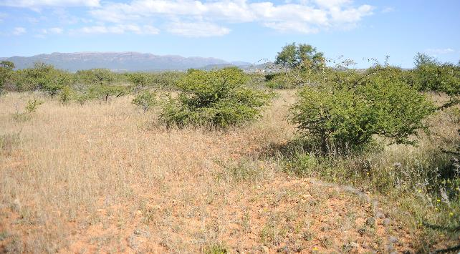
Figure 1: Proposed Rampheri Substation site – heavily disturbed woodland

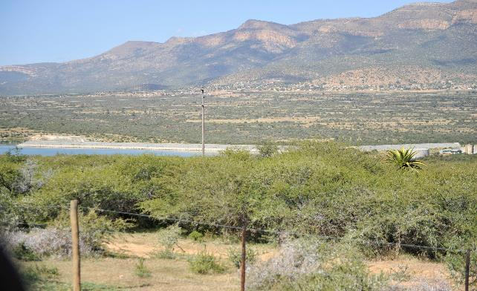
Figure 2: A typical dam found in the study area.

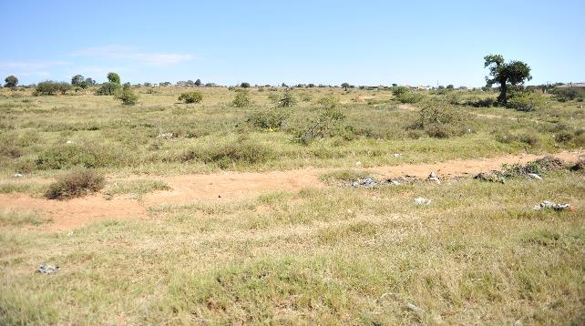
Figure 3: Old agricultural lands

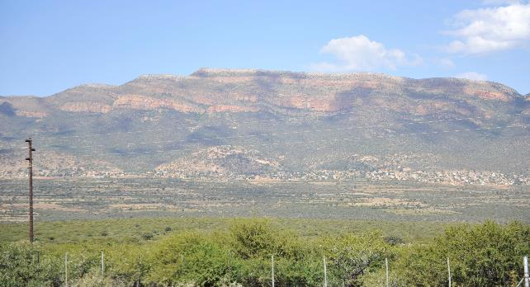
Figure 4: The Wolkberg Mountains to the south of the study area.

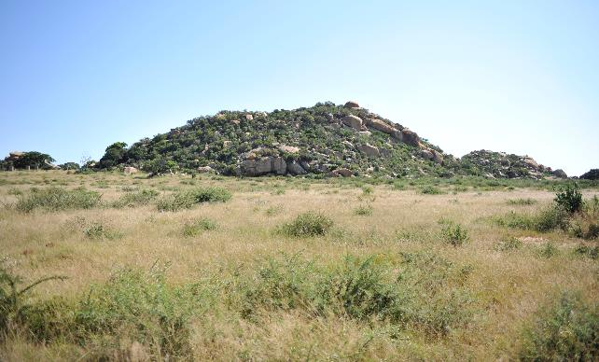
Figure 5: Relic areas of intact woodland (savanna) are found mostly on koppies

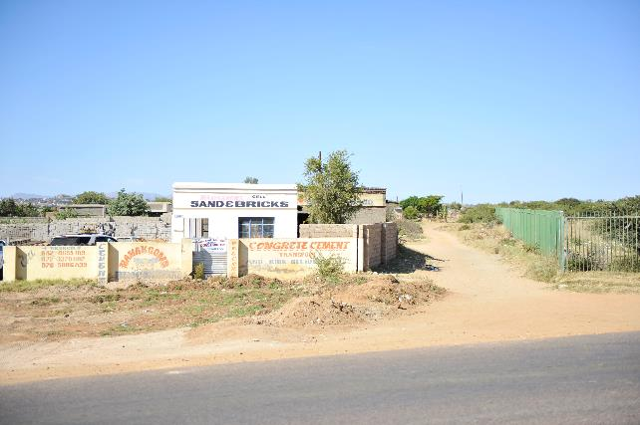
Figure 6: Typical urban areas and road infrastructure observed in the study area.

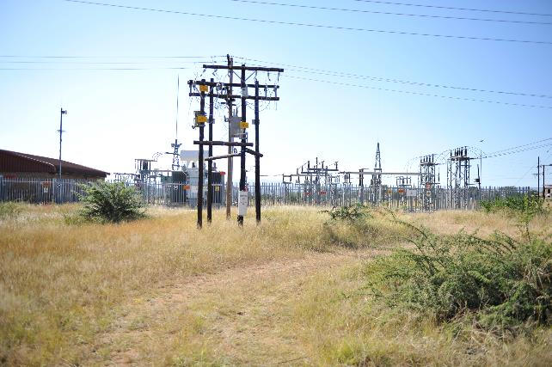
Figure 7: Syferkuil substation.

APPENDIX 2: STRUCTURE TYPES
