|  |  |  |
| --- | --- | --- |
| Drawing1 | PROJECT PROPOSAL TEMPLATE: HOT WATER LOAD CONTROL SYSTEMS | Eskom |

|  |  |  |  |
| --- | --- | --- | --- |
| Title: | REPAIRS , EXTENSION AND/OR INSTALLATION OF RESIDENTIAL HWLC IN VARIOUS MUNICIPALITIES  (MUNICIPALITY NAME) | Document Identifier | 240-55464756 |
| Area of Applicability  Functional Area | Eskom Holdings SOC Ltd  Eskom |
| Revision: |  |
| Next Review Date: | March 2024 |
| Disclosure Classification: | PUBLIC DOMAIN |

***NAME OF CONTRACTOR***

**CONTRACTOR/PD/ESCO company registration number – CK _________________**

**VENDOR NO. __________________________**

**Postal and street address (including postal codes)**

**Contact Person:**

**Tel : (0) _______________ Fax : (0) _______________**

***NAME OF MUNICIPALITY:***

**Postal and street address (including postal codes)**

**Contact Person:**

**Tel: (0) _______________ Fax : (0) _______________**

**PROPOSAL ACCEPTED__________________________ DATE_________________________**

**MUNICIPALITY**

**PROJECT SITE INFORMATION:**

Project site information and responsible person

Table 1: Project site information and responsible person

|  |  |  |  |  |
| --- | --- | --- | --- | --- |
| **Site, Ward no, Area** | **Name Municipality** | **Postal and Physical address** | **Contact Person** | **Contact details, phone, cell and email** |
|  |  |  |  |  |
|  |  |  |  |  |
|  |  |  |  |  |
|  |  |  |  |  |
|  |  |  |  |  |

Contents

**1.** **PROJECT SUMMARY** 2

**2.** **INTRODUCTION** 3

**2.1.** **Background on Project Developer** 3

**2.2.** **Background on Municipality** 3

**3.** **PROJECT BACKGROUND** 4

**4.** **PROJECT / PROCESS BACKGROUND (SCOPE OF WORK)** 5

**5.** **SAVINGS & CONSUMPTION** 6

**6.** **LOAD PROFILES** 7

7. FINANCE 7

8. PROJECT RISKS 9

9. ENVIRONMENTAL ISSUES (if applicable) 9

10. PROCUREMENT DETAILS 9

APPENDIX A: LOAD PROFILES example 11

APPENDIX B: ADDITIONAL DOCUMENTATION 13

# **PROJECT SUMMARY**

Short overview of project and checklist

1. State what you will be doing: (Repair only or repair and extend or extension only or New installations)
2. What is the MW shiftable
3. State the period and ensure that the Eskom evening peaks – 17:00-19:00 (winter) and/or 18:00-20:00 (summer) clearly defined and corresponds to the demand reduction MW
4. Are the savings (MW and MWh) monthly/yearly/seasonal/winter/summer?
5. Estimated Implementation period of the project 6/12 months? This excludes the 8 quarter performance assessment period
6. What are the monetary savings to the Municipality due to the intervention?
7. Is the Municipality aware of the Proposal? Is the proposal signed?

Table 2: Project Savings and Finance Summary

|  |  |
| --- | --- |
| Total Capital Costs | R xxx |
| Total Labour Costs | R xxx |
| Project Management and Travelling Subsistence Costs | R xxx |
| Total Costs | R xxx |
| Total Project Savings | xxx MW |
| R’m/MW | Xxx |

***\*please ensure the greyed part in the table is FULLY Complete***

1. Indicate the R’m/MW –“Rand million per MW” (this is the total project costs excl. VAT divided total project savings).

**ACCEPTANCE OF PROJECT PROPOSAL BY MUNICIPALITY:**

______________________ ______________________ __________________

Name [Municipal Contact person] Signature Date

Municipality Name:

# **INTRODUCTION**

# **Background on Project Developer**

* Include expertise / track record of company and personnel, organogram (reference and attach as annexure/appendices)
* Experience in project management
* Experience/track record with regard to the technology proposed
* Qualifications of staff
* Capacity to complete the work
* BEE/BWO/SMME status
* Has a consultancy agreement been signed between the Project Developer and the Municipality (letter of intent)?

# **Background on Municipality**

Focus on the following: Location, population (if available), Wards, Areas, Number of households of the targeted area/ complex etc.

Is the customer (including affected households) aware of this project?

* That M&V will be monitoring the project and will need access to the site, this might include going to couple of households for verification?

# **PROJECT BACKGROUND**

Mention what will be covered by the project (if there are many areas within one site like the different areas on a mine, list them here) e.g.

Table 3: Individual Site/area/ward Proposed Savings

|  |  |  |  |
| --- | --- | --- | --- |
| **Site/Areas/Wards** | **Existing (KW)** | **Proposed (KW)** | **Savings** |
| **Site 1** |  |  |  |
| **Site 2** |  |  |  |
| **Site 3** |  |  |  |
| **Site 4** |  |  |  |
| **Site 5** |  |  |  |
| **Site 6** |  |  |  |
| **Total** |  |  |  |

.

# **PROJECT / PROCESS BACKGROUND (SCOPE OF WORK)**

Describe what you will be doing, and explain about the different areas – what will be done, how will it be done (time frames etc.), and the list of material and pricing.

Provide diagrams and drawing of the project layout

# **SAVINGS & CONSUMPTION**

***Guidelines:***

5.1. Are the savings quantified, time stamped and stated on the proposal in terms of MWh and MW? (Daily, weekly, monthly, summer vs. winter, seasonal average, yearly average),

5.2. Have you included the methodology for the establishment of the savings (energy and demand) in the proposal? What ADMD was used in calculating movable load

5.3. What is the baseline based on (actuals investigations, measurements or manufacturers specifications)?

5.4. Are the BEFORE and AFTER DSM intervention load profiles included in the proposal?

5.5. Have any variables that may affect the baseline been included in the proposal?

5.6. Check from which meter/systems was the data taken to calculate the baseline (type of meter, location of meter)?

5.7. Is the project, after implementation of the DSM measures, energy neutral?

5.8. Have you stated the operational hours of the system clearly? Have you also included the tariff structure?

5.9. Have the voltage, energy and demand levels been measured and taken into consideration?

# **LOAD PROFILES**

* 1. Daily load profile (kW/MW) - Should include **baseline (before) vs. proposed profiles** in a form of a graph., See appendix A for an example

Figure 1: Simple Baseline vs. Proposed profiles

Load Profile picture

**NB:** This should be accompanied by data half hourly or hourly figures.

Ensure that the comeback load matches the reduced load and it doesn’t introduce a new peak

* 1. If there is an existing IDM project(s) of the same technology on the site, the profile of the original baseline should be included and there will be a total of **three profiles** namely: The original baseline (*before any DSM intervention*), Actual (*after the first intervention this is also the baseline for the new intervention*), and then the proposed profile (**Example below**).

Figure 2: Proposed profile for the site with an existing DSM project on the same technology

* 1. If there are several technologies to be implemented, each technology should have its own profile (Existing vs. Proposed)
  2. Tariff Structure if applicable
  3. Copy of Municipalities’ electricity bill

# **FINANCE**

* 1. Overall project costs

Table 4: Overall Costs EXAMPLE

|  |  |
| --- | --- |
| Total Capital Costs | R 19,320,000 |
| Total Labour Costs | R 3,380,000 |
| Project Management | R 800,000 |
| Pre-Audit, marketing, communication, if applicable | R 80,000 |
| Travelling and Subsistence, if applicable | R 200,000 |
| **Subtotal** | **R 1,080,000** |
| **Total Costs excl. VAT** | **R 23,780,000** |
| **Total Costs incl. VAT** | **R 27,109,200** |

NB:- Figures should tie/add up with the ones given in earlier sections of the document.(table 2)

* Although Eskom is buying the MW, its important to indicate to us how you arrived at the total cost in case we need to negotiate the final R/MW
  1. Monetary savings
  2. Show amount that Municipality will save due to the intervention

# **PROJECT RISKS**

* 1. Risks
* State any risks that you know of that may be detrimental to the project.
* Is there a risk associated with the technology/DSM Programme to the Municipality?
* Is there any risk associated with the technology in South Africa?
* If a risk assessment has been done for the project, kindly show the results.
  1. Mitigation
* State how all of the above risks will be mitigated correspondingly

You can tabulate this section

# **ENVIRONMENTAL ISSUES (if applicable)**

* State how unwanted / old material will be disposed of during the implementation stage.
* Environmental impacts table to be inserted.

# **PROCUREMENT DETAILS**

* 1. Indicate Finances (reference section 9)
  2. Scope of work (Reference Section 6)
  3. List of Equipment and Pricing (Reference Section 6)
  4. Detailed Labour Cost Breakdown : Labour cost: (specify who will be working on project and at what rate)

**NB: Must be consistent in rates used and should tie-up/ add up to table 2 with the figures given earlier in the document**

Table 5: Example of detailed labour costs breakdown

|  |  |  |  |  |
| --- | --- | --- | --- | --- |
| Description - Labour | Quantity | Hourly Rate | Hours | Total Costs Per Category |
|  |  |  |  |  |
|  |  |  |  |  |
|  |  |  |  |  |
|  |  |  |  |  |
|  |  |  |  |  |
|  |  |  |  |  |
|  |  |  |  |  |
| Total Costs |  |  |  |  |

Other costs: **(if applicable)**

* 1. Project Pre-Audit Fees (rates and times must tie up with those already given).
  2. Travelling subsistence Costs (again rates and times must tie up with those already given).
  3. Use of Subcontractors (BEE, SMME, etc.), state if, when & where you will be using a subcontractor , what portion of the work will be contracted and give details of the company/person etc.

# **APPENDIX A: LOAD PROFILES**

The following section indicated the municipal consumption and proposed shifts

Table 6: Example Municipality XXX RLM: load profile

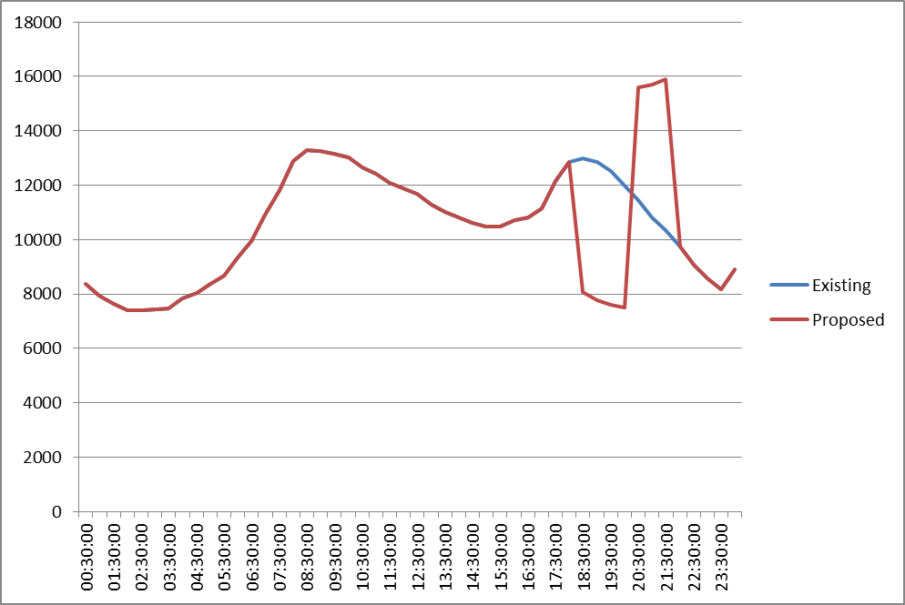



# APPENDIX B: ADDITIONAL DOCUMENTATION

Please ensure that the Safety, Quality and Environmental Information are prepared and ready to be shared when requested.

Attach any additional information not stated in this document to support your proposal

Please update table of contents after completing this document (right click on the table of contents and select update field and update entire table)