Report No: 4348/401629

ENVIRONMENTAL IMPACT ASSESSMENT: OPEN CYCLE GAS TURBINE POWER PLANT IN MOSSEL BAY:
PROPOSED ADDITIONAL UNITS

FINAL ENVIRONMENTAL IMPACT REPORT

APRIL 2007



LEAD CONSULTANT  Ninham Shand Consulting Services  P.O. Box 509  George  6530 | PROPONENT  Eskom Holdings Ltd.  Megawatt Park  Maxwell Drive  Sandton  2199
Tel: (044) 874 2165 | Tel: (011) 800 3501
Fax: (044) 873 5843 | Fax: (011) 800 5140
Email: enviro@shands.co.za | Website: www.eskom.co.za/EIA
PROJECT DETAILS

DEA&DP REF EG 12/2/3/2-D6/27-352/06, Patrysfontein 228/1 OCGT

TITLE Environmental Impact Assessment: Open Cycle Gas Turbine Power Plant in Mossel Bay: Proposed Additional Units.

AUTHORS Brett Lawson
Charles Norman

SUB-CONSULTANTS AirShed Planning Professionals (air quality impact)
Jongens Keet Associates (noise impact)
Visual Resource Management Africa (visual impact)
Conservation Management Services (ecological impact)
Liezl Coetzee (social impact)
Ninham Shand (traffic impact)
ERM (risk assessment)

CLIENT Eskom Holdings Ltd

PROJECT NAME Mossel Bay OCGT Additional Units

REPORT STATUS Final

REPORT NUMBER 4348/401629

DATE 30 April 2007

..........................................
BRETT LAWSON
Project Manager
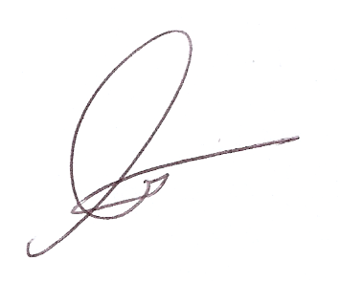

..........................................
CHARLES NORMAN
Environmental Practitioner

This report is to be referred to in bibliographies as:
NINHAM SHAND. 2007. Environmental Impact Assessment: Open Cycle Gas Turbine Power Plant in Mossel Bay: Proposed Additional Units: Final Environmental Impact Report. Report No. 4348 / 401629.

