

DETAILS OF SPECIALIST AND DECLARATION OF INTEREST

 | (For official use only)
File Reference Number: | 12/12/20/
NEAS Reference Number: | DEAT/EIA/
Date Received:

Application for authorisation in terms of the National Environmental Management Act, 1998 (Act No. 107 of 1998), as amended and the Environmental Impact Assessment Regulations, 2010

PROJECT TITLE
Proposed Solar Installation at Grootvlei power station

Specialist: | ARC-Institute for Soil, Climate and Water
Contact person: | D.G. Paterson
Postal address: | Private Bag X79, Pretoria
Postal code: | 0001 | Cell: | 083 556 2458
Telephone: | (012) 310 2500 | Fax: | (012) 323 1157
E-mail: | Garry@arc.agric.za
Professional affiliation(s) (if any) | Soil Science Society of SA; SA Council for Natural Scientific Professions (Pr. Sci. Nat. 400463/04); SA Soil Surveyors Organisation

Project Consultant: | Environmental Impact Management Services (Pty) Ltd
Contact person: | Liam Whitlow
Postal address: | P.O. Box 2083 Pinegowrie
Postal code: | 2123 | Cell: | (083) 393 2208
Telephone: | (011) 789 7170 | Fax: | (011) 787 3059
E-mail: | liam@eims.co.za
The specialist appointed in terms of the Regulations
DG Paterson
I, , declare that --

General declaration:
- I act as the independent specialist in this application;
- I will perform the work relating to the application in an objective manner, even if this results in views and findings that are not favourable to the applicant;
- I declare that there are no circumstances that may compromise my objectivity in performing such work;
- I have expertise in conducting the specialist report relevant to this application, including knowledge of the Act, regulations and any guidelines that have relevance to the proposed activity;
- I will comply with the Act, regulations and all other applicable legislation;
- I have no, and will not engage in, conflicting interests in the undertaking of the activity;
- I undertake to disclose to the applicant and the competent authority all material information in my possession that reasonably has or may have the potential of influencing - any decision to be taken with respect to the application by the competent authority; and - the objectivity of any report, plan or document to be prepared by myself for submission to the competent authority;
- All the particulars furnished by me in this form are true and correct; and
- I realise that a false declaration is an offence in terms of Regulation 71 and is punishable in terms of section 24F of the Act.
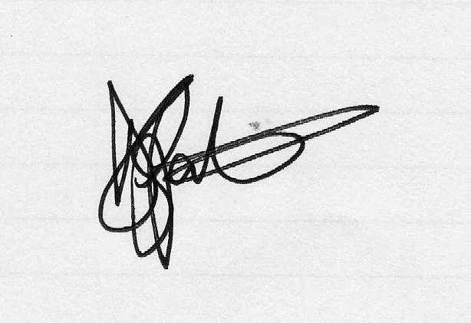

Signature of the specialist:

ARC-Institute for Soil, Climate and Water
Name of company (if applicable):

24th May 2013
Date:

