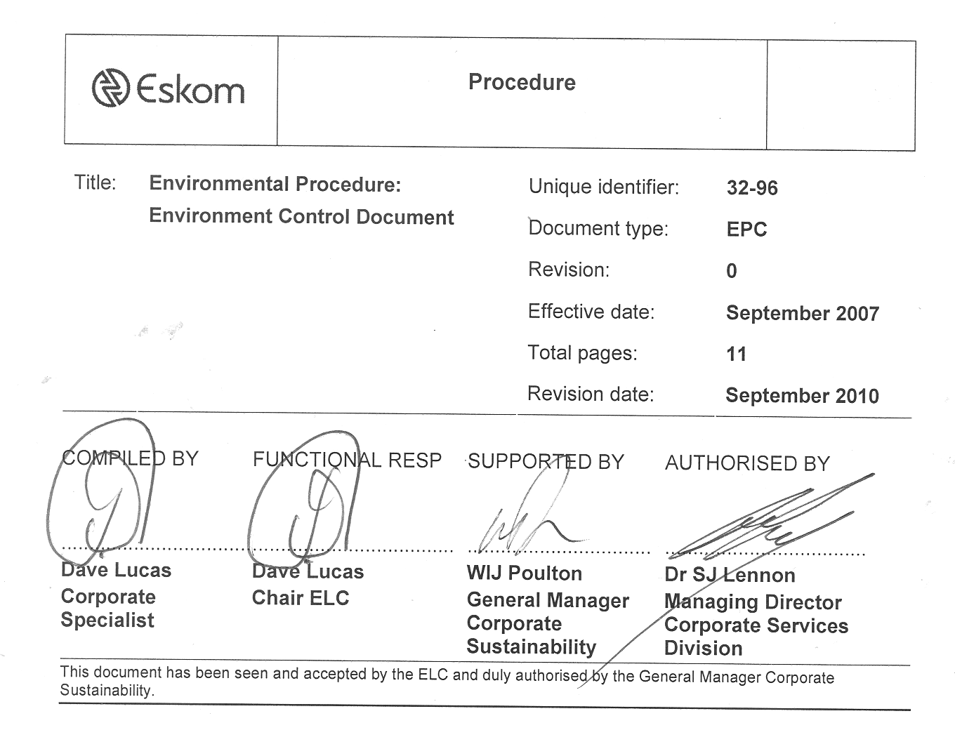
Procedure
(0.2)

Title: | Environmental Procedure:  Environment Control Document | Unique identifier: | 32-96
Title: | Environmental Procedure:  Environment Control Document | Document type: | EPC
Title: | Environmental Procedure:  Environment Control Document | Revision: | 0
Title: | Environmental Procedure:  Environment Control Document | Effective date: | September 2007
Title: | Environmental Procedure:  Environment Control Document | Total pages: | 11
Title: | Environmental Procedure:  Environment Control Document | Revision date: | September 2010

COMPILED BY | FUNCTIONAL RESP | SUPPORTED BY | AUTHORISED BY
..................................  Dave Lucas  Corporate Specialist | ....................................  Dave Lucas  Chair ELC | .................................  WIJ Poulton  General Manager Corporate Sustainability | ....................................  Dr SJ Lennon  Managing Director Corporate Services Division
This document has been seen and accepted by the ELC and duly authorised by the General Manager Corporate Sustainability.
Table of contents
Page
1 Introduction 2
2 Document content - Statement 2
3 Supporting clauses 3
4 Authorisations 10
6 Development team 11

1 Introduction
This Control Document for the Environmental Procedure covers all requirements of, and serves as the basis for, the environmental procedure. It contains all supporting documentation and clauses required for environmental procedures in Eskom and should be referenced in all documentation forming part of the procedure. All requirements and clauses shall apply to all supporting documentation unless specifically mentioned.

2 Document content - Statement
List of all relevant environmental management procedures, with implementation date and reference numbers.

Reference | Name | Implementation date | Revision
EPC 32-96 | Environmental Control Document | September 2007 | 0
EPC 32-245 | Waste Procedure | September 2007 | 0
Annex A: Fluorescent Tubes and Mercury Containing Device Management
Annex B: Disposal and Safe Handling of SF₆ and by-products
Annex C: PCB Management
Annex D: Oil Management
Annex E: Asbestos Management
Annex F: Health Care Risk Waste
Annex G: Metals
Annex H: E-waste
Annex I: Solvents
Annex J: Ozone Depleting Substances
EPL 32-97 | Land Policy | September 2007 | 0
EPC 32-247 | Vegetation Clearance and Maintenance within Overhead Power Line Servitudes | September 2007 | 2
EPC 32-258 | Due Diligence Procedure | September 2007 | 1
EPC 32-249 | ELC Reporting Procedure | September 2007 | 6
EPC 32-246 | Reporting on Environmental Expenditure Procedure | September 2007 | 1
EPC 32-259 | ELC Terms of Reference | September 2007 | 6

3 Supporting clauses
All documents listed under the above statement will comply with the following supporting clauses unless otherwise stated within the document.
Index of Supporting Clauses
3.1 Scope 3
3.2 Normative/Informative References 3
3.3 Definitions 3
3.4 Abbreviations 5
3.5 Roles and Responsibilities 6
3.6 Implementation date 6
3.7 Process for Monitoring 6
3.8 Related documents 7
4 Authorisations 10
3.8 Revisions 11

3.1 Scope

3.1.1 Purpose
This procedure serves as the basis for environmental management in Eskom Holdings Limited (Eskom) inside and external to South Africa and in relevant subsidiaries and to ensure uniformity in the application thereof in all applicable operations.

3.1.2 Applicability
This policy shall apply throughout Eskom, its divisions’ subsidiaries, and entities in which Eskom has a controlling interest or significant influence, including identified contractors, suppliers and service providers, and customers to Eskom and Eskom subsidiaries where significant impacts and risks may occur.

3.2 Normative/Informative References
The latest version of all documents shall apply:
Eskom Safety, Occupational Health, and Environmental Policy
ELC Terms of Reference

3.3 Definitions
These lists will serve as the definitive definition and abbreviation lists for Eskom environmental documentation.
3.3.1 | Compliance audits: | Any audit designed in such a way that it will measure/evaluate compliance with legal and Eskom requirements, including identified good practices.
3.3.2 | Contractors: | Registered business or employer to whom a contract is awarded to conduct business on behalf of Eskom.

3.3.3 | Controlling interest: | (a) The ownership or control (directly or indirectly) of more than 50 % (fifty per cent) of the voting share capital of the relevant undertaking;  (b) the ability to direct the casting of more than 50 % (fifty percent) of the votes exercisable at general meetings of the relevant undertaking on all, or substantially all, matters; or  (c) the right to appoint or remove directors of the relevant undertaking holding a majority of the voting rights at meetings of the Board on all, or substantially all, matters.
3.3.4 | Emergency incident: | “Incident” means an unexpected sudden occurrence, including a major emission, fire, or explosion leading to serious danger to the public or potentially serious pollution of, or detriment to, the environment, whether immediate or delayed.
3.3.5 | Environment: | The surroundings within which humans exist and that are made up of:  (i) the land, water, and atmosphere of the earth;  (ii) micro-organisms and plant and animal life; and  (iii) any part or combination of (i) and (ii) and the interrelationships among and between them; and the physical, chemical, aesthetic, and cultural properties and conditions of the foregoing that influence human health and well-being.
3.3.6 | Event: | SHE happenings reported by business units to divisions and the ELC, including all media and occurrences and issues in contravention of legislation and within legal parameters.
3.3.7 | Hazard: | Means a source of, or exposure to, danger.
3.3.8 | Incident: | Undesired accidental event that results in injury, damage, or loss.
3.3.9 | Occupational health and safety: | Includes occupational hygiene, occupational safety, occupational medicine, fire safety and public safety, and emergency preparedness.
3.3.10 | Pollution: | Means any change in the environment caused by  (i) substances;  (ii) radioactive or other waves; or  (iii) noise, odours, dust, or heat;  emitted from any activity, including the storage or treatment of waste or substances, construction, and the provision of services, whether engaged in by any person or an organ of state, where that change has an adverse effect on human health or well-being or on the composition, resilience, and productivity of natural or managed ecosystems or on materials useful to people, or will have such an effect in the future.
3.3.11 | Risk: | The probability that injury or damage will occur.
3.3.12 | Safety: | The management and control of associated risks to provide an environment that is safe for people to work in.
3.3.13 | Subsidiary: | Eskom Enterprises and the line divisions should they become incorporated or any other company in which Eskom Holdings Limited is a holding company controlling a majority of the votes (that is, more than 50 %).
3.3.14 | Sustainability: | The integration of sustainable development into business strategy, practices, and operations.

3.3.15 | Sustainable development: | “Meeting the needs of the present without compromising the ability of future generations to meet their own needs.” Sustainable development is also defined as the integration and consideration of three pillars, namely, economic, social, and environmental issues.
3.3.16 | Significant influence: | The power to participate in the financial and operating policy decisions of an entity, but is not control over those policies.  Entities included in this definition are:  - associates where Eskom owns, directly or indirectly, more than 20 %, but not more than 50 %, of the voting power; and  - joint ventures where Eskom owns, directly or indirectly through subsidiaries, less than 50 % of the voting power, but does not have operational control.
3.3.17 | Waste: | Includes any substance, whether solid, liquid, or gaseous, that is:  - discharged, emitted, or deposited in the environment in such volume, constituency, or manner as to cause an alteration to the environment;  - a surplus substance or one that is discarded, rejected, unwanted, or abandoned;  - reused, recycled, reprocessed, recovered, or purified by a separate operation from that which produced the substance or that may be or is intended to be reused, recycled, reprocessed, recovered, or purified; or  - identified as waste by prescribed regulation.  Ref. National Environmental Management: Waste Management Bill, for general comment. General Notice 1832 of 2007, 12 January 2007.
3.3.18 | Commercial timber growers: | Timber growers, both individually or as represented by the Forest Owners Association, the South African Wattle Growers Union, or the South African Timber Growers Association and their personnel (Commercial Timber Growers Guideline).
3.3.19 | Plantation: | Any trees planted and managed by commercial timber growers for commercial purposes (Commercial Timber Growers Guideline).

3.4 Abbreviations
Current abbreviations in use in the environmental field in Eskom:
3.4.1 | Board SC: | Eskom Holdings Board Sustainability Committee
3.4.2 | CE: | Chief Executive
3.4.3 | COID: | Compensation for Occupational Injuries and Disease
3.4.4 | CS (SHE): | Corporate Sustainability (Safety, Health, and Environment)
3.4.5 | CS: | Corporate Sustainability
3.4.6 | GMCS: | General Manager Corporate Sustainability
3.4.7 | CTAD: | Corporate Technical Audit Division
3.4.8 | CTADM: | Corporate Technical Audit Division Manager
3.4.9 | Dx: | Distribution Division
3.4.10 | EA: | Environmental Audit
3.4.11 | EDTT: | Environmental Documentation Task Team

3.4.12 | Ex: | Enterprises Division
3.4.13 | EHB: | Eskom Holdings Board
3.4.14 | ELC: | Environmental Liaison Committee
3.4.15 | EMP: | Environmental Management Programme
3.4.16 | EMS: | Environmental Management System
3.4.17 | ESPI | Eskom Sustainability Performance Index
3.4.18 | EXCO: | Executive Management Committee
3.4.19 | EXCO S&SSC: | Executive Management Committee Sustainability and Safety Sub-committee
3.4.20 | Fx: | Finance Division
3.4.21 | GRI: | Global Reporting Initiative
3.4.22 | Gx: | Generation Division
3.4.23 | KPA: | Key Performance Area
3.4.24 | KPI: | Key Performance Indicator
3.4.25 | NEMA: | National Environmental Management Act
3.4.26 | OHSA: | Occupational Health and Safety Act
3.4.27 | OHSLC: | Occupational Health and Safety Liaison Committee
3.4.28 | OSR: | Operational Sustainability Report
3.4.29 | PCBs: | Polychlorinated Biphenyls
3.4.30 | PCO: | Pest Control Officer
3.4.31 | ppm: | Parts Per Million
3.4.32 | SHE: | Safety, Occupational Health, and Environment
3.4.33 | SLC | Sustainability Liaison Committee
3.4.34 | TT | Task Team
3.4.35 | Tx | Transmission Division
3.4.36 | WIS | Waste Information System (National Waste Management Strategy)

3.5 Roles and Responsibilities
Not applicable

3.6 Implementation date
The implementation date will be August 2007.

3.7 Process for Monitoring
Monitoring and measurement requirements are included in the current document, ELC Reporting Procedure, EPC 32-249.

3.8 Related documents
This is the full list of environmental documentation, current and historical, in Eskom. Documents included have Eskom-wide application (Level 1 documents). This list does not contain division-specific documentation (Level 2 documents).
Status as at September 2007:

New reference No. | Old reference No. | Name | Revision date | Status September 2007
EPL 32-94 | N/A | Eskom Safety, Occupational Health, and Environmental Policy | 1 January 2010 | Approved November 2006
EPC 32-96 | N/A | Environmental Procedure: Environmental Control Document | 1 May 2010 | Approved October 2006
EPL 32-157 | ESKPBAAY7 | Climate Change Policy | 1 January 2010 | Approved March 2006
EPC 32-246 | ESKADABC8 | Environmental Procedure: Reporting on Environmental Expenditure Directive | 1 May 2010 | Approved October 2006
N/A | ESKADABE9 | EIA Directive | N/A | Cancelled
N/A | ESKADABD1 | EMS Directive | N/A | Cancelled; issues included in SHE Policy (EPL 32-94)
N/A | ESKADAAO3 | Corporate Directive for the Management of Polychlorinated Biphenyls (PCB) | N/A | Cancelled; included in Environmental Procedure: Waste Procedure (EPC 32-245)
N/A | ESKADABK1 | Environmental Land Management Directive | N/A | Cancelled; replaced by Environmental Policy: Land Policy (EPL 32-97)
N/A | ESKPBAAD6 | Environmental Management Policy | N/A | Cancelled; replaced by SHE Policy (EPL 32-94)
N/A | ESKPBAAM2 | Environmental Education Policy | N/A | Cancelled
N/A | ESKPBAAA3 | Air Quality Management Policy | N/A | Cancelled; replaced by Gx Atmospheric Emissions Management Policy (GGPP1327)
N/A | ESKPBAAA4 | Ozone Depleting Compounds Management and Phase-out Policy | N/A | Cancelled; included in Environmental Procedure: Waste Procedure (EPC 32-245)

New reference No. | Old reference No. | Name | Revision date | Status September 2007
N/A | ESKPBAAB6 | Policy on Power Frequency Electric and Magnetic Fields (EMF) |  | Under review by OHSLC
N/A | ESKPBAAD4 | Herbicide Management | N/A | Cancelled; issues included in Environmental Procedure: Procedure for Vegetation Clearance and Maintenance within Overhead Power Line Servitudes and on Eskom-owned Land (EPC 32-247)
N/A | ESKPBAAJ4 | Water Management | N/A | Cancelled
N/A | ESKPBAAC4 | Waste Management Policy | N/A | Cancelled; included in Environmental Procedure: Waste Procedure (EPC 32-245)
N/A | ESKPBAAR4 | Flue Gas Detoxification Policy | N/A | Cancelled; issues included in Gx Atmospheric Emissions Management Policy (GGPP1327)
N/A | ESKPVABW6 | EMS standard | N/A | Cancelled; issues included in SHE Policy (EPL 32-94)
N/A | ESKPVACS0 | Compilation and Review of Eskom Environmentally-related Documents | N/A | Cancelled
 | ESKPVAAG5 | Requirements for the Safe Processing, Storing, Removing, and Handling of Asbestos or Asbestos-containing Materials Procedure | N/A | Re-issued
N/A | ESKPVAAZ1 | Environmental Management Plans Procedure | N/A | Cancelled; issues included in Environmental Procedure: Environmental Management Programme Guideline (EPC 32-248)

New reference No. | Old reference No. | Name | Revision date | Status September 2007
EPC 32-249 | ESKPVABX8 | Environmental Performance Indicator Reporting Procedure | 1 May 2010 | Re-issued as Environmental Procedure: Environmental Liaison Committee (ELC) Performance Indicator Reporting Procedure (EPC 32-249)
N/A | ESKASABT0 | Oil Spill Clean-up and Rehabilitation Procedure | N/A | Cancelled; issues included in Environmental Procedure: Waste Procedure (EPC 32-245)
N/A | ESKASAAL0 | The Safe Use of Pesticides and Herbicides (Standard) | N/A | Cancelled; issues included in Environmental Procedure: Procedure for Vegetation Clearance and Maintenance within Overhead Power Line Servitudes and on Eskom-owned Land (EPC 32-247)
N/A | ESKASAAC2 | Management of PCBs (Standard) | N/A | Cancelled; issues included in Environmental Procedure: Waste Procedure (EPC 32-245)
EPC 32-247 | ESKASABG3 | Standard for Bush Clearance and Maintenance within Overhead Power Line Servitudes (Standard) | 1 May 2010 | Reissued as Environmental Procedure: Procedure for Vegetation Clearance and Maintenance within Overhead Power Line Servitudes and on Eskom-owned Land (EPC 32-247)
N/A | ESKASABT0 | Oil Spill Clean-up and Rehab (Standard) | N/A | Cancelled; issues included in Environmental Procedure: Waste Procedure (EPC 32-245)

New reference No. | Old reference No. | Name | Revision date | Status September 2007
N/A | ASAAE1.PDF- | The Safe Handling of SF₆ and Its Products | August 2002 | Cancelled; included in waste procedure. New NRS under development
EPC 32-259 | ESKASABH0 | Environmental Liaison Committee Terms of Reference | 1 May 2010 | Reissued as Environmental Procedure: ELC Terms of Reference (EPC 32-259)
N/A | ESKAGAAO6 | Guide to Developing an EMS that Complies with SABS/ISO 14001 | N/A | Cancelled; issues included in SHE Policy (EPL 32-94)
N/A | ESKAGAAJ6 | Safe Handling and Disposal of Fluorescent Tubes | N/A | Cancelled; issues included in Environmental Procedure: Waste Procedure (EPC 32-245)
N/A | ESKAGAAJ6- | Guidelines for the Rehabilitation and Vegetation Management of Herbicide-treated Sites | N/A | Guideline; uncontrolled document
EPC 32-258 | ESKGAAZ6 | Environmental Land Due Diligence Audit Guideline | 1 May 2010 | Reissued as Environmental Procedure: Due Diligence (EPC 32-258)

4 Authorisations
This document has been seen and accepted by:
Name | Designation
PJ Maroga | Chief Executive
B Nqwababa | Finance Director
ME Letlape | Managing Director (Human Resources Division)
EN Matya | Managing Director (Generation & Generation Primary Energy)
E Johnson | Managing Director (Systems Operations & Planning)
MM Ntsokolo | Managing Director (Transmission Division)
JA Dladla | Managing Director (in the office of the Chief Executive)
Dr SJ Lennon | Managing Director (Corporate Services Division)
BA Dames | Managing Director (Enterprises Division)
A Noah | Managing Director (Distribution Division)
3.8 Revisions
Approved date | Revision | Activity
June 2005 | 0 | Document development
April 2006 | 1 | Update status of documents  Update list of procedure content
August 2007 | 0 | New document number, EDC ISO formatted

6 Development team
ELC

