Receipts Format For Step Tariff
Rev 2.4 26 Nov 2010

Overview

A single credit token is generated irrespective of number of steps used for the transaction. Separate FBE and refund transactions will still be used as is done today but they also contribute to the steps.

The Rand amount and total kWh for the specific token must still be shown in the top portion of the receipt. (The same as it is already shown today for the flat rate receipts).

Additionally, all the steps desciption must be shown from either the <CustomerMsg> field or the
Tariff: <desc> field with all the relevant prices (c/kWh) per step populated. The OVS server will populate the data in both fields but the vendor must only show the data from one of these fields, not both.

The <CustomerMsg> is only populated as an interim measure since it is already implemented by all vendors. However, all vendors must convert their receipt printing to use the Tariff: <desc> field instead, as soon as possible, since the <CustomerMsg> field is intended for other use in future.

Note that there is an additional feld, defined for the Tariff: <name> field which will also be populated but it must not be printed as part of the steps detail.

The steps description detail in the response will be populated both of the above mentioned fields without any formatting as indicated below:
aaaa.aa_kWh_@_vvv.vv_c/kWh:_bbbb.bb_kWh_@_xxx.xx_c/kWh:_cccc.cc_kWh_@_yyy.yy_c/kWh:_dddd.dd_kWh_@_zzz.zz_c/kWh:_
The “_” character indicates a space.

Note: There will be a Tariff: <desc> field for every token in a transaction response, if there are multiple tokens in a single transaction, e.g. an auto FBE token and a Vend token. But there is only one <CustomerMsg> field for all the tokens included in a single response and OVS will correctly sum the information for all the tokens into that single message. It is preferred that the message be printed only once at the bottom if there are multiple tokens in a single response, but it may alternatively be printed at the bottom of every token as shown in the examples below.

Step Data Layout For Receipt

Only the respective kWh values for the steps that are included in the particular transaction, are populated. The kWh for the unused steps must be shown as zero’s since they are not part of this transaction. (The prices for all steps must always be shown).

The required Step detail on the receipt must be shown as follows:

aaaa.a_kWh_@_vvv.vv_c/kWh:_
bbbb.b_kWh_@_xxx.xx_c/kWh:_
cccc.c_kWh_@_yyy.yy_c/kWh:_
dddd.d_kWh_@_zzz.zz_c/kWh:_
Alternatively the vendor may arrange his own layout of the data on the receipt but the layout must be approved by Eskom before implementation.

- The steps detail are 28 printable characters per row, (including spaces)
- The total description length is 112 characters if no <CR> / <LF> characters are counted,
- Total steps description length is 120 characters if <CR> and <LF> characters included.

Receipts Layout With Step Detail

  - Purchase Credit Token Only

Element Name | Content (Server Populated)
<dispHeader> | “CREDIT VEND – TAX INVOICE”
<customerMsg> or Tariff: <desc> | Free text max 160 characters.
MeterSpecificTokenIssue: <desc> | “Normal Sale”, “Trial Vend”, “FBE Token”, “Over recovery token”

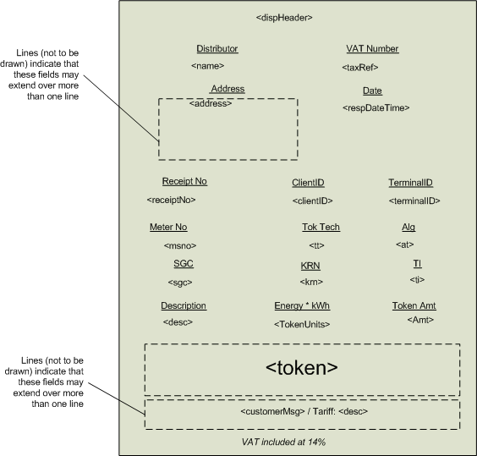
Figure 1 – Credit Token only receipt
  - Purchase Credit Token With Debt Recovery

Element Name | Content (Server Populated)
<dispHeader> | “CREDIT VEND – TAX INVOICE”
<customerMsg> or Tariff: <desc> | Free text max 160 characters.
MeterSpecificTokenIssue:<desc> | “Normal Sale”
PayAccTx:<accDesc> | “Debt Recovery”
Tariff:<name> | Free text 8 characters.

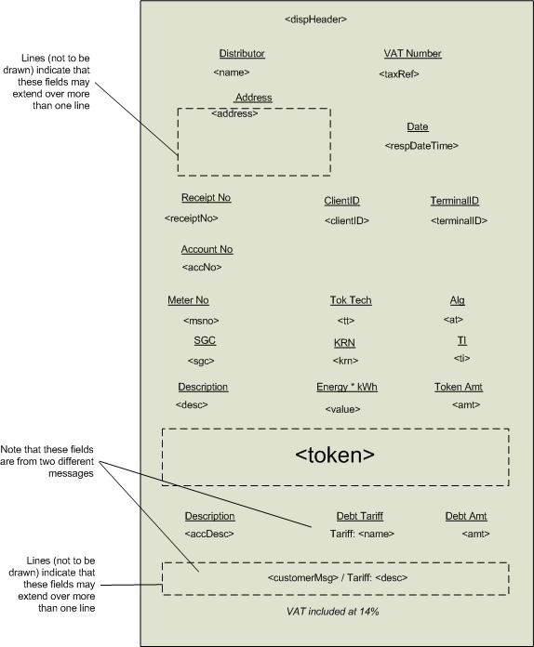
Figure 2 –Credit Token and Debt Recovery receipt

Debt recovery is automatically included in the response if it applies for the customer. This is simply a monetary deduction which is shown in two lines of the receipt. This is already implemented today and does not change in any way when the step tariffs are implemented. Neither will it affect the step tariffs, exept that the transaction amount will be reduced by the debt amount. All these actions are automatically handled by OVS.

Receipt Examples

Step | Threshold | Max Step Size | Price
Step 1 | 0.01 - 50 kWh | 50 kWh | 62.36 c/kWh
Step 2 | 50.01 - 350 kWh | 300 kWh | 66.67 c/kWh
Step 3 | 350.01 - 600 kWh | 250 kWh | 87.04 c/kWh
Step 4 | » 600 kWh | ∞ kWh | 95.46 c/kWh
Typical Step Tariff definition as used in examples

Note: Receipts that are sent via SMS to a cell phone do not include any tariff description details. If a customer requires the step tariff descriptions, he will have to request a reprint from a normal vending outlet that can print a full receipt on paper. Thefore there are no changes required for any SMS based receipts.

First purchase for R50.00 |  | Second purchase for R250.00
CREDIT VEND - TAX INVOICE  Distributor VAT Number  Eskom Online 4740101508  Date  2010/10/08 04:01:57 PM  Address  Megawatt Park, Contact Centre tel 086-003-7566  Receipt No  CIGIC2A65089788  Client ID Terminal ID  6004708022653 0000000086032  Meter No Tok Tech Alg  04085285281 01 07  SGC KRN TI  100405 1 07  Energy *kWh Token Amt  78.3 R 50.00  Description  Normal Sale  4051 1839 1187  7965 1048  0050.0 kWh @ 062.36 c/kWh:  0028.3 kWh @ 066.67 c/kWh:  0000.0 kWh @ 087.04 c/kWh:  0000.0 kWh @ 095.46 c/kWh:  VAT included at 14% |  | CREDIT VEND - TAX INVOICE  Distributor VAT Number  Eskom Online 4740101508  Date  2010/10/15 12:01:22 AM  Address  Megawatt Park, Contact Centre tel 086-003-7566  Receipt No  EAPOLVA02854276  Client ID Terminal ID  6004708053837 1  Meter No Tok Tech Alg  04085285281 01 07  SGC KRN TI  100405 1 07  Energy *kWh Token Amt  350.9 R 250.00  Description  Normal Sale  0396 5997 4923  6066 4087  0000.0 kWh @ 062.36 c/kWh:  0271.8 kWh @ 066.67 c/kWh:  0079.1 kWh @ 087.04 c/kWh:  0000.0 kWh @ 095.46 c/kWh:  VAT included at 14%

Combined R80.00 purchase and 70kWh FBE transaction for same meter
FREE BASIC ELECTRICITY (FBE)  Distributor VAT Number  Eskom Online 4740101508  Date  2010/10/08 03:38:20 PM  Address  Megawatt Park, Contact Centre tel 086-003-7566  Receipt No  QAMPS2A43243724  Client ID Terminal ID  6004708041509 123  Meter No Tok Tech Alg  07051745858 02 07  SGC KRN TI  100210 1 55  Energy *kWh Token Amt  70.0 R 0.00  Description  FBE Token  5551 2352 4557  8276 3199  0050.0 kWh @ 062.36 c/kWh:  0128.0 kWh @ 066.67 c/kWh:  0000.0 kWh @ 087.04 c/kWh:  0000.0 kWh @ 095.46 c/kWh:  VAT included at 14% |  | CREDIT VEND - TAX INVOICE  Distributor VAT Number  Eskom Online 4740101508  Date  2010/10/08 03:38:20 PM  Address  Megawatt Park, Contact Centre tel 086-003-7566  Receipt No  QAMPS2A43243724  Client ID Terminal ID  6004708041509 123  Meter No Tok Tech Alg  07051745858 02 07  SGC KRN TI  100210 1 55  Energy *kWh Token Amt  108.0 R 72.00  Description  Normal Sale  4883 3708 3580  3782 1857  Description  Debt Recovery  Debt Tarriff Amount  10 R 8.00  0050.0 kWh @ 062.36 c/kWh:  0128.0 kWh @ 066.67 c/kWh:  0000.0 kWh @ 087.04 c/kWh:  0000.0 kWh @ 095.46 c/kWh:  VAT included at 14%

  - Receipt Example For Minimum Acceptable Data
This example is for combined Vend transaction (including Debt recovery) and FBE transaction.
The example shows the minimum acceptable fields and data content. Also many of the headings and line breaks have been removed. This makes the receipt less readable but reduces paper usage.
Please note that it is important to highlight the Header at the beginning of every transaction if they are combined, so it is preferred that it is a somewhat larger font.

FREE BASIC ELECTRICITY (FBE)
Distributor VAT Number
Eskom Online 4740101508
Megawatt Park, Contact Centre tel 086-003-7566
Date 2010/10/08 03:38:20 PM
Receipt No Client ID
QAMPS2A43243724 6004708041509
Meter No Tok Tech Alg
07051745858 02 07
SGC KRN TI
100210 1 55
Description Energy kWh Token Amt
FBE Token 70.0 R 0.00
4883 3708 3580
3782 1857
0050.0 kWh @ 062.36 c/kWh:
0020.0 kWh @ 066.67 c/kWh:
0000.0 kWh @ 087.04 c/kWh:
0000.0 kWh @ 095.46 c/kWh:

CREDIT VEND - TAX INVOICE
Description Energy kWh Token Amt
Normal Sale 108.3 R 72.00
5551 2352 4557
8276 3199
Description Debt Tarriff Debt Amt
Debt Recovr 10 R 8.00
0000.0 kWh @ 062.36 c/kWh:
0108.3 kWh @ 066.67 c/kWh:
0000.0 kWh @ 087.04 c/kWh:
0000.0 kWh @ 095.46 c/kWh:

VAT included at 14%

