DRAFT SCOPING REPORT
LIMPOPO EAST CORRIDOR STRENGTHENING PROJECT
PROPOSED CONSTRUCTION OF ±110KM 400KV POWER LINE FROM FOSKOR MTS TO SPENCER MTS WITHIN MOPANI DISTRICT MUNICIPALITY, LIMPOPO PROVINCE
PREPARED FOR:



P. O. Box 1091
Johannesburg
2000

APRIL 2017
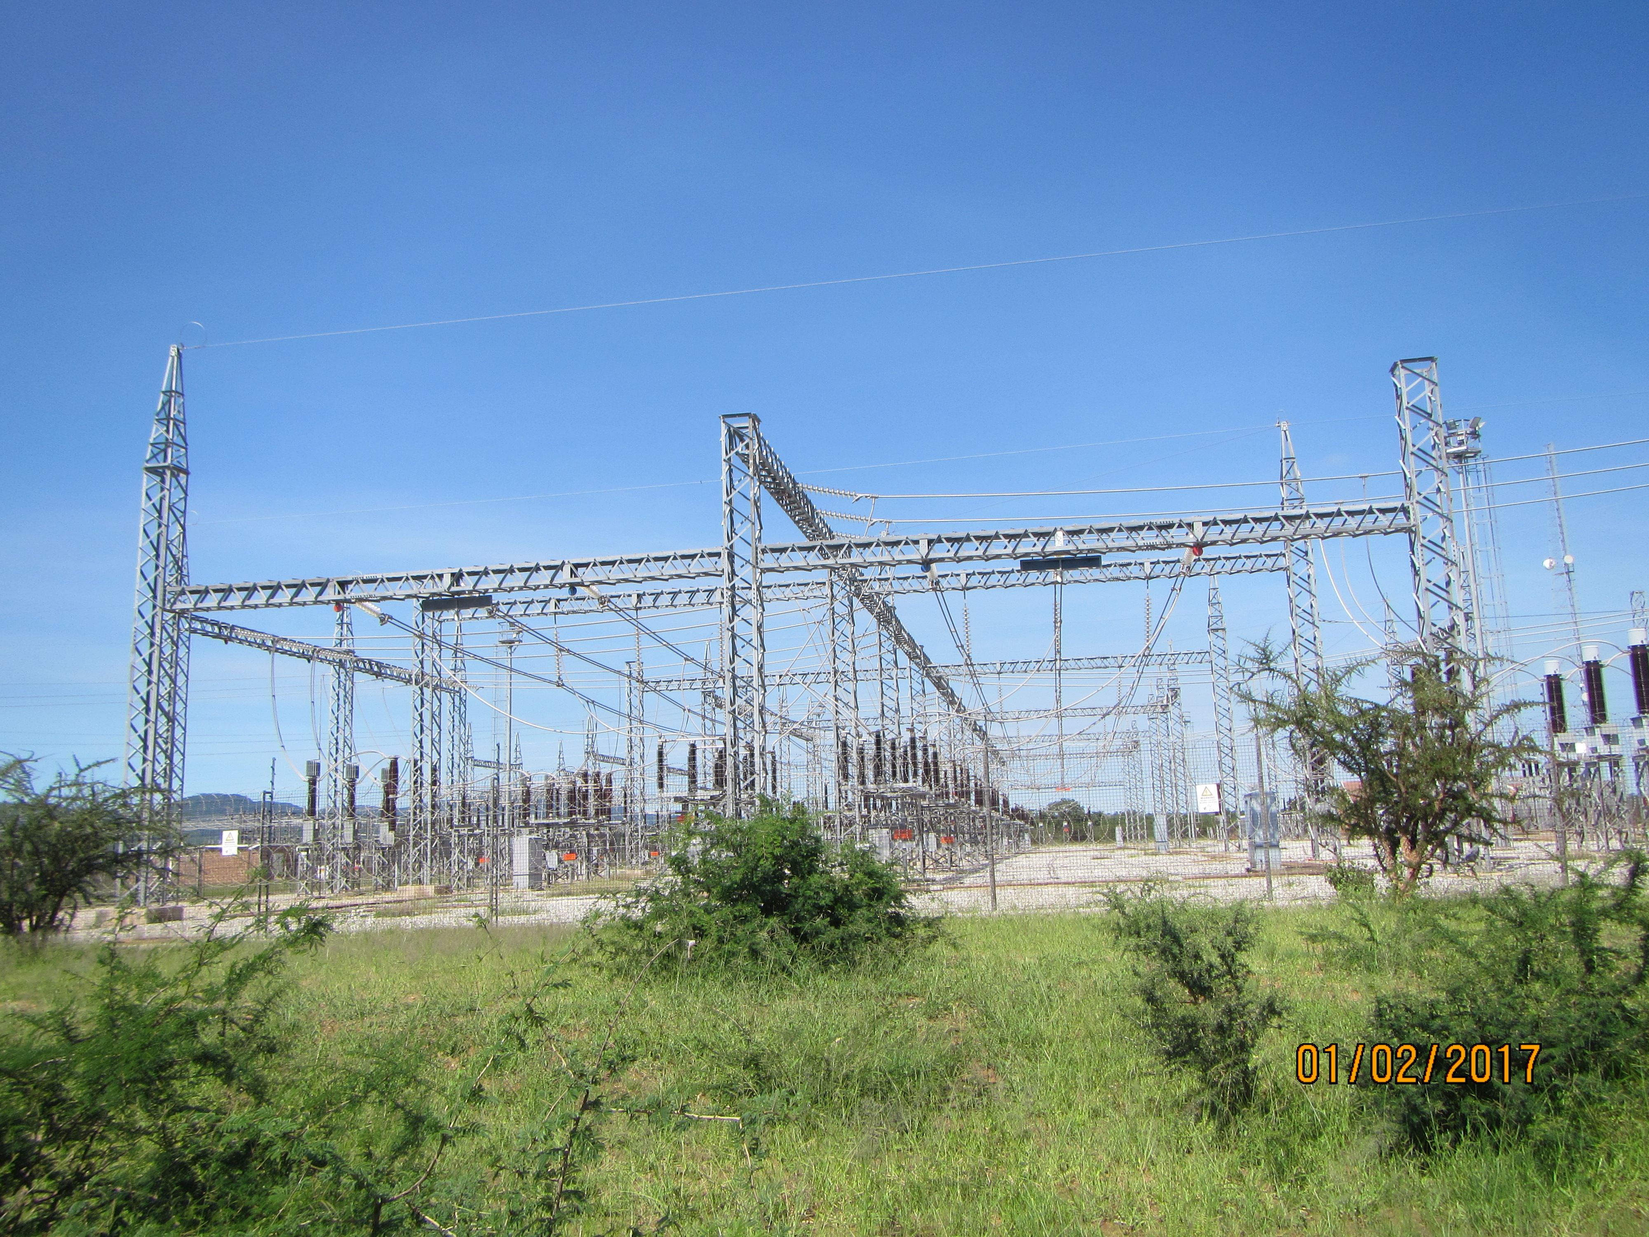
PREPARED BY:

P. O. Box 7068
Midrand
1685

ESKOM HOLDING SOC LIMITED
LIMPOPO EAST CORRIDOR STRENGTHENING PROJECT
PROPOSED CONSTRUCTION OF ±110KM 400KV POWER LINE FROM FOSKOR MTS TO SPENCER MTS WITHIN MOPANI DISTRICT MUNICIPALITY, LIMPOPO PROVINCE

APRIL 2017
This document presents the Draft Scoping Report for the Limpopo East Corridor Strengthening Project and the information and assessment presented is based on the information supplied by the ‘applicant’, Eskom Holdings SOC Limited, environmental baseline data collected during the field surveys conducted between October 2016 and February 2017.
 | Name | Signature | Date
Prepared By | B. MAKANZA
Approved By | B. TAENZANA
Revision Number | 1
Distribution

Prepared By Prepared For:
DIGES ESKOM HOLDINGS SOC LTD
Our Address: Address:
Suite 2 Eskom Megawat Park
546 Constantia Park 1 Maxwell Drive
16th Road Sunninghill
Midrand

Tel: 011 312 2878 Tel: 011 800 5145
Fax: 011 312 7824/086 750 4109 Fax: 086 602 9704
Email: brendam@diges.co.za E-mail: david.tunnicliff@eskom.co.za

EXECUTIVE SUMMARY

- BACKGROUND

The load profile undertaken for the Province showed that Spencer substation will be having a peak demand of 318MVA by 2018. Eskom Transmission Grid Planning therefore initiated a study to investigate possible alternatives and solutions to address the transformation constraints at Spencer MTS, as well as 275kV transmission network constraints on the network supplying Spencer MTS supply zone. The activities identified to address these constraints entailed the following:
- Construct a 400kV power line from Foskor Substation to Spencer Substation with a length of approximately 110km.
- Establish 400/132kV transformation and install 1 x 500MVA, 400/132kV at Spencer Substation; and
- Establish 400/275kV transformation at Foskor substation.
A separate project is currently underway to obtain the environmental approval of the 400/275kV transformation at Foskor substation. This report will thus focus on the proposed construction of the 400kV power line from Foskor substation to Spencer substation and the upgrade of Spencer substation.

According to Listing Notice 1 and 2 of the EIA Regulations, Government Notice R982, undertaking these activities will result in detrimental impacts to the environment. Eskom Holdings SOC Limited has therefore appointed DIGES Group to carry out the Environmental Impact Assessment for the proposed works in compliance with the EIA Regulations, Government Notice R982. As part of the Environmental Impact Assessment (EIA) application for the proposed development, a scoping phase is to be undertaken. This scoping report therefore identifies the issues that the Environmental Impact Assessment will examine and the scope of the assessment required to ensure that the EIA will conform to the requirements of the National Environmental Management Act No. 107 of 1998.

Project Description
The proposed project involves the construction and operation of the following infrastructure:
- ±120km 400kV power line from the existing Foskor substation to Spencer substation;
- Extension of Spencer substation by adding/constructing 400/132kV transformation yard and 1x500MVA, 400/132kV transformer; and
- The construction of a transformer oil holding dam with a capacity of 120m³.

Location
The proposed project is located within Mopani District Municipality and will span four Local Municipalities; Ba-Phalaborwa, Greater Letaba, Greater Tzaneen and Maruleng. The District Municipality is in the north east of Limpopo Province and can be accessed via the R71 from Tzaneen, R40 from Lydenburg, R81 from Polokwane and various district roads. The proposed alternative power line corridors will traverse across nature reserves, residential areas, mining areas, commercial and subsistence farms, natural areas and several rivers and drainage lines. Refer to Appendix C-1 for the Locality Map.
The land-use within the project area is largely comprised of nature reserves, residential, mining, commercial and subsistence farming. The farms are in private ownership and communal land owned by the Government and under the control of Traditional Authorities.

- REPORT LAYOUT
To address the information required as set in Appendix 2 of the EIA Regulations of December 2014, the Scoping Report will follow the structure or layout outlined below:
Section 1: Background – deals with background of the project including the objectives of this EIA and the process.
Section 2: Administrative, Legal and Policy Requirements – To facilitate the scoping assessment and understand the significance of the constructing and maintain the proposed development in the area, all relevant requirements from applicable laws, and provincial and local regulations are discussed and their relevance ascertained.
Section 3: Project description – locality, and technical details of the project, as well as need and desirability of the project.
Section 4: Alternatives evaluation – A description of the alternatives identified and being assessed.
Section 5: The receiving environment – a summary of the environment that will be potentially affected by the project activities.
Section 6: Public Consultation– a summary of the consultation process undertaken with stakeholders and Interested and Affected Parties (I&AP’s), and the issues identified during this process.
Section 7: Alternatives- This section identifies the activity alternatives including the no-go option.
Section 8: Potential impacts and Determination of Significance – A discussion of the anticipated impacts during the construction and operational phase.
Section 9: Plan of Study: details the steps to be undertaken when carrying out the EIA and outlines the Terms of Reference for the identified specialist studies required.
Section 10: Conclusions and recommendations
Section 11: References

Appendices: Appendices relating to Scoping Phase are collated at the back of the document. The following documents form the Appendices of the Report:

- APPROACH TO THE STUDY
A Scoping and Environmental Impact Assessment was prescribed to assess the damage that will be done during the project cycle (construction, operation and decommissioning) as the activity falls under activities 14 and 27 of R983, and 9 of R984 which are listed in the table below.
Relevant Government Notice | Activity | Description | Applicability
R983 | 14 | The development of facilities for the storage or for the storage and handling of a dangerous good where such storage occurs in containers with a combined capacity of 80 cubic metres or more but not exceeding 500 cubic metres. | The oil holding dam for the 400/132kV transformer has a capacity of 120m³.
R983 | 27 | The clearance of an area of 1 hectares or more, but less than 20hectares of indigenous vegetation. | The expansion of the transformation yard requires ±1 ha.
R984 | 9 | The development of facilities or infrastructure for the transmission and distribution of electricity with a capacity of 275 kilovolts or more, outside an urban area or industrial complex. | Construction of ±120km, 400kV power line

The scoping phase entailed the following:
- Site visits to assess and identify alternatives;
- Identification of Interested and Affected parties
- Notification of the relevant stakeholders
- Public participation meetings, newspaper adverts and placement of site notices to inform the public
- Identification of specialists studies needed to evaluate the potential impacts; and
- Drafting of a plan of study explaining how the environmental impact assessment will be undertaken.

- PRELIMINARY FIELD INVESTIGATION
Determination of the Current Environmental Baseline Conditions through review of existing information as well as field surveys to establish site specific issues and sensitivity. Literature relating to the project area was reviewed to comprehend the status quo of the project area and its surroundings. Topographic and thematic maps outlining the project area were also utilized. DIGES Group conducted several site inspections from November 2016 to February 2017. During the field surveys, most of the project area were covered with a vehicle where access routes existed. Photographs were taken to document the existing environmental conditions on site.

- PUBLIC PARTICIPATION
Public Participation Process was done according to Regulation 41 of the Government Notice R982 in terms of the Environmental Impact Assessment Regulation amended in December 2014 that set out the need and the processes that have to be followed when doing public participation.

An active approach was taken to identify potential Interested and Affected Parties. The proposed alternative routes were mapped and the affected farms were identified and an on-site survey was carried out to identify the land owners and their contact details. Where land owners were not identified on site, Windeed and the Department of Rural Development and Land Reform were consulted. Stakeholder Government Departments and affected Municipalities were also contacted to get the contact details of the relevant officials. Notification letters and Background Information Documents were submitted to stakeholders via e-mails and post.

Notices containing all information concerning the proposed development were placed on site to inform local people about the proposed project.

The project was advertised in the Mopani, Letaba, Hoedspruit, Phalaborwa Heralds and The Citizen from the 20th to the 24th of January 2017.
Public meetings were held from the 8th of February to the 3rd of March 2017.

- ALTERNATIVES
Corridor/Location Evaluation
The proposed activity has two alternative power line corridors with a deviation corridor starting from Mabyepelong to Ga-Moroko village.
86% of the area is in a natural or near-natural state and this is largely due to the conservation and protected areas that are within the District Municipality. The land cover within the protected and conservation area is characterized of woodland, open bushland, thicket or dense bushland and grassland. Foskor substation and some sections of the power line corridors traverse across mining areas in Phalaborwa and Gravelotte. Rural settlements are located in areas surrounding Spencer substation and subsistence agriculture and grazing also occurs close to the settlements. Commercial agriculture is also concentrated along the Groot Letaba River.
An initial assessment of these two corridors and substation site was done and at the Environmental Impact Assessment Phase, the specialist studies will also be undertaken to select the corridor that is preferable in terms of minimum environmental damage, accessibility during maintenance, and the interested and affected parties’ concerns.
Activity Alternatives
Power can be transmitted by either overhead power lines or underground power lines. The advantages and disadvantages for installing either the underground or the overhead power lines are mainly related to magnetic fields, engineering and costs. The advantages and disadvantages of both types of power lines were taken into account and overhead power lines were preferred and there will be no further assessment of the underground lines
Access Routes
Access to the power line route will be from the existing village access roads and the existing tracks within the nature reserves. Where no access exists near to the power line route, access tracks will be created which will suite the nature of the terrain and the activities undertaken within the area.
Substation Structure
Substations are built to ESKOM’s specific standards in terms of their structure and layout for operation and maintenance purposes. The proposed 400/132kV transformation yard and 1x500MVA, 400/132kV transformer is therefore expected to be generic with standard specification facilities.
Operation Alternatives
Operation alternatives were not considered because ESKOM has standards and regulations in place for the operation and maintenance of 400kV power lines and 400/132kV substations.
No-go Alternatives
The ‘no-go’ alternative assumes that the activity does not go ahead implying that the current state does not change; power lines and substation upgrade will not be constructed. This option would entail not strengthening the existing network in order to test the robustness of the Spencer Network.

- POTENTIAL IMPACTS
Risks and key issues were identified through an internal process based on similar developments and site visits. The identified impacts included the following:
- Biodiversity impacts;
- Hydrological impacts;
- Soil/Land Impact
- Atmospheric impact;
- Visual and noise impact;
- Heritage and archeological impacts;
- Tourism related impacts;
- Land use impacts; and
- Socio-economic Impacts

- PLAN OF STUDY
The Plan of Study (PoS) for the Environmental Impact Assessment Phase has been prepared in order to meet the requirements of the EIA Regulations, Government Notice R982 as outlined in Appendix 2, Section 2(i) of EIA Regulations, Government Notice R982. The purpose of the PoS is to outline how DIGES will carry out the Environmental Impact Assessment for the proposed development. The PoS includes the following;
- Description of the proposed activity;
- Terms of Reference for the specialist studies to be undertaken;
- The methods for assessing the impacts; and
- An indication of when the Competent Authority will be consulted. A projected timeframe is also included.

- CONCLUSION
A baseline survey was carried out at scoping phase to identify the potential biophysical and socio-economic impacts for the proposed area. Avi-fauna, Agricultural Potential, Biodiversity, Heritage, Socio-economic, Tourism, Visual, and Wetland Delineation specialist studies will be undertaken to assess the potential impacts identified at the scoping phase. These studies will form part of the Environmental Impact report. An Environmental Management Programme will be compiled as per Appendix 4 of Government Notice R982, to mitigate the identified negative impacts.

TABLE OF CONTENTS
1. INTRODUCTION 22
1.1 Introduction 22
1.2 Details of Environmental Impact Assessment Practitioner (EAP) 23
1.3 Background to EIA Study 24
1.3.1 Screening Phase 25
1.3.2 Scoping and Environmental Impact Assessment Phase 25
1.3.3 Environmental Impact Phase 25
1.3.4 Structure and Content of the Scoping Report 26
1.3.5 Assumptions and Limitations 30
1.4 The process to date 31
2. ADMINISTRATIVE, LEGAL AND POLICY REQUIREMENTS 33
2.1 The Constitution of the Republic of South Africa 33
2.2 National Environmental Management Act (Act No. 107 of 1998) 34
2.2.1 Environmental Impact Assessment (EIA) Regulations 35
2.3 Other Relevant Legislation 36
3. PROJECT DESCRIPTION 42
3.1 Need and Desirability 42
3.1.1 Eskom’s Mandate 42
3.1.2 Transmission System 42
3.2 Project Activities 45
3.3 Location 46
3.3.1 Regional Context of the Project 46
3.3.2 Substation Locations 47
3.3.3 Land Ownership 48
3.5 Technical Details of the Project 57
3.5.1 Requirements for the 400kV Power line 57
3.5.2 Power line Infrastructure 57
3.5.3 Electric and Magnetic Fields (EMF) 60
3.5.4 60
3.6 Pre-construction and Construction Phase 61
3.6.1 Pre-Construction 61
3.6.2 Construction Phase 62
3.6.3 Substation Construction 64
3.6 Bulk Services and Infrastructure 65
3.6.1 Water 65
3.6.2 Sewerage 65
3.6.3 Storm water 65
3.6.4 Solid waste 65
3.7 Operation and Maintenance of the Power line 65
3.8 Decommissioning Phase 66
4. ALTERNATIVES 67
4.1 Location Alternatives 67
4.1.1 Power line Corridor 1 69
4.1.2 Power line Corridor Alternative 2 72
4.1.3 Foskor-Spencer Deviation 1a 75
4.1.4 Substation Extension 75
4.1.4 No-Go Action Alternatives 76
4.1.5 Access Routes 77
4.2 Activity Alternatives 77
4.3 Scheduling Alternatives 78
5. THE RECEIVING ENVIRONMENT 79
5.1 Climate 79
5.2 Soils 80
5.3 Surface Water Resources 80
5.4 Ground water 82
5.5 Geological conditions 83
5.5.1 Lithostratigraphy 83
5.6 Topography 83
5.7 Flora & Fauna 83
5.7.1 Flora 83
5.7.2 Fauna 88
5.7.3 Avi-fauna 88
5.8 Critical Biodiversity Areas 88
5.8.1 Protected and Nature Reserves 91
5.9 Land use 92
5.10 Archaeological and palaeontological attributes 93
5.11 Visual Environment 93
5.12 Air Quality 93
5.13 Socio-Economic Environment 96
5.13.1 Population Demographics 96
5.13.2 Gender 97
5.13.3 Language 97
5.13.4 Level of Education 97
5.13.5 Employment Profile 97
5.13.6 Households by Dwelling Type 98
5.13.7 Access to Services 98
5.13.8 Economic Activity 99
5.13.9 Tourism 100
6. PUBLIC PARTICIPATION PROCESS 101
6.1 Introduction 101
6.2 Objectives and approach to the PPP 101
6.3 Public Participation Team 102
6.4 Limitations Associated with Public Participation Process 103
6.5 Summary of PP Activities undertaken 103
6.6 Methodology Adopted 104
6.6.1 Stakeholder Identification 106
6.6.2 Giving Notice to all Interested and Affected Parties 107
6.7 Meetings 108
6.7.1 Meetings with Landowners 109
6.7.2 Meetings with Traditional Authorities (or Community Property Association) 109
6.7.3 Meetings with Local Government (Municipalities) 110
6.8 Comments and Responses Report 110
6.9 Concluding Remarks and Recommendations 110
6.10 Way Forward 112
7. POTENTIAL IMPACTS AND DETERMINATION OF SIGNIFICANCE 113
7.1 Potential Impacts 113
7.1.1 Biodiversity Impacts 113
7.1.2 Soil/Land Impacts 114
7.1.3 Hydrological Impacts 115
7.1.4 Land use 116
7.1.5 Waste Generation 116
7.1.6 Air Quality 116
7.1.7 Archaeological Impacts 116
7.1.8 Visual Impacts 117
7.1.9 Noise 117
7.1.10 Health and Safety 117
7.1.11 Socio-economic 118
7.1.12 Infrastructure Framework: Transportation 120
7.1.15 Increased Safety Risk 120
8. PLAN OF STUDY 121
8.1 Introduction 121
8.2 Project Description 121
8.3 Location 122
8.4 Specialists’ Assessment 122
8.4.1 Terms of Reference 123
8.5 Methodology used to analyse impacts 128
8.5.1 Characteristics of Environmental Impacts 129
8.6 Environmental Impact Reporting 134
8.7 Environmental Management Programme (EMPr) 135
8.8 Public Participation Process 135
8.9 EIA Programme 136
9. CONCLUSION 137
10. REFERENCES 139

TABLE OF FIGURES
Figure 1-1: Locality Map 22
Figure 1-2: Summary of EIA Process 28
Table 2-1: List of Activities for the Power line and Associated Spencer MTS works 35
Table 2-2: Legislative Framework 36
Figure 3-1: Electricity Provision in South Africa 42
Figure 3-2: Transmission Network 43
Table 3-1: Load Forecasts for Limpopo CLN 44
Figure 3-3: Regional Context of Project Area 47
Figure 3-4: Spencer Substation 48
Figure 3-5: Foskor Substation 48
Figure 3-6 48
Table 3-2: Farm Details and ownership 49
Figure 3-7: Cross Rope Suspension Tower 58
Figure 3-8: Guyed Suspension Tower 59
Figure 3-9: Self-Supporting Tower 59
Figure 3-10: Example of clearing at tower sites 62
Figure 3-11: Example of Construction/Storage Camp 63
Figure 3-12: Example of excavated pits 63
Figure 3-13: Laydown Areas 64
Table 4-1: Corridor Selection Matrix 68
Figure 4-1: First Section of the corridor from Foskor Substation 69
Figure 4-2: Turn Point T3 to T4 70
Figure 4-3: Last section of the corridor to Spencer substation 71
Figure 4-4: First Section of the Corridor from Foskor substation 72
Figure 4-5: Turn points P1-P2 73
Figure 4-6: The corridor will run parallel the 132kV line 74
Figure 4-7: Last Section of Corridor to Spencer Substation 74
Figure 4-8: Locality of the Deviated Corridor 75
Figure 4-9: Substation Layout 76
Table 5-1: Average Monthly minimum temperature (ºC) 79
Table 5-2: Average Annual Rainfall, 2014-2016 80
Table 5-3: Prominent Rivers within the Project Area 80
Figure 5-1: Merekome River 81
Figure 5-2: Dam near Xihoko 81
Figure 5-3: Olifants Water Management Area 82
Figure 5-4: Vegetation types within the project area 85
Figure 5-5: Vegetation in some areas near Selati Game Reserve 86
Figure 5-6:Vegetated areas near Spencer Substation 87
Table 5-4: CBA Categories 89
Figure 5-7: CBA Areas within Project Area 90
Figure 5-8: Protected areas and nature reserves within project area 94
Figure 5-9: Land cover within project area 95
Table 5-6: Population and Municipal Land Coverages 96
Table 6-1: Roles and Experience of PP team 102
Table 6-2: Summary of PP Activities 103
Figure 6-1: Role Players in the PPP 105
Figure 6-2: Role Players 105
Table 6-3: Advertising 108
Table 6-4: Concluding Remarks 111
Table 8-1: List of Specialist Studies to be carried out. 123
Table 8-2: Criteria for Site and Route Selection 128
Table 8-3: Scoring of Intensity 130
Table 8-4: Scoring of Extent 130
Table 8-5: Scoring for Duration 131
Table 8-6: Scoring for Probability 131
Table 8-7: Scoring for Reversibility of Impact 132
Table 8-8: Scoring for Resource Loss 132
Table 8-9: Score for Mitigatible 132
Table 8-10: Categories for Cumulative Impact 133
Table 8-11: Categories for the Status of the Impact 133
Table 8-12: Significance Ratings of Impacts 134
Table 8-13: EIA Programme 136

LIST OF APPENDICES
Appendix A: EAPs’CV
Appendix B-1: Spencer Substation Preliminary Layout
Appendix B-2: Transformer Oil Dam Facility Illustration
Appendix B-3: Site Photos
Appendix C: Maps
Appendix C-1: Locality Map
Appendix C-2: Vegetation Map
Appendix C-3: Protected Areas Map
Appendix C-4: CBA Maps
Appendix C-5: Land cover Map
Appendix D: Public Participation
Appendix D-1a: I & AP Database
Appendix D-1b: List of Landowners
Appendix D-2:
Appendix D-2a: Background Information Document
Appendix D-2b: Proof of Notification
Appendix D-3: Newspaper Adverts
Appendix D-4: Site Notices
Appendix D-5a: Meeting Invites
Appendix D-5b: Minutes of Focus Meetings
Appendix D-5c: Circulation of Minutes
Appendix D-5d: Attendance Register
Appendix D-6a: Comments and Response Report
Appendix D-6b: Written Comments

LIST OF ABBREVIATIONS
APNR Associated Private Nature Reserves
CARA Conservation of Agricultural Resources Act
DEA Department of Environmental Affairs
DEAT Department of Environmental Affairs and Tourism
DSR Draft Scoping Report
DWA Department of Water Affairs
DWS Department of Water and Sanitation
DME Department of Minerals and Energy
EA Environmental Authorization
EAP Environmental Assessment Practitioner
ECA Environment Conservation Act
EIA Environmental Impact Assessment
EIR Environmental Impact Report
EMP Environmental Management Programme
GDP Gross Domestic Product
HA Hectares
IAP Interested and Affected Parties
IEM Integrated Environmental Management
LED Local Economic Development
MTS Main Transmission Substation
NBA National Biodiversity Assessment
NEMA National Environmental Management Act
NHRA National Heritage Resources Act
PNR Private Nature Reserve
PP Public Participation
PPP Public Participation Process
ROW Right of Way
SAHRA South African Heritage and Resources Agency
SANS South African National Standards
TDP Transmission Development Plan
V Voltage
WMA Water Management Area

DEFINITIONS
- Affected environment: Those parts of the socio-economic and biophysical environment impacted on by the development.
- Alien Vegetation: Alien vegetation is defined as undesirable plant growth which shall include, but not be limited to; all declared category 1, 2 and 3 listed invader species as set out in the Conservation of Agricultural Resources Act (CARA) regulations. Other vegetation deemed to be alien shall be those plant species that show the potential to occupy in number, any area within the defined construction area and which are declared to be undesirable.
- Alternatives: A possible course of action, in place of another, that would meet the same purpose and need (of proposal). Alternatives can refer to any of the following but are not limited hereto: alternative sites for development, alternative layouts or alternative designs, alternative processes and materials. In Integrated Environmental Management, the so-called "no action" alternative may also require investigation in certain circumstances;
- Assessment: The process of collecting, organizing, analyzing, interpreting and communicating data that is relevant to some decision.
- Bio-regional plan: inform land-use planning and decision-making by a range of sectors whose policies and decisions impact on biodiversity.
- Conservation Areas: are areas of land not formally protected by law but informally protected by the current owners and users; and managed at least partly for biodiversity conservation.
- Critical Biodiversity Areas (CBA1): are areas that are
- Irreplaceable;
- required to meet biodiversity pattern and/or sites that are required to meet each ecological process targets; and
- natural and near-natural sites including some degraded areas.
- Critical Biodiversity Areas (CBA2): these are:
- Best design selected sites;
- Areas selected to meet biodiversity pattern and/or sites that are required to meet each ecological process targets;
- Alternative sites may be available to meet targets; and
- natural and near-natural sites including some degraded areas, including areas modified by agriculture.
- Development: The act of altering or modifying resources to obtain potential benefits.
- Ecological Support Areas (ESA1): are areas that are natural, near natural and degraded areas supporting CBAs by maintaining the ecological processes on which CBAs depend.
- Ecological Support Areas (ESA2): Areas with no natural habitat that is important for supporting ecological processes.
- Environment: The external circumstances, conditions and objects that affect the existence and development of individual, organism or group. These circumstances include biophysical, social, economic, historical, cultural and political aspects.
- Environment Authorization: A written statement from the Department of Environmental Affairs that records its approval of a planned undertaking and the conditions of such an approval.
- Environmental impact: The degree of change in environmental components resulting from the effects of an activity on the environment, whether desirable or undesirable. Impacts may be the direct consequence of an organization’s activities or may be indirectly caused by them.
- Environmental impact assessment: A process of examining the environmental effects of a proposed development.
- Environmental issue: A concern felt by one or more parties about some existing, potential or perceived environmental impact.
- Environmentally Sensitive Area: An area designated in regional or local land use plans, or by a local, regional, provincial or federal government body as being sensitive to disturbance or identified by an applicant as being sensitive for some reason.
- Erosion: The process by which material, such as rock or soil, is worn away or removed by wind or water.
- Evaluation: The process of weighing information, the act of making value judgments or ascribing values to data to reach a decision;
- Hazardous substance: Any substance that is of risk to health and safety, property or the environment. Hazardous substances have been classified under the SANS 10228-B The identification and Classification of Dangerous Goods and Substances’.
- Heritage Site: A site that contains either archaeological artefacts, graves, buildings older than 60 years, meteorological or geological fossils, etc.
- Integrated environmental management (IEM): is a process of integrating environmental, Socio-economic and cultural factors in decision making to promote sustainable development. Principles underlying IEM provide for a democratic, participatory, holistic, sustainable, equitable and accountable approach.
- Landowner: The individual or company that owns the land through which the servitude crosses.
- Mitigation: the elimination, reduction or control of the adverse environmental effects of the project, and includes restitution for any damage to the environment caused by such effects through replacement, restoration, compensation or any other means.
- Monitoring Programme: The program for observing the potential environmental effects of a project, resolving specific outstanding environmental issues, and determining the action required based on the result of these activities.
- National protected area means-
a) a special nature reserve;
b) a national park; or
c) a nature reserve or protected environment-
(i) managed by a national organ of state; or (ii) which falls under the jurisdiction of the Minister for any other reason.
- Nature reserve means-
(a) an area declared, or regarded as having been declared, in terms of section 23 of the National Environmental Management: Protected Areas Act, 2003, as a nature reserve; or
(b) an area which before or after the commencement of this Act was or is declared or designated in terms of provincial legislation for a purpose for which that area could in terms of section 23(2) of the National Environmental Management: Protected Areas Act, 2003, be declared as a nature reserve.
- No Natural Areas Remaining: are areas without intact habitat remaining.
- Other Natural Areas: are areas that still contain natural habitat but that are not required to meet biodiversity targets.
- Power line: An overhead line of whatever voltage, erected for the conducting of electricity.
- Protected Area: Protected environment means -
(a) an area declared, or regarded as having been declared, in terms of section 28 of the National Environmental Management: Protected Areas Act, 2003, as a protected environment;
(b) an area which before or after the commencement of this Act was or is declared or designated in terms of provincial legislation for a purpose for which that area could in terms of section 28(2) of the National Environmental Management: Protected Areas Act, 2003, be declared as a protected environment; or
(c) an area which was a lake area in terms of the Lake Areas Development Act, 1975 (Act No. 39 of 1975), immediately before the repeal of that Act by section 90(1) of the National Environmental Management: Protected Areas Act, 2003,
- Private nature reserve means privately owned land declared as a nature reserve under section 23 of the National Environmental Management: Protected Areas Act, 2003.
- Right of Way (ROW): The strip of land acquired for which ESKOM has obtained the rights for construction and operation of the distribution line.
- Scoping: The process of determining the key issues to be addressed in an environmental assessment. The main purpose of scoping is to focus the environmental assessment on a manageable number of important questions. Scoping should also ensure that only significant issues and reasonable alternatives are examined;
- Stakeholder: A stakeholder is any group or individual that may be potentially affected by a proposed project. Stakeholders typically include elected officials, government and non-government agencies, environmental and other special interest groups, developers, educators, landowners and members of the public.
- Study Area: The area within the spatial boundaries of the scope of the environmental and socio-economic effects assessment.
- Substation: A network of switching, interrupting and voltage-transforming apparatus for the purpose of transferring power from the electrical transmission system to the local electrical distribution system for utilization by electrical customers.
- Water body: Means a body containing water and includes dams and wetlands, whether ephemeral or permanent.
- Water course: Means any river, stream and natural drainage channel whether carrying water or not.

INTRODUCTION

1.1 Introduction
Eskom Holdings SOC Ltd (herein referred to as Eskom) intends to construct ±110km 400kV power line from the existing Foskor Main Transmission Substation (MTS) near Phalaborwa to the existing Spencer Main Transmission substation near Giyani within Mopani District, Limpopo Province. In addition, Spencer MTS will be upgraded by adding a 400/132kV transformation yard and 1 x500MVA, 400/132kV transformer. Reference is made to the Figure 1-1 for locality of the project.

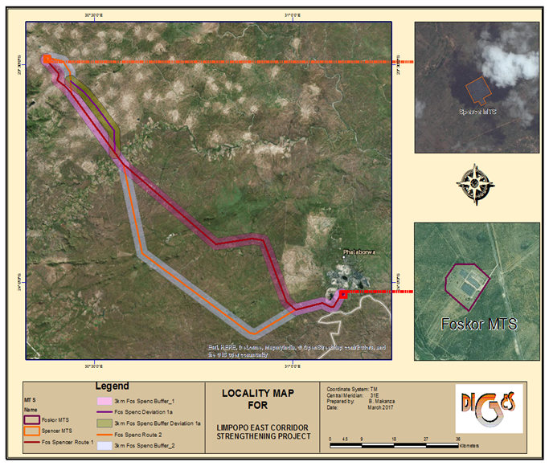
Figure 1-1: Locality Map

The proposed activities to be undertaken (together with the infrastructure to be provided) are listed as having detrimental impacts on the environment and as such requires that an Environmental Impact Assessment be undertaken prior to the commencement of the project. Eskom Holdings SOC Ltd has therefore appointed DIGES to lodge an application with the Department of Environmental Affairs for the proposed development in terms of Section 24 and 24D of the National Environmental Management Act (Act No.107 of 1998). The EIA will be undertaken to comply with the Environmental Impact Assessment Regulations (Government Notice R982) of December 2014.

1.2 Details of Environmental Impact Assessment Practitioner (EAP)
Section 13 of EIA Regulations, Government Notice No. R982 clearly indicates that an Environment Assessment Practitioner (EAP) should be independent and have expertise in conducting environmental impact assessments, including knowledge of the Act, and any guidelines that have relevance to the proposed activity.

DIGES Group is a black owned BBB-EE consultancy company established in 2004 and offers services in the geo-environmental sector. The company has successfully completed many Environmental Impact Assessments for different developments.
Declaration of Independence
DIGES Group is an independent consultant and hereby declare that it does not have any financial or other vested interest in the undertaking of the proposed activity, other than remuneration for the work performed in terms of the National Environmental Management Act (Act No. 107 of 1998). In addition, remuneration for services provided by DIGES is not subjected to or based on the approval of the proposed development by the Competent Authority.

The details for the project EAP and compiler of this report are given below as per Section 2(a) of Appendix 2 of the EIA Regulations R982.

Brenda Makanza (Pr. Sci. Nat)
- BSc (Hons) Environmental Science (NUST, 2004),
- Professional Diploma GIS (Universitat of Salzburg, 2015)
- Certificate GIS (University of Johannesburg, 2012)
A dedicated and passionate Environmentalist with valuable theoretical and experiential acumen in the areas of environmental conservation and administration. I have 12 years’ experience gained through direct involvement in a number of conservation initiatives. Currently a Senior Environmental Consultant of DIGES Group responsible for leading, administrating and completing assessments on Environmental Impact Assessments, as well as overseeing studies, interpreting technical reports and appendices regarding the same.
I leverage academic skills gained through an honours level degree in Environmental Science & Health and Post Graduate Certificates in Integral Water Management and Geo-informatics; alongside the proficient ability to actively and valuably participate in the development, design and implementation of environmental / conservation management policies and consultation initiatives; thereby supporting the highest standards of Environmental Management and Sustainable Development, in all undertakings. Reference is made to the CV attached in Appendix A.

1.3 Background to EIA Study
An Environmental Impact Assessment (EIA) is a proactive and systematic process where both positive and negative potential environmental impacts associated with certain activities are assessed. Every Environmental Impact Assessment project has two objectives namely, process and content objectives. The process objectives are to ensure that the process is open, transparent and inclusive, supplies stakeholders with sufficient information, affords them ample opportunity to contribute and makes them feel that their contributions are valued. The content objectives of the project are in the form of “hard” information: facts based on scientific and technical study, statistics or technical data.

Section 24(4) of NEMA prescribes that the procedures for the investigation, assessment and communication of the potential consequences or impacts of activities on the environment must, inter alia, with respect to every application for environmental authorisation, ensure that the general objectives of integrated environmental management are taken into account. The Environmental Impact Assessment should include an investigation of the potential consequences or impacts of the alternatives to the activity on the environment and assessment of the significance of those potential consequences or impacts, including the option of not implementing the activity. Section 24(2) indicates that the Minister can publish a list of activities that that may not commence without an environmental authorization. Three listing notices, Listing Notice 1, 2 and 3 were published in 2014 and these listings determine whether a Basic Assessment (Listing Notice 1 and 3) or Scoping and Environmental Impact Assessment (Listing Notice 2) should be undertaken.

1.3.1 Screening Phase
Screening is the first stage in the EIA process whereby the EAP determines if an EIA is required for the project in terms of the EIA Regulations Government Notice R982 and its associated Listings. The screening process was carried out and it determined that based on the project activities, a scoping and EIA process was required as the construction of the 400kV power lines is listed in Listing Notice 2. In addition, the substation extension/upgrade and the construction of the transformer oil holding dam is listed in Listing Notice 1.

1.3.2 Scoping and Environmental Impact Assessment Phase
The second stage of the EIA process is the scoping phase which entails a baseline study and preliminary site survey to ascertain the biophysical conditions of the site and identify the anticipated negative and positive impacts of the development in relation to the environment. This phase also includes public and stakeholder participation. Guidance in relation to the scoping phase is provided in Regulation 21 of the EIA Regulations, Government Notice R982 of 2014.

1.3.2.1 Objectives of the Scoping Report
Based on the above description of the process, the main objectives of this Scoping Report are thus:
- To engage stakeholders at an early stage of the proposed development so that they may contribute their views and provide relevant information;
- To define the scope of the EIA which will accompany any planning application;
- To identify the potential significant and non-significant environmental effects of the proposed development; and
- To define the methodologies to be used in the EIA to assess these effects.

1.3.3 Environmental Impact Phase
The third phase entails the undertaking of an EIA as outlined in Plan of Study included in the Scoping Report. As a means of determining the significance of the various impacts that can or may be associated with the power line and Spencer substation upgrade, a series of assessment criteria are used for each impact. These criteria include an examination of the nature, extent, duration, intensity and probability of the impact occurring, and assessing whether the impact will be positive or negative for the biophysical and social environments at the site and surrounding areas. Mitigatory measures are compiled based on the alternatives that will have the least negative impact on the surrounding environment. These recommended describe possible actions for the reduction of the significant negative environmental impacts identified in the assessment and will detail the management of the impact through monitoring and control, and the involvement of the I&APs in consideration of mitigating measures, where appropriate.

Figure 1-2 on page 6 shows the tasks to be performed during the scoping and EIA which are dictated by the Regulations published in Government Notice R982 under Sections 24 (5) and 44 of the National Environmental Management Act (Act No. 107 of 1998).

1.3.4 Structure and Content of the Scoping Report

1.3.4.1 Structure of the Report
To address the information required as set in Appendix 2 and to present it in a clear manner, the following structure or layout outlined below was used:
Section 1: Background – deals with background of the project including the objectives of this EIA and the process.
Section 2: Administrative, Legal and Policy Requirements – To facilitate the scoping assessment and understand the significance of the constructing and maintain the proposed development in the area, all relevant requirements from applicable laws, and provincial and local regulations are discussed and their relevance ascertained.
Section 3: Project description – locality, and technical details of the project, as well as need and desirability of the project.
Section 4: Alternatives evaluation – A description of the alternatives identified and being assessed.
Section 5: The receiving environment – a summary of the environment that will be potentially affected by the project activities.
Section 6: Public Consultation– a summary of the consultation process undertaken with stakeholders and Interested and Affected Parties (I&AP’s), and the issues identified during this process.
Section 7: Alternatives- This section identifies the activity alternatives including the no-go option.
Section 8: Potential impacts and Determination of Significance – A discussion of the anticipated impacts during the construction and operational phase.
Section 9: Plan of Study: details the steps to be undertaken when carrying out the EIA and outlines the Terms of Reference for the identified specialist studies required.
Section 10: Conclusions and recommendations
Section 11: References

Appendices: Appendices relating to Scoping Phase are collated at the back of the document.

Pre-EIA
Investigate load restraints
Identify activity to address restraints
Site Route Selection
Alternative Routes Alternative
PROJECT
Activity, Alternative Routes
Scoping
SCOPING AND PLAN OF STUDY
Baseline study
Identification of impacts
Terms of Reference for EIA Phase
Compilation of draft report.
PUBLIC PARTICIPATION
Identification of I & APs
Notification of I & Aps
Advertising
Site Notices
Draft Scoping Report & PoS
DEA
Final Scoping Report & PoS
Stakeholders to comment on DSR for 30 days
DEA
Revise report and incorporate comments
Submit Application
EIA
Specialists studies integration;
Impact Analysis;
Definitive Route Selection; and
Mitigation and Impact Management.

Draft EIR and EMPr
Final EIR and Draft EMPr
Review of Draft report by stakeholders for 30 days
DEA
DEA
Issuing of Environmental Authorisation
Stakeholders notified of DEAs Decision within 14 days
Figure 1-2: Summary of EIA Process

1.3.4.2 Content of the Scoping Report
The scoping report was compiled as per the guidelines indicated in Appendix 2 of the EIA Regulations, Government Notice R982. Table 1-1 summarizes the information required and identifies where in the report the information can be found:
Table 1-1: Scoping Report
Information as Required in Appendix 2 of EIA Regulations R982 | Relevant Section in the Report
2 (a)(i) details of the EAP who prepared the report; and | Page i
2 (a) (ii) details of the expertise of the EAP; | Section 1.2, Appendix A
2 (b) (i) the location of the activity, including the 21-digit Surveyor General code of each cadastral land parcel; | Section 3.2.3 and Appendix D-1b
2(b) (ii) the location of the activity where available, the physical address and farm name; | Section 3.2.3 and Appendix D-1b
2(c) (i) A plan which locates the proposed activity or activities applied for at an appropriate scale or if it is a linear activity, a description and co-ordinates of the corridor in which the proposed activity or activities is to be undertaken; | Section 1 and Appendix C-1
2(d) (i) a description of the proposed activity, including all listed and specified activities triggered and being applied for; | Section 2.2.1
2(d) (ii) a description of the activities to be undertaken including associated structures and infrastructure. | Section 3.4
2 (e ) A description of policy and legislative context within which the development is proposed including an identification of all legislation, policies, plans, guidelines, spatial tools, municipal development planning frameworks and instruments that are applicable to the activity and have been considered in the preparation of the scoping report; and | Section 2
2(f) Need and Desirability for the proposed development including the need and desirability of the activity in the context of the preferred location; | Section 3.1
2(h)(i)the process followed to reach the proposed preferred site including details of all alternatives considered. | Section 4
2(h)(ii) details of the public participation process undertaken at each of the sites in terms of regulation 44 of these Regulations, including copies of the supporting documents and inputs; | Section 6
2(h)(iii) a summary of the issues raised by interested and affected parties, and an indication of the manner in which the issues were incorporated into the scoping document, or the reasons for not including them; | Section 6 and Appendix D-6a and D-6b
2(h) (iv) the environmental attributes associated with the sites identified focusing on the geographical, physical, biological, social, economic and cultural aspects; | Section 5
2(h)(v) the impacts and risks identified including the nature, significance, consequence, extent, probability and duration of the impacts including the degree to which these impacts-;  (aa) can be reversed;  (bb) may cause irreplaceable loss of resources; and  (cc) can be avoided, managed or mitigated. | Section 7, The significance, consequence, extent, probability will be fully assessed during the EIA Phase.
2(h)(vi) the methodology used in determining and ranking the nature, significance, consequences, extent, duration and probability of potential environmental impacts and risks associated with the alternatives; | To be assessed during the  EIA phase.
2(h)(vii) description of the advantages and disadvantages that the proposed activity and alternatives will have on the environment and on the community that may be affected; | Section 4.3
2(h)(viii) the possible mitigation measure that could be applied and the level of residual risk; | To be discussed in the Environmental Impact report
2(h)(ix) the outcome of the site selection matrix; | To be discussed in the Environmental Impact report
2(h)(x) if no alternatives sites were investigation, the motivation for not considering | Not applicable
2(h)(xi) a concluding statement indicating the preferred alternatives including preferred location of the activity | Section 9
2(i)(i) a plan of study for undertaking the environmental impact assessment process to be undertaken on the preferred site, including a description of the alternatives to be considered and assessed, including the option of not proceeding with the activity; | Section 8
2(i)(ii) a description of the aspects to be assessed as part of the environmental impact assessment process; | Section 8.1
2(i)(iii) Aspects to be assessed by specialists; | Section 8.4.1
2(i)(iv) a description of the proposed method of assessing the environmental aspects including a description of the proposed method of assessing alternatives including alternatives to be assessed by specialists; | Section 8.5
2(i)(v) a description of the proposed method of assessing significance; | Section 8.5.1.7
2(i)(vi) an indication of the stages at which the competent authority will be consulted; | Section 8.9
2(i)(vii) particulars of the public participation process that will be conducted during the environmental impact assessment process; and | Section 8.8
2(i)(viii)a description of the tasks that will be undertaken as part of the environmental impact assessment process; | Section 8.1
2(i)(ix) Identify suitable measures to avoid, reverse, mitigate or manage identified impacts and to determine the extent of the residual risks that need to be managed and monitored. | To be identified during the EIA Phase
2(j) an undertaking under oath or affirmation by the EAP in relation to the level of agreement between the EAP and interested and affected parties on the plan of study for undertaking the environmental impact assessment. | Section 9

1.3.5 Assumptions and Limitations
The following assumptions have been made during this study:
- It is assumed that the Applicant has provided adequate details with regards to the activities to be carried out and the processes to be followed during the construction and operation phase;
- The study team obtained its data on affected farm owners on Windeed-Deeds office and on- site visits undertaken by Potlako. It is assumed that this information is correct and has identified all the affected land-owners;
- Some areas were not easily accessed due to private land ownership;
- Information used to inform the assessment was limited to data and GIS coverage’s available at a local, regional and national level at the time of the assessment;
- The field assessment was carried out in the summer season hence it does not take into account seasonal variations; and
- It is also assumed that the public participation carried out is adequate and has identified all the Interested and Affected Parties.

1.4 The process to date
It should be noted that the approach adopted for the scoping study is not only to the scoping report goes beyond the identification of key issues for possible further investigation and assessment. Specialist reports and assessments of issues, by determining significance ratings, will be included in the Environmental Impact Report (EIR), thus providing additional information for decision-making.

In addition, the tasks to be performed during Scoping and Environmental Assessment are dictated by the Regulations published in Government Notice No. R.982 under Section 24 and 24D of the National Environmental Management Act (Act No. 107 of 1998).
The following general stages were followed as a basis for this assessment:
- Determination of the Current Environmental Baseline Conditions through review of existing information as well as field surveys to establish site specific issues and sensitivity. Literature relating to the project area was reviewed to comprehend the status quo of the project area and its surroundings. Topographic and thematic maps outlining the project area were also utilized. DIGES Group conducted several site inspections from November 2016 to February 2017. The first site inspection undertaken was sort of reconnaissance field survey where the different alternatives were briefly assessed. During the field surveys, most of the project area was covered with a vehicle where access routes existed. Photographs were taken to document the existing environmental conditions on site. Reference is made to Appendix B-3;
- Determination of Policy, Legal and Administrative Framework and requirements through identification of relevant legal documents, guidelines and planning procedures. These have been reviewed to ensure that necessary measures are included in the design and implementation of the project. In particular, those measures which could have an implication on environmental resources were identified. Reference is made to Section 2 of this report.
- Public Participation: An active approach was taken to identify potential Interested and Affected Parties. The proposed alternative routes were mapped and the affected farms were identified and an on-site survey was carried out to identify the land owners and their contact details. Where land owners were not identified on site, Windeed and the Department of Rural Development and Land Reform were consulted. Stakeholder Government Departments and affected Municipalities were also contacted to get the contact details of the relevant officials. See Appendix D-1a and D-1b for the list of stakeholders and land owners. Notification letters and Background Information Documents were submitted to stakeholders via e-mails and post. Reference is made to Appendix D-2b for the proof of notification.

Notices containing all information concerning the proposed development were placed on site to inform local people about the proposed project. Reference is made to Appendix D-4 for site notice photos.

The project was advertised in the Mopani, Letaba, Hoedspruit, Phalaborwa Heralds and The Citizen from the 20th to the 24th of January 2017. Public meetings were then held from the 8th of February to the 3rd of March 2017. See Appendix D-2a, D-3 and D-6a for the Background Information Document, newspaper adverts and comments and response report respectively.

ADMINISTRATIVE, LEGAL AND POLICY REQUIREMENTS

Environmental laws are formulated for realizing sustainable development strategy, preventing adverse impacts on the environment from implementation of plans and construction projects, and promoting coordinative development of the economy, society and environment. Most of South Africa’s environmental law and principles are regulated by legislation with the Constitution of the Republic of South Africa and the National Environmental Management Act (NEMA) 1998 being the cornerstone of environmental law. The following laws, principles and regulations have also been formulated to promote environmental sustainability including the interaction of the living and non-living environment which also have relevance to this project are discussed below:

2.1 The Constitution of the Republic of South Africa
Section 24 of the Constitution of South Africa guarantees basic human rights and provides guiding principles for society. The environmental rights in the constitution states:

“Everyone has the right –
- to an environment that is not harmful to their health or well-being; and
- to have the environment protected, for the benefit of present and future generations, through reasonable legislative and other measures that -
  - prevent pollution and ecological degradation;
  - promote conservation;
  - Secure ecologically sustainable development and use of natural resources while promoting justifiable economic and social development.”

The Bill of Rights in Chapter 2 of the Constitution entrenches the right to information; the right to freedom of expression; the right to participate in political activity; the right to administrative justice; and fundamental science, cultural, legal, economic and environmental rights. In addition, the Constitution requires all legislatures to facilitate public involvement in the legislative and other policy processes. Citizens have the right to engage in public initiatives and processes on an ongoing basis.

2.2 National Environmental Management Act (Act No. 107 of 1998)
The National Environmental Management Act aims to improve the quality of environmental decision-making by setting out principles for environmental management that apply to all government departments and organisations that may affect the environment. NEMA also creates a framework for facilitating the role of civil society in environmental governance (see below).
The Principles of National Environmental Management state that - (DEAT 1998b)
- Environmental management must place people and their needs at the forefront of its concern.
- Development must be socially, environmentally and economically sustainable.
- Environmental management must be integrated, acknowledging that all elements of the environment are linked and interrelated.
- Environmental justice must be pursued.
- Equitable Services Access to environmental resources to meet basic human needs and ensure human well-being must be pursued.
- Responsibility for the environmental health and safety consequences of a project or activity must exist throughout its life cycle.
- The participation of all interested and affected parties in environmental governance must be promoted.
- Decisions must consider the interests; needs and values of all interested and affected parties.
- The social, economic and environmental impacts of activities, must be considered, assessed and evaluated, and decisions must be appropriate in the light of such consideration and assessment.
- Decisions must be taken in an open and transparent manner, and Services Access to information must be provided in accordance with the law.
- The environment is held in public trust for the people, the beneficial use of which environmental resources must serve the public interest and the environment must be protected as the people’s common heritage.
- The costs of remedying pollution, environmental degradation and consequent adverse health effects must be paid for by those responsible for harming the environment.
- Sensitive, vulnerable, highly dynamic or stressed ecosystems, such as coastal shores, estuaries, wetlands, and similar systems require specific attention in management and planning procedures, especially where they are subject to significant human resource usage and development pressure.

2.2.1 Environmental Impact Assessment (EIA) Regulations
The Environmental Impact Assessment Regulations emanate from Section 24 (5) and 44 of NEMA and they set out the processes that must be followed to obtain an Environmental Authorization. Listing Notice 1 (Government Notice R983) and Listing Notice 2 (Government Notice R984) provide lists of activities that require a Basic Assessment and EIA respectively whilst Listing Notice 3 (Government Notice R985) lists activities that would require authorization if carried out in a specified geographical area. The proposed activities that Eskom intends to undertake are listed in Listing Notice 1 and 2 and are detailed below:
Table 2-2: List of Activities for the Power line and Associated Spencer MTS works
Relevant Government Notice | Activity | Description | Applicability
R983 | 14 | The development of facilities for the storage or for the storage and handling of a dangerous good where such storage occurs in containers with a combined capacity of 80 cubic metres or more but not exceeding 500 cubic metres. | The oil holding dam for the 400/132kV transformer has a capacity of 120m³.
R983 | 27 | The clearance of an area of 1 hectares or more, but less than 20hectares of indigenous vegetation. | The expansion of the transformation yard requires ±1 ha.
R984 | 9 | The development of facilities or infrastructure for the transmission and distribution of electricity with a capacity of 275 kilovolts or more, outside an urban area or industrial complex. | Construction of ±120km, 400kV power line

The following series of IEM Guidelines will be used during the entire EIA process:
- DEAT (2002), Scoping, Integrated Environmental Management, Information Series 2;
- DEAT (2002), Stakeholder Engagement, Integrated Environmental Management, Information Series 3;
- DEAT (2002), Specialists Studies, Integrated Environmental Management, Information Series 4;
- DEAT (2002), Impact Significance, Integrated Environmental Management, Information Series 5;
- DEAT (2002), Ecological Risk Assessment, Integrated Environmental Management, Information Series 6;
- DEAT (2004), Cumulative Effects Assessment, Integrated Environmental Management, Information Series 7; and
- DEAT (2004), Criteria for determining alternatives, Integrated Environmental Management, Information Series 11.

2.3 Other Relevant Legislation
In addition to the two laws indicated above, the following laws, regulations and documents in Table 2-2 also have relevance to the project:
Table 2-3: Legislative Framework
Name | Overview | Permits/Licenses
INTERNATIONAL
Convention of Biological Diversity (CBD) | South Africa is a signatory to the CBD, which requests countries to:  • Establish a system of protected areas to conserve biodiversity;  • Develop guidelines for the selection, establishment and management of protected areas; and  • Promote the protection of ecosystems, natural habitats and the maintenance of viable populations of species.
Biosphere reserves: The Seville Strategy and the Statutory Framework of the World Network. UNESCO, Paris (UNESCO, 1996) | The primary objectives of biosphere reserves are the conservation of biological diversity; sustainable use and fair and equitable sharing of benefits arising from the utilization of genetic resources (in accordance with the Convention on Biological Diversity).
NATIONAL
Environmental Conservation Act (Act No. 73 of 1989) | This Act was superseded by NEMA as the primary environmental framework act. The purpose of the Act is to provide for effective protection and controlled utilisation of the environment.
National Environmental Management: Biodiversity Act (Act No. 10 of 2004) | This Act controls the management and conservation of South African biodiversity within the framework of NEMA. The Act lists species that are threatened or require protection to ensure their survival in the wild, while regulating the activities, which may involve such listed threatened or protected species and activities which may have a potential impact on their long-term survival. The Act has listed flora and fauna species. | A list has been published under Section 56 (1) of critically endangered, endangered, vulnerable and protected species and as such a permit is required prior to undertaking restricted activities in areas with the species.
National Spatial Biodiversity Assessment, 2004 | The National Spatial Biodiversity Assessment (NSBA) classifies areas as worthy of protection based on its biophysical characteristics, which are ranked according to priority levels.
National Forest Act (Act No. | This Act provides for the management, utilisation and protection of forests through the enforcement of permitting requirements associated with the removal of protected tree species, as indicated in a list of protected trees | Protected and indigenous tree cutting permits in terms of the Section 15(1) of the Act. The protected trees that shall not be cut are listed in Schedule A of Notice No. 1602 of 23 December 2016.
National Environmental Management: Protected Areas Act (Act No.57 of 2003) | The Act makes provision for the protection and conservation of ecologically viable areas that show the country’s biodiversity, natural landscapes. It also takes into account the declaration of the various categories of protected areas and envisages a national register of protected areas, with a simplified classification system of Special Nature Reserves, National Parks, Nature Reserves and Protected Environments. In addition, the Act brings in the concept of biological diversity protection and ecosystem management.
National Water Act (Act No 108 of 1997) | This Act aims to provide management of the national water resources to achieve sustainable use of water for the benefit of all water users. Section 21 states the water uses that require a licence or authorisation. | General Authorization is required from the Department of Water and Sanitation in terms of Section 39 of NWA for water use as defined in Section 21(c) and 21(i).
National Environmental Management: Waste Act (Act No. 59 of 2008) | In terms of the Waste Act; no person may commence, undertake or conduct a waste management activity except in accordance with:  - The requirements or standards determined in terms of the Waste Act for that activity; and  - A waste management license issued in respect of that activity, if a license is required. | The waste produced during the construction and operation and storage thereof is below the minimum threshold specified in the listed activities Category A, B or C.
The National Environmental Management: Air Quality Act (Act No.39 of 2004) | The main objective of the Air Quality Act (NEMAQA) is the protection of the environment and human health, in a sustainable (economic, social and ecological) development framework, through reasonable measures of air pollution control. | Schedule of activities that require and atmospheric emission license has been published. The proposed power line and substation extension are not listed as having detrimental impacts on air quality.
The Hazardous Substance Act (Act No. 15 of 1973) | The Hazardous Substances Act (HAS, No. 15 of 1973) was promulgated to provide for the control of substances which may cause injury, ill-health or death. Substances are defined as hazardous if their inherent nature is: toxic, corrosive, irritant; strongly sensitising, flammable and pressure generating (under certain circumstances) which may injure cause ill-health, or death in humans. | Minimum requirements of dealing with hazardous wastes should be followed when dealing with hazardous substatnces.
Conservation of Agricultural Resources Act (Act No. 43 of 1983) | The Conservation of Agricultural Resources Act ([CARA] Act 43, 1983) provides for the:  - Protection of wetlands; and  - Requires the removal of listed alien invasive species.  This Act also requires that any declared invader species on Eskom land must be controlled according to their declared invader status.
The National Heritage Resources Act (Act No. 25 of 1999) | Section 34 (1)): No person may alter or demolish any structure or part of a structure which is older than 60 years without a permit issued by the South African Heritage Resources Agency (SAHRA), or the responsible provincial resources authority.  Section 35 (4): No person may, without a permit issued by the SAHRA or the responsible heritage resources authority, destroy or damage, excavate, alter or remove from its original position, or collect, any archaeological material or object.  Section 36 (3)No person may, without a permit issued by SAHRA or a provincial heritage authority, destroy, damage, alter, exhume or remove from its original position or otherwise disturb any grave or burial ground older than 60 years, which is situated outside a formal cemetery administered by a local authority. | Permits are required for any development that may affect heritage resources such as graves and old buildings. The need for permits can only be ascertained when the Heritage specialists undertakes a final walk-down after the project has been authorized.
Civil Aviation Act (Act No. 13 of 2009) | This Act provides for the establishment of a stand-alone authority mandated with controlling, promoting, regulating, supporting, developing, enforcing and continuously improving levels of safety and security throughout the civil aviation industry. All proposed developments or activities in South Africa that potentially could affect civil aviation must thus be assessed by SACAA in terms of the SA 71 CARs and South African Civil Aviation Technical Standards (SA CATS) to ensure aviation safety. | The Obstacle Evaluation Committee (OEC) which consists of members from both the SA CAA and South African Air Force (SAAF) fulfils the role of streamlining and coordinating the assessment and approvals of proposed developments or activities that have the potential to affect civil aviation, military aviation, or military areas of interest.
Promotion of Access to Information Act (Act No. 2 of 2000) | The Act maintains and protects South Africans' right to access any information held by the State and/or information held by another person that is needed to protect or exercise any rights. Access to information will be granted once certain requirements have been met. The Act also recognizes that the right of access to information may be limited if the limitations are reasonable in an open and democratic society.
Promotion of Administrative Justice Act (Act No.3 Of 2000) | The Promotion of Administrative Justice Act (PAJA) aims to make the administration effective and accountable to people for its actions. It promotes South African citizens' right to just administration. Section 33 of the Constitution guarantees that administrative action will be reasonable, lawful and procedurally fair and it makes sure that people have the right to ask for written reasons when administrative action has a negative impact on them.
Occupational Health and Safety Act 85 Of 1993 | The act aims to provide for the health and safety of persons at work and for the health and safety of persons about the use of plant and machinery; the protection of persons other than persons at work against hazards to health and safety arising out of or about the activities of persons at work.
National Energy Act Of 2008 & Electricity Regulation Act | The purpose of the act is to ensure that diverse energy resources are available, in sustainable quantities and at an affordable price and to provide for integrated energy planning, increased generation and consumption of renewable energies, contingency energy planning, holding of strategic fuel stocks and carriers, provide appropriate energy infrastructure, data on energy demand, supply and generation and establish institutions responsible for energy research.
White Paper on Energy Policy 1998 | The policy has five objectives for energy sector which are:  - increased access to affordable energy services;  - improving energy governance;  - stimulating economic development, managing energy related environmental impacts;  - securing diversity through diversity; and  - The need to provide alternative sources of energy including renewable.
Strategic Integrated Projects | The South African Government adopted an Infrastructure Plan and from the spatial analysis of the country’s needs carried out, 17 Strategic Integrated Projects (SIP) have been identified that cover a wide range of economic and social infrastructure. This project addresses one of the SIPs namely:  SIP 10: Electricity transmission and distribution for all  Expand the transmission and distribution network to address historical imbalances, provide access to electricity for all and support economic development. Align the 10-year transmission plan, the services backlog, the national broadband roll-out and the freight rail line development to leverage off regulatory approvals, supply chain and project development capacity.
Spatial Planning and Land Use Management Act (Act No. 16 of 2013 | This act is a framework act for all spatial planning and land-use management legislation in South Africa. It seeks to promote consistency and uniformity in procedures and decision-making in this field.
Provincial, Local and District Municipalities Documents
The following provincial and district plans and guidelines are applicable to the proposed project and as such the requirements in these documents are considered in this report:
- Limpopo Environmental Management Act (Act No. 7 of 2003);
- Limpopo Spatial Development Plan;
- Limpopo Conservation Plan;
- Mopani District Spatial Development Framework;
- Mopani District Bioregional Plan;
- Integrated Development Plan (Mopani, Phalaborwa, Greater Letaba, Greater Tzaneen and Maruleng).
Eskom Standards and Guidelines
- Chemical Spillage Assessment and reporting;
- Waste Management;
- Water Strategy;
- Water Management Policy;
- Vegetation management and maintenance within Eskom land servitudes and Right of Way.

PROJECT DESCRIPTION
3.1 Need and Desirability

3.1.1 Eskom’s Mandate
ESKOM is mandated by the South African Government to ensure the provision of reliable and affordable power to South Africa. Electricity provision involves the following three phases shown in Figure 3-1:
- Generation is the process by which electricity is produced;
- Transmission is the transportation of electricity that has been generated in power stations via high voltage, long distance power lines to local networks for distribution; and
- Distribution is the actual delivery of electricity to end consumers.
The generation and transmission of electricity constitute electricity supply and this is largely the function of Eskom whilst the distribution function is shared between municipalities and Eskom.
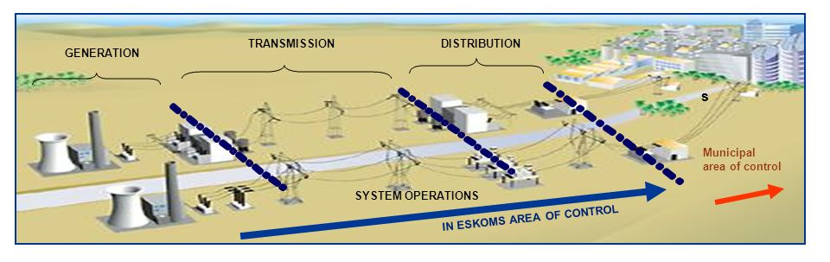
Figure 3-3: Electricity Provision in South Africa

3.1.2 Transmission System
The transmission system plays a vital role in the delivery of reliable, high quality electricity throughout South Africa by delivering electricity in bulk to load centres and very large end-users. The Transmission Grid is divided into seven grid boundaries that operates and maintain 275kV, 400kV and 765kV power lines and associated transmission substations where the power lines terminate. Reference is made to Figure 3-2 overleaf for the transmission power lines and substations within the seven grids.

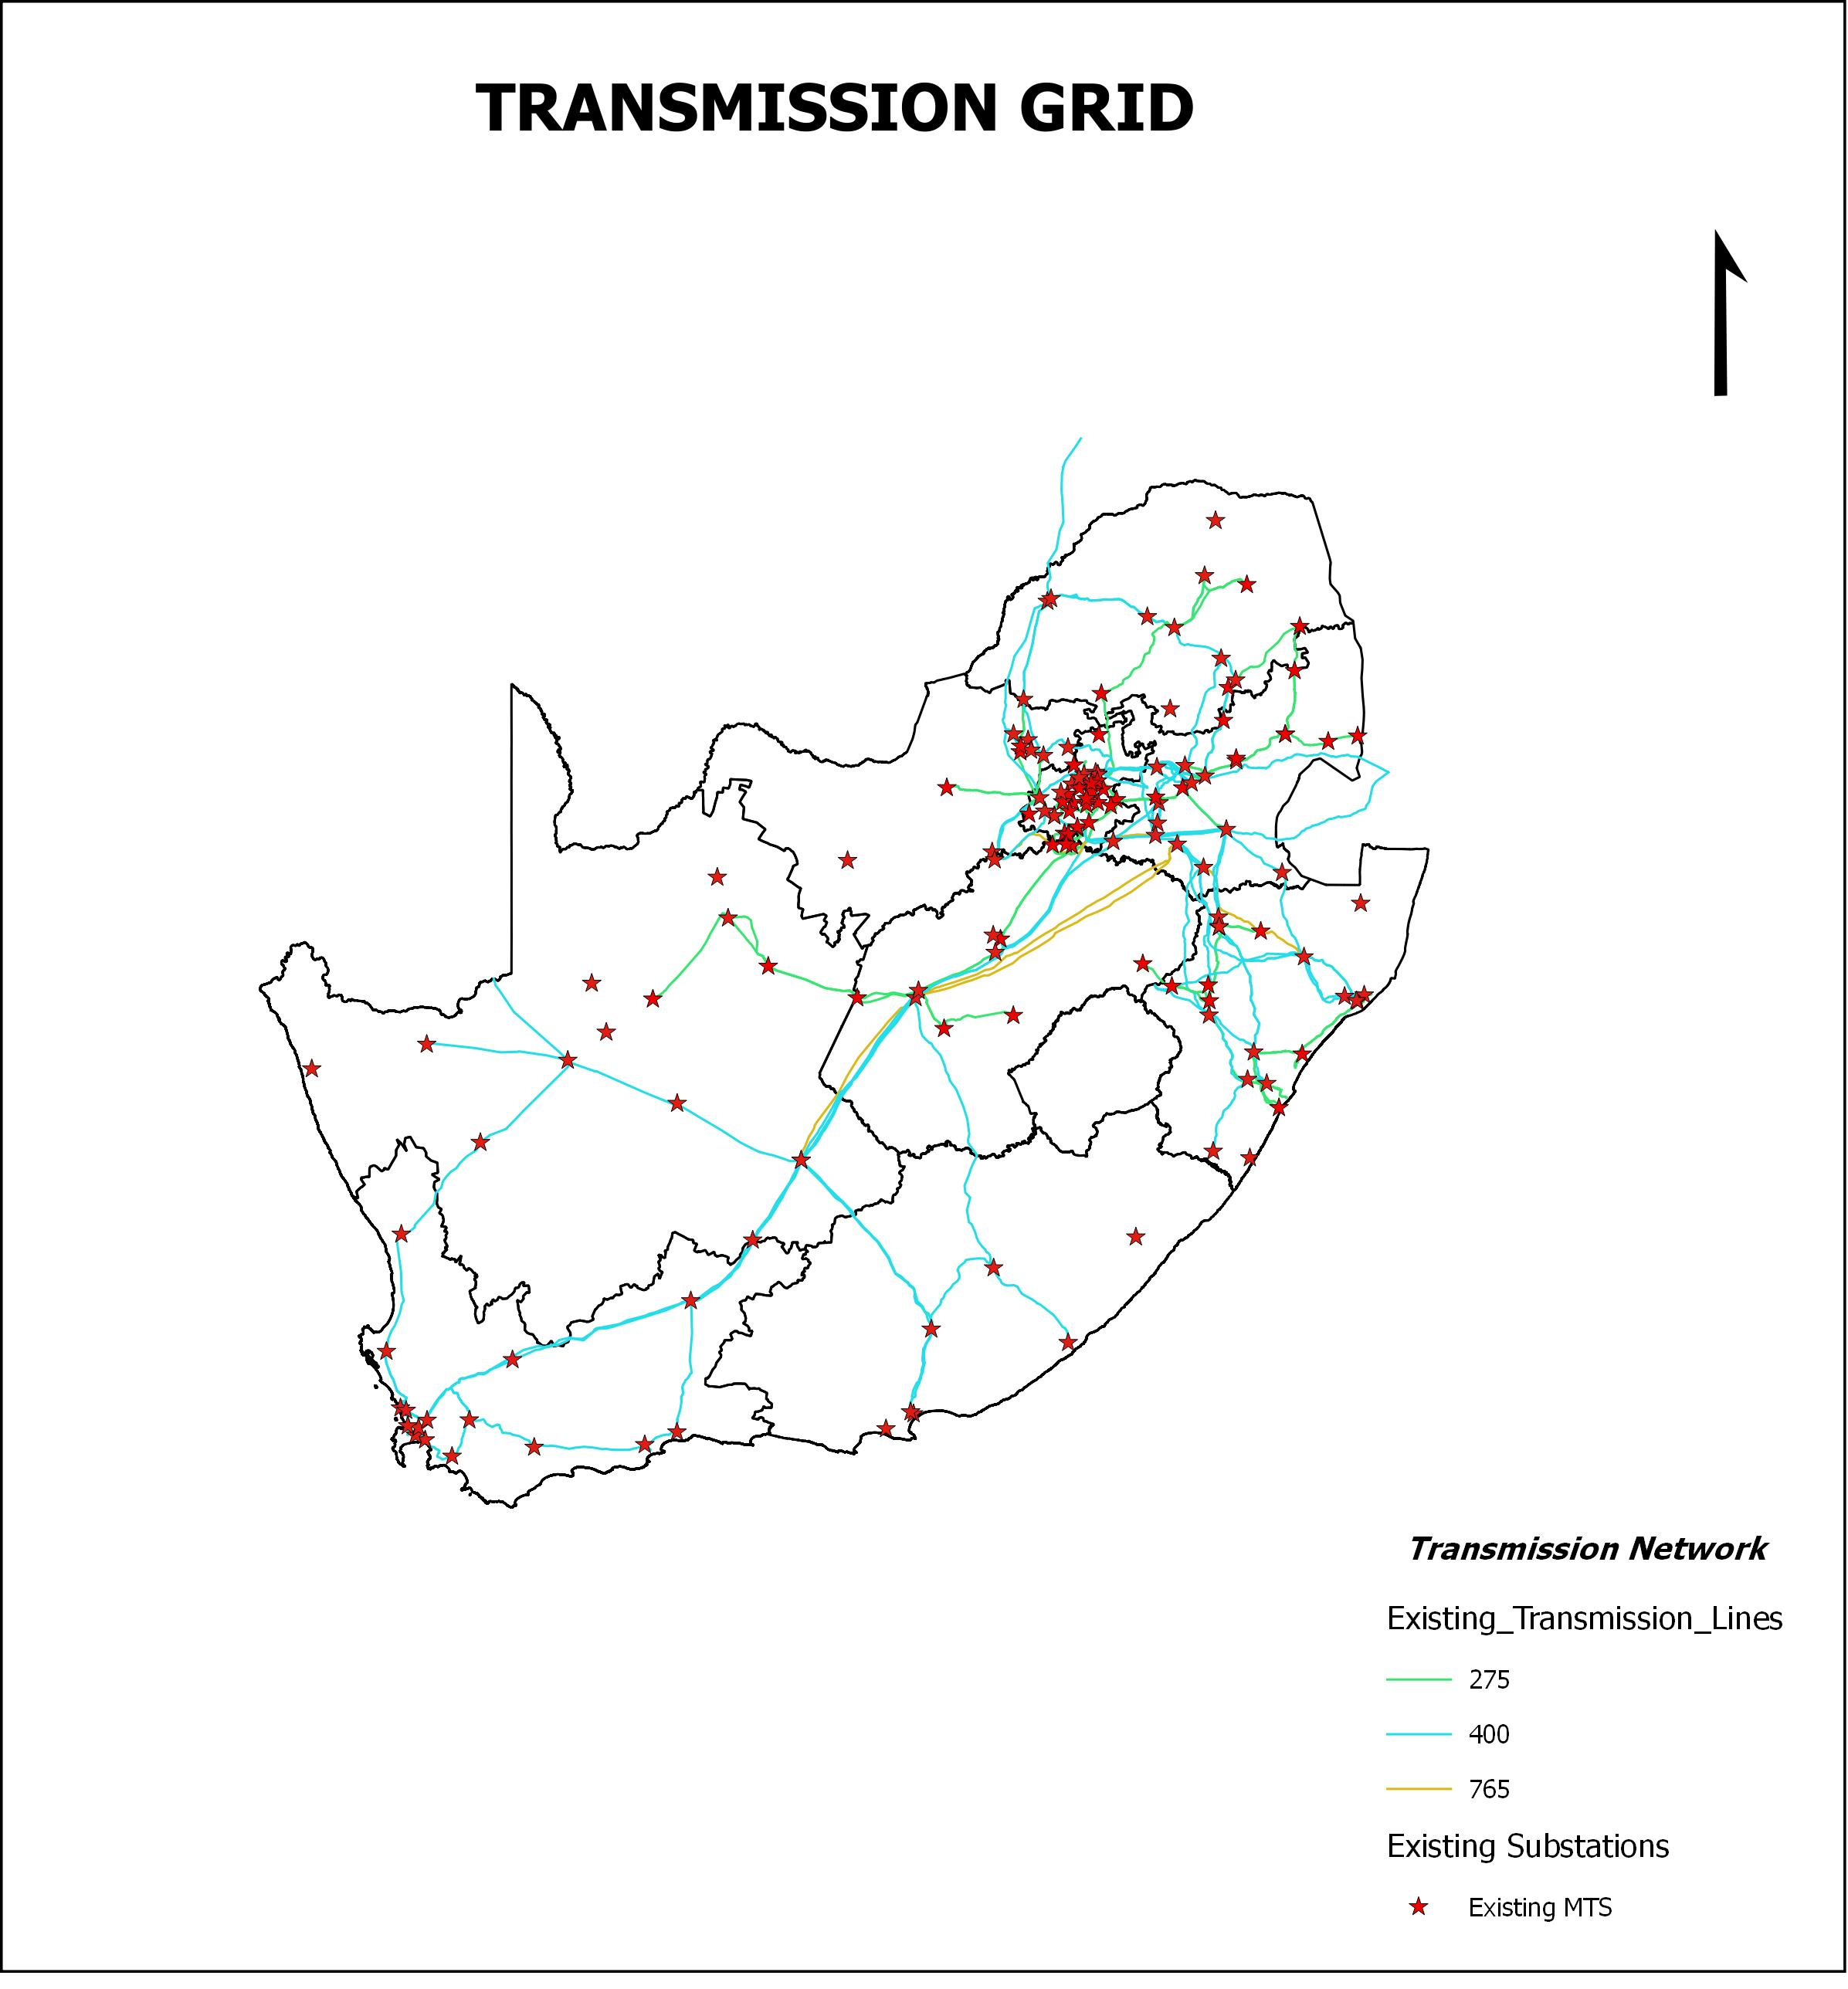
Figure 3-4: Transmission Network

3.1.2.1 Limpopo Customer Load Network (Polokwane CLN)
As the transmission system has expanded over the years, surplus capacity available on transmission lines always seems to be consumed as the system grows or as transmission users find more economical ways of meeting system demands. Transmission congestion results when an electricity transmission path cannot accommodate increased power flow. Although the reasons for congestion vary, the common consequence is that increased power flow on a transmission path is not possible without risking system reliability. To ensure grid capacity and integrate the generation predicted in the IRP, Eskom compiles a 10-year Transmission Development Plan (TDP) that is modified on an annual basis to accommodate changes in both generation and load requirements. The load profile undertaken by Eskom Holdings SOC Ltd in 2015 for the Limpopo Transmission Network indicated that there is an expected growth within Limpopo CLN as shown in Table 3-1 below:
Table 3-4: Load Forecasts for Limpopo CLN
Transmission Supply Areas (CLNs) | Percentage Growth | 2016 | 2020 | 2025
Polokwane | 3.13 | 1506 | 1556 | 1871
Lephalale | 5.45 | 866 | 1240 | 1383
Phalaborwa | 7.61 | 1889 | 2543 | 3390
Source: Transmission Development Plan 2016-2025 (Limpopo Province)
To reinforce the province’s transmission system and ensure reliable supply of electricity, several projects have been planned which consists of extending 400kV and 275kV power lines and installation of additional transformers at existing substations. This report will focus on one of the projects, i.e the Limpopo East Strengthening Project.

3.1.2.2 Polokwane Customer Load Network
Mining operations, residential, agricultural and industrial activities in some parts of Limpopo Province are supplied by the Polokwane Customer Load Network (PCLN) which is comprised of 4 substations with Spencer 275/132kV substation being one of them. Spencer substation is located approximately 37km south west of Giyani and is currently fed by 275kV power lines from Tabor and Witkop substations located approximately 86km and 136km respectively. In addition, the substation is equipped with 2x250MVA, 275/132kV transformers. The load profile undertaken for the Province showed that Spencer substation will be having a peak demand of 318MVA by 2018. Eskom Transmission Grid Planning therefore initiated a study to investigate possible alternatives and solutions to address the transformation constraints at Spencer MTS, as well as 275kV transmission network constraints on the network supplying Spencer MTS supply zone. The activities identified to address these constraints entailed the following:
- Construct a 400kV power line from Foskor Substation to Spencer Substation with a length of approximately 110km.
- Establish 400/132kV transformation yard and install 1 x 500MVA, 400/132kV transformer at Spencer Substation; and
- Establish 400/275kV transformation at Foskor substation.
A separate project is currently underway to obtain the environmental approval of the 400/275kV transformation at Foskor substation. This report will thus focus on the proposed construction of the 400kV power line from Foskor substation to Spencer substation and the upgrade of Spencer substation.

3.2 Project Activities
The proposed project addressed in this document, involves the construction and operation of the following infrastructure:
- ±110km, 400kV power line from Foskor substation near Phalaborwa to Spencer substation near Mohlabaneng village. Two alternative corridors and a deviation from these corridors have been identified and will be assessed. Though a 400kV power line requires a 55m wide servitude, this study will assess a 3000m wide corridor to cater for constraints which might be posed by the location of physical features and the final engineering designs. Reference is made to the Locality Map attached in Appendix C-1. The buffer in the maps indicate the corridors;
- 400/132kV transformation yard and 1 x 500MVA, 400/132kV transformer which will cater for the proposed 400kV power line coming from Foskor substation. This extension will require a footprint area of ±9 ha. The final layout will be attached to the Final Environmental Impact Report. A preliminary layout is attached in Appendix B-1;
- A transformer oil holding dam with a capacity of 120m³. The oil dam is required to contain any spillage from the 1 x500MVA, 400/132kV transformer and to prevent pollution to the environment and ensure compliance with the Environmental Legislations. Reference is made to the drawing in Appendix B-2.

The proposed activities are listed in Listing Notice 1 and 2 as having a detrimental impact to the environment hence require an Environmental Impact Assessment to be undertaken. The proposed activity to be undertaken (together with the infrastructure to be provided) is listed as activities 14, 27 of R983 and 27 of R984 dated December 2014 which reads as follows:

14 of R983: The development of facilities for the storage or for the storage and handling of a dangerous good where such storage occurs in containers with a combined capacity of 80 cubic metres or more but not exceeding 500 cubic metres;

27 of R983: The clearance of an area of 1 hectares or more, but less than 20hectares of indigenous vegetation; and

9 of R984: The development of facilities or infrastructure for the transmission and distribution of electricity with a capacity of 275 kilovolts or more, outside an urban area or industrial complex.

3.3 Location

3.3.1 Regional Context of the Project
The proposed project is within Mopani District Municipality located in the north-eastern part of the Limpopo Province and bordered by Ehlanzeni District Municipality in the south, Greater Sekhukhune District Municipality in the south west, Capricorn District in the west and Vhembe District in the north west. The proposed power line alternatives will traverse across 4 local municipalities within the District Municipality namely Maruleng, Greater Tzaneen, Greater Letaba and Ba-Phalaborwa which are approximately 90km, 44km, 65km and 115km west of Polokwane respectively. The District can be accessed via R71, R81, R40, R526 and various district roads. Reference is made to the Figure below for the regional context of the project:
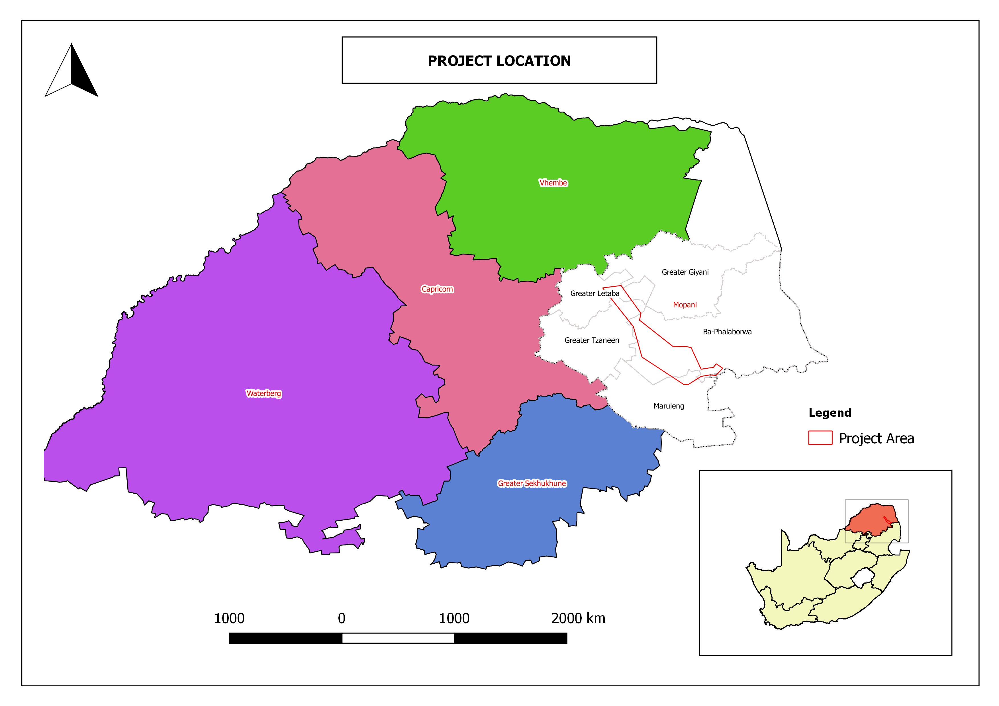
Figure 3-5: Regional Context of Project Area

3.3.2 Substation Locations
Foskor Main Transmission Substation is located on farm Loole 31LU within Foskor Mine which is approximately 9km south of Phalaborwa and 12km west of Kruger National Park. Foskor substation can be accessed via R40 and R71. Spencer substation is located 37km south west of Giyani, on farm Worcester 200LT and is near Mohlabaneng. The substation can be accessed via R81 road to Giyani. Reference is made to Figure 3-4 and 3-5 overleaf for the substations:

Figure 3-6: Spencer Substation
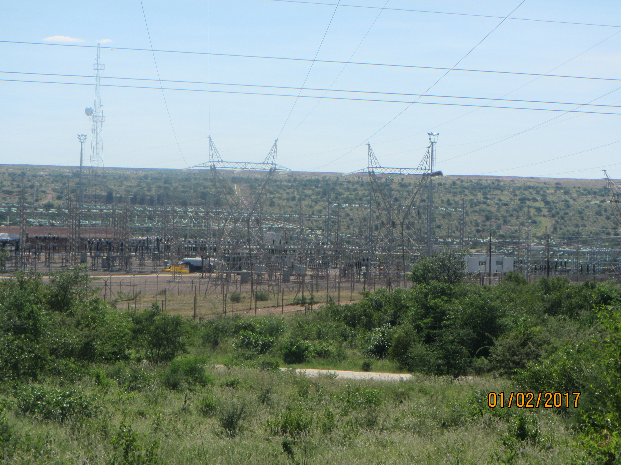
Figure 3-7: Foskor Substation
Figure 3-8

3.3.3 Land Ownership
The land-use within the project area is largely comprised of nature reserves, residential, mining, commercial and subsistence farming. The farms are in private ownership and communal land owned by the Government and under the control of Traditional Authorities. Reference is made to Table 3-2 overleaf for the farm details and ownership:

Table 3-5: Farm Details and ownership
FARM NAME | PTN | SG 21 DIGITS |  | OWNER
Loole 31LU | 0 | T0LU00000000003100000 | Mining | National Government
Wegsteek 30LU | Rem | T0LU00000000003000000 | Mining | National Government
Sheila 10LU | Rem | T0LU00000000001000000 | Mining | National Government
Sheila 10LU | 1 | T0LU0000000000100001 | Public Service Infrastructure | Eskom Holdings Ltd
Rhoda 9KU | 0 | T0KU00000000000900000 | Mining | National Government
Doreen 8KU | Rem | T0KU00000000000800000 | Mining | National Government
Doreen 8KU | 1 | T0KU00000000000800001 | Public Service Infrastructure | Transnet Ltd
Doreen 8KU | 2 | T0KU00000000000800002 | Public Service Infrastructure | Transnet Ltd
Doreen 8KU | 3 | T0KU00000000000800003 | Public Service Infrastructure | Transnet Ltd
Paul 7KU | Rem | T0KU00000000000700000 | Mining | National Government
Paul 7KU | 1 | T0KU00000000000700001 | Public Service Infrastructure | Transnet Ltd
Grietjie 6KU | 107 | T0KU00000000000600107 | Private Nature Reserve | Burger, Pieter Andries
Grietjie 6KU | 106 | T0KU00000000000600106 | Private Nature Reserve | Plast 1 Pty Ltd
Grietjie 6KU | 105 | T0KU00000000000600105 | Private Nature Reserve | Brown, Trevor Anthony
Grietjie 6KU | 104 | T0KU00000000000600104 | Private Nature Reserve | Lotter, Anita
Grietjie 6KU | 118 | T0KU00000000000600118 | Private Nature Reserve | Olifants River Estate
Grietjie 6KU | 96 | T0KU00000000000600096 | Private Nature Reserve | Arends, Richard
Grietjie 6KU | 97 | T0KU00000000000600097 | Private Nature Reserve | Austin, Henry Struben
Grietjie 6KU | 98 | T0KU00000000000600098 | Private Nature Reserve | Nieprins cc
Grietjie 6KU | 95 | T0KU00000000000600095 | Private Nature Reserve | Mount Shilo Safari cc
Grietjie 6KU | 94 | T0KU00000000000600094 | Private Nature Reserve | Mount Shilo Safari cc
Grietjie 6KU | 93 | T0KU00000000000600093 | Private Nature Reserve | Kruger, Johannes Hendrik Trustees
Grietjie 6KU | 81 | T0KU00000000000600081 | Private Nature Reserve | De Swardt, Guillaume
Grietjie 6KU | 82 | T0KU00000000000600082 | Private Nature Reserve | Vroegop cc (Mupaya Lodge)
Grietjie 6KU | 87 | T0KU00000000000600087 | Private Nature Reserve | Phalaborwa Hoedspruit Makelaar cc
Grietjie 6KU | 86 | T0KU00000000000600086 | Private Nature Reserve | Schaap, Anna Sussanna
Grietjie 6KU | 80 | T0KU00000000000600080 | Private Nature Reserve | Pretorius, Joachim Marthinus Wessel (Antonette Hays)
Grietjie 6KU | 77 | T0KU00000000000600077 | Private Nature Reserve | 37 Cherries-Glass Bead Studio & Guesthouse Pty Ltd
Grietjie 6KU | 78 | T0KU00000000000600078 | Private Nature Reserve | Van Rooyen, Lindie
Grietjie 6KU | 76 | T0KU00000000000600079 | Private Nature Reserve | Outbreak Beliggings 5 cc
Grietjie 6KU | 75 | T0KU00000000000600075 | Private Nature Reserve | Ackermann, Ester
Grietjie 6KU | 74 | T0KU00000000000600074 | Private Nature Reserve | Citadel Prop Holdings cc
Grietjie 6KU | 44 | T0KU00000000000600044 | Private Nature Reserve | Jankowitz, Johannes Daniel
Grietjie 6KU | 41 | T0KU00000000000600041 | Private Nature Reserve | Micheleti, Guy Robert George, Fredrick
Grietjie 6KU | 40 | T0KU00000000000600040 | Private Nature Reserve | Dhooge, Andries Christiaan Lanke, Walter Marie
Thankerton 144KT | 2 | T0KT00000000014400002 | Agricultural Game Farm | Verticure cc
Thankerton 144KT | RE/3 | T0KT00000000014400003 | Agricultural Game Farm | Overvaal eiendomme Pty Ltd
Thankerton 144KT | 6 | T0KT00000000014400006 | Public Service Infrastructure | South African National Roads Agency Ltd
Magdalena 154KT | 0 | T0KU00000000000600086 | Game | Malevelyn Holding Pty Ltd (Olifants North Game Reserve)
Parson 155KT | 43 | T0KU00000000015500043 | Agriculture (Vacant) | Grunert Inv Pty Ltd
Parson 155KT | 44 | T0KU00000000015500044 | Agriculture (Vacant) | Grunert Inv Pty Ltd
Parson 155KT | 45 | T0KU00000000015500045 | Agriculture (Vacant) | Grunert Inv Pty Ltd
Parson 155KT | 46 | T0KU00000000155000046 | Agriculture (Vacant) | Grunert Inv Pty Ltd
Parson 155KT | 47 | T0KU00000000155000047 | Agriculture (Vacant) | Grunert Inv Pty Ltd
Parson 155KT | 48 | T0KU00000000015500048 | Agriculture (Vacant) | Grunert Inv Pty Ltd
Parson 155KT | 49 | T0KU00000000015500049 | Agriculture (Vacant) | Loftell, Richard Patrick
Parson 155KT | 50 | T0KU00000000015500050 | Agriculture (Vacant) | Loftell, Richard Patrick
Parson 155KT | 79 | T0KU00000000015500079 | Agriculture (Vacant) | Loftell, Richard Patrick
Parson 155KT | 80 | T0KU00000000015500080 | Agriculture (Vacant) | Loftell, Richard Patrick
Excellence 157KT | Rem | T0KT00000000015700000 | Agricultural | Excellence Farm Pty Ltd
Hoofpyn 269KT | 3 | T0KT00000000026900003 | Agricultural Game Farm | Inyaku Game Farm Pty Ltd
Morelag 5KU | 0 | T0KU00000000000500000 | Agricultural | Ba-Phalaborwa Ba Maseke CPA
Morelag 5KU | 1/3 | T0KU00000000000500001  T0KU00000000000500003 | Agricultural Game Farm | Banakome CPA
Morelag 5KU | 2 | T0KU00000000000500002 | Mining | Freddies Prop PTB Pty Ltd
Try 153KT (now Amsterdam) | 0 | T0KU00000000153000000 | Communal | National Government (Ba-Phalaborwa Ba Maseke CPA)
Punt 151KT | 2/3/7/8 | T0KT00000000151000002  T0KT00000000151000003  T0KT00000000151000007  T0KT00000000151000008 | Agricultural Game Farm | Mashishimale CPA
Mashisimale 800LT | 0 | T0LT00000000080000000 | Communal Land | Mashisimale Traditional Council
Croc-Ranch 835LT | 0 | T0LT00000000835000000 | Communal Land | Mashishimale Traditional Council
Brook 772LT | Rem/1 | T0LT00000000077200000  T0LT00000000077200001 | Agricultural Game Farm | Mashishimale Traditional Council
Seaphole |  |  | Communal Land | Modjadji Traditional Authority
Northampton 201LT | 0 | T0LT00000000020100000 | Communal Land | Modjadji Traditional Authority
Worcester 200LT | 0 | T0LT00000000020000000 | Communal Land | Modjadji Traditional Authority
Breakfast 773LT | Rem | T0LT00000000077300000 | Communal Land | Mashishimale CPA
Breakfast 773LT | 1 | T0LT00000000077300001 | Agricultural Game Farm | Majeje Traditional Authority
Landraad 774LT | Rem | T0LT00000000077400000 | Agricultural Game Farm | Majeje Traditional Authority
Landraad 774LT | 1 | T0LT00000000077400000 | Agricultural Game Farm | Mashishimale CPA
Voster 775LT | 1 | T0LT000000000775000001 | Agricultural Game Farm | Selatirus Pty Ltd
Voster 775LT | 3 | T0LT000000000775000003 | Agricultural Game Farm | Gedeelte 3 van die plaas Voster Pty Ltd
Josephine 749 (B.V.B Ranch 776LT) | 31 | T0LT00000000076500031 | Agricultural Game Ranch | Antenna eiendomme pty ltd
Josephine 749 (B.V.B Ranch 776LT) | 32 | T0LT00000000076500032 | Agricultural Game Ranch | Bezuidenhout phillipus lourens
Josephine 749 (B.V.B Ranch 776LT) | 9 | T0LT00000000076500009 | Agricultural Game Ranch | Joubert Phillip Joseph
Josephine 749 (B.V.B Ranch 776LT) | 12 | T0LT00000000076500012 | Agricultural Game Ranch | Lepelle Industrial & Mining Supplies cc
Josephine 749 (B.V.B Ranch 776LT) | 13 | T0LT00000000076500013 | Agricultural Game Ranch
Begin 765LT | Rem | T0LT00000000076500000 | Agricultural Game Farm | Sebakwe Trust
Begin 765LT | 1 | T0LT00000000076500001 | Agricultural Game Farm | SANDF
Begin 765LT | 3 | T0LT00000000076500003 | Agricultural Game Farm | Balepye CPA
Malati 764LT | 0 | T0LT00000000076400000 | Agricultural Game Farm | LE Thom Pty Ltd
Volstruis 753LT | Rem/2/3 | T0LT00000000075300000  T0LT00000000075300002  T0LT00000000075300003 | Agricultural Game Farm | SANDF (Government of RSA)
Free State 763LT | Rem/2 | T0LT00000000076300000  T0LT00000000076300002 | Agricultural Game Farm | SANDF(Government of RSA)
Riverhead 755LT | Rem | T0LT00000000075500000 | Agricultural Game Farm | Balepye CPA
Chester 754LT | Rem | T0LT00000000075400000 | Agricultural Game Farm | Farm Chester cc
Chester 754LT | 1 | T0LT00000000075400001 | Agricultural Game Farm | Morgenstern Familie Trust
Chester 754LT | 2 | T0LT00000000075400002 | Agricultural Game Farm | Balepye CPA
Black Hill 740LT | Rem | T0LT00000000074000000 | Agricultural Game Farm | Balepye CPA
La Cotte 736LT | Rem | T0LT00000000073600000 | Agricultural | Xcelsior Letsitele Prop Pty Ltd
La Cotte 736LT | 1 | T0LT00000000073600001 | Agricultural | Nouville-Lacott Pty Ltd
La Cotte 736LT | 2 | T0LT00000000073600002 | Agricultural | R Pretorius & Kinders Pty Ltd
La Cotte 736LT | 3 | T0LT000000000736000003 | Agricultural | R Pretorius & Kinders Pty Ltd
La Cotte 736LT | 4 | T0LT00000000073600004 | Agricultural | R Pretorius & Kinders Pty Ltd
La Cotte 736LT | 5 | T0LT00000000073600005 | Agricultural | CLB La Cotte Trust
Matuma 735LT | 0/4/5/8/9  11 | T0LT00000000073500000  T0LT00000000073500004  T0LT00000000073500005  T0LT00000000073500008  T0LT00000000073500009  T0LT00000000073500011 | Agricultural | Xcelsior Letsitele Prop Pty Ltd
Matuma 735LT | 1/2/6/10 | T0LT00000000073500001  T0LT00000000073500002  T0LT00000000073500006  T0LT00000000073500010 | Agricultural | Matuma Sitrus Eiendomme Pty Ltd
Matuma 735LT | 3/7 | T0LT00000000073500003  T0LT00000000073500007 | Agricultural | Dreanco Pty Ltd
Matuma 735LT | 12 | T0LT00000000073500012 | Agricultural | Merite Pakkers Pty Ltd
Gunyula 730LT | Rem | T0LT00000000073000000 | Agricultural | Grobler, Nicolaas
Gunyula 730LT | 4 | T0LT00000000073000004 | Agricultural | Lallu Farming Enterprises cc
Gunyula 730LT | 13 | T0LT00000000073000013 | Agricultural | Lallu Farming Enterprises cc
Gunyula 730LT | 16 | T0LT00000000073000016 | Agricultural | Malle Mathoka Albert Mohalea
Gunyula 730LT | 17 | T0LT00000000073000017 | Agricultural | Big Rock Construction 74 cc
Gunyula 730LT | 18 | T0LT00000000073000018 | Agricultural | GK2N Projects Trust
Gunyula 730LT | 19 | T0LT00000000073000019 | Agricultural | Last, Andre
Gunyula 730LT | 20 | T0LT00000000073000020 | Agricultural | Last, Andre
Gunyula 730LT | 21 | T0LT00000000073000021 | Agricultural | Last, Andre
Gunyula 730LT | 22 | T0LT00000000073000022 | Agricultural | Last, Andre
Gunyula 730LT | 23 | T0LT00000000073000023 | Agricultural | Last, Andre
Gunyula 730LT | 24 | T0LT00000000073000024 | Agricultural | Last, Andre
Gunyula 730LT | 26 | T0LT00000000073000026 | Agricultural | Mkhavele, Vukosi Autis
Gunyula 730LT | 27 | T0LT00000000073000027 | Agricultural | Rikhotso, Jabulani Herold
Gunyula 730LT | 28 | T0LT00000000073000028 | Agricultural | Rikhotso, Jabulani Herold
Gunyula 730LT | 29 | T0LT00000000073000029 | Agricultural | Alfred Mashau
Gunyula 730LT | 30 | T0LT00000000073000030 | Agricultural | Alfred Mashau
Gunyula 730LT | 31 | T0LT00000000073000031 | Agricultural | Mashaba, John
Gunyula 730LT | 32 | T0LT00000000073000032 | Agricultural | Wright, Candice Rochelle
Gunyula 730LT | 33 | T0LT00000000073000033 | Agricultural | Mbuyane Frank Jesaya
Gunyula 730LT | 34 | T0LT00000000073000034 | Agricultural | Williams, James Ronald
Gunyula 730LT | 35 | T0LT00000000073000035 | Agricultural | Nxumalo, Mackekwa Edwell
Gunyula 730LT | 36 | T0LT00000000073000036 | Agricultural | Tshehla, Edwin Thapedi
Gunyula 730LT | 37 | T0LT00000000073000037 | Agricultural | Manabe, Nkateko Loraine
Gunyula 730LT | 38 | T0LT00000000073000038 | Agricultural | Tshehla, Edwin Thapedi
Gunyula 730LT | 39 | T0LT00000000073000039 | Agricultural | Mashao, Malesela Alfred
Gunyula 730LT | 40 | T0LT00000000073000040 | Agricultural | Mkhvele, Vukosi Autis
Gunyula 730LT | 41 | T0LT00000000073000041 | Agricultural | Fasen, Coenraad Hendrik
Gunyula 730LT | 42 | T0LT00000000073000042 | Agricultural | Risaba, Ernest Mkansi
Gunyula 730LT | 43 | T0LT00000000073000043 | Agricultural | Risaba, Ernest Mkansi
Gunyula 730LT | 44 | T0LT00000000073000044 | Agricultural | Smith, Coenraad Jacobus
Gunyula 730LT | 45 | T0LT00000000073000045 | Agricultural | Tshehla, Edwin Thapedi
Gunyula 730LT | 46 | T0LT00000000073000046 | Agricultural | Jooste, Charlotte Catharina
Gunyula 730LT | 47 | T0LT00000000073000047 | Agricultural | Bill, Godfrey Morgan
Gunyula 730LT | 48 | T0LT00000000073000048 | Agricultural | Potgieter, Stephanus Johannes
Gunyula 730LT | 49 | T0LT00000000073000049 | Agricultural | Mbiza, Tinyiko Nicolas
Gunyula 730LT | 50 | T0LT00000000073000050 | Agricultural | Smith, Coenraad Jacobus
Gunyula 730LT | 51 | T0LT00000000073000051 | Agricultural | Phosa, Sanny
Gunyula 730LT | 52 | T0LT00000000073000052 | Agricultural | Phosa, Sanny
Gunyula 730LT | 53 | T0LT00000000073000053 | Agricultural | Risaba, Ernest Mkansi
Gunyula 730LT | 54 | T0LT00000000073000054 | Agricultural | Lallu Farming Enterprises cc
Gunyula 730LT | 55 | T0LT00000000073000055 | Agricultural | Lallu Farming Enterprises cc
Gunyula 730LT | 56 | T0LT00000000073000056 | Agricultural | Risaba, Ernest Mkansi
Gunyula 730LT | 57 | T0LT00000000073000057 | Agricultural | Risaba, Ernest Mkansi
Gunyula 730LT | 58 | T0LT00000000073000000 | Agricultural | Risaba, Ernest Mkansi
Gunyula 730LT | 59 | T0LT00000000073000000 | Agricultural | Erasmus, Carel Petrus Johannes
Gunyula 730LT | 60 | T0LT00000000073000000 | Agricultural | Erasmus, Carel Petrus Johannes
Gunyula 730LT | 61 | T0LT00000000073000000 | Agricultural | Erasmus, Carel Petrus Johannes
Gunyula 730LT | 62 | T0LT00000000073000000 | Agricultural | Erasmus, Carel Petrus Johannes
Gunyula 730LT | 63 | T0LT00000000073000000 | Agricultural | Erasmus, Carel Petrus Johannes
Gunyula 730LT | 65 | T0LT00000000073000000 | Agricultural | Erasmus, Carel Petrus Johannes
Gunyula 730LT | 66 | T0LT00000000073000000 | Agricultural | Erasmus, Carel Petrus Johannes
Gunyula 730LT | 67 | T0LT00000000073000000 | Agricultural | Erasmus, Carel Petrus Johannes
Gunyula 730LT | 68 | T0LT00000000073000000 | Agricultural | Risaba, Ernest Mkansi
Gunyula 730LT | 69 | T0LT00000000073000000 | Agricultural | Risaba, Ernest Mkansi
Gunyula 730LT | 70 | T0LT00000000073000000 | Agricultural | Risaba, Ernest Mkansi
Gunyula 730LT | 71 | T0LT00000000073000000 | Agricultural | Risaba, Ernest Mkansi
Gunyula 730LT | 72 | T0LT00000000073000000 | Agricultural | Risaba, Ernest Mkansi
Gunyula 730LT | 73 | T0LT00000000073000000 | Agricultural | Wolvaardt, Jurie Francois
La Parisa 729 LT | Rem | T0KU00000000072900000 | Agricultural | Gubitz Boerdery Pty Ltd
La Parisa 729LT | 1 | T0KU00000000072900001 | Agricultural | Lompies Kwekerye Pty Ltd
Radoo 682LT | 0 | T0LT00000000068200000 | Communal | Nyavana Traditional Authority
Sirulurul 427LT | 1/2 | T0LT000000000742700001  T0LT000000000742700001 | Communal | Modjadji Traditional Authority
Makuba 425LT | 0 | T0LT00000000042500000 | Communal | Modjadji Traditional Authority
Senobela 362LT | 0 | T0LT00000000036200000 | Communal | Modjadji Traditional Authority
Kromriviersfontein 360LT | 0 | T0LT00000000036000000 | Communal | Modjadji Traditional Authority
Square 750KT | Rem | T0LT00000000075000000 | Communal | Big Rock Ranch Pty Ltd
Square 750KT | 1 | T0LT00000000075000001 | Communal | Archie Beesplaas cc
Archie 156KT | Rem | T0KT00000000015600000 | Lodge | Baphalaborwa Ba Maseke CPA
Archie 169KT | Rem/1 | T0KT00000000016900000 | Agricultural Game Farm | Scaterfield Game Ranch Pty Ltd
Archie 169KT | 1 | T0KT00000000016900001 | Agricultural Game Farm | Royal Square Inv. 448 cc
Lillie 148KT | Rem | T0KT00000000014800000 | Agricultural Game Farm | Lillie Ranch Pty Ltd
Lillie 148KT | 1 | T0KT00000000014800001 | Agricultural Game Farm | Scaterfield Game Ranch Pty Ltd
Lillie 148KT | 2 | T0KT00000000014800002 | Agricultural Game Farm | Twin City Letaba Ranch Pty Ltd
Lillie 148KT | 3 | T0KT00000000014800003 | Agricultural Game Farm | Royal Square Inv. 448 cc
Lekkergoed 158KT | 9/23/29/50 | T0KT00000000015800009  T0KT00000000015800023  T0KT00000000015800029  T0KT00000000015800050 | Game | Limpopo Leopard Rock Nature Reserve
Lekkergoed 158KT | 15 | T0KT00000000015800015 | Agricultural Game Farm | Troutwater Trust
Transport 145KT | 1 | 0KT00000000017200001 | Agricultural Game Farm | Overvaal Eiendomme Pty Ltd
Transport 172KT | 0 | T0KT00000000017200000 | Agricultural Game Farm | Seriso 485 Pty Ltd
Hoed 146KT | 0 | T0KT00000000014600000 | Agricultural Game Farm | HL Hall & Sons Prop Pty Ltd
Arundel 788LT | Rem | T0LT00000000078800000 | Agricultural Game Farm | HL Hall & Sons Prop Pty Ltd
Arundel 788LT | 3 | T0LT00000000078800003 | Agricultural Game Farm | Pieter Ernst Familie Trust
Arundel 788LT | 4 | T0LT00000000078800004 | Agricultural Game Farm | Nyala Lodge Share Block Pty Ltd
Arundel 788LT | 7 | T0LT00000000078800007 | Agricultural Game Farm | Big Five Game Co Pty Ltd
Willie 787LT | Rem/5 | T0LT00000000078700000  T0LT00000000078700005 | Agricultural Game Farm | Dunn, Henry Brown
Willie 787LT | 2 | T0LT00000000078700002 | Agricultural Game Farm | Angetu Prop Pty Ltd
Willie 787LT | 3 | T0LT00000000078700003 | Agricultural Game Farm | Osmers, Charles Nicolaas Joubert
Willie 787LT | 6 | T0LT00000000078700006 | Agricultural Game Farm | Klipspringer Lodge cc
Willie 787LT | 10 | T0LT000000000787000010 | Agricultural Game Farm | Elphinstone, Rachel Johanna Emmarentia
Farrell 781LT | 7 | T0LT000000000781000007 | Mining | Modjadji Manufacturing Pty Ltd
Farrell 781LT | 8 | T0LT000000000781000008 | Agricultural Game Farm | PP Mare Boerdery Pty Ltd
Claimland 780LT | Rem/1 | T0LT00000000078000000  T0LT00000000078000001 | Agricultural | PP Mare Boerdery Pty Ltd
Claimland 780LT | 2 | T0LT00000000078000002 | Mining | National Government
Claimland 780LT | 4 | T0LT00000000078000004 | Agricultural | Piet Warren Plase Pty Ltd
Claimland 780LT | 5 | T0LT00000000078000005 | Mining | Consolidated Murchison Ltd
Mon Desir 782LT | Rem/1 | T0LT00000000078200000  T0LT00000000078200001 | Agricultural Game Farm | Gravelotte Iron Ore Company Pty Ltd
Mon Desir 782LT | 2 | T0LT00000000078200002 | Agricultural | Pieter Oosthuizen Landgoed Pty Ltd
Solomons Mine 762LT | Rem/3/4 | T0LT00000000076200000  T0LT00000000076200003  T0LT00000000076200004 | Agricultural Game Farm | Gravelotte Iron Ore Company Pty Ltd
Quagga 759LT | Rem/2 | T0LT00000000075900000  T0LT00000000075900002 | Agricultural Game Farm | Gravelotte Iron Ore Company Pty Ltd
The Beacon 769LT | 0 | T0LT000000000769000300 | Agricultural Game Farm | Balapye CPA
Eden 757LT | Rem/2 | T0LT00000000075700000  T0LT00000000075700002 | Agricultural Game Farm | Balapye CPA
Henley 734LT | 2 | T0LT00000000073400002 | Agricultural | Kidson, Dina Johanna
Henley 734LT | 5 | T0LT00000000073400005 | Agricultural | Labuschagne, Pieter Willem
Henley 734LT | 7 | T0LT00000000073400007 | Agricultural | Last, Andre
Henley 734LT | 8 | T0LT00000000073400008 | Agricultural | David Maswanganyi Family Trust
Henley 734LT | 9 | T0LT00000000073400009 | Agricultural | David Maswanganyi Family Trust
Henley 734LT | 10 | T0LT00000000073400010 | Agricultural | Alida & Basie Jacobs Family Trust
Henley 734LT | 11 | T0LT00000000073400011 | Agricultural | Ntimbane, Gaza Edney
Henley 734LT | 12 | T0LT00000000073400012 | Agricultural | Mathebula, Mishell
Henley 734LT | 13 | T0LT00000000073400013 | Agricultural | National Government
Henley 734LT | 14 | T0LT00000000073400014 | Agricultural | National Government
Henley 734LT | 15 | T0LT00000000073400015 | Agricultural | Dos Santos, Antonio Sardinha
Henley 734LT | 16 | T0LT00000000073400016 | Agricultural | Zeni, Robert
Henley 734LT | 17 | T0LT00000000073400017 | Agricultural | Zeni, Robert
Henley 734LT | 18 | T0LT00000000073400018 | Agricultural | Heydenrych, Alida Cornelia
Henley 734LT | 19 | T0LT00000000073400019 | Agricultural | Alcro Trust
Henley 734LT | 20 | T0LT00000000073400020 | Agricultural | Alcro Trust
Henley 734LT | 21 | T0LT00000000073400021 | Agricultural | Alcro Trust
Henley 734LT | 22 | T0LT00000000073400022 | Agricultural | Jacques Burger Family Trust
Henley 734LT | 23 | T0LT00000000073400023 | Agricultural | Jacques Burger Family Trust
Henley 734LT | 24 | T0LT00000000073400024 | Agricultural | Jacques Burger Family Trust
Henley 734LT | 25 | T0LT00000000073400025 | Agricultural | Jacques Burger Family Trust
Henley 734LT | 26 | T0LT00000000073400026 | Agricultural | Labuschagne, Saskia Jean
Henley 734LT | 27 | T0LT00000000073400027 | Agricultural | Jacques Burger Family Trust
Henley 734LT | 28 | T0LT00000000073400028 | Agricultural | Jacques Burger
Henley 734LT | 30 | T0LT00000000073400030 | Agricultural | Strathearn Mervyn Gerrity Dubaj
Henley 734LT | 34 | T0LT00000000073400034 | Agricultural | Van Heerden Family Trust
Henley 734LT | 35 | T0LT00000000073400035 | Agricultural | Botha, Antonie Johannes Carolus

3.5 Technical Details of the Project

3.5.1 Requirements for the 400kV Power line

3.5.1.1 Line Height and Servitude width
The statutory minimum ground clearance for a 400kV overhead line is 8.1m. The line must be designed to afford this clearance in ALL circumstances. The overall height of the line is also dependent on several criteria, including geographical location, topography, height above sea level, span length and conductor type. Though a 3km buffer is being assessed, the required servitude width for a 400kV power line is 55m.

3.5.1.2 Span Length
The span length also depends on the same criteria as line height. The distance between supports (span length) will vary from 300 to 400, with an average span of 350m between supports.

3.5.1.3 Service Access Roads
Services Access for construction traffic will be required and maintained to all sites during the construction phase. The width of the access roads will be less than 5.5m. Services Access arrangements for maintenance and fault repairs will have to be arranged with the relevant land owners prior to the implementation of the project.

3.5.2 Power line Infrastructure
An overhead power line is comprised of tower structures and conductors with associated hardware discussed below:

3.5.2.1 Tower Structures and Conductors
Transmission towers are utilized to suspend high voltage overhead power lines and each transmission tower must be constructed to support the level imposed on it by conductors. Although the power line towers that will be utilized for this project have not been decided, three tower structures below are generally used for 400kV power lines.

- Cross Rope Suspension Tower
The towers are supported by stays or guys to stabilize the towers. This tower is easy to assemble and the structure requires less galvanized steel than the guyed V tower making it lighter. Forces from the earth-wires, tower guys, and conductors are transferred only to the two mast peaks, thus eliminating direct bending moments in the structure and resulting in cost savings in the order of 50% per tower. The tower has an average height of 36m and requires servitude of 55m. See Figure 3-7 overleaf for the tower structure.

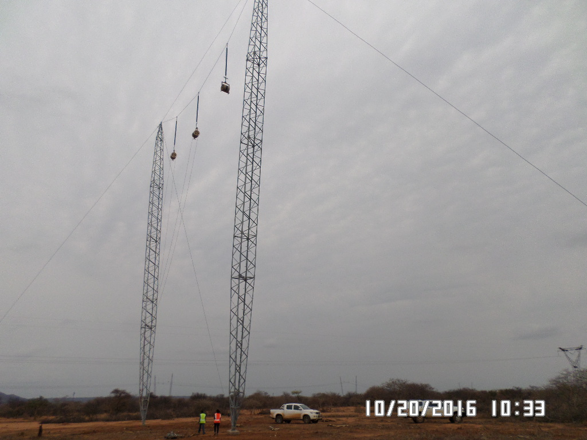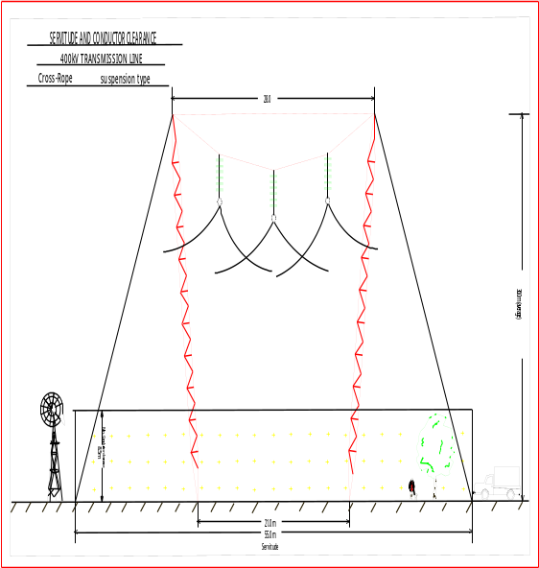
Figure 3-9: Cross Rope Suspension Tower

- Guyed Suspension Tower
The tower has one large foundation and four guys therefore four smaller foundations. They provide the best protection from lightning impulses due to ground wire and cross arm configuration. Tower cross bar helps with the live maintenace.The towers have an average height of 33m. See Figure 3-8 overleaf:

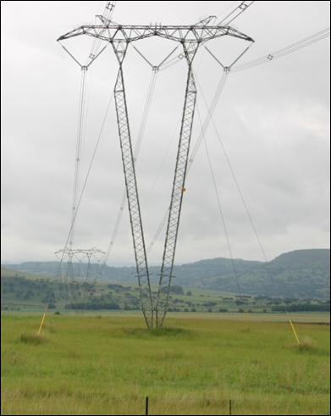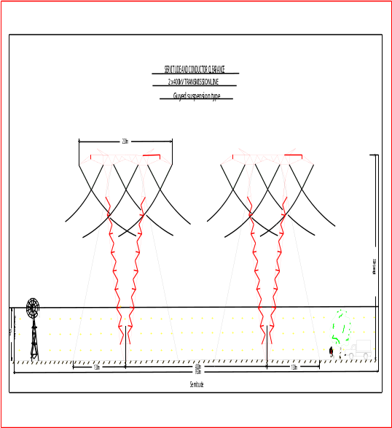
Figure 3-10: Guyed Suspension Tower

- Self-Supporting Tower
This is a typical Eskom designed self-supporting tower and utilizes a V assembly to allow for compaction of the phases. The structure was optimized to carry 190KN glass insulators which support quad zebra conductors. Commonly used before the cheaper guyed and cross rope structures were designed. Reference is made to Figure 3-9 below for the tower.
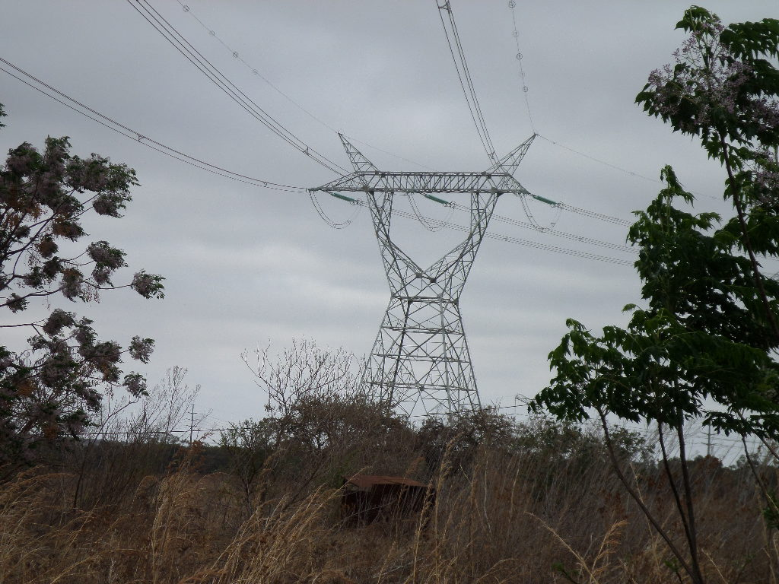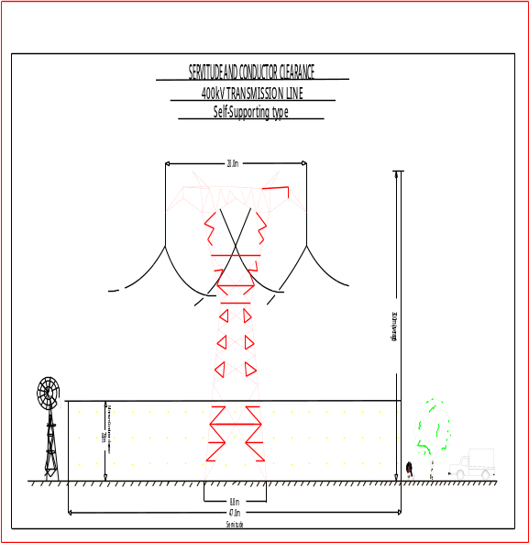
Figure 3-11: Self-Supporting Tower

3.5.3 Electric and Magnetic Fields (EMF)

3.5.3.1 Electric Fields
Power line electric fields are produced by the presence of electric charges and therefore the Voltage (V) applied to a conductor of a power line. Generally, the voltage on a system is stable and therefore the electric field under the line remains relatively constant. Tower geometry and conductor height affects the electric field at ground level. Electric fields decrease with an increase in distance from the conductor. Overhead power lines are designed to meet a maximum electric field level of 10 kV/m within the servitude and directly below the line. This level falls to lower levels and must meet the level of 5 kV/m allowed for public exposure at the servitude boundary.

3.5.3.2 Magnetic Fields
Magnetic fields are produced by the current flowing on the conductor of a power line. The current on a system may vary depending on the load supplied by the system. As the load changes, the magnetic field will change. Tower geometry and conductor height affects the magnetic field at ground level. Magnetic fields decrease with an increase in distance from the conductor. Overhead power lines are designed to meet a maximum magnetic field level of 200 µT allowed for public exposure at the servitude boundary.

3.5.4 Overhead Line Corona, Noise and Corona Discharge
Corona noise is found on transmission lines where higher voltages exist and it is more active during the increased humidity conditions provided by light rain. A large number of corona discharges are caused by water drops collecting on the conductors. In dry conditions, the conductors usually operate below the corona inception level, and less corona sources are present. Corona noise comprises two sound components: one is random crackling noise and the other is hum noise of buzzing. The random sound has a wide frequency band because the sounds caused by corona discharge occur randomly and the corona hum noise results from the electric field surrounding the conductors. The level of operational noise from overhead lines will vary depending upon the environmental conditions, the locality and a number of other factors including the distance to ground and voltage.

3.6 Pre-construction and Construction Phase
The construction phase of the project is expected to take up to 24 months with a project lifespan of 40 years or more. The main works for the construction of the 400kV power lines and substation include the following:

3.6.1 Pre-Construction

3.6.1.1 Land Negotiation
After an Environmental Authorization has been issued the following tasks will be undertaken:
- Selection of a route where the 400kV power line will traverse within the environmentally authorized corridor, i.e, the 55m servitude width required for the power line will be selected within the 3000m corridor assessed;
- Negotiate servitude on private and publicly owned land; and
- Identification of landowner conditions and requirements.

3.6.1.2 Right of Way Surveying
Prior to construction of the overhead power line a precise ground survey is carried out to determine the ground profile along the centre of the power line route and for 27.5m on either side where the ground profile slopes across the power line route. This is to ensure that the location selected for towers and stays and their relationship with each other comply with the technical limits laid down for maximum span lengths, maximum sums of adjacent spans and safe clearance to live conductors in the final siting of pole. Further consideration is given to detailed environmental effects. Where the route of the line passes over or in close proximity to trees that could infringe safe clearances to ‘live’ conductors, the trees must be felled or pruned prior to the construction of the line.

3.6.1.3 Soil sampling
Geotechnical investigations will be carried out at substation and tower positions to determine the type of foundation. The holes will be filled in after soil sampling is completed.

3.6.1.4 Structure Stacking
A survey crew will peg the substation location and the power line corridor.

3.6.1.5 Clearing
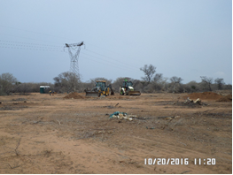
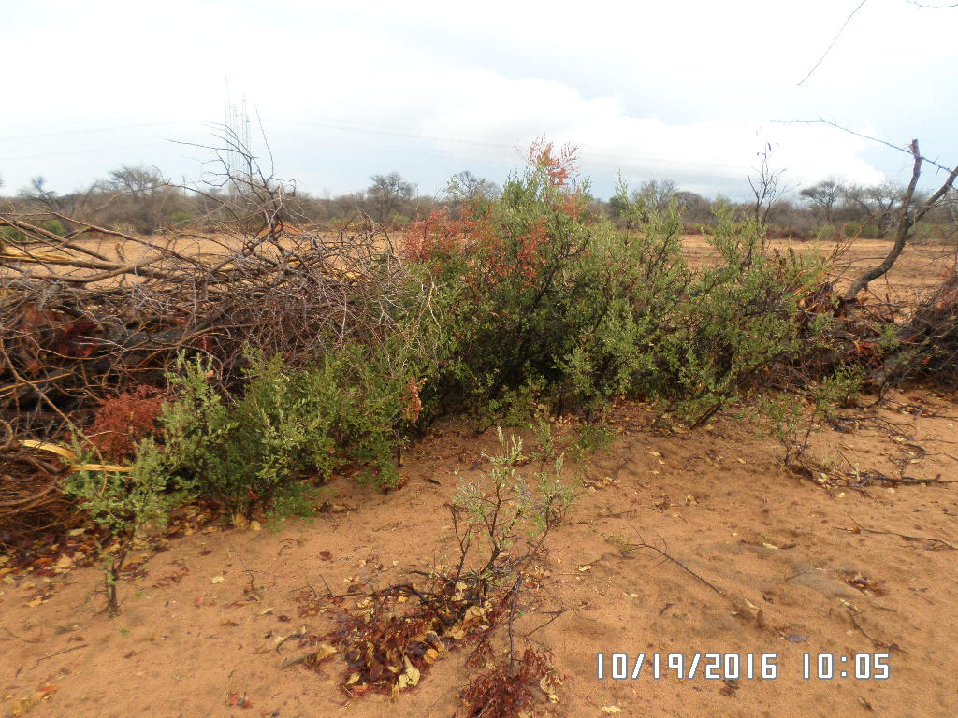
Figure 3-12: Example of clearing at tower sites

The Right of Way (ROW) must be cleared to allow for construction and operation activities of substation and power line. The land-owner and the local community will be notified prior to construction clearing. Reference is made to the Figure 3-10 above for an example of servitude clearance.

3.6.1.6 Access Road Construction
Temporary access routes are capable of accommodating construction plant, material and workers required for the construction of each tower and the installation of conductors. Where there is no existing Services Access available or where ground conditions prevent normal Services Access, temporary Services Access routes may have to be constructed.

3.6.2 Construction Phase
Overhead power line construction follows a standard sequence of activities mentioned below:

3.6.2.1 Construction Camp
The establishment of the construction camp will involve the clearing of vegetation, fencing of camp and the construction of workshops and the store rooms as well as temporary site offices. The location of the camps will ensure accessibility to the construction sites. Reference is made to Figure 3-11 below:
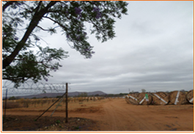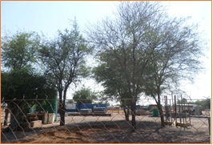
Figure 3-13: Example of Construction/Storage Camp

3.6.2.2 Foundation Installation
A work crew will excavate the foundations for the towers. The foundation is influenced by the terrain encountered as well as the underlying geotechnical condition. The actual size and type of foundation to be installed will depend on the soil bearing capacity and can be excavated manually or by using machines. The foundations will be back filled, stabilized through compaction and capped with concrete.
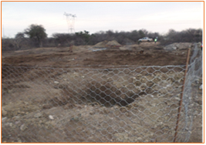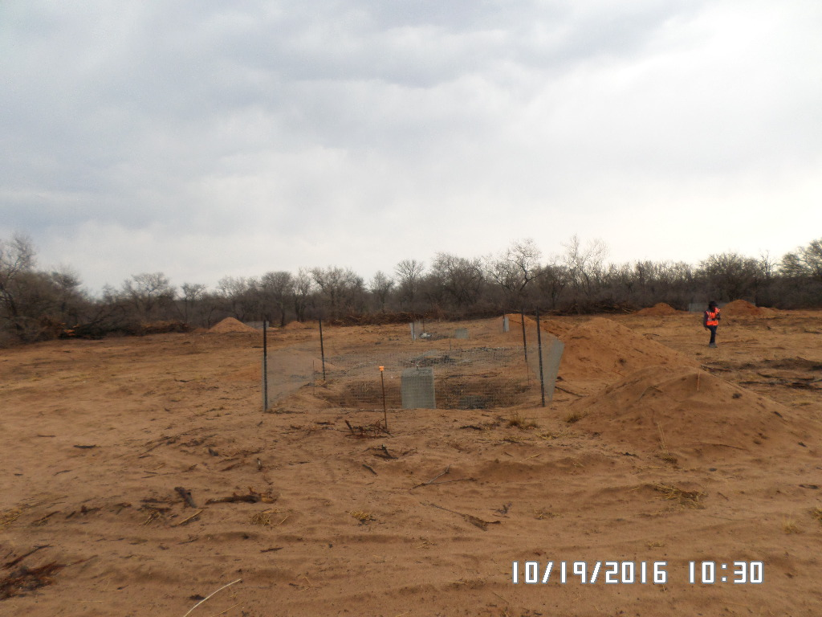
Figure 3-14: Example of excavated pits

3.6.2.3 Erecting structures and stringing Conductors
The Right of Way corridor may be used as an area for temporary storage and handling for equipment and materials related to construction. See Figure 3-13. Steel components of structures may be delivered and placed on the ground near foundation sites. Once foundations are in place, the following work will be carried out:
- Erection of the structures within the Right of Way;
- The steel components of the tower will be assembled using a crane and then lifted onto the foundations;
- Insulators and attachment hardware will be installed and stringing sheaves attached to the insulators; and
- The conductors will be strung by attaching the conductor to a steel line and pulled through each structure’s stringing sheaves under tension to keep the conductors well off the ground.
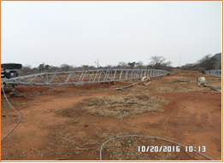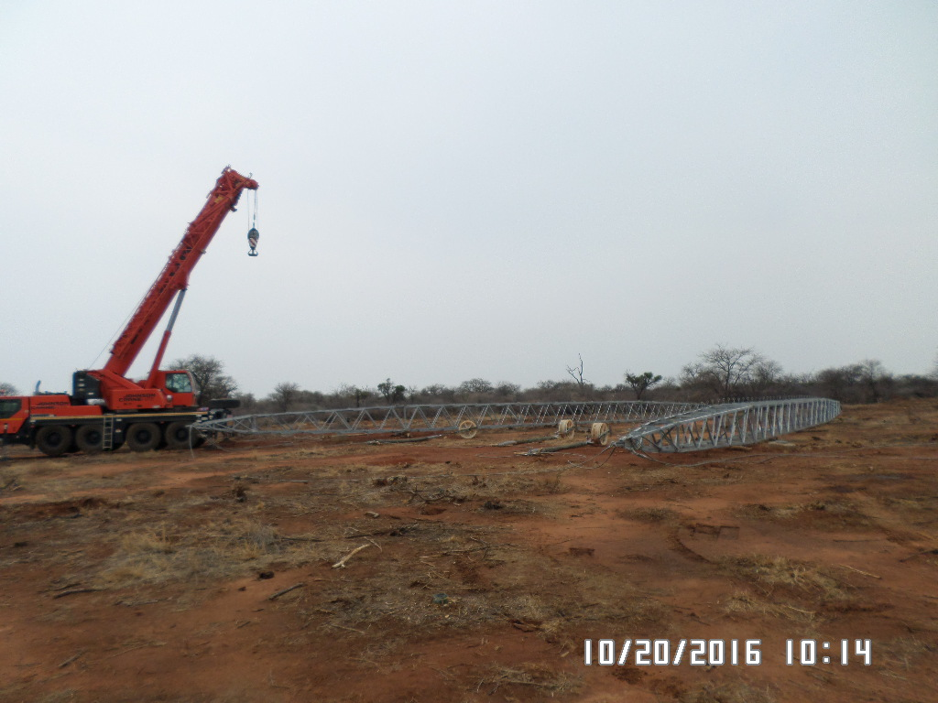
Figure 3-15: Laydown Areas

3.6.3 Substation Construction
To cater for the proposed 400kV power line, Spencer substation needs to be extended/ upgraded in order to establish the 400/132kV transformation yard and the 1x500MVA, 400/132kV transformer. In addition, a transformer oil holding dam with a capacity of 120m³ will also be constructed. The area required for this extension is approximately ±9 hectares and the layout for the substation extension will be appended to the Final Environmental Impact Report. The proposed upgrade/ extension works will entail the following activities:
- Cut and fill grading;
- Placement and compaction of structure fill to serve as a foundation for equipment;
- Grading to maintain drainage patterns;
- Installation of equipment and structure foundations;
- Construction of bund walls, oil drainage pipes and oil holding dam;
- Construction of formal drainage and storm-water control measures;
- Installation of structures and equipment;
- Connection of the new infrastructure to the existing network; and
- Erect a fence around the perimeter of the substation.

3.6 Bulk Services and Infrastructure

3.6.1 Water
This report has not quantified an expected volume of water required for the construction and operational phases of this project. Should water from nearby surface water sources be required, then a formal application for a water use license is needed. More background information and analyses on surrounding water resources will be included in the wetlands report.

3.6.2 Sewerage
Sewerage generation is anticipated during the construction phase due to the presence of the workforce contracted for the project. Consequently, the use of portable chemical toilets is suggested, which will be serviced periodically. During the operational phase, negligible amount of sewerage will be generated for which a septic tank will be provided. However, such a mechanism requires adequate maintenance to prevent leakages.

3.6.3 Storm water
Storm-water measures will be implemented to suite the terrain. The measures to be implemented will be detailed in the Environmental Impact report.

3.6.4 Solid waste
It is anticipated that solid waste will be produced mostly in the construction phase such as litter, packaging materials such as plastics, carton boxes, paper, beverages and stockpiles. This type of waste will not pose any threat to the proposed project and will not require a Waste Management License.

3.7 Operation and Maintenance of the Power line
During the operation phase, ESKOM shall perform the following activities;
- Vegetation maintenance within the servitude/ ROW and access roads. This will ensure that vegetation does not interfere with human safety, transmission line conductors, towers and impede access to the transmission line for maintenance crews;
- Access road maintenance to ensure that the roads are in good condition for all weather access by maintenance crews; and
- Transmission power lines and substation maintenance which will include routine checks and system upgrade and repairs.

3.8 Decommissioning Phase
During the decommissioning phase, the removal of the power lines and substation will be the reversal of the construction phase and rehabilitation of the ROW. The process of dismantling and removal of the line includes:
- Lowering the overhead conductors and earth wires to the ground and removing them from the site and selling them as scrap;
- Removing insulators and line hardware from structures at the site and disposing them at a registered local authority waste facility;
- Dismantling the towers and cutting them into pieces small enough to be handled and transported from the site;
- Demolition of foundations and disposing the concrete at a registered landfill site; and
- Backfiling and compaction of the excavation with suitable material.

ALTERNATIVES

This chapter identifies and describes the alternative infrastructure options and motivation for site and site selection for the proposed project. In terms of the NEMA EIA Regulations, one of the criteria to be taken into account by the competent authority when considering an application is “any feasible and reasonable alternatives to the activity which is the subject of the application and any feasible and reasonable modifications or changes to the activity that may minimise harm to the environment”. Alternatives are defined in the Regulations as “different means of meeting the general purpose and requirements of the activity”. It is therefore necessary to provide a description of the need and desirability of the proposed activity and any identified alternatives to the proposed activity that are feasible and reasonable, including the advantages and disadvantages that the proposed activity or alternatives will have on the environment and on the community that may be affected by the activity.

The “feasibility” and “reasonability” of an alternative will therefore be measured against the general purpose, requirements and need of the activity and how it impacts on the environment and on the community that may be affected by the activity. It is therefore vital that the identification, investigation and assessment of alternatives address the issues/impacts of a proposed development.

4.1 Location Alternatives
‘These are considered for the entire proposal or for a component of a proposal with the latter sometimes being considered under site layout alternatives. A distinction should also be drawn between alternative locations that are geographically quite separate and alternative locations that are in close proximity. Alternative locations in the same geographic area are often referred to as alternative sites.’ DEAT, 2004.

Prior to identifying the power line alternatives, the applicant undertook a desktop evaluation to assess and note the key challenges within the proposed area. The following aspects were noted:
- There are existing game reserves within the area;
- A major watercourse (Groot-Letaba) cuts through the study area which has increased levels of agricultural farming;
- There are villages north of the Groot Letaba River;
- Where possible to route new lines parallel to the existing 132kV. There are currently no 132kV that run all the way between the two substations; and
- There is congestion at Foskor substation due to existing mining activities in the vicinity.
A site selection matrix was used based on the aspects discussed above to select the preferred corridor. The weighting was done in accordance to features or challenges that would normally be avoided or promoted when constructing power lines:
Weighting Factors
- Nature reserves = 35% (due to their ecological diversity and tourism potential, they have a
higher weight factor)
- Major Rivers = 15%
- Agricultural = 25%
- Existing power lines = 15%
- Residential Areas = 10%

Criteria Ranking Scores
0= least desirable 1 = Poor 2= Fair 3 = good 4= most desirable

Table 4-6: Corridor Selection Matrix
Criteria | Weight Factor | Corridor 1 | x WF | Corridor 2 | x WF
Nature reserves | 0.35 | 2 | 0.70 | 0 | 0
Major Rivers | 0.15 | 1 | 0.15 | 1 | 0.15
Agricultural | 0.25 | 2 | 0.50 | 2 | 0.50
Existing Power lines | 0.20 | 1 | 0.20 | 1 | 0.20
Residential Areas | 0.05 | 2 | 0.10 | 1 | 0.05
TOTAL |  |  | 1.65 |  | 0.9
The corridor with the highest total is the preferred.

The following two alternatives with a deviation identified are:

4.1.1 Power line Corridor 1 (Preferred)
The corridor will traverse across four Local Municipalities within Mopani District Municipality namely: Maruleng, Ba-Phalaborwa, Greater Tzaneen and Greater Letaba. Route alternative 1 is approximately 112km within a 3 000m wide corridor. For ease of reference T1, T2, T3 and T4 will be used to refer to the turn points:
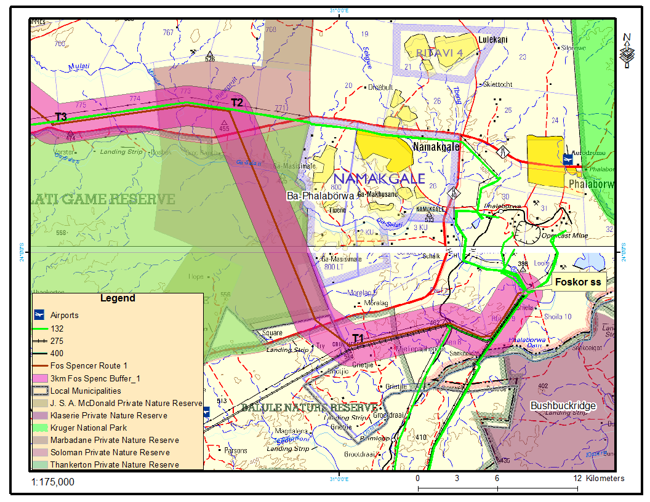
Figure 4-16: First Section of the corridor from Foskor Substation

- The corridor starts at Foskor Main Transmission Substation on farm Loole 31LU within Foskor mine running in a south westerly direction parallel to the existing 275kV power line towards T1. Reference is made to Figure 4-1 above. This area is predominantly characterized of mining activities, nature reserves and game farming. The vegetation is mainly comprised of woodland and grassland and the capability of the land is non-arable. According to the Limpopo Conservation Plan (LCP v2), the area is classified as CBA1, CBA2, ESA1 and ESA2;
- At turn point T1, the corridor will swing to the north-west crossing R40/R530, Selati Game Reserve, Tribal Lands, i.e., at the outskirts of settlements, Ga-Mashishimale and Makwareng, Ga-Selati River and R71 to turn point T2. The area is characterized of woodland and grassland and classified as a Critical Biodiversity Area with the following classifications: CBA1, CBA2 and ESA1;
- At turn point T2, the corridor will turn and traverse in a westerly direction crossing Molatle River and running parallel to the existing Gravelotte-Foskor 132kV power line for approximately 10.5km to turn point T3. A larger section of the corridor is within a Critical Biodiversity Area (CBA1) that has several drainage lines and is comprised of woodland and grassland;

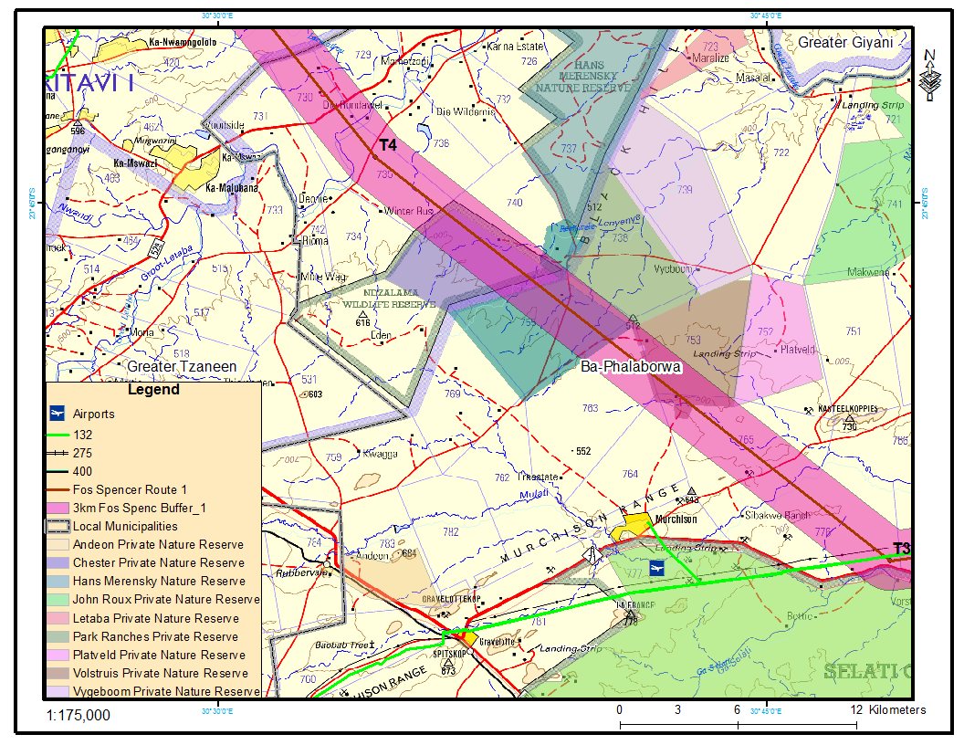
Figure 4-17: Turn Point T3 to T4

- The corridor swings to the north-west from T3 to T4 traversing across woodland, grassland, Ndzalama Wildlife Reserve, R71 road, Molatle and Reshwele rivers. The corridor will traverse across Farm Begin Volstruis 753LT and which is currently under the custodianship of the South African National Defense Forces (SANDF). These farms are currently being used for training purposes by SANDF; and
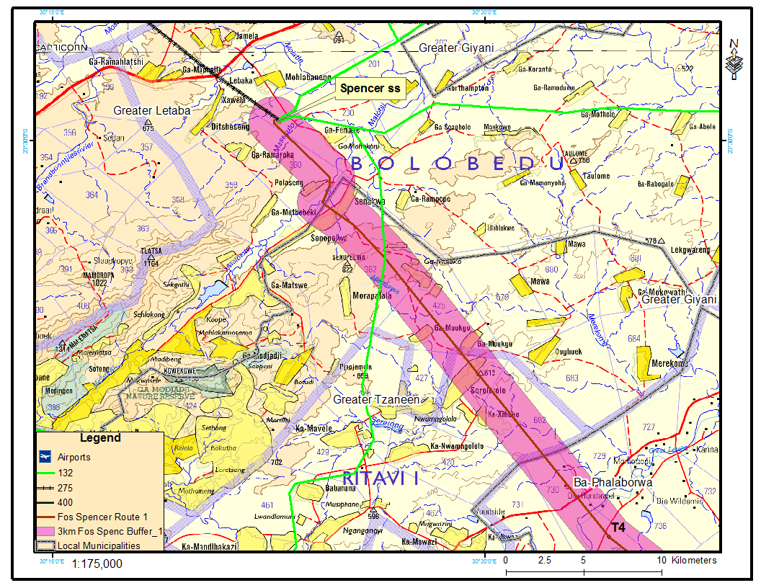
Figure 4-18: Last section of the corridor to Spencer substation

- At turn point T4, the corridor will run in a north-westerly direction towards Spencer Substation traversing across commercial agricultural holdings that are concentrated around the Greater Letaba River and settlements practicing subsistence cultivation. The corridor will traverse across two non-perennial and a perennial river: Lerwatlou, Merekome and Molototsi respectively. Sections of the corridors fall within built up areas, i.e., in Xihoko, Ga-Mawa, Senakwe, Polaseng and Ga-Moloko. The area surrounding Spencer substation is predominantly characterized of open bushland, subsistence farming and residential areas.

4.1.2 Power line Corridor Alternative 2

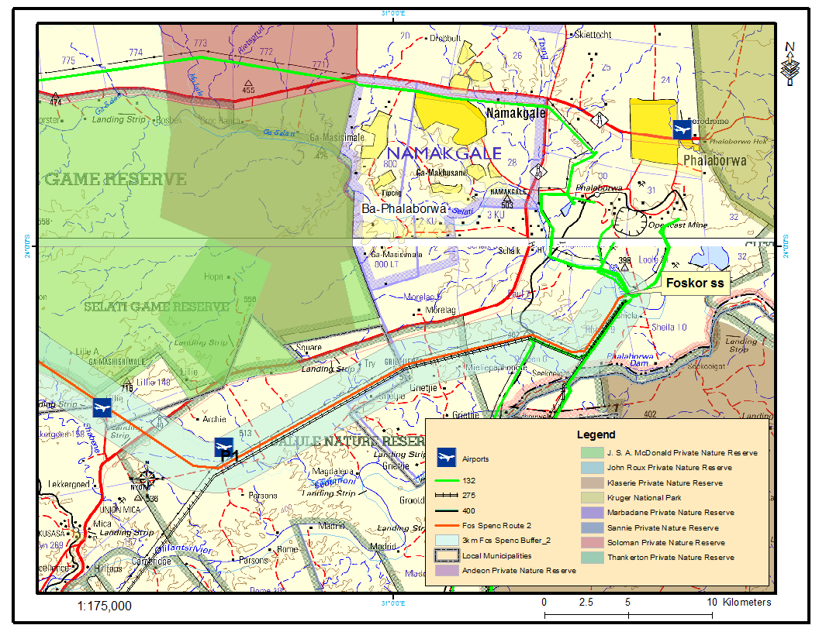
Figure 4-19: First Section of the Corridor from Foskor substation

- The proposed corridor alternative traverse areas that are similar to Alternative 1 and in some sections, will follow the same route. Reference is made to Figure 4-4, 4-5 and 4-7 for the locality of the corridor. Route alternative 2 is approximately 121km in length within a 3000m width corridor. Where corridor alternative 1 turns at T1 to run in a northerly direction, corridor alternative 2 will continue to run parallel to the 275kV for a further 12km cutting across Balule Nature Reserve towards P2. The area traversed is largely natural with mining occurring near the substation;
- At P1, the corridor crosses R40 cutting across Archie farm 156KT and Lillie 148KT and landing strips located within the farm, traversing in the southern-south east border of Selati Game Reserve. The corridor will run parallel to R526, traversing across Ga-Selati River, irregular plains, intact vegetation and R71 towards P2. Rocky outcrops and low hills can also be observed within the corridor;

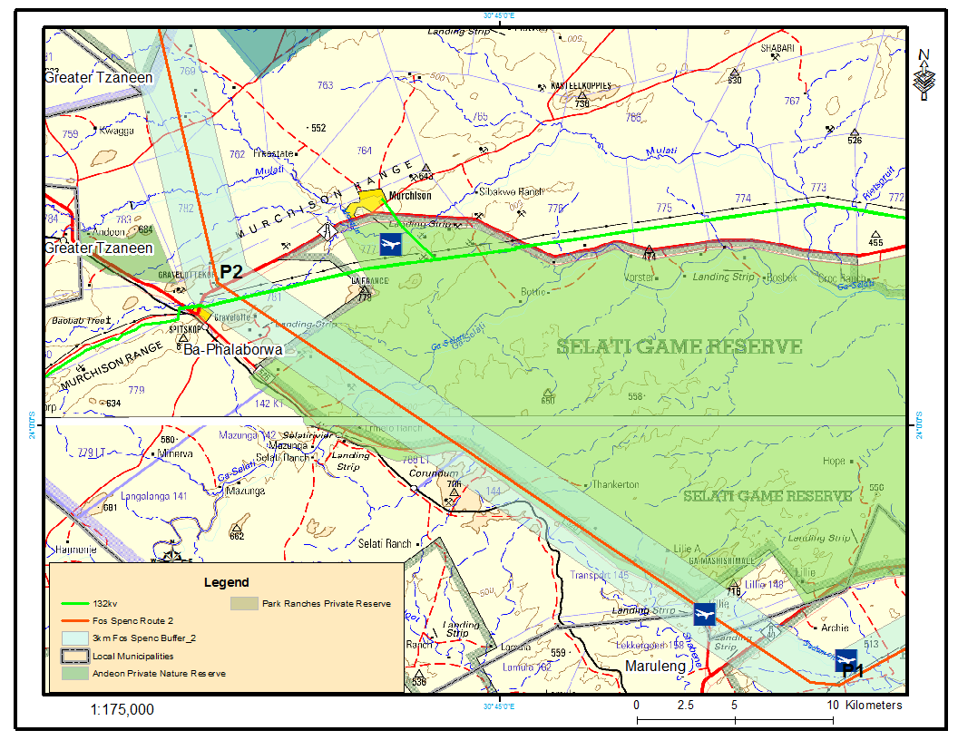
Figure 4-20: Turn points P1-P2

- At P2, the corridor turns in a northerly direction traversing at the outskirts of Gravelotte with Consolidated Murchison Mine and the airport in the north east. The corridor will traverse across Reshwele River and intact woodland towards P3 where it joins the corridor for Alternative 1 until P4 at Ga-Moloko; and
- At Ga-Moloko the corridor will swing to the north-east running parallel to an existing 132kV power line until Spencer substation. Reference is made to the Figure 4-6. This section of the corridor will traverse at the outskirts and through villages, cultivated fields and cross the perennial Molototsi river running parallel to its tributary.
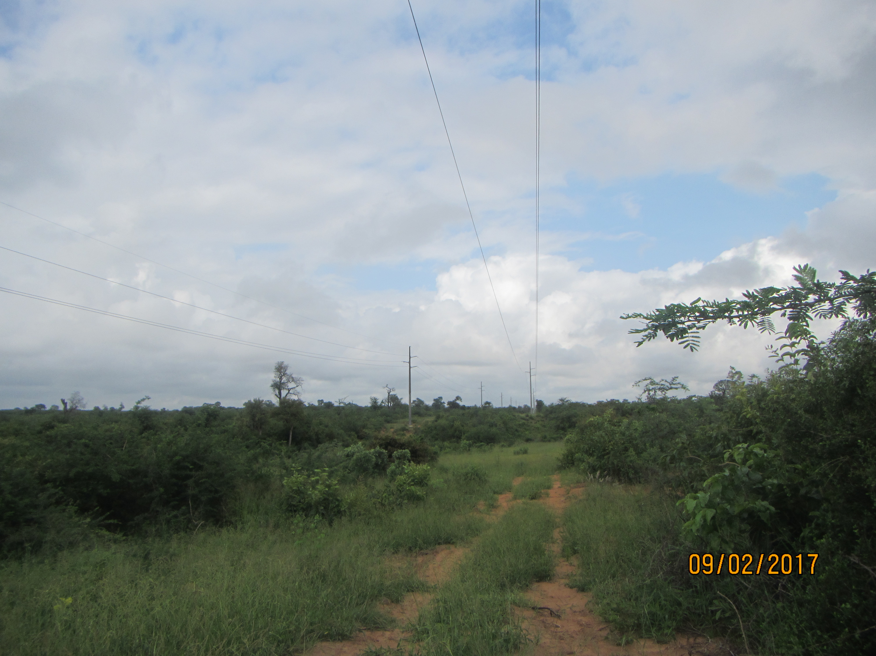
Figure 4-21: The corridor will run parallel the 132kV line
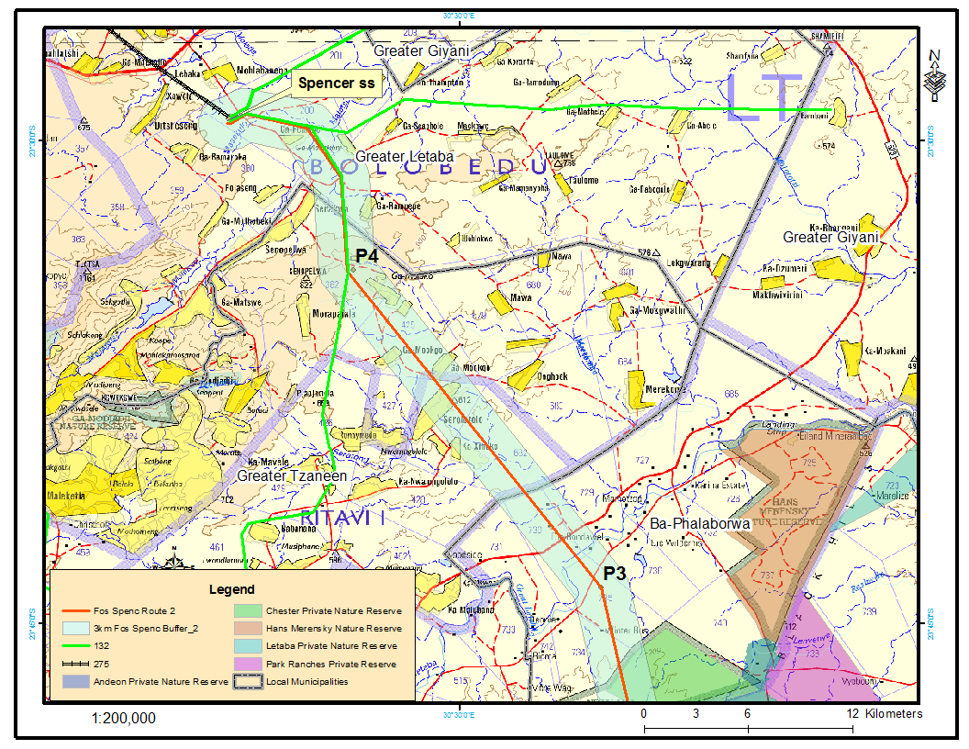
Figure 4-22: Last Section of Corridor to Spencer Substation

4.1.3 Foskor-Spencer Deviation 1a
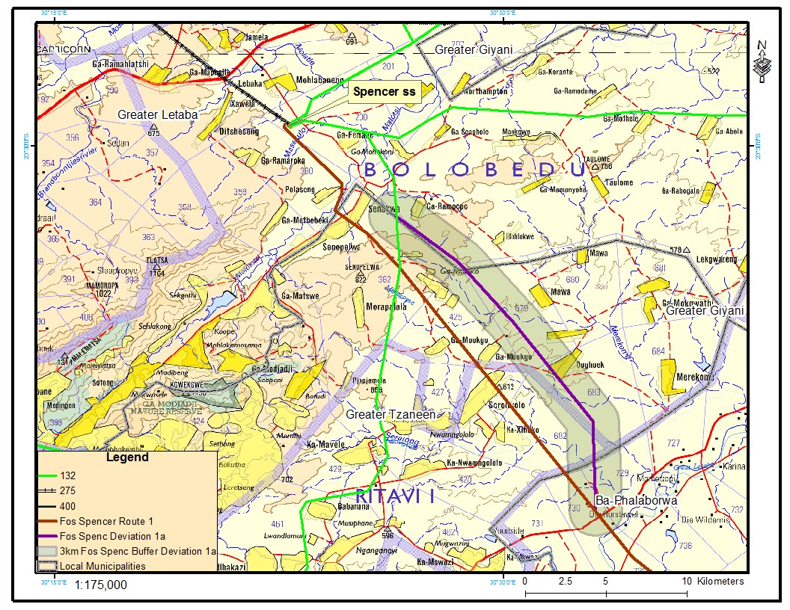
Figure 4-23: Locality of the Deviated Corridor

The deviation is approximately 23km with a 3000m corridor starting from corridor alternative 1 and 2 at the agricultural plots north of Groot-Letaba River and running for 5.6km in a north-easterly direction. The corridor will cross the Lerwatlou river and traverse across the open woodland and bushland. The corridor will then swing to the north- west traversing through and at the outskirts of villages such as Ga-Mawa, Ooghoek, Gamela, Rampede for 17km towards corridor alternative 1 and 2. It will also cross shrubland, cultivated fields, Merekome river and its tributaries. Reference is made to the map above.

4.1.4 Substation Extension
Spencer substation is located within Greater Letaba Local Municipality near Mohlabaneng. The substation can be accessed via the D3180 which branches from R81 road to Giyani. The site is relatively flat characterised of scattered vegetation in the north east, cultivated areas various villages surround the substation. Drainage lines are located approximately 500-675m north west and south of the substation. In addition, transmission and distribution power lines come in and out of the substation. The layout of the extension which will cater for the 400/132kV transformation yard, 1x500MVA, 400/132kV transformer and the oil holding dam will be finalised during the Environmental Impact Assessment Phase. Due to the nature of the proposed activities, no alternative sites will be assessed since it is an existing substation. Reference is made to the figure below for the preliminary layout.
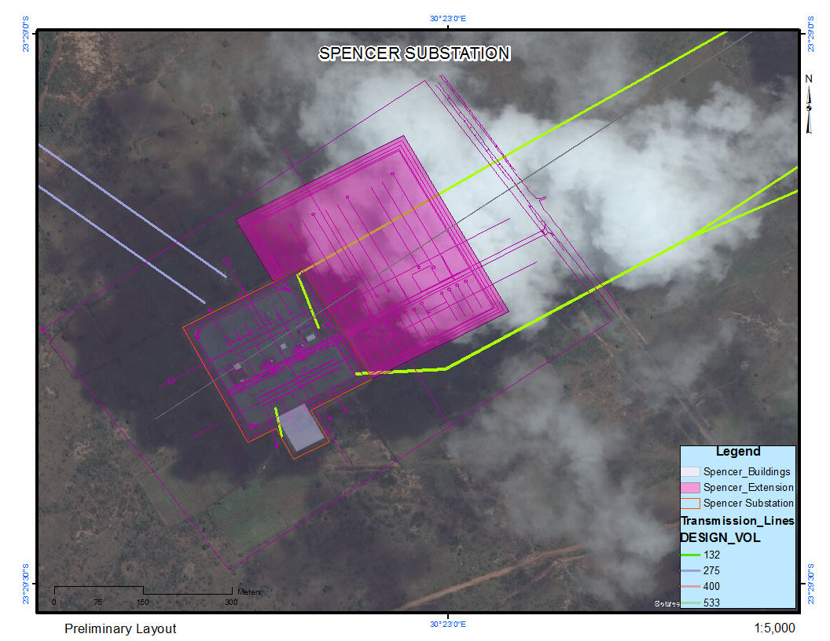
Figure 4-24: Substation Layout

4.1.4 No-Go Action Alternatives
The description of the baseline or existing environment or status quo is essential to all environmental assessments, and should be focussed on the key characteristics of, and values or importance attached to the environment. The baseline, or ‘no-go’ option, as well as all other relevant alternatives must be described, assessed and evaluated at the same scale and level of detail that enables adequate comparison with the proposed project. DEAT, 2004

This option would entail not strengthening the existing network in order to test the robustness of the Network. This option was not considered due to the following network restraints:
- Risk of load shedding from 2018 onwards;
- Further constraint on the Spencer 275/132kV transformation; and
The no-go alternative also means that the environment does not change, i.e., the land upon which the power line would traverse would primarily be used for agriculture, mining, conservation and residential unless a different development is undertaken. The impacts identified in Section 7 both positive and negative would not occur.

4.1.5 Access Routes
Access to the power line route will be from the existing village access roads and the existing tracks within the nature reserves. Where no access exists near to the power line route, access tracks will be created which will suite the nature of the terrain and the activities undertaken within the area. These tracks will not be upgraded to roads as they will be rehabilitated after construction.

4.2 Activity Alternatives
According to DEAT, 2004, consideration of activity alternatives entails the change in nature of the proposed activity to meet the same need. No go alternative can also be assessed under these alternatives. These are sometimes referred to as project alternatives, although the term activity can be used in a broad sense to embrace policies, plans, and programmes as well projects. Consideration of such alternatives requires a change in the nature of the proposed activity. (DEAT: 2004d)

Eskom ascertained that to strengthen the Limpopo East Corridor, power had to be transmitted from Foskor substation to the existing Spencer substation. Power can be transmitted by either overhead power lines or underground power lines. The advantages and disadvantages for installing either the underground or the overhead power lines are discussed below and these are mainly related to magnetic fields, engineering and costs.
- Magnetic field levels
- Underground cables produce no external electric field due to the shielding effect of the ground / covering above and to the sides of the cable;
- Due to the smaller distance to the buried cable they can have a much higher maximum magnetic field levels directly above the cable compared to overhead power lines;
- The magnetic field of the cable is also more localized compared to that of an overhead power line; and
- Where cables are buried in a tunnel, the magnetic field at the surface is much reduced and may be lower than an equivalent overhead line and often lower than background fields from other sources.
- Engineering
- 400 kV cables present inherently huge capacitances. This behavior cause voltage deviations which limits manageable application to relatively short distances. The integration of these characteristics in the existing electricity network may lead to transient overvoltages and resonance effects, jeopardising system reliability;
- Fault rate is lower for underground cables than overhead power lines but cable fault location is more challenging;
- Repair time for underground cables is more than 20 times longer compared to overhead lines. This causes longer outage periods; and
- Decommissioning of underground cables systems is more challenging and expensive.
- Costing
- 400 kV AC underground cables are between 12 and 17 times more costly solution than the overhead power line
Based on these aspects, underground cables were not considered as a viable option for strengthening the network.

4.3 Scheduling Alternatives
‘These are sometimes known as sequencing or phasing alternatives. In this case, an activity may comprise a number of components, which can be scheduled in a different order or at different times and as such produce different impacts.’DEAT,2004

Scheduling alternatives will be discussed in the Environmental Impact Report and the Environmental Management Programme, when the extent and severity of the expected impacts are addressed.

THE RECEIVING ENVIRONMENT

5.1 Climate
The project area falls within the summer rainfall area, receiving most of its rainfall in the summer months. Average minimum temperatures range from approximately 7.9-15.3ºC in summer to 5.5-10.4ºC in winter. Reference is made to Table 5-1 and 5-2 for the minimum temperatures and average annual rainfall. Table 5-1 shows that the average minimum temperature between the years are similar whilst average yearly rainfall range from 291 to 575mm from 2014 to 2016 with a 49% decrease recorded in 2015. Relative humidity is lowest during winter and spring and highest during summer and autumn.

Table 5-7: Average Monthly minimum temperature (ºC)
Months | Average Monthly Temperature (ºC)
Months | 2015 | 2016
January | 14.8 | 14.3
February | 15.1 | 14.0
March | 15.3 | 12.3
April | 11.4 | 11.5
May | 7.8 | 10.4
June | 7.8 | 4.7
July | 5.5 | 6.2
August | 5.9 | 6.0
September | 10.6 | 7.8
October | 7.9 | 12.1
November | 14.2 | 10.8
December | 14.8 | 15.7

Source: rp5.co.za (Hoedspruit Airport Station)
Table 5-8: Average Annual Rainfall, 2014-2016
Year | Average annual rainfall (mm)
2016 | 401
2015 | 291
2014 | 575
Source: rp5.co.za (Hoedspruit Airport station)
The predominant wind direction recorded at the airport is from the East North-East (ENE). Wind speeds are generally slow to moderate with wind speeds exceeding 5m/s recorded infrequently.

5.2 Soils
Areas are classified into land types based on their slope, soil type and depth and underlying geology. The project area is characterized with slopes ranging from 0-9% and there are red yellow apedal and glen rosa and/ mispah soils dominated by swelling clays. The clay content in this area is between 15% to 35%. An investigation will be carried out during the Environmental impact to assess the agricultural potential of the area. The report will be attached to the EIR.

5.3 Surface Water Resources
The proposed project area is located in the Olifants Water Management Area (WMA 2) which includes the Olifants, Letaba and Shingwedzi systems. The spatial extent of the area includes tertiary drainage regions B72 and B81. In addition to the numerous seasonal tributaries and wetlands traversed across by the power lines, three prominent rivers will also be traversed, i.e., Olifants, Groot Letaba and Ga-Selati Rivers. Table 5-3 below shows the rivers crossed by the proposed power line corridors.
Table 5-9: Prominent Rivers within the Project Area
Name | Class
Olifants River | Perennial
Ga-Selati River | Perennial
Great Letaba/ Groot Letaba | Perennial
Molototsi | Perennial
Sedumoni | Non-Perennial
Molatle | Non-Perennial
Reshwele | Non-Perennial
Lerwatlou | Non-Perennial
Merekome | Non-Perennial

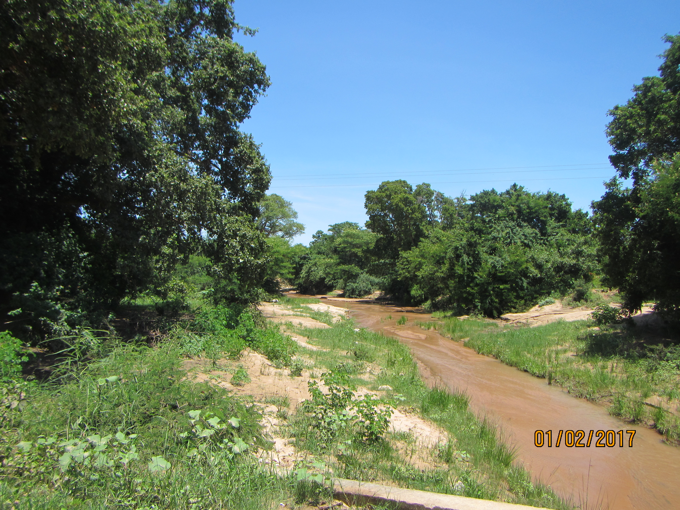
Figure 5-25: Merekome River
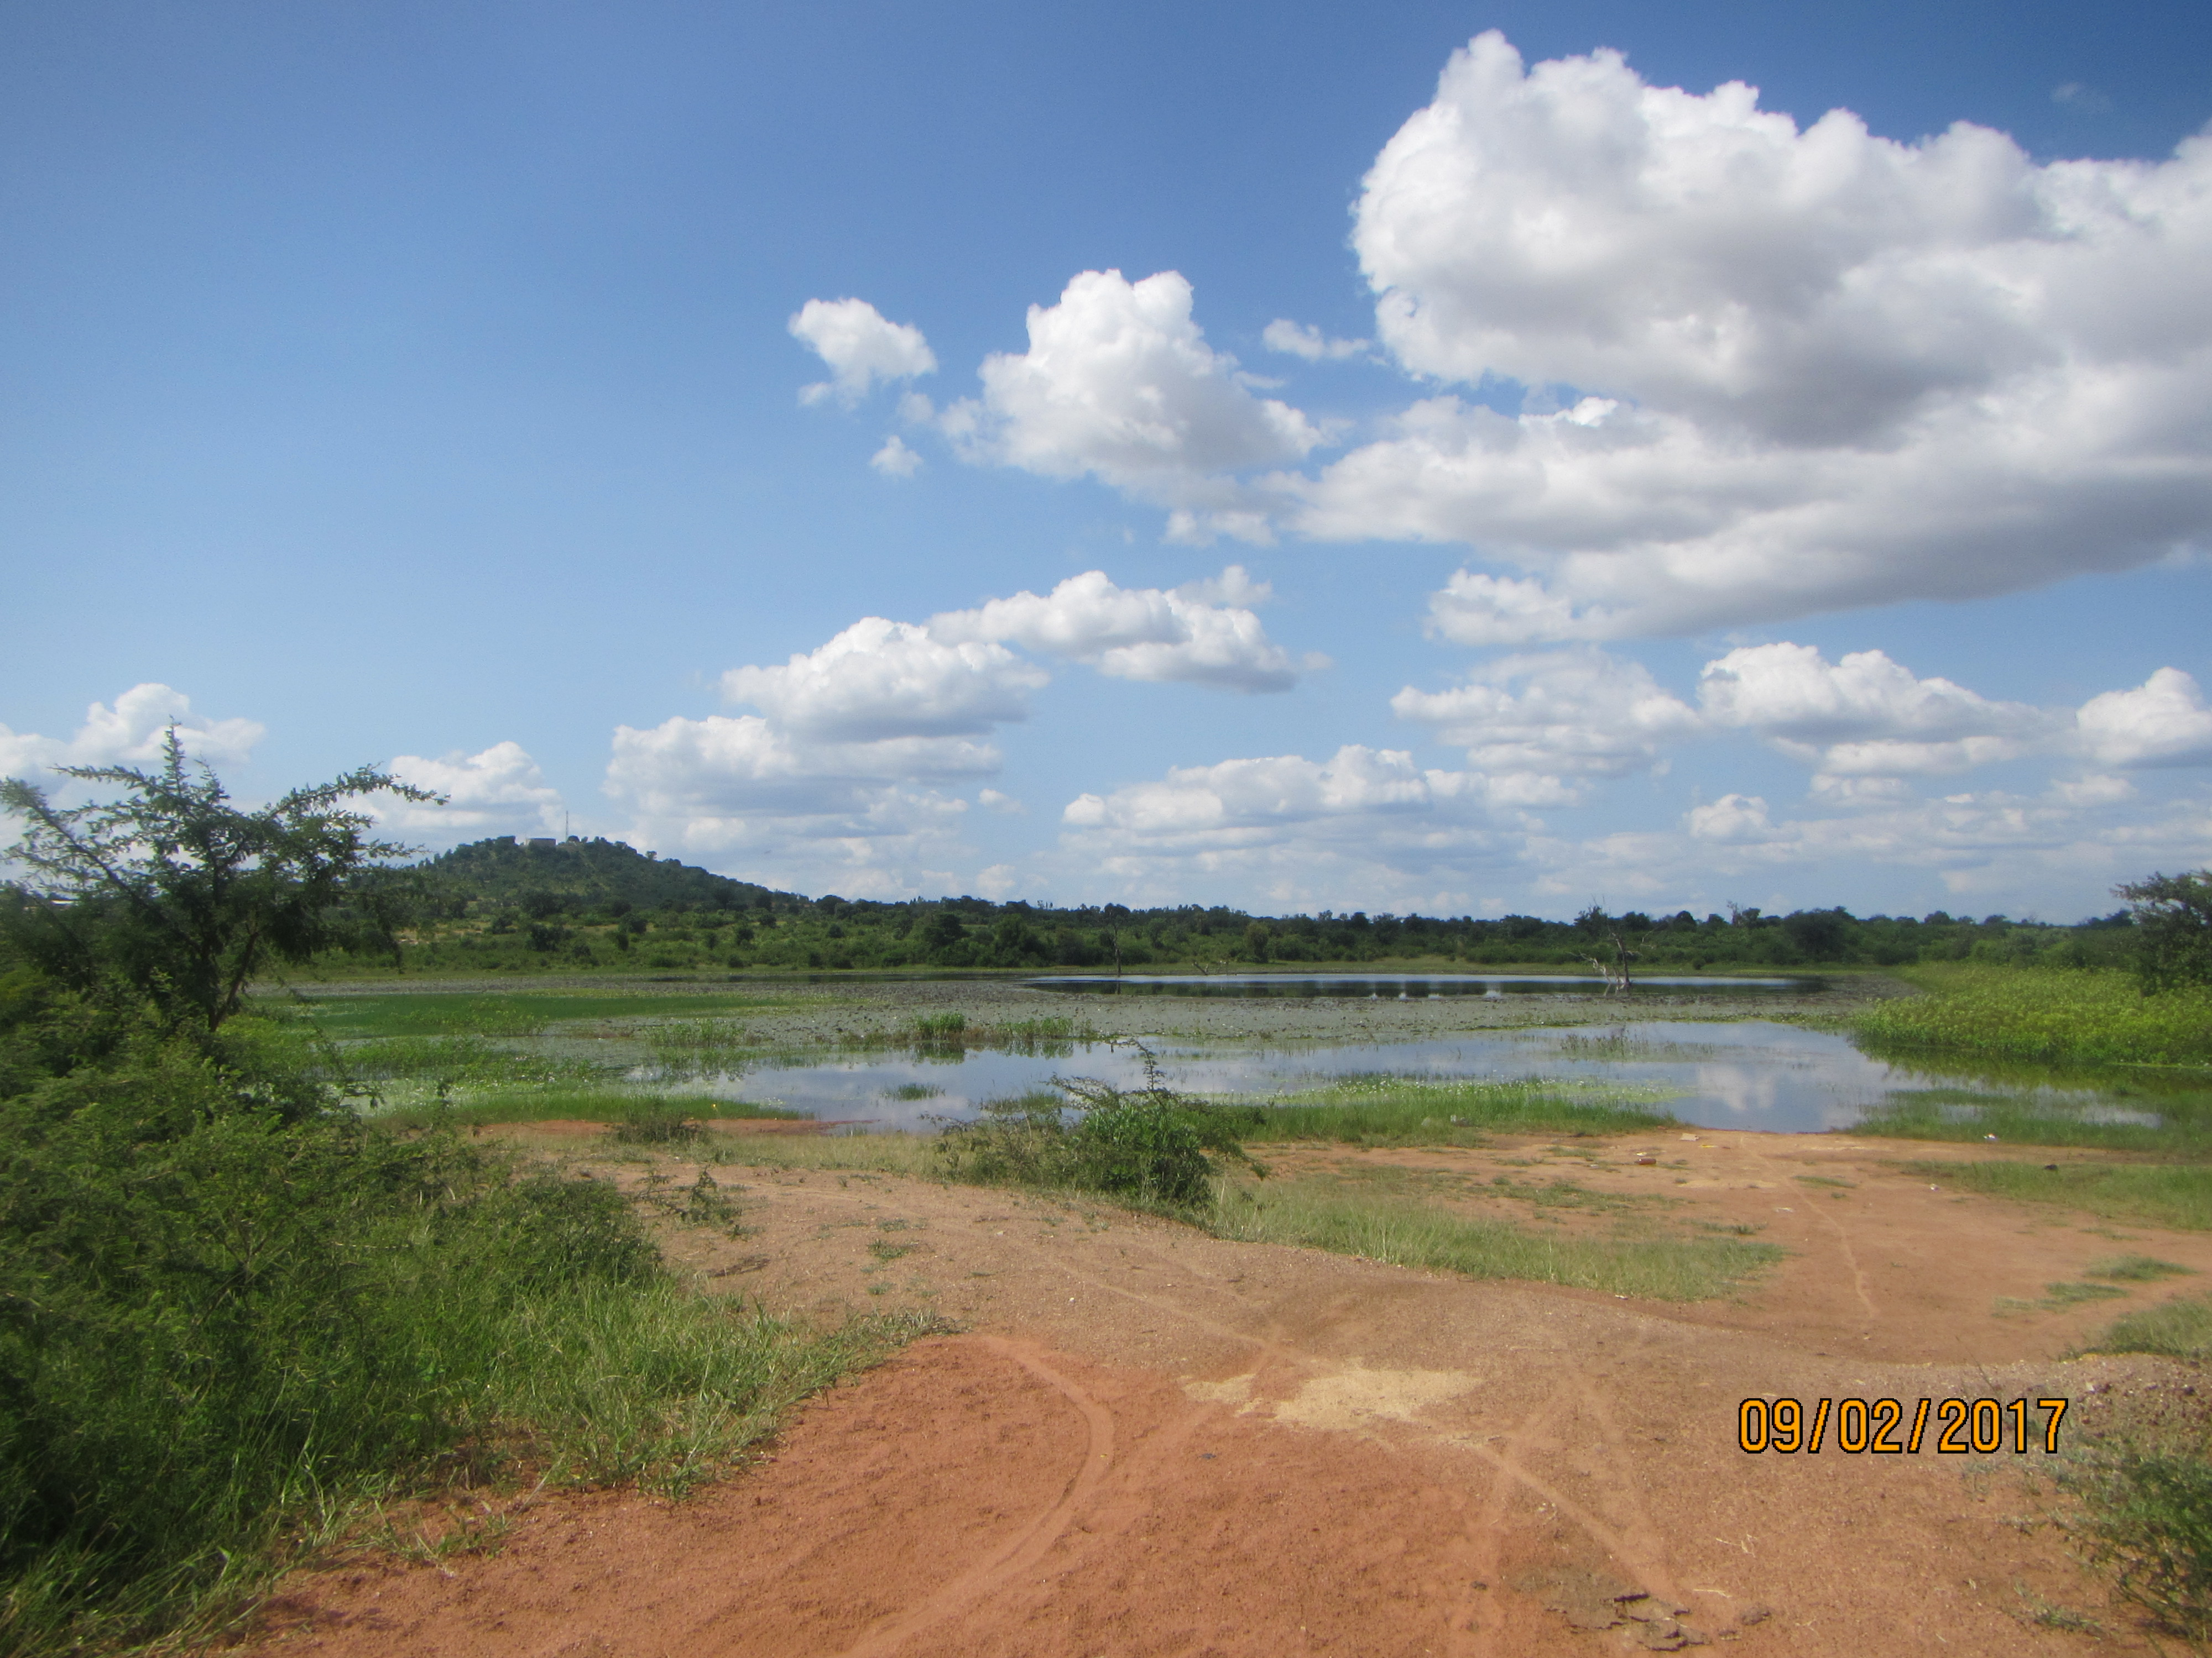
Figure 5-26: Dam near Xihoko
The Letaba River catchment is drained by the Groot Letaba River and its major tributaries are the Klein-Letaba, Middle Letaba, Letsitele and Molototsi River whilst the Olifants River catchment is a sub catchment of the Limpopo Basin and is the largest tributary of the Limpopo River. According to the Department of Water Affairs (2013), Olifants WMA is a highly utilised and regulated catchment and like many other WMAs in South Africa, its water resources are becoming more stressed due to an accelerated rate of development and the scarcity of water resources. The map below shows the Olifants WMA as well as the area affected by the proposed development.
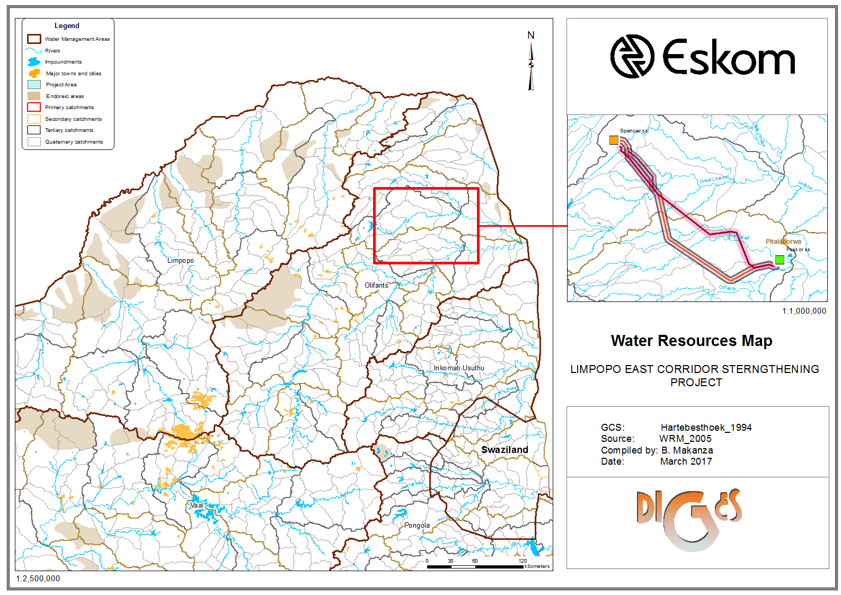
Figure 5-27: Olifants Water Management Area
A Wetland Report will be attached to the Environmental Impact Report

5.4 Ground water
Groundwater forms part of the four sources of water available within the Local Municipalities. Some villages and mining industries make use of ground water as their water source. The project area is characterized of a minor aquifer with a depth of approximately 20-30m. The groundwater zone is low to moderate yielding formation except where fractured. The water bearing fractures are principally restricted to a shallow zone below groundwater level.

5.5 Geological conditions

5.5.1 Lithostratigraphy
The Goudplaats Gneiss and Makhutswi Gneiss underlie most of the project area, with a smaller contribution from the ultramafic metavolcanics (rocks rich in chlorite, amphibole, talc and serpentine) and meta-sediments of the Giyani Greenstone Belt. Soils are red-yellow apedal, freely drained, but also shallow. Gravelotte and surrounding areas is underlain by varied geology which is largely composed of schist and amphibolite of the Gravelotte and Giyani Groups, with a few quartzitic and granitic hills. Miscellaneous, often shallow, soils with Glenrosa and Mispah forms common. Land types are mainly Ib, Fa, Ae and Fb.

5.6 Topography
Due to the length of the proposed power line corridors, the terrain the alternative power line corridors traverse across differ and they are characterised by:
- Irregular plains with low ridges: this terrain was observed in areas surrounding Foskor and Selati Game Reserve;
- Plains with open low hills: this terrain was observed in areas surrounding Spencer substation;
- Open low mountains;
- High hills; in areas surrounding Murchison and Gravelotte near Alternative 2;
- Level plains with some relief in in areas surrounding Murchison and Gravelotte near Alternative 2; and
- Plains with open high hills in areas surrounding Spencer Substation
Surrounding elevations range from approximately 200-1000 metres above mean sea level with the proposed sites situated at approximately 330- 620 metres above sea level.

5.7 Flora & Fauna

5.7.1 Flora
The threat of an ecosystem status defines the degree to which an ecosystem is still intact or has lost some of its vital aspects of its structure, function or composition. The proposed power line traverses across five vegetation types of the savanna type, two of which have been listed as threatened in terms of the Environmental Management Act (NEM:BA). A detailed Biodiversity Report will be attached to the Environmental Impact Report.

The vegetation within the project area is discussed below. Reference is also made to the Vegetation Map attached overleaf:

- Tsende Mopaneveld (SVmp5)
This vegetation type is distributed around the Hans Merensky Nature Reserve in the west to the vicinity of Letaba Rest Camp in the east. The vegetation is classified as least threatened characterized of a medium to high shrub dominated savanna with scattered trees and a dense field layer. Tree and shrub species include Acacia nigrescens and Sclerocarya birrea subsp. caffra; Colophospermum mopane, Combretum apiculatum, Combretum hereroense, Dichrostachys cinerea, Euclea divinorum and Grewia bicolor (tall shrubs), amongst others. The field layer comprises Clerodendrum ternatum, Indigofera schimperi, Bothriochloa radicans, Digitaria eriantha subsp. pentzii, Heteropogon contortus and Panicum maximum (grasses). The vegetation type is endemic and well protected.

- Lowveld Rugged Mopaneveld (SVmp6)
This vegetation type is distributed in the Limpopo and Mpumalanga Provinces. In the project area, it is distributed around the Foskor substation, parts of Balule Private Nature and Selati Game Reserve. The vegetation is usually characterized of dense shrubs with occasional trees and a sparse ground layer. Woody plants can become particularly dense where fire is excluded by very rocky terrain, such as in the vicinity of the Olifants River. Trees and shrubs found in this vegetation type include: Acacia nigrescens, Sclerocarya birrea subsp. Caffra, Colophospermum mopane, Combretum apiculatum, Terminalia prunioides, Acacia exuvialis, A. nilotica and Boscia albitrunca. It is classified as least threatened with a target conservation status of 19%. 34% is statutorily conserved in the Kruger National Park whilst an additional 5% conserved in private reserves such as Klaserie, Letaba Ranch and Selati Game Reserve. Approximately 20% is already transformed mainly by cultivation and some urban and built-up areas.

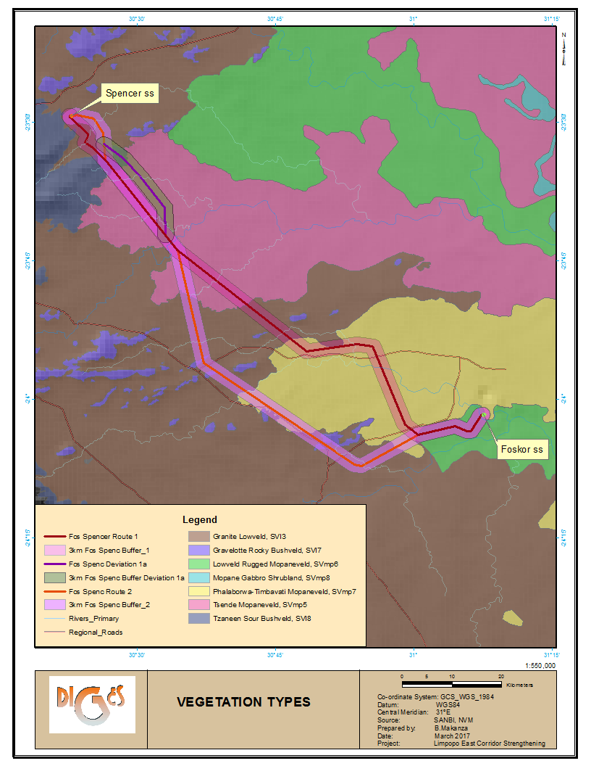
Figure 5-28: Vegetation types within the project area

- Phalaborwa-Timbavati Mopaneveld (SVmp7)
This vegetation is distributed in Limpopo and Mpumalanga Provinces and occurs south of the Olifants River between Amalgated Private Nature Reserves and Kruger National Park at an altitude between 300-600m. The vegetation is characterized of open tree savanna on undulating plains with the sandy uplands dominated by Combretum apiculatum, Terminalia sericea and Colophospermum mopane trees, with T. sericea. This type is classified as least threatened with a target for conservation set at 19%. Vegetation type is largely protected in Kruger National Park and the Private Nature Reserves. Approximately 5% has been transformed, mainly by development of human settlements as well as by mining. Reference is made to Figure 5-5 below for the vegetation near Selati Game Reserve.
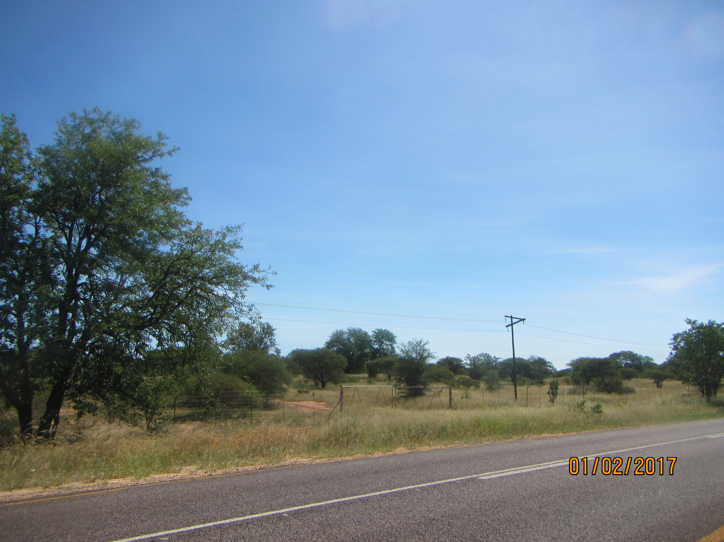
Figure 5-29: Vegetation in some areas near Selati Game Reserve

- Granite Lowveld (SVI3)
The vegetation type is distributed in Limpopo and Mpumalanga Provinces, Swaziland and marginally also KwaZulu-Natal. In the project area, it can be found in areas surrounding Murchison and Spencer Substation. Vegetation is characterized of dense thicket to open savanna with Acacia nigrescens, Dichrostachys cinerea, Grewia bicolor in the woody layer. The dense herbaceous layer contains the dominant Digitaria eriantha, Panicum maximum and Aristida congesta. The vegetation type is classified as vulnerable with a target for conservation set at 19%. 17% is statutorily conserved in the Kruger National Park. Approximately the same amount conserved in private reserves mainly the Selati, Klaserie, Timbavati, Mala Mala, Sabi Sand and Manyeleti Reserves. More than 20% is already transformed, mainly by cultivation and by settlement development.
- Gravelotte Rocky Bushveld (SVI7)
The vegetation is found in Limpopo Province around the Murchison Range in the Gravelotte area including surrounding mountains and hills including Ga-Mashishimale. It is characterized of open deciduous to semideciduous woodland on rocky slopes and inselbergs, contrasting strongly with the surrounding plains. Encephlartos dyerianus is endemic to this area. The vegetation type is least threatened with a target for conservation at 19%. 7% is conserved in a small proportion of the area in the northern part of the Selati Game Reserve. Approximately 15% is transformed due to cultivation and some development of settlements.
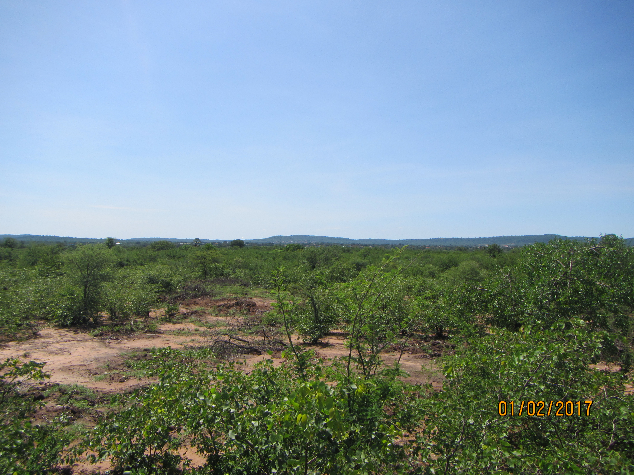
Figure 5-30:Vegetated areas near Spencer Substation

- Tzaneen Sour Bushveld (SVI8)
The vegetation type is found near the Spencer substation and is characterized of deciduous, tall open bushveld with a well-developed, tall grass layer, occurring on low to high mountains with undulating plains mainly at the base of and on the lower to middle slopes of the northeastern escarpment. Scattered alien plants associated with this type include Solanum mauritianum, Melia azedarach and Caesalpinia decapetala. The conservation status is endangered with a target for conservation set at 19%. The vegetation on site has been transformed mainly by settlements and cultivation.

5.7.2 Fauna
Various nature reserves are scattered across the project area and these are characterized of natural and near natural habitats for fauna species. More than 55 mammal species have been recorded including lion, rhino, elephant and sable. The mammal species of conservation concern will be listed in the Biodiversity Report to be attached to the Environmental Impact Report.

5.7.3 Avi-fauna
The proposed project area is characterised by natural and near natural environment consisting of open woodland, shrub land and grassland habitat potential for hosting a variety of avi-faunal species. The presence of rivers, drainage lines and dams also offers habitat for breeding and foraging wetland associated species. A Avi-fauna Impact assessment will be carried out and the report will be attached to the Environmental Impact Report.

5.8 Critical Biodiversity Areas
The current Systematic Biodiversity Plan for the province is the Limpopo Conservation Plan (version 2) whose purpose is to inform land-use planning and development on a provincial scale and to aid in natural resource management. One of the outputs is a map of Critical Biodiversity Areas (CBA’s) and Ecological Support Areas (ESA’s) which are classified into different categories based on biodiversity characteristics, spatial configuration and requirement for meeting targets for biodiversity pattern and ecological processes. The table below describes the different classes and their coverages thereof within the District Municipality. The map overleaf shows the different classes traversed by the proposed corridors:

Table 5-10: CBA Categories
CBA MAP CATEGORY | DESCRIPTION | % COVERAGE
Protected Areas | Declared and formally protected areas under the Protected Areas Act, such as National Parks, legally declared Nature Reserves, World Heritage Sites and Protected Environments | 30.8
Critical Biodiversity Area (CBA1) | are sites that are required to meet each ecosystem’s biodiversity targets | 18.7
Critical Biodiversity Area (CBA2) | The selected sites are the ones that best achieve targets of the systematic biodiversity plan though their areas that might achieve these targets. | 13.6
Ecological Support Area (ESA1) | Areas that are important for maintaining the ecological processes on which CBAs depend. These are largely natural areas. | 9.50
Ecological Support Area (ESA2) | These areas are no longer intact but potentially retain significant importance from a process perspective. | 8.40
Other Natural Areas | areas that still contain natural habitat but that are not required to meet biodiversity targets. | 11.9
No Natural Areas | These are areas without intact habitat remaining. | 7.3

The table above shows that protected areas and CBA1 areas constitute a larger percentage of the area in the District Municipality. The Nature Reserves traversed by the power line corridors are classified as CBA1 areas whilst the areas near the Spencer substation are classified as Other Natural Areas and No Natural Areas. This is due to the human activities such as settlements and substance farming.

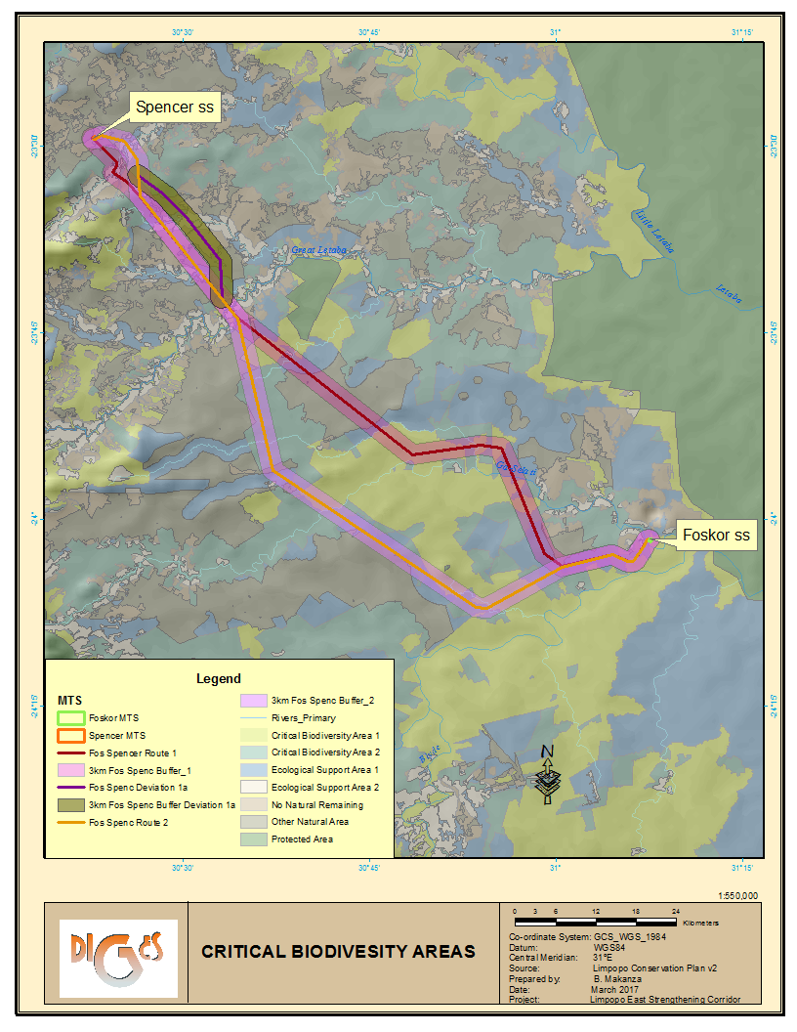
Figure 5-31: CBA Areas within Project Area

5.8.1 Protected and Nature Reserves
According to the Draft Mopani Bioregional Plan, protected areas including a portion of the Kruger National Park (KNP) cover 31.7% of Mopani District and private reserves cover an additional 10.2%. The Associated Private Nature Reserves (APNR) represents the bulk of the Private Nature Reserves (PNR) that are within the project area. The APNR is comprised of:
- Timbavati Private Nature Reserve;
- Umbabat Private Nature Reserve;
- Klaserie Private Nature Reserve; and
- Balule Private Nature Reserve
These areas are not formally protected by law but are considered to be conservation areas which also represent part of the Kruger to Canyons Biosphere Region. The proposed project area traverses across the Balule Private Nature Reserve and other nature reserves. The table below and the map overleaf lists the Nature Reserves within and in close proximity to the corridors.
Table 5-11: Protected and Conservation Areas within and near the Project Area
Name | Management Authority | Distance from Corridors
Protected Areas
Kruger National Park | SANParks | - 7.5km east of corridors
Letaba Ranch Nature Reserve | LEDET | - 9km north east of Alternative 1;  - 14km north east of Alternative 2.
Hans Merensky Nature Reserve | LEDET | - 2km north east of Alternative 1;  - 8km north east of Alternative 2.
Conservation Areas
Amalgated Private Nature Reserves | Private | - Corridor will traverse across some portions of Grietjie.
Solomon Private Nature Reserve | Private | - Alternative 1 traverses across it;  - 9km North East of Alternative 2
J.S.A. Macdonald Private Nature Reserve | Private | - < 5km from both corridors
Marbadane Nature Reserve | Private | - 2.8km North East of Alternative 1;  - 23.6km North East of Alternative 2.
Thankerton Private Nature Reserve | Private | - 10km South West of Alternative 1;  - Alternative 2 crosses the reserve.
Mazunga Private Nature Reserve | Private | - 15.6km South West of Alternative 1;  - < 2km from Alternative 2.
Andeon Private Nature Reserve | Private | - 13km South West of Alternative 1;  - < 1km from Alternative 2
Sannie Private Nature Reserve | Private
Volstruis Nature Reserve | Private | - Alternative 1 traverses across it;  - 10km North East of Alternative 2
Parks Ranches Nature Reserve | Private | - Alternative 1 crosses at the border
John Roux Nature Reserve | Private | - 6.5km North East of Alternative 1
Chester Nature Reserve | Private | - Both corridors traverse across the reserve.
Ndzalama Private Nature Reserve | Private | - Alternative 1 traverses across the reserve;  - <500m North East of reserve.
Vyeboom Private Nature Reserve | Private | - 4.5km North East of Alternative 1;  - 12km North East of Alternative 2.
Platveld Private Nature Reserve | Private | - <500m from Alternative 1;  - 14km from Alternative 2.

5.9 Land use
Land cover data indicates that 86% of the Mopani District is in a natural or near-natural state and this is largely due to the conservation and protected areas that are within the District Municipality. (Draft Mopani District Bioregional Plan, 2016) The alternative power line corridors will traverse these areas as shown in the map on page 63. The land cover within the protected and conservation area is characterized of woodland, open bushland, thicket or dense bushland and grassland. Foskor substation and some sections of the power line corridors traverse across mining areas in Phalaborwa and Gravelotte. Rural settlements are located in areas surrounding Spencer substation and subsistence agriculture and grazing also occurs close to the settlements. Commercial agriculture is also concentrated along the Groot Letaba River.

5.10 Archaeological and palaeontological attributes
According to the National Heritage Resources Act, 1999 (Act No.2 of 1999) objects that may be affected include the burial sites, buildings of more than 60 years of age, special geological features (fossil prints and bushman rock art) and paleontological objects. Clearing the area may result in the discovery of such objects. Construction of the service access roads, the proposed substation extension and power lines could potentially impact on heritage sites. A detailed heritage study will be included in the EIA report.

5.11 Visual Environment
The visual character of the environments through which the corridor alternatives would pass is quite varied, characterised by rural settlements, cultivated, mining and conservation areas. Areas close to the two substations, Foskor and Spencer are characterised of power lines of different voltages. These power lines traverse the area for distances between 5- 10km. A visual impact report will be attached to the EIR.

5.12 Air Quality
Several activities associated with transmission line construction can cause particulate matter and gases to enter the atmosphere and degrade air quality. Particulate matter originates from smoke from open burning of waste vegetation as well as from dust generated by construction activities. Gaseous hydrocarbons and oxides of sulfur and nitrogen are emitted from vehicle exhaust and open burning. The impact that these air pollutants have on sensitive persons or crops depends on topographic and meteorological factors, as well as the amount of each pollutant emitted. The air quality in areas surrounding Foskor substation is generally poor due to the mining activities undertaken in the area. The topography of the area also contributes to poor air quality by trapping air pollutants in the atmosphere under stable atmospheric conditions. The main impacts on air quality result from pollution and dust emissions from mining, agricultural, domestic and industrial activities.

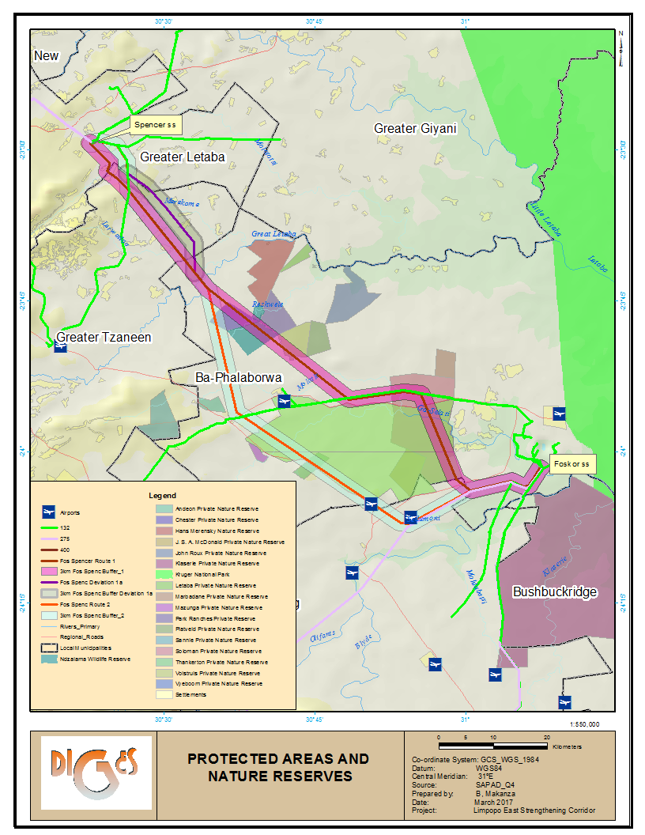
Figure 5-32: Protected areas and nature reserves within project area
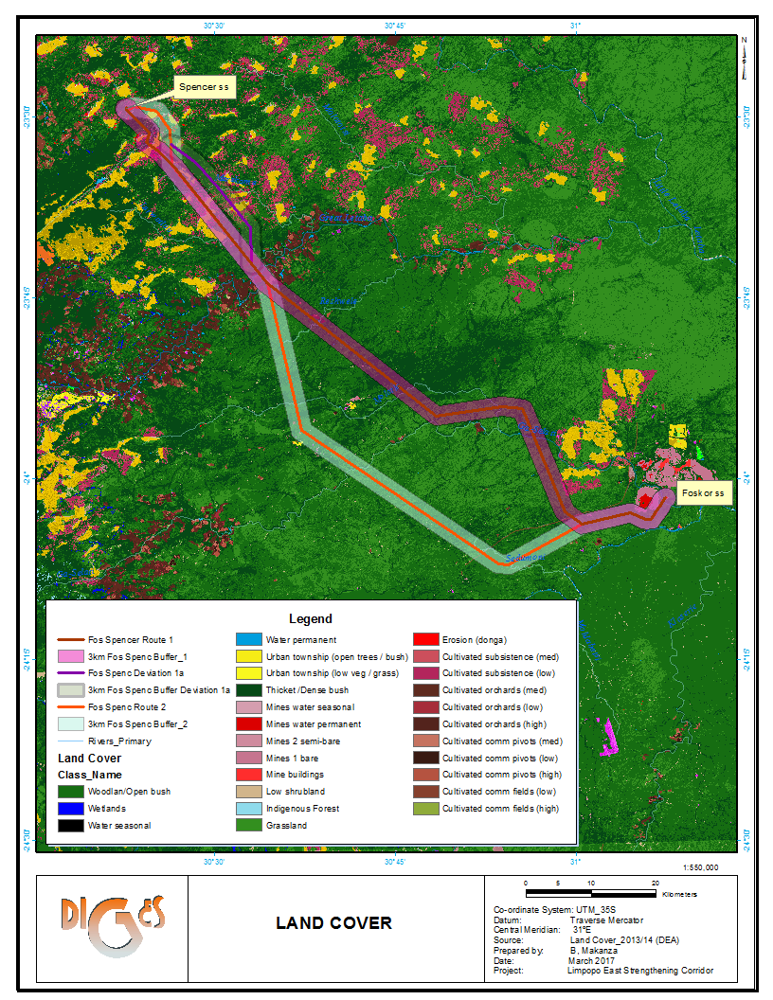
Figure 5-33: Land cover within project area

5.13 Socio-Economic Environment
According to Tony Barbour, 2007, there is a need to understand the social environment and communities affected by the proposed development in order to ensure that positive benefits associated with the project are enhanced and the negative impacts are avoided or mitigated. There is therefore a need to collect baseline data on the current social environment and historical social trends. This section therefore covers the socio-economic profile of the area at a local and regional level. Desktop review of the Mopani District Municipality, Greater Letaba, Greater Tzaneen, Ba-Phaloborwa and Maurelng Local Municipalities Integrated Development Plans and documents pertaining to the project area were consulted.

5.13.1 Population Demographics
According to Census 2011, Mopani District’s population accounts for 20.1% of the Province’s population whilst Greater Tzaneen Local Municipality has the highest population within the district accounting for 35.7%. Table 5-6 overleaf show the total land area and population per municipality within the District Municipality.

Table 5-12: Population and Municipal Land Coverages
Municipalities | Population | % of District Population | Land Area | % of District Land Area
Greater Tzaneen | 390 095 | 35.7 | 3 242.6km² | 16.2
*Greater Giyani | 244 217 | 22.4 | 4 171.6km² | 20.8
Greater Letaba | 212 701 | 19.5 | 1 890.9km² | 9.4
Ba-Phalaborwa | 150 637 | 13.8 | 7 461.6km² | 37.3
Maruleng | 94 857 | 8.7 | 3 244.3km² | 16.3
Mopani District | 1 092 507 | 100 | 20 011 km² | 100
Source: Mopani District IDP (2016/17 version 1)
*Local Municipality is not within the project area
Ba-Phalaborwa accounts for 13.8% of the District’s population though it occupies the largest area within the District. This can be attributed to the nature reserves that are within the Local Municipality which occupy large tracts of land. Greater Letaba Local Municipality is largely rural accounting for 94.3% respectively per the Local Municipality’s population whilst Ba-Phalaborwa has the highest urban and farming population accounting for 51% and 12.8% respectively. (Source: Mopani District Municipality IDP 2016/17 version 1)

The percentage growth of population for Ba-Phalaborwa has increased immensely by 14.9% from 2001 to 2011. This growth is higher than the District Municipality and it can be attributed to the mining and conservation activities being undertaken in Phalaborwa and Gravelotte. Greater Letaba Local Municipality population decreased by 3.4% and this can be attributed to out-migration.

5.13.2 Gender
In almost all local municipalities there are more females than males. This is significant in Greater Letaba Municipality which is primarily rural in nature. This could be attributed to low levels of education intensified by the out migration by men seeking jobs elsewhere. Ba-Phalaborwa has comparable balance in numbers between females and males, however with more males than females work within the economically active age group.

5.13.3 Language
According to Mopani District Municipality 2016/17 IDP, the most dominant languages are Northern Sotho and Tsonga accounting for 46% and 44% respectively of the total district’s population. Akrikaans and English account for 2% and 1.3% respectively.

5.13.4 Level of Education
Education is very important in one’s life. It creates a range of options which a person can choose from and it also opens doors to better opportunities and great achievements. The District Municipality has a low level of education accounting for 40% of the adult population being regarded as functionally illiterate. Approximately 13,7% have only completed some form of primary education whilst 6.5% has completed some form of higher education. (Mopani District IDP version 1)

5.13.5 Employment Profile
The farming sectors is the second largest employer within the District Municipality employing 25.9% of the District population. In Ba-Phalaborwa, mining is the second largest employer accounting for 19.5% of the population. 39% of the economically active population in the District are unemployed, 60% of which are women. The unemployment rate is higher in Greater Tzaneen accounting for 42% of the district’s unemployed population.

5.13.6 Households by Dwelling Type
According to the Rustenburg Local Municipality IDP 2013-2014, there are four broad types of settlements within the Local Municipality which are distinguished primarily by the availability of services and the security of tenure. The settlements are described as follows:
- Formal Urban Settlements
These have a formal layout, are serviced with a full range of municipal services and the settlement households can obtain security of tenure. These include areas such as Phalaborwa, Gravelotte,

- Tribal Settlements
Large areas of land in the District, mainly Greater Letaba Municipality are owned by the National Governemnt of South Africa and former Lebowa and Gazankulu Government with tribal and community authorities as custodians. These traditional authorities play a very important role in terms of their traditional culture and therefore also have a major influence in the manner in which land is made available to individuals for settlement, as well as the use for economic purposes.
- Rural Settlements
These are settlements that are similar in nature to the tribal settlements regarding the residential densities and functions, but they are not located on tribal land.

5.13.7 Access to Services
Access to social and economic services enables people to participate fully in the economy and their communities. When services such as water, energy and transport are available to people, they can spend more time doing profitable work, and communication establishes a vital link between people and the outside world.

- Energy
Eskom provide electricity for lighting to most of the communities within the Mopani District Municipalities. The most frequent use of electricity in Ba-Phalaborwa LM and Greater Letaba LM is lighting accounting for 90.8 % electricity for lighting.

- Water
Mopani District Municipality is the water service authority (WSA) and is responsible for bulk water supply and sanitation facilities within the local municipalities. The municipalities are responsible for water reticulation in agreement with the district municipality.

- Toilet facilities
The towns and their extensions have well developed sanitation systems whilst most rural areas do not due to their dispersed nature which makes it difficult to provide services. Most dwellings in the rural areas use pit latrines or have no sanitation facilities at all.

- Refuse removal and Waste Disposal
Most of waste management services by municipalities are prioritized in urban areas (townships & towns) and most of rural communities in the Mopani District Municipality do not have access to waste removal services by their local municipalities. This results to residents in rural areas dispose waste on their own, often to illegal dumping occurring. According to Census 2011, Ba-Phalaborwa Municipality has the highest percentage (48.8%) of refuse removal per week whilst Maruleng Local Municipality only accounts for 5.9% of refuse removal per week.

There are only two local Municipalities, Greater Tzaneen and Maruleng with legal landfill sites whilst Greater Letaba transports its waste to Greater Tzaneen.

5.13.8 Economic Activity
The mining sector is the largest contributor of the Mopani District Municipality’s GDP constituting 30% whilst agriculture is the most important sector in Greater Tzaneen, Greater Letaba and Maruleng Local Municipalities. Mining is concentrated in Ba-Phalaborwa Local Municipality where it contributes approximately 80% of the Local Municipality’s GDP and employs more than 2 000 people and an additional 450 contractors. Agriculture is predominant in Tzaneen, Maruleng and Letaba where ZZ2 dominates the industry in terms of output and the major focus is on sub-tropical fruit. These two industries focus is to produce for exportation. According to Mopani District Municipality’s IDP, Greater Letaba currently makes the least contribution to the District’s GDP.

5.13.9 Tourism
Tourism is deemed to be an engine that drives growth and development in areas and is often seen as a mechanism for local communities to capitalize on assets such as the natural environment and cultural heritage. In Mopani District Municipality, it also plays an important role. The indigenous forests, biospheres, nature reserves, wetlands, endangered species as well as Kruger National Park offer several opportunities for tourism. These include opportunities for eco-tourism, as well as tourism associated with the variety of historical and cultural interests found within the district. Mopani District is also considered the home of the big five due to abundance of such animals in Kruger National Park and surrounding private game farms and nature reserves. The numerous nature reserves within the district include: Selati Game reserve, Chester Reserve, Ndzalama Wildlife Reserve, Klaserie, Thorny Bush and Timbavati, Westfalia Estates, Merensky Reserve, Letaba Ranch, Geothermal springs in Hans merensky Nature Reserve and Soutini Baleni, Manotsa and Madrid and Shiluvane. Tourism related activities offered in these areas include: hiking, white water rafting, abseiling, hot air ballooning, rock climbing and bird watching. A Tourism Impact Assessment will be carried out during the EIA and the report detailing the impacts of constructing the power line in the area will be attached to the Environmental Impact Report.
Airports
There are several landing strips within the area which play a significant role in increasing tourist traffic and establishing the area as a gateway to the Kruger National Park and the surrounding areas. There are two airports within the 3000m corridor located on Archie 156KT and Lillie 148KT with the landing strip having a length of 1.1km. These airports cater for visitors to the Boulders Game Ranch. Two other airports are also near the corridors, namely Hendrick Van Eick Airport and Gravelotte Airports which are approximately 9km and 4km south west of the corridors.

PUBLIC PARTICIPATION PROCESS

6.1 Introduction
Public Participation Process (PPP) is viewed as a process of empowering communities and stakeholders in their efforts to safeguard the resource-base in more efficient ways and to use the resources sustainably. It also enables people to play lead roles in identifying, designing, directing and implementing any development activity which has an impact on their immediate environment, and therefore on their way of life. When undertaking an EIA project, public participation process is undertaken in terms of the Regulations set out in Chapter 6 of the EIA Regulations, Government Notice R982 of December 2014. The activities carried out as part of the process are as follows:
- Section 40 –all registered Interested and Affected Parties (I&APs) are given 30 days to submit comments on generated reports;
- Section 41 – the person conducting a PPP must give notice to all I&APs by fixing notice boards, giving written notice and placing advertisements in local newspapers and provincial/national newspapers;
- Section 42 – open and continuously maintain a register of Interested and Affected Parties (I&APs);
- Section 43 – all registered I&APs are entitled to comment on all reports and the person conducting the PPP must ensure that comments raised are brought to the attention of the proponent or applicant; and
- Section 44 – the person conducting the PPP must ensure that comments of I&APs and records of meetings are recorded and responded to. The comments and responses report must be attached to the reports that are submitted to the competent authority.

6.2 Objectives and approach to the PPP
The objectives of the PPP are:
- To gather input from Interested and Affected Parties (I&APs) regarding the level and nature of their interest to better plan public participation activities related to the EIA;
- To obtain local knowledge from the public to enhance our understanding of the environmental, cultural and socio-economic setting of the proposed project for use in the EIA;
- To understand the reasons behind the views of the public regarding the potential environmental impacts;
- To solicit public input or views regarding potential alternatives and mitigation measures to reduce environmental impacts;
- To work with the public to resolve a topic specific issue;
- To obtain public comments on the Environmental Impact Report to verify whether information in the report is accurate, representative and adequate;
- To provide feedback to Interested and Affected Parties about how their input, views, issues and concerns have been considered in the process; and
- To inform the public about the Competent Authority’s (Department of Environmental Affairs) decision and next steps to follow.

6.3 Public Participation Team
A team of Public Participation Practitioners was assembled to undertake the PPP taking into consideration the geographic nature/area of the receiving environment, process needs of I&APs (language; organizational structures etc.) and the technical nature of the project. Reference is made to the table below for the roles and experience of the PP team:

Table 6-13: Roles and Experience of PP team
Name | Position | Experience
Moses Mahlangu | PP Team Manager: | - Involved in more than 20 EIA projects for Eskom power lines and substations.  - Handled consultations with municipality councillors, traditional leaders in different regions in South Africa using six different languages  - Has been involved in 8 Eskom construction project as an ECO  - Previously worked as a teacher and school inspector for 12 years
Vicus Coetser | Facilitator for Public Meetings | - Mr Vicus Coetser commands a vast experience of facilitating public meetings which involve farming communities  - Currently involved in the handling of negotiations for Eskom servitude for different powerlines in Limpopo Province. He is thus familiar with farming community in the study area.
Calvin Netshaulu | PPP Officer | More than 10 Eskom (Tx & Dx) projects since 2010. Mr Netshaulu is responsible for continuous database management. Database management is internally considered as a backbone of public participation process since an accurate record keeping of participating stakeholders is needed for the flow of information between stakeholders, the study team and the proponent.
Khazamula Daniel Chauke | Local PP Officer | - Mr Chauke is a local person who speaks both xiTsonga and North Sotho  - He has worked in the area of Tzaneen-Phalaborwa-Giyani as agricultural extension officer, working in villages. Mr Chauke brings the skill of communicating with the villagers and good knowledge of the affected villages.

6.4 Limitations Associated with Public Participation Process
Certain limitations are found with any public participation process. The most important are:
- I&APs not registering and therefore not partaking in public events and the public participation process;
- I&AP not attending public events relating to the proposed project;
- I&AP not receiving information timeously and commenting timeously;
- Lengthy time associated with identifying and contacting all I&AP in a study area.
- I&APs focusing on issues that do not relate to the proposed project.

6.5 Summary of PP Activities undertaken
The activities undertaken and proposed during the Pre-Application and Scoping Phases of the assessment are outlined in Table 6-2 below.
Table 6-14: Summary of PP Activities
DATE | ACTIVITY | PARTICIPANTS | PRODUCTS
26/09/2016 | Identified Interested and Affected Parties and listed them in the database | Consultants and the public | I&AP Database  (See Appendix D-1a)
13/01/2017 | Placed posters in the study area | PP Consultant | Posters  (See Appendix D-4)
19/01/2017 | Distribution of PP documents (BID, Reply Sheet, Study Area Map and list of properties owners) | Consultants and the Public | Information documents distributed (See Appendix D-2a)
20/01/2017 and 24/01/2017 | Officially announced the project through the newspapers advertisements (One regional and four different local newspapers) | Project Proponent (Eskom), Consultants and general public | Newspapers adverts  (See Appendix D-3)
08/02/2017 | Focus Group meeting (Majeje TA) | Project Proponent (Eskom), Consultants and Majeje Traditional Authority) | Minutes  (See Appendix D-5b)
08/02/2017 | Focus Group meeting (Mashishimale CPA) | Project Proponent (Eskom), Consultants and Mashishimale CPA | Minutes  (See Appendix D-5b)
09/02/2017 | Focus Group meeting (Selati Game Reserve) | Consultants and Selati Game Reserve | Minutes  (See Appendix D-5b)
10/02/2017 | Focus Group meeting (Grietjie Community Members) | Consultants and Grietjie Community Members | Minutes  (See Appendix D-5b)
10/02/2017 | Focus Group meeting (The Local Governments and Key Stakeholders) | Project Proponent (Eskom), Consultants, the Local Government and Key Stakeholders. | Minutes  (See Appendix D-5b)
02/03/2017 | Focus Group meeting (Modjadji Traditional Authority) | Project Proponent (Eskom), Consultants and Modjadji Traditional Authority | Minutes  (See Appendix D-5b)
02/03/2017 | Focus Group meeting (Olifants North Game Reserve) | Project Proponent (Eskom), Consultants and Olifants Game Reserve Representatives | Minutes  (See Appendix D-5b)

6.6 Methodology Adopted
Public Participation Process entails that all stakeholders that might be affected or have interest in the proposed project be afforded an opportunity to participate in the impact assessment of the project and they must each realize that they have responsibilities. See Figure 6-1 and 6-2 for the role of the Interested and Affected Parties (I&APs), the EAP and the Competent Authority (CA):

The EAP &
Facilitators
I&APs
Authorities
Proponent
Competent Authority
Commenting Authorities

Role
Players

Stakeholders

Figure 6-34: Role Players in the PPP

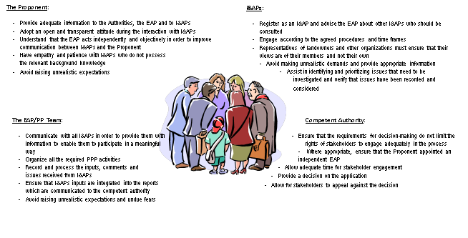
Figure 6-2: Role Players

Due to the larger area traversed by the proposed power lines and the different groups, there was need to have a diversified team who understand the cultures and languages of the different groups of people. Preliminary information with regards to possible Interested and Affected Parties was collected prior to the public participation activities. This allowed us to better plan the public participation activities. Potlako Negotiators were tasked with identifying all the landowners within the project area whilst Mr Moses Mahlangu and Mr Khazamula Chauke undertook a reconnaissance site visit to the area on the 12th and 13th of January 2017 in order:
- To develop the preliminary understanding of the social context (representative structures; language; communication media, etc.);
- To identify points where information could be made accessible to the local communities (venues for meetings and public places where information documents could be placed); and
- To identify those parties or structures that may be interested in and/or affected by the proposed developments (farming communities; municipalities and tribal lands)

6.6.1 Stakeholder Identification
EIA Regulations, 2014 GNR. No 982, Chapter 6 [Section 42 – open and continuously maintain a register of I&APs]

With the help of land-owners’ database developed by Potlako Negotiators and Services (Pty) Ltd and through networking and advertising, I&APs were identified and these I&APs are currently registered on the database. Two separate databases are maintained viz. the database for landowners and the database for all other stakeholders (I&APs). The two databases of registered stakeholders submitted with this report includes stakeholders from:
- National, Provincial and Local Government
- Landowners
- Non-Governmental Organisations
- Business, Industry & Tourism
(Reference is made to Appendix D-1a and D-1b)
DIGES Group endeavored to ensure that individuals/organisations from a 'vertical' (institutional) as well as a 'horizontal' (geographical) point of view were identified. Geographically, DIGES Group focused on nearby, adjacent and directly affected landowners, Traditional Authorities, Community Property Associations and organisations that represent them. A 'vertical' approach was used to identify those institutions or individuals that might be affected by or could make a contribution to the project, but who are not necessarily in its direct sphere of impact. At the time of officially introducing the project to the public, 218 of the landowners in the study area had already been identified by Potlako Negotiators and Services (Pty) Ltd as such contact details were known and most landowners received the Background Information Document (BID) early in the study process. Reference is made to Appendix D-1a and D-2b for the landowner database and proof of notification respectively. These stakeholders will be invited to different meetings that will be held in the study area. Government departments and the four local municipalities under the Mopani District Municipality have also been identified and registered on the database. Officials from the municipalities in the study area have also received information on this project and were invited to focus group meeting held on the 10th of February 2017 in Tzaneen.

6.6.2 Giving Notice to all Interested and Affected Parties

Identified potentially Interested and Affected Parties were informed about the projected as required in terms of EIA Regulations, 2014 GNR. No 982, Chapter 6 [Section 41 – the person conducting a PPP must give notice to all I&APs by fixing notice boards, giving written notice and placing advertisements in local newspapers and provincial/national newspapers.]

To create awareness, use was made of Background Information Document (BID), emails; telephone calls; newspaper advertisements and site notices; visits to different Traditional Authority offices and municipal offices. Visiting Traditional Authority offices and municipal offices also helped the PPP Team to establish the preferred consultation process in the area.

- Emailed and posted letters
The first strategy of informing the public about the proposed project after the reconnaissance site visit was to send out personalised letters via emails and post to all stakeholders on the database informing them about the project and inviting them to submit their comments and issues about the proposed project in their area. A BID was also included in this package. (Refer to Appendix D-2b for a copy of this letter).

- Media Advertisement
Advertisements were placed in national/provincial and local newspapers inviting I&APs to register to receive information on the project. (Refer to Appendix D-3 for a copy of the advertisements). The following newspapers were used:

Table 6-15: Advertising
Newspaper | Date | Extent
The Citizen | 24/01/2017 | National
Hoedspruit Herald | 20/01/2017 | Maruleng Local Municipality
Phalaborwa Herald | 20/01/2017 | Phalaborwa Local Municipality
Mopani Herald | 20/01/2017 | Giyani-Tzaneen-Phalaborwa
Letaba Herald | 20/01/2017 | Greater Letaba Local Municipality

- Site Notices
The advertisement was enlarged into A1 size posters that were placed at strategic points on the study area, mainly at the different municipal offices and Traditional Authority offices where community members could easily see them. (Refer to Appendix D-4 for a copy of this poster).

- Distribution of Other Documents
Background Information Documents (BIDs) (Please see Appendix D-2a for a copy of the BID) with registration forms were forwarded to all I&APs in the database. The purpose of the BID was to provide l&APs with background information on the Environmental Impact Assessment Process, the Public Participation Process, and the need for the proposed Foskor-Spencer 400kV Eskom Transmission power line and the related upgrade of Spencer Substation. It also provides information on the location of the alternative corridors and specialist studies to be conducted as part of the process. The BID provided people, who are interested and/or affected by the project, with the opportunity to officially register as an l&AP. As part of the BID, a register and comment sheet was provided to enable the public to register as an I&AP and to provide the consultants with written comments. The registration sheet also ensured that the names and contact details of I&APs are captured correctly on the database so that they may receive all project-related information and invitations to public events.

6.7 Meetings
Different groups of stakeholders were identified and registered as stakeholders. The PP Team considered it necessary to consult with different stakeholders separately as their perceptions of such projects differed e.g. villagers usually consider such project as bringing development and job opportunities whilst stakeholders that are involved in ecotourism and game farming consider power lines as being destructive to their industry. Hence the need to be consulted with separately and sometimes individually. Proximity of locations of different stakeholders also made it difficult to get them to attend the same meetings. Invitations to the meetings were sent out, see Appendix D-5a for proof of invitations

6.7.1 Meetings with Landowners
At the time of submitting the Draft Scoping Report (DSR) landowners consulted were from Grietjie Game Reserve and Olifants North Game Reserve. Mr. Sean Nielson indicated that he will represent Banakome CPA (Maseke community who owns Maseke Game Reserve. Mr. Nielson did not attend the meeting of the 02nd of March 2017 as was expected. As the consultation process progressed it was observed that landowner involvement was not showing an encouraging level of participation by property owners. To improve the situation the PP Team enlisted the services of more local key persons as Public Involvement Officers as follows:
- Mr. Dusty Joubert – He is a manager of Selati Game Reserve which is composed of fifteen farms. The PP Team leader met Mr. Joubert to agree on the consultation strategy for landowners forming Selati Game Reserve. Mr. Joubert reported that the shareholders of the Selati Game Reserve appointed a committee of four (4) members who will meet the study team during the review period of DSR
- Mr. Mike Joseph – He is a chairperson of Grietjie Nature Reserve and he mobilised property owners on Grietjie farm to meet with the PP Team leader to agree on the consultation process preferred by the Grietjie community. Concerns and questions to be addressed by Eskom were noted and it was agreed that a more formal meeting will be held during the review period of the DSR
- Mr. Ernest Mkansi – He owns several farm portions of the farm Gunyula and he agreed to help set up a meeting for the study team to come and present the project. The plan is to arrange a meeting once the DSR is made available for public review.
- Mr. Sean Nielsen – Mr. Nielsen indicated that he will represent the Banakome CPA (Maseke Community) who owns Maseke Game Reserve. He will arrange some members of the Banakome CPA to meet the study team during the review of DSR
- Mr. Joe Parson – Mr. Parson manages the Olifants North (Balule) Game Reserve. He mobilised landowners belonging to ONGR to attend a meeting that was Scheduled 02nd of March 2017. At this meeting, mainly landowners from Grietjie Game farm attended and very few ONGR property owners attended.
- Ruan Burger – The farm Henley has several farm portions owned by different owners. Since Mr. Burger owns quite a number of farm portions it was decided to ask him to help set up a meeting with his neighbours. He indicated that the feeling of most landowners is that, the issue of consultation with Eskom for a powerline servitude in the area must be handled by Afriforum on their behalf. At the time of finalising the draft scoping report Afriforum had not as yet contacted the PP team. The way forward at this stage is therefore to try and meet Afriforum or properties owners during the comment period of the DSR (i.e. April – May 2017)

6.7.2 Meetings with Traditional Authorities (or Community Property Association)
Two traditional authorities have been met (Majeje, Mashishimale and Modjadji) and the minutes of these meetings and attendance registers are included under Appendix D-5b and Appendix D-5d. The only outstanding Traditional Authority is the Nyavana. The minutes of the meetings held were circulated to all attendees for confirmation (see Appendix D-5c for proof of submission).

6.7.3 Meetings with Local Government (Municipalities)
A focus group meeting was arranged for the 10th of February 2017 in Tzaneen. Several key stakeholders registered in the database were invited to the meeting. The minutes of this meeting are included under Appendix D-5b and the attendance register is under Appendix D-5d.

6.8 Comments and Responses Report
EIA Regulations, 2014 GNR. No 982, Chapter 6 [Section 44 – the person conducting the PPP must ensure that comments of I&APs and records of meetings are recorded and responded to. The comments and responses report must be attached to the reports that are submitted to the competent authority.

Comments and Issues raised during this phase of the project were recorded and responded to in the Comment & Response Report (see Appendix D-6a). The key issues raised centered around economic benefits (job opportunities during construction), compensation for the land taken as servitude and the perceived negative impacts of the proposed power lines on eco-tourism industry (game farms and lodges).

6.9 Concluding Remarks and Recommendations
The PP Team hereby submit concluding remarks as indicated in the table below:

Table 6-16: Concluding Remarks
Level of Interest | Meetings and communications with landowners in the study area occurred at different levels of interest in that:  - Traditional Authorities/Councils are generally welcoming to the project in that they see potential for job/economic opportunities and compensation for the use of their land  - Community Property Associations form land management arms of the Traditional Authorities/Councils and are also receptive to the project  - Game Farmers and Nature Reserves owners are strongly opposed to the power line on their properties as they perceive it to be destructive to eco-tourism industry.  - Commercial farmers are still to be met but those that have been contacted telephonically are also opposed to the power line (were there reasons for this opposition or are they too varied? The reason I am asking is because you have provided reasons for the others).
The Consultation Process | - The process and the intention of consultation up to now has been focused on introducing the project to stakeholders. This has been in the form of sending out information documents (BID; maps; farm list and questionnaires).  - The project has also been introduced to the public by advertising in different local newspapers and site notices that were placed at different public places. One national newspaper was used to advertise the project. Landowners on the database have been forwarded the information documents.  - Several meetings have been held with some traditional authorities/CPAs, landowners and government officials. Further meetings will be held during the review period of the Draft Scoping Report.
Comments, Issues & Responses | Except for comments recorded at different meetings, very few comments have been received via the reply/registration sheet up to now. Comments, issues and questions raised have been addressed in the Comments and Response Report.

Based on the above information it is recommended that:
- Communication with I&APs, especially the communities in the vicinity of the proposed routes, should continue to ensure informed decision-making and a transparent process throughout.
- Ongoing communication with the landowners that are potentially directly affected by the proposed 400kV power lines in the form of focus group meetings should continue. Landowners should be encouraged to attend meetings meant to discuss the project.
- Identified issues and concerns must be fed into the technical and planning processes to enhance the development of measures for successful mitigation/avoidance of negative impacts.

6.10 Way Forward
The Draft Scoping Report (DSR) will be issued and made available to the public for review and comment during April 2017. The availability of the DSR and the comment period will be advertised in all newspapers that were used to announce the project to the public. Copies of the DSR will be placed at information points identified. Electronic copies of the DSR will also be available to I&APs on request. The Executive Summary will be sent to all I&APs on the database. The public will have 30 days to review the DSR and comment.

After the public review period for the DSR, a Final Scoping Report (FSR) will be compiled and sent to the Department of Environmental Affairs for approval together with the Plan of Study for the EIA. Registered stakeholders will be informed about the submission of the FSR to authorities and about the decision of the authority.

POTENTIAL IMPACTS AND DETERMINATION OF SIGNIFICANCE
This section of the report evaluates the possible negative and positive impacts, which may occur because of going ahead with the proposed project. Potential environmental impacts have been identified based on the following:
- A review of the proposed activity;
- The nature of the receiving environment;
Risks and key issues were identified through an internal process based on similar developments and site visits. These included the following:
- Biodiversity impacts;
- Soil/Land Impacts;
- Hydrological impacts;
- Waste impact;
- Air quality impact;
- Visual and noise impact;
- Heritage and archeological impacts;
- Tourism related impacts;
- Land use impacts; and
- Socio-economic Impacts

7.1 Potential Impacts

7.1.1 Biodiversity Impacts
Vegetation
The vegetation type on site is classified as vulnerable, endangered and least threatened with commercial farming, conservation and residential being the most prominent land use. The following impacts are anticipated:
Construction
- Clearing of vegetation leads to loss of habitat;
- Loss of conservation important species; and
- The establishment of alien invasive species.
Operation
- Loss of conservation important species; and
- The establishment of alien invasive species.
Fauna and avi-fauna
The proposed power line alternatives traverse across nature reserves, i.e., Selati and Ndzalama Game reserves and other Private Nature reserves which are home to diverse animal species that include elephants, rhinos, sable, lion and cheetah. The following impacts are anticipated.
Construction
- Loss of habitat for fauna species due to vegetation clearance;
- Disturbance during construction activities;
- Loss of conservation species;
- Vegetation removal and associated habitat destruction would lead to habitat loss for avifauna;
- The destruction of avifaunal nests when vegetation is being cleared;
- Disturbances through construction activities that will displace various avifaunal species.

7.1.2 Soil/Land Impacts
During construction of roads and structures, unstable soils, any form of vegetation clearing and excavations presents a risk of a negative impact. The following impacts are anticipated:
Construction Impacts
- Vegetation cover within the areas where the construction materials are laid down will be damaged, which could leave soil bare and susceptible to erosion;
- Oil or fuel leakages from construction equipment will contaminate soils;
- The movement of heavy machinery will result in soil compaction that will modify habitats, destroy vegetation and inhibit re-vegetation; and
- Erosion of stockpiled topsoil and the disturbance of soils due to vegetation stripping will lead to habitat inundation.
- Loss of agricultural land due to the Spencer upgrade.
Operation
- Oil or fuel leakages from maintenance vehicles will contaminate soils.
- Possible spillage from the transformer oil holding dam.

7.1.3 Hydrological Impacts
Surface water features are a very important component of the natural environment, as they are typically characterised by high levels of biodiversity and are critical for the sustaining of human livelihoods through the provision of water for drinking and other human uses. They are sensitive features of the natural environment and pollution or degradation of rivers/streams can result in a loss of biodiversity, as well as an adverse impact on the human users which depend on the resource to sustain their livelihoods. The following impacts are expected:
Construction Impacts
- The uncontrolled interaction of construction workers with watercourses that could lead to the pollution of the water in these drainage systems.
- Leakage of hazardous materials including chemicals and hydrocarbons such as fuel, and oil, which could potentially enter nearby surface water resources through storm water flows;
- The incorrect mixing (batching) of cement could lead to siltation and contamination of watercourses;
- Inadequate storm water management and soil stabilisation measures in cleared areas could lead to erosion that may lead to siltation of nearby watercourses;
- The creation of new access roads for construction traffic across watercourses may lead to the erosion of banks and disturbance of riparian vegetation that may trigger the further development of gulley (donga) erosion thereby reducing the quality of water; and
- Construction of accesses across watercourses may impede the natural flow of water (especially if access is required across flowing water). This would alter the hydrology of the watercourse and potentially affect the quality of water at some downstream water users.
- Water may be illegally abstracted from water bodies for construction activities such as dust suppression; and
- Landscaping may have an indirect impact on the existing drainage lines and dry water courses by causing increased run off, erosion and limited seepage.
Operation
During routine maintenance, water may be impacted by the following:
- Servitude clearing would increase surface water runoff and sedimentation in local water bodies;
- Fuel leaks from maintenance vehicles or spills of materials such as oil during maintenance would result in a deterioration of water quality; and
- Waste or maintenance material may be dumped in local water bodies.

7.1.4 Land use
The substation area and sections of the proposed power line corridors traverse across areas that are currently being used for commercial and subsistence agriculture. Impacts associated with the proposed project include:
- Impact of the change of land use on the surrounding area.
- Impact on arable land; and
- Loss of agricultural land.

7.1.5 Waste Generation
Any construction work generates solid waste, which can spread through the environment. Solid waste generation at the site will include metal scraps and wooden packing material. Hazardous waste is the oil waste, transformer oil and sewerage.

7.1.6 Air Quality
Air quality will be negatively impacted through the following activities:
- Combustion emissions resulting from the construction equipment which includes diesel construction equipment used for site grading and excavations, heavy duty diesel tanks used to deliver materials and trucks used to transport workers to, from and around the construction site; and
- Fugitive dust emissions resulting from the site grading or excavation activities, construction of plant, roads and vehicles using gravel/unpaved roads.

7.1.7 Archaeological Impacts
The construction of the power lines and the upgrade of Spencer substation will entail ground disturbing activities that could directly impact cultural resources by damaging and displacing artefacts, diminishing site integrity and altering the characteristics that make the resources significant. Activities that may result in this includes:
- General cutting and filling; and
- Foundation excavations.

7.1.8 Visual Impacts
Visual intrusion is highly dependent on the type of infrastructure planned and the surroundings of the development. The major visual components of transmission facilities would be the structures or towers, the conductors and the right-of-way whilst the area near Foskor substation is characterised of mining activities and nature reserves that include landing strips. The activities that are expected to cause landscape impacts and that are associated with the construction phase, are the establishment of the construction camp, construction of access roads and the clearance of the servitude. These activities will create surface disturbances which will result in the removal of vegetation and the exposure of the underlying soil. The placement or establishment of the power lines in areas that are largely natural is expected to have a negative visual impact on the residents, tourists and motorists.

7.1.9 Noise
Heavy machinery is often required for construction works. This machinery contributes to tremendous amount of sustained noise. Such noise elevations affect the environment by:
- Sonically vibrating structures; and
- Presenting a danger to human welfare.
Even when it is not perceived consciously, the noise elevations can affect human and animal welfare in varying degrees, both physiologically and psychologically. The proposed transmission line would produce operation noise impacts associated with the transmission power line during adverse weather conditions. In addition, at Spencer substation the addition of a transformer will have a cumulative impact as they emit a low-frequency, long wavelength hums.

7.1.10 Health and Safety
Health of construction workers may be at risk if appropriate clothing or equipment is not used for specific activities.

7.1.11 Socio-economic
The actual impacts experienced at a given project site will depend on a variety of factors that range between the baseline conditions, the public participation process, engagement and capacity building that has taken place, the type of construction methods used, the role of politics and other processes of social change either already underway or which may develop during the life of a project. Social change process expected are categorised into four groups:
- Economic Processes
These affect economic activity in the region including the way in which people make a living as well as macroeconomic factors that affect the society as a whole. The anticipated impacts are:
- Waged labour/ employment creation and decrease in unemployment- development directly influences changes in employment and income opportunities in communities. There will be reasonably few numbers of short and medium term employment opportunities available which can potentially create tension among community members;
- Geographic processes
These affect the land-use patterns of a community and impacts expected are:
- Conversion and diversification of land-use- the land is currently being used for mining, conservation, agricultural and residential by the surrounding communities. The construction of substation and power line will change the land use for the project site.
- Institutional and legal processes
These processes affect the efficiency and effectiveness of various organisations that are responsible for the supply of goods and services that people depend on. Expected impacts include:
- Gender relations: in most societies certain roles, occupations and responsibilities and qualities are associated with being male or female. Women lack representation in high paying professions such as construction and mining; and
- Capacity building and skills transfer- the project is expected to have a positive impact in capacity building in the communities as opportunities exist to develop the skills of the local residents.
- Socio-cultural processes
These affect the culture of a society, i.e., all aspects of the way that people live together. Impacts expected are:
- Unacceptable social behaviour- the presence of incoming workers and or the influx of jobseekers can lead to deviant social behaviour in the communities they are based. Where sourcing of local labour is not possible, "outsiders" will need to be employed in order to provide necessary skills. These employees may be accommodated in a construction camp. Historically, such camps create social impacts by introducing new people to an area. Changes can be both positive and negative - positive in that people exchange ideas and backgrounds, and negative in terms of conflict that these differences may evoke. The construction camp may also attract women who may use the opportunity to generate income. This may increase the potential for family disintegration as well increased incidences of sexually transmitted diseases;
- Loss of natural and cultural heritage during construction;
- Physical quality of the living environment relate to the exposure to dust, noise, risk, odour, vibration and artificial light. During the construction and operation phase the activities carried out on site have a potential to create pollution;
- Aesthetic quality of the living environment and sense of place- it is expected that the activities carried out on site could impact on the sense of place, visual quality and aesthetic appeal;
- Health and Social Well-being- construction related public health impacts are possible due to the air, nose and light pollution. Construction activities will result in increased traffic in the area, particularly from heavy vehicles, as well as disruptions to traffic flow along affected roads. This increase in traffic together with construction activities such as open trenches will lead to an increase in safety risks for residents, motorists
and passengers.
- Personal safety and hazard exposure/crime and violence- personal safety and risk exposure due to the construction site and related infrastructure and due to the influx of strangers entering the local communities.

7.1.12 Infrastructure Framework: Transportation
The use of the road network will play a large role in delivering materials and resources to the construction camp during construction. An increase in traffic volumes is expected to be minimal and short term, during the construction period. The roads that will be used for access include the R40, R526, R529, R81, R71 and district roads.

7.1.13 Increased Safety Risk
Construction activities will result in increased traffic in the area, particularly from heavy vehicles, as well as disruptions to traffic flow along affected roads. This increase in traffic together with construction activities such as open trenches will lead to an increase in safety risks for residents, motorists and passengers.

PLAN OF STUDY

8.1 Introduction
This section describes the proposed Plan of Study (PoS) to be undertaken during the Environmental Impact Assessment Phase. The PoS has been prepared to meet the requirements of the EIA Regulations, Government Notice R982 as outlined in Appendix 2 Section 2(i). The following activities will be undertaken:
- Specialist studies;
- Compilation of draft and final Environmental Impact Report and draft Environmental Management Programme;
- Public Participation including consultations with stakeholders; and
- Submission of Final Environmental Impact Report and Draft Environmental Management Programme.

8.2 Project Description
Due to the increasing load demand in the Limpopo Province, Eskom Holdings intends to strengthen the Limpopo East Corridor by constructing and operating the following infrastructure:
- ±110km, 400kV power line from Foskor substation near Phalaborwa to Spencer substation near Mohlabaneng village. Two alternative corridors and a deviation from these corridors have been identified and will be assessed. Though a 400kV power line requires a 55m wide servitude, this study will assess a 3000m wide corridor to cater for constraints which might be posed by the location of physical features and the final engineering designs. Reference is made to the Locality Map attached in Appendix C-1. The buffer in the maps indicate the corridors;
- 400/132kV transformation yard and 1 x 500MVA, 400/132kV transformer which will cater for the proposed 400kV power line coming from Foskor substation. This extension will require a footprint area of ±9 ha. The final layout will be attached to the Final Environmental Impact Report. A preliminary layout is attached in Appendix B-1;
- A transformer oil holding dam with a capacity of 120m³. The oil dam is required to contain any spillage from the 1 x500MVA, 400/132kV transformer and to prevent pollution to the environment and ensure compliance with the Environmental Legislations. Reference is made to the drawing in Appendix B-2.

8.3 Location
The proposed project area is within Mopani District Municipality which is located in the north east of the Limpopo Province. The proposed power line will traverse across 4 Local Municipalities: Maruleng, Ba-Phalaborwa, Greater Tzaneen and Greater Letaba and can be accessed via R71, R81 from and R40. Foskor substation is approximately 9km south of Phalaborwa and Spencer substation is near and approximately 37km of Giyani. Reference is made to Appendix C-1 for the locality map.

8.4 Specialists’ Assessment
The first site inspection undertaken by both Consultants and applicant was sort of reconnaissance field survey where different components of the environment that are likely to be affected by the proposed development were briefly assessed. Based on the environment observed and the nature of the development, there is need to have an in depth understanding of the status quo of various aspects of the environment and how the development will have an impact on these environmental aspects. Specialists studies are therefore required to inform the Environmental Impact Process by taking into account the specific nature of the environment within which the development is to be undertaken. The results of the studies will serve as a basis to identify the potential impacts expected should be development be undertaken. Noise and air quality impacts while important are likely to be less significant hence they will not require a specialist assessment. The following eight specialist assessments will be undertaken:
- Avi-fauna Impact Assessment;
- Agricultural and Land Capability Assessment;
- Biodiversity Impact Assessment;
- Heritage Impact Assessment;
- Social Impact Assessment;
- Tourism Impact Assessment;
- Visual Impact Assessment; and
- Wetland Impact Assessment

The table below shows the Specialists who will undertake the study and their areas of study.
Table 8-17: List of Specialist Studies to be carried out.
AREA OF SPECIALIST | SPECIALIST
Avi-fauna | Chris Van Rooyen
Agricultural and Land Capability | FNR Lesesdi Organic Farming Development
Biodiversity | Dr. Wynand Vlok
Heritage and Palaeontology | Vhubvo Archaeo-Heritage Consultant
Socio-Economic Assessment | Afro Conserva Integration
Tourism | Engwe Scoping Cultural Heritage
Visual | AXIS Landscape Architects
Wetlands | Sazi Environmental Consultants

In addition to the Terms of Reference listed below, the specialists will be guided by:
- Regulation 13 of Environmental Impact Assessment Regulations of 4 December 2014, Government Notice No. R982;
- Appendix 6 of Environmental Impact Assessment Regulations of December 2014, Government Notice No. R982; and
- Specialists Studies, Integrated Environmental Management, Information Series 4 which can be downloaded from the Department’s website: www.environment.gov.za.

8.4.1 Terms of Reference
The following specialists’ studies will be carried out:
- Agricultural Potential
Key Issues
Sections of the proposed power line corridors traverse across areas that are currently being used for commercial and subsistence agriculture. In terms of the Conservation of Agricultural Resources Act (CARA), there is need to determine the impact of the proposed project on the agricultural potential of the affected area. The approach to this study is listed below:

Approach
- Define parameters of land as stipulated by the Subdivision of Agricultural Land Act No. 70 of 1970 and the Amended Regulation of Conservation of Agricultural Resources Act No. 43 of 1983;
- Classify high potential agricultural land in South Africa compiled by the Agricultural Research Council for the National Department of Agriculture;
- Identify the current land-use on the farms and that of the neighbourhood;
- Identify other Agro-ecological factors prevailing in the area;
- Identify the agricultural potential of the area and possible crop types;
- Undertake an economic analysis; and
- Provide a recommendation and mitigation measures to reduce the identified impacts.

- Avi-fauna
Key Issues
During the construction phase and maintenance of power lines and substations, habitat destruction and alteration inevitably takes place. There is a need to assess the impact of the development on birds and to recommend if the development should be undertaken and indicate the corridor which will have the least negative impact on avi-fauna. The Terms of Reference for the assessment will be:

Approach
- Provide a description of the study area pertaining to the power line sensitive avi-fauna;
- Identify concerns and potential impacts on avifauna;
- Provide sensitive and possible no-go areas;
- Evaluate the envisaged impacts on sensitive avifauna;
- Provide recommendations on the envisaged impacts on avifauna and preferred alternatives; and
- Preparation of a map that indicate locations of birds and bats including roosting and foraging.

- BIODIVERSITY

Key Issues
The project area is comprised of several private nature reserves and is also classified under the Kruger to Canyon Biosphere. The natural environment is intact in most of these areas and the vegetation types are classified as threatened, endangered and vulnerable. The clearing of vegetation and movement of construction vehicles will have a negative impact on the flora and fauna within the servitude. The Terms of Reference for this study is as follows:
Approach
- Undertake baseline survey and describe affected environment within the project footprint;
- Take into consideration the National Environmental Management: Biodiversity Act (Act No. 10 of 2004), Limpopo Conservation plan, the Mopani District Bioregional Plan and any other relevant acts;
- Assess the current ecological status and the conservation priority within the project footprint;
- Undertake sensitivity study to identify protected species, Red Data species and alien species;
- Compile a plant rescue and protection plan which allows for the maximum transplant of conservation of important species from areas to be transformed.
- Compile a re-vegetation and habitat rehabilitation plan to be implemented during the construction and operation of the facility including time frames for restoration which must indicate rehabilitation within the shortest possible time after completion of construction activities to reduce the amount of habitat converted at any one time.
- Compile an alien invasive management plant to be implemented during construction and operation of the facility.
- Prepare maps that indicate critical biodiversity areas and ecological support areas; critical endangered and endangered vegetation areas; and
- Recommend the preferred alternatives and mitigation measures.

- Heritage
Key Issues
The power line will traverse across areas that were previously and are still inhabited. There is a need to understand the archaeological, cultural, and general heritage sensitivity of the area proposed for the development. The anticipated impacts are:

The Terms of Reference for the study are:
Approach
- Undertake a Phase 1 Heritage and Paleontology Impact Assessment in accordance with the South African Heritage Resources Act (Act No. 25 of 1999);
- Undertake baseline study indicating the location of heritage and paleontology resources, the nature and degree of significance and the present physical condition;
- Prepare a heritage and paleontology sensitivity map, based on the findings of the study;
- Identify the resources to be monitored; and
- Recommend the preferred corridor with mitigations measures to be implemented.

- Social Impact Assessment
Key Issues
The proposed power lines will be constructed in areas characterised of mining, conservation activities and residential. There is need for community members and landowners to decide how much and what type of new development the community can accommodate without compromising the day-to-day quality of life for local residents. The assessment should assist in making decisions that promote long-term sustainability, including economic prosperity, a healthy community and social well-being.

Approach
- Identify relevant legislation, standards and policies;
- Define and describe the receiving environment in terms of the footprint, local and regional from a social perspective, and identify, analyse and in detail assess the opportunities and constraints arising from or potentially limiting the proposed infrastructure;
- Investigate the potential social benefits of the proposed infrastructure to ensure maximum benefit to the local community and associated structures;
- Assess the development impact of the proposed infrastructure on the economy of the local area (from a social point of view), which will form an important component for establishing the overall feasibility of the project; and
- Recommend mitigation measures to the impacts identified.

- Tourism Impact Assessment
Key Issues
- Impact on the tourism potential locally and regionally.
Approach
- Provide status of tourism within and in close proximity to the study area;
- Identify conservation/protected areas in conjunction with tourism worthy areas;
- Identify provincial, regional and local tourism trends;
- Identify existing tourism products in surrounding region;
- Undertake an impact assessment of the proposed development on existing tourism industry; and
- Identify mitigation measures of the proposed infrastructure on the ecotourism industry.

- Visual Impact Assessment
Key issues
Landscape and visual impacts may result in changes to the landscape. A distinction should be made between impacts on the landscape and on the viewers. The former are impacts on the physical landscape that may result in changes to landscape character while the latter are impacts on the viewers themselves and the views they experience. To assess these impacts in greater detail, the specialist assessment will undertake the following activities:

Approach
- Determine of the extent of the study area;
- Identify and describe the landscape character of the study area;
- Identify of the elements of visual value and -quality that could be affected by the proposed project;
- Identify the landscape- and visual receptors in the study area that will be affected by the proposed project and assess their sensitivity;
- Indicate the potential landscape and visual impacts;
- Assess the significance of the landscape and visual impacts; and
- Recommendations of mitigation measures to reduce and/or alleviate the potential
adverse landscape and visual impacts.

- Wetland Delineation
The proposed power line corridors will cross various rivers, drainage lines and wetlands.
Key Issues
- Impact on wetlands and surface waters;
Approach

- Identify the relevant legislature and guidelines pertaining to water resources;
- Delineate all wetlands as per the guideline by DWAF 2005
- Provide suitable mitigation measures to protect watercourses during project life-cycle;
- Recommend monitoring programme and mmeasures to protect hydrological features and other sensitive features from construction impacts including spillages; and
- Prepare a map as per National Freshwater Priority Areas including buffer zones.

8.5 Methodology used to analyse impacts
ISO 2001:2004 defines an impact as any change to the environment, whether adverse or beneficial, wholly or partially resulting from an organization’s environmental aspect whilst an environmental aspect is defined as an element of an organization’s activities or products or services that can interact with the environment. The project related impacts have been identified as detailed in Section 7.1 and will be assessed as per the criteria specified in Table 8-2 below:
Table 8-18: Criteria for Site and Route Selection
Aspect | Criteria | Rationale
Visual Impact | Avoid area used for tourism and recreational activities | - Avoid aligning the route across or in front of areas with scenic and wilderness qualities, particularly areas visited frequently.  - Keep the power lines off higher ground, and rather align them in valleys and lower lying areas where they will be less obtrusive.
Housing Infrastructure | Avoid crossing existing infrastructure | - To avoid interference with the day to day activities of the residents during construction and maintenance.
Biodiversity | Avoid steep slopes, and water courses which have species diversity | - To maintain the integrity of biodiversity,
Topography | Avoid steep terrain and rocky outcrops. | - These areas are difficult to access, would require roads that are prone to erosion,
Archaeological Attributes | Avoid vulnerable and important archaeological sites. | - Archaeological sites are important from a cultural and tourism perspective, and would likely be damaged during if the construction activities.
Birds | Avoid important bird habitats, including migration routes, cliff and steep slopes, and larger riverbeds. | - Electrocution/ collision of birds with the powerline is likely to occur during the operation phase
Accessibility | Issues concerning accessibility during construction and maintenance should be considered | - The power line should be constructed where it will be accessible to the construction and maintenance.
Technical Feasibility | Issues concerning the Right of Way | - The power line should follow routes where the Right of way will not be compromised. A 132kV power lines needs approximately 36m
The table above shows the criteria that will be used to select a corridor from the identified alternatives. A scale of Low (-1), Medium (-2) and High (-3) for disadvantages and Low (+1), Medium (+2) and High (+3) for advantages.

The assessment will consider the descriptions of how an environmental effect will occur or how the project will interact with the environment. The type of effect was determined by the environmental components sensitivity to and the ability to recover from the impact was also considered by evaluating the extent, magnitude, duration and the reversibility of the impact resulting from project activities. The evaluation criteria used for the project is presented in Section 8.5.1 below.

8.5.1 Characteristics of Environmental Impacts
The significance of an impact is an expression of the cost or value of an impact to society. Impacts are divided according to phases: pre-construction, construction, operation and decommissioning phase. The following parameters will be used to assess the identified environmental impacts:

8.5.1.1 Magnitude/ Intensity of the effect
This refers to the degree to which the project area is affected by an impact. The intensity of the impact is considered by examining whether the impact is destructive or benign, whether it destroys impacted environment, alters its functioning, or slightly alters the environment itself.
Table 8-19: Scoring of Intensity
CATEGORY | DESCRIPTION | SCORE
Minor  (MI) | The impact alters the affected environment in such a way that the natural processes or functions are not affected. | 2
Low (LO) | The affected environment is altered, but functions and processes continue, albeit in a modified way. | 4
Medium (ME) | The impact alters the affected environment in such a way that the natural processes or functions are modified to a great extent. | 6
High (HI) | Function or process of the affected environment is disturbed to the extent where it temporarily or ceases. | 8
Very High (VH) | Function or process of the affected environment is disturbed to the extent where it permanently ceases. | 10

8.5.1.2 Extent
These are geographic boundaries that reflect the physical area in which an impact occurs.
Table 8-20: Scoring of Extent
CATEGORY | DESCRIPTION | SCORE
Footprint (F) | The impacted area extends only as far as the activity, including the total footprint occurring within the total site area. | 1
Site (S) | The impact could affect the whole, or a significant portion of the site. | 2
Regional (R) | The impact could affect the area including the neighboring properties, the transport routes and the adjoining towns or suburbs. | 3
National (N) | The impact could have an effect that expands throughout the country (South Africa). | 4
International (IN) | Where the impact has international ramifications that extend beyond the boundaries of South Africa. | 5

8.5.1.3 Duration
Duration pertains to the length of time that the environmental impact will be felt by the affected entities.
Table 8-21: Scoring for Duration
CATEGORY | DESCRIPTION | SCORE
Short term (ST) | The impact will either disappear with mitigation or will be mitigated through a natural process in a period shorter than that of the construction phase. | 1
Short to Medium  Term (SMT) | The impact will be relevant through to the end of a construction phase. | 2
Medium term (MT) | The impact will last up to the end of the development phases, where after it will be entirely negated. | 3
Long term (LT) | The impact will continue or last for the entire operational lifetime of the development, but will be mitigated by direct human action or by natural processes thereafter. | 4
Permanent (P) | This is the only class of impact, which will be non-transitory. Mitigation either by man or natural process will not occur in such a way or in such a time span that the impact can be considered transient. | 5

8.5.1.4 Probability
This describes the likelihood of the impacts actually occurring. The impact may occur for any length of time during the life cycle of the activity, and not at any given time.

Table 8-22: Scoring for Probability
CATEGORY | DESCRIPTION | SCORE
Improbable (IM) | The possibility of the impact occurring is none, due either to the circumstances, design or experience. The chance of this impact occurring is zero (0%). | 1
Possible (PO) | The possibility of the impact occurring is very low, due either to the circumstances, design or experience. The chances of this impact occurring is defined as 25%. | 2
Likely (L) | There is a possibility that the impact will occur to the extent that provisions must therefore be made. The chances of this impact occurring is defined as 50%. | 3
Highly Likely (HL) | It is most likely that the impacts will occur at some stage of the development. Plans must be drawn up before carrying out the activity. The chances of this impact occurring is defined as 75%. | 4
Definite (D) | The impact will take place regardless of any prevention plans, and only mitigation actions or contingency plans to contain the effect can be relied on. The chance of this impact occurring is defined as 100%. | 5

Table 8-23: Scoring for Reversibility of Impact
CATEGORY | DESCRIPTION | SCORE
Completely  Reversible (CR) | The impact can be completely reversed with the implementation of the correct mitigation and rehabilitation measures as stipulated in the Environmental Management Programme. | 90-  100%
Partly reversible (PR) | The impact can be partly reversed providing that mitigation measures as stipulated in the Environmental Management Programme are implemented and rehabilitation measures are undertaken. | 6-89%
Irreversible (IR) | The impact cannot be reversed, regardless of the mitigation or rehabilitation measures taking place | 0-5%

Table 8-24: Scoring for Resource Loss
CATEGORY | DESCRIPTION | SCORE
Resource will not  be lost (RL) | The resource will not be lost or destroyed provided that mitigation and rehabilitation measures as stipulated in the Environmental Management Programme are implemented. | 90-  100%
Resource may be  partly destroyed  (RPD) | Partial loss or destruction of the resources will occur even though all management and mitigation measures as stipulated in the Environmental Management Programme are implemented. | 1-89%
Resource cannot  be replaced (RR) | The resource cannot be replaced no matter which management or mitigation measures are implemented. | 0%

Table 8-25: Score for Mitigatible
CATEGORY | DESCRIPTION | SCORE
Completely  Mitigatible (CM) | The impact can be completely mitigated providing that all management and mitigation measures as stipulated in the Environmental Management Programme are implemented | 90-  100%
Partly mitigatible  (PM) | The impact cannot be completely mitigated even though all management and mitigation measures as stipulated in the Environmental Management Programme are implemented. Implementation of these measures will provide a measure of mitigatibility. | 1-89%
Un-mitigatible (UN) | The impact cannot be mitigated no matter which management or mitigation measures are implemented. | 0%

8.5.1.5 Cumulative Impacts
According to DEAT 2002, cumulative impacts are impacts that result from the incremental impact of the proposed activity on a common resource when added to the impacts of other past, present or reasonably foreseeable future activities. Cumulative impacts can occur from the collective impacts of individual minor actions over a period of time.

Table 8-26: Categories for Cumulative Impact
CATEGORY | DESCRIPTION
Marginal | Insignificant
Compounding | Increased impact

8.5.1.6 Status
Table 8-27: Categories for the Status of the Impact
CATEGORY | DESCRIPTION
Positive | Impacts have a positive socio-economic and environmental benefits.
Negative | There are negative socio-economic and environment impacts.

8.5.1.7 Significance
The potential impacts are assigned a significance rating (S), based on the information in the tables above. It provides an indication of the importance of the impact in terms of both tangible and intangible characteristics. The significance of the impact “without mitigation” is the prime determinant of the nature and degree of mitigation required. Where the impact is positive, significance is noted as “positive”. (S) is formulated by adding the sum of numbers assigned to Extent (E), Duration (D), and Intensity (I) and multiplying the sum by the Probability.
S= (E+D+M) P
Table 8-28: Significance Ratings of Impacts
CATEGORY | DESCRIPTION | SCORE
Zero Impact | No impact | 0
Low | Mitigation of impacts is easily achieved where this impact would not have a direct influence on the decision to develop in the area. | <30
Medium | Mitigation of impact is both feasible and fairly easy. The impact could influence the decision to develop in the area unless it is effectively mitigated. | 30-60
High | Significant impacts where there is difficult. The impact must have an influence on the decision process to develop in the area. | >60

8.6 Environmental Impact Reporting
An Environmental Impact Report will be compiled that will describe the process undertaken and assess the significance of the impacts identified at scoping stage. The EIR will include the specialist impact assessment reports commissioned as part of the environmental process to investigate and assess the two alternative power line corridors, deviation and the substation upgrade and their associated impacts as well as provide additional information required by I&APs to inform their comment and the decision-making process. An Environmental Impact Statement (EIS) will be provided which will summarise the impacts of the proposed project, alternatives assessed and the mitigation measures that have been recommended. Based on the outcome of the assessment, we will recommend to the Department of Environmental Affairs whether the project should be approved or not and the conditions and/ stipulations of such approval. The recommendations will be based on:
- The information provided by the applicant with regards to the project activities;
- Assumptions and limitations during the assessment;
- The impact assessment
- The specialists input;
- GIS mapping; and
- The public input, i.e., stakeholders and Interested and affected parties.

8.7 Environmental Management Programme (EMPr)
After impacts are assessed and an Environmental Impact Statement given, DIGES will compile an Environmental Management Programme (EMPr) that discusses the impacts and the mitigation measures recommended to minimize the impacts expected during construction, operation and operation of the 400kV power line and Spencer substation upgrade. This document will also identify corrective actions if monitoring indicates that the performance requirements have not been met and notifies the responsible parties to undertake the actions required. Integrated Environmental Management (IEM) principles will also influence the development of these measures, which are aimed at achieving broadly acceptable standards at minimum costs. These measures, procedures and monitoring guidelines will be designed to ensure that the impacts anticipated as a result of the proposed development are limited to the acceptable significance predicted in this study. The document will be prepared to meet the requirements of the EIA Regulations, Government Notice R982 as outlined in Appendix 4.

8.8 Public Participation Process
Public participation is an on-going process that is undertaken throughout the project cycle. The Interested and Affected Parties register will therefore be open throughout the EIA process. The draft Environmental Impact Report will undergo a public review for a period of 30days where they are able to evaluate and comment on the contents of the report. The availability of the report will be advertised in the newspapers used during the Scoping Phase. The draft Environmental Impact Report will also be submitted to the public places within the project area, the land owners and the Government stakeholders.

Issues/concerns and/or comments that are raised during the commenting period will be considered and categorized in terms of their complexity with regards to environmental aspects. These issues/concerns and/or comments will be recorded and form part of the final report that will be submitted to the Department of Environmental Affairs for review. These comments will also help the consultant to come up with sound mitigation measures that will reduce certain impacts either socially or environmentally.

8.9 EIA Programme
The intended study programme including the dates that the Competent Authority will be consulted is set out below:

Table 8-29: EIA Programme
PHASE |  | DATES | CONSULTATION WITH COMPETENT AUTHORITY
Screening | Applicant to determine location and project activities | March 2016
Screening | EAP to determine applicability of the EIA Regulations | 05 -23 September 2016
Scoping | Baseline Site Investigations
Scoping | Identify I &APs | 16 Sept-31 Oct 2016
Scoping | Notify I & Aps about project | 13-25 January 2017
Scoping | Advertise | 20-24 January 2017
Scoping | Focus Group Meetings | 19 January-31 May 2017
Scoping | Public Review of DSR | 28 April-8 June 2017
Scoping | Incorporate comments | 12 June-13 July 2017
Scoping | Submit FSR and PoS to CA | 14 July 2017
Scoping | CA to review document and issue decision | 17 July-14 September 2017 | Yes
Environmental Impact Assessment | On -going Public Participation | 17 July 2017-June 2018
Environmental Impact Assessment | On-going stakeholder database management | 17 July 2017-June 2018
Environmental Impact Assessment | Specialist Assessment | 26 July-5 September 2017
Environmental Impact Assessment | Impact Assessment and incorporation of Specialist Assessments | 26 July -31 October 2017
Environmental Impact Assessment | Public Review of DEIR and DEMPr | 3 -14 November 2017
Environmental Impact Assessment | Focus Group Meetings | 8-11 November 2017
Environmental Impact Assessment | Incorporate comments | 12 December 2017-8 January 2018
Environmental Impact Assessment | Submit FEIR | 15 January 2018 | Yes
Environmental Impact Assessment | Competent Authority to review documents and issue a decision | 16 January-13 June 2018 | Yes
Notification | Notification of I &AP of CA decision | 18 June 2018 | Yes
Notification | Advertise | 18 June 2018

CONCLUSION
A scoping assessment was undertaken as guided by EIA Regulations, Government Notice R982 of December 2014 and this report was compiled as per Appendix 2 of the Regulations. A site selection matrix carried out has indicated the Corridor alternative 1 is the preferred corridor mainly due to the few nature reserves within the corridor and it also runs parallel existing power lines at Foskor and Spencer substations. All corridor alternatives including the deviation will be fully assessed during the EIA phase.

A baseline survey was carried out to identify the potential biophysical and socio-economic impacts for the proposed area. Avi-fauna, Biodiversity, Heritage, Social, Soil and Land Capability, Tourism, Visual, and Wetland Delineation specialist studies will be undertaken to fully assess the potential impacts identified at the scoping phase. These studies will form part of the Environmental Impact report. A draft Environmental Management Programme will be compiled as per Appendix 4 to mitigate the identified negative impacts.

Public participation was undertaken and guided by Chapter 6 of the EIA Regulations, R982. As indicated in Section 6 of this report there were challenges that were faced with regards to the public meetings. Lessons will be drawn from these challenges and during Environmental Impact Assessment Phase, DIGES will ensure that all interested and affected parties are up to date with the process.
Declaration of Disclosure
DIGES undertakes to disclose to the Competent Authority any material information that has or may have the potential to influence the decision of the Competent Authority or the objectivity of any report or document required in terms of National Environmental Management Act (Act No. 107 of 1998) and will provide the Competent Authority with access to all information at its disposal regarding the application, whether such information is favourable to the application or not.

Signature Date

REFERENCES
- ARC, ICCS, 2009. Management Plan: Associated Private Nature Reserves. ICCS, ARC. Pretoria
- DEAT, 1998. Guideline Document on the EIA Regulations implementation of sections 21, 22 and 26 of the Environment Act, Government Printer, Pretoria.
- DEAT(2002), Scoping, Integrated Environmental Management, Information Series 2.DEAT. Pretoria;
- DEAT (2002), Stakeholder Engagement, Integrated Environmental Management, Information Series 3. DEAT. Pretoria;
- DEAT (2002), Specialists Studies, Integrated Environmental Management, Information Series 4. DEAT. Pretoria;
- DEAT (2002), Impact Significance, Integrated Environmental Management, Information Series 5. DEAT. Pretoria;
- DEAT (2002), Ecological Risk Assessment, Integrated Environmental Management, Information Series 6. DEAT. Pretoria;
- DEAT (2004), Cumulative Effects Assessment, Integrated Environmental Management, Information Series 7. DEAT. Pretoria;
- DEAT (2004), Criteria for determining alternatives, Integrated Environmental Management, Information Series 11. DEAT. Pretoria;
- DEAT (2004), Environmental Management Plans, Integrated Environmental Management, Information Series 12. DEAT. Pretoria;
- DEAT (2004), Review in EIA, Integrated Environmental Management, Information Series 13. DEAT. Pretoria;
- DEAT (2005), Environmental Reporting, Integrated Environmental Management, Information Series 17. DEAT. Pretoria;
- DEAT, 2002. Impact Significance, Integrated Environmental Management, Information Series 5, Department of Environmental Affairs and Tourism, Pretoria;
- Department of Energy.2009. Integrated Resource Plan for Electricity 2010-2030. Department of Energy. Pretoria;
- Department of Water Affairs, South Africa, January 2013. Classification of Significant Water Resources in the Olifants Water Management Area (WMA 4): Management Classes of the Olifants WMA. Report No: RDM/WMA04/00/CON/CLA/0213
- Eskom Holdings SOC Limited. 2016. Transmission Development Plan 2016-2025. Eskom. Johannesburg
- Eskom Holdings SOC Limited. 2016. Transmission Development Plan (2016-2015), Limpopo Province (Northern Grid). Eskom. Polokwane.
- Limpopo Department of Economic Development Environment & Tourism (LEDET).2016. Mopani District Municipality Bioregional Plan, Draft 3. LEDET. Polokwane.
- Low and Rebelo.1996. Vegetation of Southern Africa, Botanical Research Institute, Pretoria.
- Mopani District Municipality. 2014. Mopani District Spatial Development Framework, Final Draft. MDM. Giyani.
- Mopani District Municipality. 2016. Mopani District Municipality Reviewed Integrated Development Plan, 2016-2021 (2016/17 Version 1), MDM. Giyani
- Mucina L., Rutherford M.C. & Powrie L.W. (eds) (2005). Vegetation Map of South Africa, Lesotho and Swaziland, 1:1000000 scale sheet maps.
- Nel J.L. and Driver A. 2012. South African National Biodiversity Assessment 2011: Technical Report. Volume 2: Freshwater Component. CSIR Report No.CSIR/NRE/ECO/IR/2012/0022/A. Council for Scientific and Industrial Research. Stellenbosch
- PBA International. 2007 Generic Environmental technical Notes: Powerline Construction Process and Construction Camps. South Africa.
- Rustenburg Local Municipality.2013. Draft Integrated Development Framework 2013-2014. Rustenburg Local Municipality. Rustenburg;
- Rustenburg Local Municipality.2011. Local Economic Development Strategy Review. Rustenburg Local Municipality. Rustenburg;
- Statistics South Africa. 2012. Census 2011. Municipal Report Limpopo. Statistics South Africa. Pretoria.
- Thompson, M.A., 1988. The determination of Impact Significance in Environmental Impact Assessment, Unpublished Master of Science Thesis, University of Manchester, UK
- Van Niekerk,L. And Turpie, J.K.(eds) 2012. South African National Biodiversity Assessment 2011: Technical Report. Volume 3: Estuary Component. CSIR Report No.CSIR/NRE/ECOS/ER/2011/0045/B. Council for Scientific and Industrial Research. Stellenbosch.

Appendix A
EAPs’CV

Appendix B
Site Photos

Appendix B-1
Preliminary Substation Design
Appendix B-2
Transformer Oil Dam

Appendix B-3
Site Photos

Appendix C
Maps
Appendix C-1
Locality Map
Appendix C-2
Vegetation Map
Appendix C-3
Protected Areas Map
Appendix C-4
CBA Maps
Appendix C-5
Land cover Map
Appendix D
Public Participation
Appendix D-1a
I & AP Database
Appendix D-1b
List of Landowners
Appendix D-2
Appendix D-2a
Background Information Document
Appendix D-2b
Proof of Notification
Appendix D-3
Newspaper Adverts
Appendix D-4
Site Notices
Appendix D-5a
Meeting Invites
Appendix D-5b
Minutes of Focus Meetings
Appendix D-5c
Circulation of Minutes
Appendix D-5d
Attendance Register
Appendix D-6a
Comments and Response Report
Appendix D-6b
Written Comments

