**DRAFT SCOPING REPORT ON**

|  |
| --- |
| **Medupi Power Station FGD Technology Retrofit** |

|  |
| --- |
| **Report No :** 12949-Rep-001-DSR-Draft8 |

|  |
| --- |
| **Submitted to:**  Eskom Holdings (SOC)  Megawatt Park Sunninghill |

**DISTRIBUTION:**

2 Copies - Eskom Holdings (SOC)

1 Copy - Zitholele Consulting (Pty) Ltd – Library

August 2014 12949

**EXECUTIVE SUMMARY**

Text

**TABLE OF CONTENTS**

**SECTION PAGE**

1 introduction 10

1.1 Project Background 10

1.1.1 Introduction to SO2 10

1.1.2 Flue gas desulphurisation 10

1.1.3 Wet scrubber designs 11

1.2 Proponent 11

1.3 Details of Environmental Assessment Practitioner 11

1.3.1 Expertise of Environmental Assessment Practitioner – Project Manager 12

2 Project description 13

2.1 Project activities/facilities 13

2.1.1 FGD System 13

2.1.2 Flue Gas Duct System 15

2.1.3 Draft System 15

2.1.4 Chimney 15

2.1.5 Makeup water and Wash Water Supply 16

2.1.6 Limestone handling and reagent preparation 16

2.1.7 Gypsum refinement and dewatering system 16

2.1.8 FGD Wastewater Treatment and Zero Liquid Discharge System 17

2.1.9 Auxiliary Steam System 17

2.1.10 FGD closed cycle cooling water 17

2.1.11 Auxiliary power supply 18

2.1.12 Control system 18

2.2 Motivation for the Project 18

2.2.1 Environmental and Health Motivation 18

2.2.2 Socio-Economic Motivation 19

3 Environmental legislation 20

3.1 The Constitution of the Republic Of South Africa, 1996 (Act No. 108 Of 1996) 20

3.2 National Environmental Management Act, 1998 (Act No. 107 of 1998) 21

3.3 The National Environmental Management Waste Act, 2008 (Act No. 59 of 2008) 23

3.4 The National Water Act, 1998 (Act No. 36 of 2008) 25

3.5 Additional Environmental Legislative Requirements 27

4 alternatives 29

4.1 Site alternatives 29

4.2 Technology alternatives 29

4.2.1 Wet FGD 30

4.2.2 Wet FGD with Inlet gas Cooler 30

4.2.3 Dry and semi-dry FGD 30

4.2.4 Selected technology 30

4.2.5 Technology Alternatives for purposes of EIA 31

4.3 Design alternatives 31

4.3.1 Wet FGD Design alternatives 31

4.3.2 Design Alternatives for purposes of EIA 31

4.4 Waste disposal facility alternatives 31

4.4.1 Off-site disposal at existing landfill 32

4.4.2 Co-disposal at the Ash Disposal Facility 32

4.4.3 Co-disposal on site, separating chemical from ash and gypsum 32

4.4.4 New on-site facility. 32

4.4.5 Alternatives for purposes of EIA 33

4.5 Transportation alternatives 33

4.5.1 Conveyor 33

4.5.2 Piping 33

4.5.3 Rail 33

4.5.4 Truck 33

4.5.5 Alternatives for purposes of EIA 33

5 scoping process 34

5.1 Site investigation 34

5.2 Identification of Issues 34

5.3 Identification of required Specialist Studies 34

5.3.1 Air quality 35

5.3.2 Waste Classification 35

5.4 Public Participation 35

5.4.1 Objectives of public participation in an EIA 36

5.4.2 Identification of interested and affected parties 36

5.4.3 Announcement of opportunity to become involved 37

5.4.4 Obtaining comment and contributions 38

5.4.5 Comments and Response Report 38

5.4.6 Draft Scoping Report 38

5.4.7 Final Scoping Report 39

5.4.8 Public participation during the Impact Assessment 39

5.5 Reporting 40

6 issues identified 41

6.1 Waste handling and disposal 41

6.2 Air quality 41

6.3 Water Usage 42

7 receiving environment 43

7.1 Climate 43

7.2 Air quality 43

7.3 Ecology 44

7.4 Geology 45

7.5 Groundwater 47

7.6 Surface Water 47

7.7 Water Uses 49

7.8 Land Use 49

7.9 Socio-economic 50

8 Potential environmental and social impacts 51

8.1 Waste Management 51

8.2 Air quality 51

8.3 Water utilisation 51

8.4 Socio-economic 51

9 Plan of study for eia 52

9.1 Introduction 52

9.2 Terms of Reference for Specialist Studies 52

9.2.1 Waste Classification 53

9.2.2 Air Quality Assessment 53

9.3 Impact Assessment Methodology 54

9.3.1 Significance Assessment 54

9.3.2 Spatial Scale 56

9.3.3 Duration Scale 56

9.3.4 Degree of Probability 56

9.3.5 Degree of Certainty 57

9.3.6 Quantitative Description of Impacts 57

9.3.7 Cumulative Impacts 58

9.3.8 Notation of Impacts 59

9.4 Environmental Impact Report 59

9.5 Environmental Management Programme 59

9.6 Public Participation during the EIA Phase 59

9.6.1 Announcing the availability of the Draft EIR and the EMPr 60

9.6.2 Public review of Draft EIR and EMPr 60

9.6.3 Announcing the availability of the Final EIR and EMPr 60

9.6.4 Progress feedback 61

9.6.5 Announce authorities’ decision 61

9.7 Submission of Final EIR and Decision Making 61

9.8 Overall EIA Project Schedule 61

10 Conclusion and WAY FORWARD 62

11 references 63

**LIST OF FIGURES**

Figure 1 : Locality Map for Medupi Power Station 14

Figure 2: Simplified process flow diagram for the FGD system 15

Figure 3: Site Notice at main road entrance to Medupi Power Station (Road XXX) 37

Figure 4: Distribution of Background Information Document in surrounding 37

Figure 5: EIA Process Notices put up in prominent public places 38

Figure 6: Photograph of the current condition of the receiving ecology 44

Figure 7 : Underlying geology in the Lephalale area 46

Figure 8 : Surface Water for the Lephalale study area 48

**LIST OF TABLES**

Table 1: Description of Listed Activities 22

Table 2: Description of applicable Waste Management Activities listed in the Government Notice 921 (2013) 24

Table 3: Description of Water Uses 26

Table 4: List of additional applicable Environmental Legislation 27

Table 5: List of public places where the Draft Scoping Report will be made available 39

Table 6: Water usage volumes for Wet FGD technology 42

Table 7: Quantitative rating and equivalent descriptors for the impact assessment criteria 54

Table 8: Description of the significance rating scale 55

Table 9: Description of the significance rating scale 56

Table 10: Description of the temporal rating scale 56

Table 11: Description of the degree of probability of an impact occurring 56

Table 12: Description of the degree of certainty rating scale 57

Table 13: Example of Rating Scale 57

Table 14: Impact Risk Classes 58

Table 15 - Example of cumulative impact assessment 58

Table 16: Primary milestones of the Project 61

**LIST OF APPENDICES**

APPENDIX A : Project Management Schedule 64

APPENDIX B : Curriculum Vitae of EAP and project team 65

APPENDIX C : Technology Assessment and Selection 66

APPENDIX D : Process Flow Diagrams 67

APPENDIX E : Public Participation Supporting Documents 68

**Glossary of terms**

|  |  |
| --- | --- |
| Term used in Report | Definition of Term |
| 400V power system |  |
| Absorber | Where the limestone reagent reacts with the SO2 and water to remove the SO2 from the flue gas. |
| Blowdown |  |
| Boiler auxiliary steam supply system |  |
| Chlorine bleed stream |  |
| Clarifier |  |
| Closed cycle cooling tower |  |
| Condensate | The liquid produced by the condensation of steam. |
| Delta-wye transformer |  |
| Dewatered solids (from waste water treatment) |  |
| Dry-type transformers |  |
| Feeder breakers |  |
| Filter cake |  |
| Flue Gas |  |
| Flue Gas Desulphurisation |  |
| Flue Gas Duct System |  |
| Gypsum dewatering hydrocyclone station |  |
| Heat rejection |  |
| Horizontal vacuum belt filters |  |
|  |  |
| Hydrocyclone station |  |
| Induced Draft Fans |  |
| Low voltage |  |
| MCWAP | Mokolo and Crocodile River (West) Water Augmentation Project – the Medupi Power Station will be supplied with water from this scheme. Medupi already has been allocated a water supply in phase 1 of MCWAP. |
| Makeup water |  |
| Mobile packed beds |  |
| Plate towers |  |
| Reagent preparation |  |
| Slurry |  |
| Switchgear |  |
| Switchgear buses |  |
| Three-phase power |  |
| Tiebreakers |  |
| Transformers |  |
| Venturis |  |
| Wastewater treatment area auxiliary steam header |  |
| Weigh belt feeders |  |
| Wet ball mill |  |
| Wet scrubbing process |  |
| ZLD | Waste water treatment plant that treats water for reuse within the system without requiring the discharge of any effluent or dirty water to the environment. |

**Abbreviations**

|  |  |
| --- | --- |
| Abbreviation | term |
| ADF | Ash Disposal facility |
| CaCl2 | Calcium chloride |
| CaF2 | Calcium fluoride |
| DEIR | Draft Environmental Impact Report |
| DSR | Draft Scoping Report |
| EIA | Environmental Impact Assessment |
| EMPr | Environmental Management Programme Report |
| FGD | Flue Gas Desulphurisation |
| IAP | Interested and Affected Party |
| ID fans | Induced Draft Fans |
| MCWAP | Mokolo and Crocodile River (West) Water Augmentation Project |
| MgSO4 | Magnesium sulphate |
| PP | Public Participation |
| PPP | Public Participation Process |
| ZLD | Zero Liquid Discharge |

# introduction

## Project Background

Medupi is a green field coal powered power station that forms part of the Eskom capital expansion programme. The word Medupi means “rain that soaks parch lands, giving economic relief” in Sepedi. Medupi Power Station is the fourth dry-cooled based-load power station in South Africa, following Kendal, Majuba and Matimba. Medupi Power Station is located about 15km west of the town of Lephalale in the Limpopo Province. The Power Station is situated on 883 hectares that was historically operated as a game and livestock farm (Bohlweki, 2005).

Medupi Power Station has 6 x 800 MW units and utilises a super critical boiler and turbines technology designed to operate at higher temperatures and pressures. This allows for maximum efficiency of the power station. The dry-cooling technology is efficient for operation in areas of water shortage, such as Lephalale, and utilises approximately 0.2 litres of water per unit of electricity produced.

Medupi is the largest construction project in the southern hemisphere and is the 4th largest coal fired power station in the world. Medupi Power Station has an design lifespan of 50 years.

The 6 units at Medupi Power Station have been designed and constructed to accommodate the installation of wet limestone Flue Gas Desulphurisation technology. Subsequent to the initial design and current construction of the Medupi Power Station, Eskom has now initiated the relevant process required for the future retrofit of the FGD (Bohlweki, 2005).

### Introduction to SO2

Electricity is generated in coal-fired power stations by the combustion of the mineral coal. Coal is composed primarily of carbon along with variable quantities of other elements, chiefly hydrogen, sulphur, oxygen, and nitrogen. When coal is burned, the sulphur combines with oxygen to form sulphur oxides (SOx) including sulphur dioxide (SO2) and sulphur trioxide (SO3) (COP17 fact sheet; 2014).

Sulphur dioxide contributes to the formation of acid rain, which damages forests, crops, and buildings, and acidifies lakes, streams, and rivers, making them unsuitable for aquatic plant and animal life. In addition, sulphur dioxide irritates the nose, throat, and airways to cause coughing, wheezing, shortness of breath, or a tight feeling around the chest.

Stringent air quality regulations have been implemented worldwide to combat the emissions of SOx. Since the major emission of SOx is by coal-fired power stations, removing sulphur from the flue gas is a common technique for reducing these emissions (US EPA website; 2014).

### Flue gas desulphurisation

Flue-gas desulfurization (FGD) is a set of technologies used to remove sulphur dioxide (SO2) from exhaust flue gases of fossil-fuel power plants, and from the emissions of other sulphur oxide emitting processes. Commonly-used methods include: wet scrubbing using a slurry of alkaline sorbent, spray-dry scrubbing using similar sorbent slurries, wet sulphuric acid process and dry sorbent injection systems.

Most FGD systems employ two stages: one for fly ash removal and the other for SO2 removal. In wet scrubbing systems, the flue gas normally passes first through a fly ash removal device, either an electrostatic precipitator or a wet scrubber, and then into the SO2-absorber. An important design consideration associated with wet FGD systems is that the flue gas exiting the absorber is saturated with water and still contains some SO2. These gases are highly corrosive to any downstream equipment such as fans, ducts, and stacks. Two methods that may minimize corrosion are: (1) reheating the gases to above their dew point, or (2) using materials of construction and designs that allow equipment to withstand the corrosive conditions.

SO2 is an acid gas, and, therefore, the typical sorbent slurries or other materials used to remove the SO2 from the flue gases are alkaline. The slurries include CaCO3 (limestone), Ca(OH)2 (lime) slurry, Mg(OH)2 (magnesium hydroxide) slurry and seawater.

### Wet scrubber designs

To promote maximum gas-liquid surface area and residence time, a number of wet scrubber designs have been used, including spray towers, venturis, plate towers, and mobile packed beds. Because of scale buildup, plugging, or erosion, which affect FGD dependability and absorber efficiency, the trend is to use simple scrubbers such as spray towers instead of more complicated ones. The configuration of the tower may be vertical or horizontal, and flue gas can flow concurrently, counter-currently, or cross-currently with respect to the liquid. The chief drawback of spray towers is that they require a higher liquid-to-gas ratio requirement for equivalent SO2 removal than other absorber designs.

Approximately 85% of the flue gas desulfurization units installed in the United States (US) are wet scrubbers, 12% are spray dry systems, and 3% are dry injection systems. The highest SO2 removal efficiencies (greater than 90%) are achieved by wet scrubbers.

## Proponent

Eskom Holdings SOC Limited (Eskom) is the foremost South African utility that generates, transmits and distributes electricity. Eskom was established in 1923 by the South African government and today supplies approximately 95% of the country's electricity, as well as about 45% of the electricity used in Africa. The utility is the largest producer of electricity in [Africa](http://en.wikipedia.org/wiki/Africa), is among the top seven utilities in the world in terms of generation capacity and among the top nine in terms of sales. Eskom plays a major role in accelerating growth in the South African economy by providing a high-quality and reliable supply of electricity.

Eskom initiated the building of additional power stations, including Medupi Power Station, and major power in order to meet rising electricity demand in South Africa. The Eskom capacity expansion budget was estimated at R385 billion up to 2013 and is expected to grow to more than a trillion rand by 2026. Through the capacity expansion programme Eskom will double its capacity to 80 000MW by 2026.

## Details of Environmental Assessment Practitioner

Eskom appointed Zitholele Consulting (Pty) Ltd. to undertake the regulatory Environmental Impact Assessment, Waste Management License Application and Water Use License Application Processes for the proposed Medupi FGD Retrofit Project. Zitholele Consulting (Pty) Ltd. is an empowerment company formed to provide specialist consulting services primarily to the public sector in the fields of Water Engineering, Integrated Water Resource Management, Environmental and Waste Services, Communication (public participation and awareness creation) and Livelihoods and Economic Development. Zitholele Consulting (Pty) Ltd has no vested interest in the proposed project and hereby declares its independence as required by the EIA Regulations.

**Table 1-1 Details of the Environmental Assessment Practitioner**

|  |  |
| --- | --- |
| Details of the Environmental Assessment Practitioner | |
| Name and Surname | Sharon Meyer-Douglas |
| Company Represented | Zitholele Consulting (Pty) Ltd. |
| Physical Address | Building 1, Maxwell Office Park, Magwa Crescent West, Corner Allendale Road and Maxwell Drive, Waterfall City, Midrand |
| Postal Address | P O Box 6002, Halfway House, 1685 |
| Contact Number | 011 207 2073 |
| Facsimile | 086 676 9950 |
| E-mail | sharonm@zitholele.co.za |

### Expertise of Environmental Assessment Practitioner – Project Manager

Sharon Meyer-Douglashas over 14 years of experience within the field of Environmental Assessment and Impact Management. Ms Meyer-Douglas has a BSc Honours in Geography and Environmental Science and an MSc in Zoology and Biological Control. Ms Meyer-Douglas is a long-time member of the International Association for Impact Assessments (IAIA) and is a registered professional natural scientist (*Pr. Sci. Nat.)* in the field of environmental management with the South African Council for Natural Scientific Professionals since 2005.

Ms Meyer-Douglas has been involved in electricity generation, transmission and distribution projects and their potential impacts on the environment since the start of her career. Sharon has vast experience in managing integrated environmental authorisation processes. She has successfully managed large projects through the phases of EIA for the purposes of the National Environmental Management Act, 1998 (Act No. 107 of 1998) and National Environmental Management Waste Act, 2008 (Act No. 59 of 2008). Ms Meyer-Douglas has also been involved in Water Use Licensing as a component of integrated authorisation processes.

Sharon has a comprehensive understanding and working knowledge of the relevant environmental legislation and works intimately with specialist consultants to ensure that potential impacts are accurately identified, assessed and mitigated. With her experience in similar projects, Ms Meyer-Douglas is ideally positioned to manage this environmental authorisation process with integrity and independence, while advising the client toward alternatives that have less potential for environmental impact.

# Project description

## Project activities/facilities

The Medupi FGD Retrofit Project is aimed at the addition of FGD systems to six (6) x 800 megawatt coal fired steam electric generating units. The project will encompass several activities and facilities that are necessary for the installation and operation of the Flue Gas Desulphurisation system. These activities are discussed within this chapter. Please note that all information on project activities and facilities is taken directly from the “Medupi FGD Retrofit Conceptual Design Report” (Harris; 2014).

The Medupi FGD retrofit will be installed within the existing Medupi Power Station footprint. Figure 1 provides a locality map indicating the position of the Medupi Power Station within the Lephalale Municipal area.

### FGD System

The objective of the flue gas desulphurisation system is to reduce the sulphur dioxide (SO2) produced during the combustion of coal. Uncontrolled SO2 emissions for the Medupi design, at 1.1% sulphur in the coal will be approximately 3 406mg/Nm3. The environmental protection limit is currently 400mg/Nm3, therefore requiring that the Medupi Power Station reduce SO2 emissions by up to 93%.

Medupi will retrofit the wet limestone FGD system. This system reacts limestone (CaCO3) with gaseous SO2 to form non-toxic gypsum crystals (CaSO4) and water. To achieve this the limestone is ground into fine particles to increase the surface area for reaction. A mixture of limestone and water will circulate from the absorber reaction tank to pray headers in the upper part of the absorber.

The slurry formed in the absorber will be atomized into fine droplets by spray nozzles and distributed throughout the flue gas entering the absorber. During the return to the absorber reaction tank, the slurry droplets will absorb the acids, including SO2, from the flue gas. The water from the slurry will evaporate and saturate the flue gas. The water loss will be compensated for by the addition of makeup water. The solids will be retained in the absorber tanks and will form gypsum crystals (CaCO4) due to the addition of oxidation air via compressors located near the absorbers.

Wastes from the FGD system will be treated in a waste treatment and Zero Liquid Discharge (ZLD) Plant so that the usable liquid can be reused within the FGD plant, and a waste stream of salts and sludge can be isolated for disposal. Absorber slurry will be pumped from the absorber reaction tank to the gypsum bleed tank for storage until it is processed in the gypsum dewatering system.

See Figure 2 for the process flow diagram for the FGD system operation.

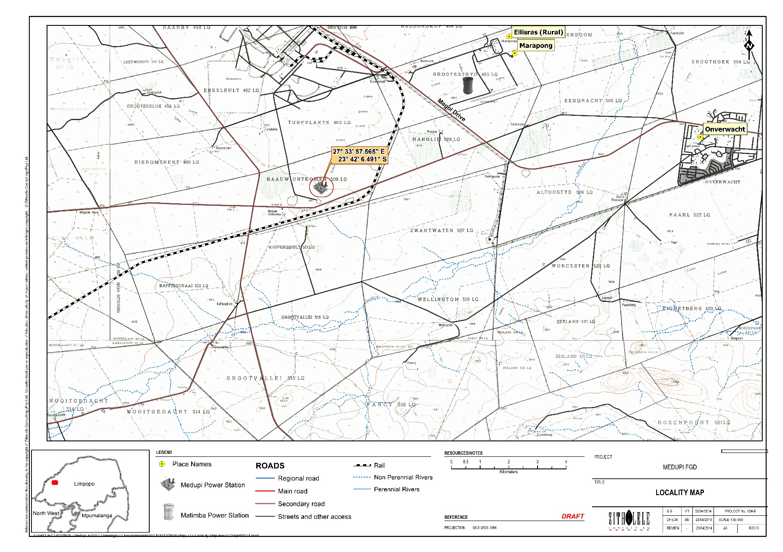

Figure 1 : Locality Map for Medupi Power Station



Figure 2: Simplified process flow diagram for the FGD system

### ****Flue Gas Duct System****

The flue gas coming from the boiler will pass through a fabric filter and an ID fan upstream of the FGD plant. In order to protect the absorbers in the case of malfunction, a flue gas bypass ductwork system will be used. This will avoid complete plant shutdown in the case of absorber malfunction by routing the flue gas through the bypass ductwork system until the absorber can be restarted.

### Draft System

The existing ID fans have been constructed with sufficient pressure capacity in their original design in order to provide additional pressure increase required to overcome the system resistance of the FGD retrofit. During the final FGD design, the modifications to the ductwork will be reviewed to identify an impact to the draft system.

### Chimney

Each of the two chimneys contains the flues from three boilers. The existing chimneys will be used for the FGD retrofit and require no modifications. The flues and chimneys are of adequate design to accommodate the impacts of the FGD system. The chimney drain piping and the chimney drain system will return collected condensation to the FGD absorber.

### Makeup water and Wash Water Supply

Makeup water for the FGD system will be supplied by the existing raw water reservoir which is supplied by the MACAP scheme. A sand filter pre-treatment system will clarify the water to appropriate levels required by the FGD equipment. Water will be supplied by gravity feed or by two of the low pressure raw water pumps drawing water from the reservoir.

After pre-treatment the water is combined with effluent water from the condensate polisher regeneration in the FGD make up water tanks. The water is then utilised in the FGD process and gypsum washing process. The backwash from the raw water filters will be discharged into the existing dirty water tanks.

The makeup water tanks have a storage capacity of 6 hours of full load operation, and will supply all FGD water demands. Six makeup water pumps will each provide 100 percent redundancy, with one spare pump for each tank, to secure the necessary backup water supply. Water will be delivered from these pumps to all systems needing clean makeup water.

Makeup water will be consumed entirely by the FGD process plant an no water will be returned to the existing plant. However, effluent water from the FGD makeup water pre-treatment plant will be returned to the dirty water tank.

Appendix D provides a visual representation of the process followed for water handling associated with the FGD process.

### Limestone handling and reagent preparation

New limestone material handling systems will be developed to receive limestone arriving via rail cars. The limestone will be stockpiled and evaluated before it is conveyed to the limestone silos located in the reagent preparation area. The limestone stockpile will provide 30 days’ worth of limestone storage for the FGD system. Each of the three limestone silos will have a storage capacity of 24 hours catering to 50% of the design consumption.

From the silos the limestone will be fed into the wet ball mills by weigh belt feeders. These ball mills will be constructed as overflow ball mills. The mill itself will primarily consist of a rotating drum containing steel balls. The total mill feed flow will be composed of water and new limestone feed, which will pass through the grinding chamber and be reduced in size. The ground slurry will be collected in the mill recycle tank and classified by means of pumps and a hydrocyclone station.

The final product will slow from the hydrocyclone overflow by gravity to the limestone slurry feed tank, with oversize particles being recycled to the mill inlet for additional grinding.

### Gypsum refinement and dewatering system

Gypsum will be produced from the limestone as a by-product of the wet scrubbing process. A slurry will comprise gypsum, a mixture of salts (MgSO4 and CaCl2), limestone, CaF2, and dust particles. Refinement is necessary to separate the gypsum from the other materials. The refinement process will be carried out in two steps – separation and dewatering.

Separation will be carried out by means of gypsum hydrocyclones. Then dewatering will occur using horizontal vacuum belt filters. The gypsum discharged from the horizontal vacuum belt filter will be dropped onto a collecting conveyor and taken to a transfer house. Here the gypsum will be transferred to one of two gypsum link conveyors which feed a series of gypsum conveyors. The gypsum will either be fed to overland ash conveyors for co-disposal with fly ash at the ash disposal facility, or will be fed onto an elevated mobile tripper car at the gypsum facility. Material from the car will be stacked in the three indoor day storage bunkers. The storage bunkers will allow for one pile to be stacked while another is being reclaimed and a third is quality tested.

Gypsum which is not commercial-grade will be disposed of either at the ADF or at an alternative facility. Commercial-grade gypsum will be reclaimed from the storage piles for sale. It is anticipated that up to 20% of the gypsum produced will be of saleable quality (Harris; 2013). It is anticipated that almost 250 000 Kg of gypsum will be produced per hour during the operational phase.

Appendix D provides a flow diagram of the activities involved in gypsum refinement and dewatering.

### FGD Wastewater Treatment and Zero Liquid Discharge System

A new FGD wastewater treatment and zero liquid discharge system will be required to treat the FGD system chloride bleed stream and the existing total organic compound scavenger rejects. The FGD chlorine bleed stream is pre-treated to remove suspended solids and heavy metals prior to entering the ZLD system. The de-watered solids will be directed for disposal at the ADF or alternative disposal facility.

Liquid distillate effluent from the ZLD will be used as makeup water to the closed cycle cooling tower or returned to the reclaim water tanks. Dewatered sludge will be disposed of using trucks to transport to onsite or offsite dumps. Dewatered brine will be disposed of using trucks to transport to appropriately licensed disposal facilities.

Appendix D provides a visual interpretation of the activities carried out during the wastewater handling.

### Auxiliary Steam System

An extension of the existing boiler auxiliary steam supply system will supply steam to the wastewater treatment area auxiliary steam header. Condensate from the equipment and low point drains will be collected in a condensate receiver and pumped back to the existing plant condensate system.

### FGD closed cycle cooling water

A new, independent closed cycle cooling water (CCCW) system will provide heat rejection for the heat exchangers associated with the FGD equipment that requires water cooling. The CCCW system will provide cooling to:

* Limestone ball mill lubrication system;
* FGD system air compressors;
* Wastewater treatment equipment in waste water treatment and ZLD area.

The CCCW system will include a two-cell wet cooling tower. Each cell will be sized to reject 100 percent of the required heat duty. Blow down from the cooling tower will be directed to the ZLD buffer tank.

### Auxiliary power supply

#### Medium Voltage

New auxiliary transformers will transform 11kV three-phase power supplied from the existing 11kV system, to 6900V three-phase power as required by the FGD system. The transformers will supply 6900V to the FGD plant board switchgear buses through main breakers. The switchgear buses for similar service will be connected through a tiebreaker. The main breakers and the tiebreaker will make it possible for a switchgear bus to be fed from two separate sources.

#### Distribution 400V power system

The 400V FGD auxiliary power system will consist of low-voltage (LV) switchgear, power cables, and LV loads. The main supply to the LV switchgear will be from the 6.6kV switchgear through the 6.6kV/0.42kV dry-type transformers. These transformers will be an integral part of the LV switchgear.

Main power supply to a board or switchgear will be through a 6.6/0.42kV dry-type, delta-wye transformer. Tiebreakers will connect boards of similar service. The main breaker and the tiebreaker will make it possible for a switchgear bus to be fed from two separate sources. The switchgear buses will distribute power through feeder breakers to 400V FGD loads.

#### Emergency electrical supply

A new emergency diesel generator (EDG) will be required to provide emergency shutdown power at 400V upon loss of normal 400V power supply. The EDG will be connected to a 400V essential switchgear and provide a backup power feed to the essential 400V boards in each of the FGD clusters.

### Control system

The existing Medupi control and instrumentation system will be extended to include all equipment required to allow the operation and monitoring of the FGD system and associated activities.

## Motivation for the Project

### Environmental and Health Motivation

One of the most significant air quality impacts of electricity generation is the emission of SO2 to the atmosphere. SO2 reacts with other compounds in the environment to form particles that are a risk to human health. These small particles penetrate into the tissue of the lungs and can cause emphysema and bronchitis and can aggravate existing heart disease (UN Environmental Protection Agency; 2014). Evidence has been documented of a connection between short term SO2 exposure and adverse respiratory symptoms including bronchoconstriction and aggravated asthma.

At Medupi Power Station the uncontrolled SO2 emissions for the design coal will be about 3,°406mg/Nm3. The environmental protection limit for SO2 emissions is 400mg/Nm3. The flue gas desulphurisation process proposed for retrofit at the power station will reduce the SO2 emissions by approximately 88%. This brings the emissions to within the environmental protection threshold and reduces the impacts of the power station on the environment.

The retrofit of the FGD will not have significant impact to the receiving environment because the infrastructure and the construction phase activities are limited to within the already disturbed Medupi Power Station footprint. Moreover, there will be very little loss and discharge of water due to the use of a Zero Liquid Discharge (ZLD) system.

### Socio-Economic Motivation

It must be noted that the Medupi Power Station is funded by the World Bank. In complying to the conditions of the World Bank loan agreement, Medupi must effectively reduce SO2 emissions. The Medupi Power Station is part of an integral building plan to ensure that Eskom is able to meet the electricity demand projected for the future. Eskom must double its capacity to 80 000MW by 2026 for this purpose (Eskom website; 2014).

The Medupi Power Station will increase the current Eskom generation capacity by 4, 800MW. This is crucial to addressing the current electricity crisis in South Africa. Without the addition of the new power stations, such as Medupi and Kusile, the current demands for electricity will not be met. This will significantly impact on the provision of basic serves to a large percentage of the South African population.

Electricity brown-outs and black-outs have considerable social effects, which are most devastating on the low income populations. These include compromise of safety and health to vulnerable communities. Furthermore, the loss of consistent electricity supply has massive repercussions on industry and economics of the country. Short and medium term unreliable electricity supply may have devastating impacts to large and small businesses due to loss in production and damage to equipment. This in turn will have a definite implication on our country’s economy.

# Environmental legislation

This part of the Scoping Report (SR) is intended to provide a detailed account of all environmental legislation which may have bearing on the proposed project. Particular attention will be paid to the National Environmental Management Act, 1998 (Act No. 107 of 1998) (NEMA). The NEMA (1998) is regarded as South Africa’s Environmental Management Framework Act. An overview of sector specific environmental Acts which govern specific elements or project activities and the relevance to the proposed project will also be provided.

In order to ensure that Environmental Management Best Practice Principles are adhered to, all guidelines which are relevant to the proposed project activities have also been taken into consideration during the preparation of this SR. Determining the applicability of all environmental management legislation is fundamental to facilitating compliance with the applicable provisions of these Acts.

## The Constitution of the Republic Of South Africa, 1996 (Act No. 108 Of 1996)

The Constitution of the Republic of South Africa, 1996 (hereafter referred to as "the Constitution") is the supreme Law in South Africa. The Bill of Rights is included in Chapter 2 of the Constitution. The Environmental Right as set out in Section 24 of the Constitution and states that –

Everyone has the right –

1. to an environment that is not harmful to their health or well-being; and
2. to have the environment protected, for the benefit of present and future generations, through reasonable legislative and other measures that –
3. prevent pollution and ecological degradation;
4. promote conservation; and
5. secure ecologically sustainable development and use of natural resources,
6. while promoting justifiable economic and social development.

The National Environmental Management Act, 1998 (Act No. 107 of 1998) is the primary statute which gives effect to Section 24 of the Constitution. The Environmental Right contained in Section 24 of the Constitution also places responsibility on the Environmental Assessment Practitioner (EAP), the Applicant and the Competent Authority to ensure that this right is not infringed upon. The Sector Guidelines for Environmental Impact Assessment (2010) (Government Notice 654) describes a number of responsibilities which are placed on the EAP, Applicant and Competent Authority to ensure conformance with the statutory Environmental Right.

These responsibilities include:

* All parties to the EIA Process have a duty not to infringe other persons’ rights in terms of Section 24 of the Constitution.
* The Applicant must ensure that while the development incorporates measures that prevent or control environmental pollution or degradation, it also maximises the positive environmental impacts.
* There must be an equitable balance between the rights of the applicant and the broader public. In this regard, the consideration of need and desirability is critical as it requires the strategic context of the development to be considered with the broader societal needs and public interest.
* The provisions of the Bill of Rights are binding on decision-makers.
* Decision-makers must ensure that their decisions are in keeping with the environmental right and promote an environment that is not harmful to health or well-being.

## National Environmental Management Act, 1998 (Act No. 107 of 1998)

Environmental Management can be defined as the management of human interaction with the environment. Fuggle and Rabie (2009) defines Environmental Management as the regulation of the effects of peoples’ activities, products and services on the environment. Although South Africa has a comprehensive array of environmental legislation and policies in place, these must be aligned with the provisions of the NEMA (1998), in particular the National Environmental Management Principles stipulated in Chapter 1 of the NEMA (1998). The Environmental Management Principles are centred around providing explicit guidance for co-operative and environmental governance on all matters relating to decision-making which will affect the environment, institutions that will promote co-operative governance and procedures for co-ordinating environmental functions exercised by organs of state, and to provide for matters connected therewith.

Although the proposed project is primarily concerned with the retrofit of the flue gas desulphurisation system, all supporting infrastructure and activities must be included within the application process for authorisation and/or licensing. The supporting infrastructure and project activities, in addition to the FGD retrofit, fall within the ambit of the NEMA (1998). These project activities trigger activities listed in the Environmental Impact Assessment Regulations Listing Notice 2 (Government Notice R545) as amended, therefore requiring Environmental Authorisation before they may be implemented. The proposed activities prompt a full Scoping and Environmental Impact Reporting Process. Each of the project activities as well as the corresponding listed activity is provided in Table 1**.**

Table 1: Description of Listed Activities

| **No.** | **Listing Notice** | **Listed Activity** | | **Description** |
| --- | --- | --- | --- | --- |
|  | Listing Notice 2 of 2010, Government Notice R544 | 3 | The construction of facilities or infrastructure for the storage, or storage and handling, of a dangerous good, where such storage occurs in containers with a combined capacity of more than 500 cubic metres. | Limestone will be purchased off site and will be transported to site either by railway or by truck. The limestone will be stored on site for use within the FGD process. |
| The FGD process will produce wastes in the form of gypsum, sludge and salts. These wastes will be stored on site prior to disposal either on site or off site. Gypsum may be of commercial grade and will be sold. |
|  | Listing Notice 2 of 2010, Government Notice R545 | 6 | The construction of facilities or infrastructure for the bulk transportation of dangerous goods –   1. in solid form, outside an industrial complex, using funiculars or conveyors with a throughput capacity of more than 50 tons day. | Limestone will be transported to the Power Station via railway line or trucking. The limestone will be transported on site via conveyors. In addition, waste products may require transport to off-site disposal facilities, should they not be disposed of on site. This may be done by conveyors should an appropriate disposal site be identified in close proximity to the Power Station (Matimba PS for example). Transportation on site will be predominantly by conveyor. This is within an industrial area. |
|  | Listing Notice 2 of 2010, Government Notice R545 | 11 | The construction of railway lines, stations or shunting yards, excluding –   1. Railway lines, shunting yards and railway stations in industrial complexes or zones; 2. Underground railway lines in a mining area; and 3. Additional railway lines within the reserve of an existing railway line. | The railway yard will be constructed on an area adjacent to the Medupi Power Station and will be for the purposes of transporting the limestone to the Power Station by rail. The railway yard will also facilitate the transportation of other materials to and from the Power Station. |
|  | Listing Notice 2 of 2010, Government Notice R545 | 15 | Physical alteration of undeveloped vacant or derelict land for residential retail, commercial, recreational, industrial or institutional use where the total area to be transformed is 20 hectares or more. | The railway yard will be constructed on an area adjacent to the Medupi Power Station and will be for the purposes of transporting the limestone to the Power Station by rail. The railway yard will also facilitate the transportation of other materials to and from the Power Station. |

## The National Environmental Management Waste Act, 2008 (Act No. 59 of 2008)

All Waste Management Activities are regulated by the National Environmental Management Waste Act, 2008 (Act No. 59 of 2008) (NEM:WA) and the regulations thereunder. Owing to the nature and composition of the ash that is generated by the combustion of coal, it is considered to be hazardous waste and as such also falls within the ambit of the National Environmental Management Waste Act, 2008 (Act No. 59 of 2008) (NEM:WA). A number of the project activities associated with the proposed KPS Continuous Ash Disposal Facility project are regarded as Waste Management Activities. As such these activities are governed by the NEM:WA (2008) and must conform to the provisions of the Act.

In order to regulate waste management activities and to ensure that they do not adversely impact on human health and the environment, the NEM:WA (2008) introduced the licensing of waste management activities. All waste management activities which are listed in Government Notice 921 (2013) in terms of the NEM:WA (2008) requires licensing from the Competent Authority before these activities may proceed. Prior to the implementation of any waste management activity listed in Category A, of Government Notice 921 (2013), a Basic Assessment Process as set out in the Environmental Impact Assessment Regulation made under Section 24(5) of the NEMA (1998) must be carried out as part of the Waste Management License Application Process. However prior to the implementation of any Waste Management Activities listed in Category B of Government Notice 921 (2013), a Scoping and Environmental Impact Reporting Process must be carried out as part of the Waste Management License Application Process. Each of the project activities, as well as the corresponding waste management activity, is provided in Table 2

Table 2: Description of applicable Waste Management Activities listed in the Government Notice 921 (2013)

| **No.** | **Category** | **Waste Management Activity** | | **Description** |
| --- | --- | --- | --- | --- |
|  | Category B | 1 | The storage of hazardous waste in lagoons excluding storage of effluent, wastewater or sewage. | Sludge and salts generated by the FGD process may be stored on site in lagoons prior to disposal. This has not yet been confirmed, but the application includes this activity for completeness. |
|  | Category B | 5 | The treatment of hazardous waste in lagoons, excluding the treatment of effluent, wastewater or sewage. | This activity will only be triggered should the preferred co-disposal of all wastes at the ADF not be feasible. In which case, an alternative and additional waste facility will need to be constructed on site, requiring that the salts and sludge be treated in lagoons. |
|  | Category B | 7 | The disposal of any quantity of hazardous waste to land. | While the ash disposal facility has been authorised and licensed, the co-disposal of gypsum and possibly salts and sludge at the ADF will require that the disposal of these new, but associated wastes be licensed. |
|  | Category B | 10 | The construction of a facility for a waste management activity listed in Category B of this Schedule (not in isolation to associated waste management activity). | While the ADF has already been licensed, the operation may change should co-disposal be authorised for this application.  Additionally, should co-disposal not be authorised, then new and additional facilities will need to be constructed, including lagoons for the treatment and disposal of sludge and salts. |
|  | Category C | 2 | The storage of hazardous waste at a facility that has the capacity to store in excess of 80m3 of hazardous waste at any one time, excluding the storage of hazardous waste in lagoons or temporary storage of such wastes. | Limestone will be purchased off site and be transported to site via rail or truck. The limestone will need to be stored prior to use in the FGD process.  Gypsum, sludge and salts will be generated by the FGD process and may require storage prior to treatment and/or disposal, or, in the case of gypsum, possible sale. |

## The National Water Act, 1998 (Act No. 36 of 2008)

The activities associated with the proposed Medupi Power Station FGD retrofit project trigger some of the Water Uses that are defined in Section 21 of the National Water Act, 1998 (Act No. 36 of 1998) (NWA) (refer to Table 3). Accordingly these Water Uses may not be undertaken without being granted a Water Use License from the DWS. In accordance with Sections 40 and 41of the NWA (1998), a Water Use License Application Process will be carried out. The resultant documents from the WULA process will include completed WULA Forms as well as a Technical Report. These documents will be submitted to DWS for review and decision making. Although a joint PPP is followed for the WULA within the EIA Phase, these two EA processes constitute separate applications and submissions are made to the respective Competent Authorities.

Table 3: Description of Water Uses

| **Water Use** | **Description** | **Potential Section 21 Water Uses** |
| --- | --- | --- |
| Section 21 (b) | Storing of water. | Water for the FGD process will be stored in a reservoir prior to the water being input into the system. Need details of reservoir size??? |
| Section 21 (g) | Disposing of waste in a manner which may impact on a water resource. | This water use is related to the disposal of wastes at the ADF which may have a potential impact on ground and surface water resources. |
| Section 21 (h) | Disposal of water that has been heated within a power generation process. | This may be triggered by the disposal of any water that has been treated or heated within the power generation process. The only water that may be disposed of will be that used to condition ash, gypsum, sludge, salts prior to the disposal of these wastes at the Ash Disposal Facility. |

## Additional Environmental Legislative Requirements

A number of additional legislation and guidelines may have a bearing on the proposed KPS Continuous Ash Disposal Facility project. Although authorisation in terms of these various acts may not necessarily be mandatory the requirements of these acts have been taken into account.

Table 4: List of additional applicable Environmental Legislation

| **Act** | **Applicable Section** | **Relevance on project** |
| --- | --- | --- |
| National Heritage Resources Act, 1999 (Act No. 25 of 1999) | Section 34: Structures | Structures which are older than 60 years may not be demolished without a permit issued by the relevant provincial Heritage Resources Authority. No structures older than 60 years were recorded in the Heritage Impact Study. |
| National Heritage Resources Act, 1999 (Act No. 25 of 1999) | Section 35: Archaeology, palaeontology and meteorites | Any archaeological or paleontological objects that are found on the site, must be reported to the provincial Heritage Resources Authority. The discovered archaeological or paleontological objects may not be removed from its original position and damaged, destroyed or altered prior to a permit being issued by the heritage resources authority. |
| National Heritage Resources Act, 1999 (Act No. 25 of 1999) | Section 36: Burial grounds and graves | Any graves that are discovered may not be destroyed, damaged, altered, exhumed or removed from its original position without a permit issued by SAHRA or a provincial heritage resources authority. |
| National Heritage Resources Act, 1999 (Act No. 25 of 1999) | Section 38(1)(c): Heritage Resource Management | As the proposed development area may exceed 5000 m2, with the submission of the Heritage Impact Assessment to SAHRA, the responsible heritage resources authority has been notified of the project and provided with information relating to the project. Authorisation to proceed with the development is required from SAHRA. |
| Hazardous Substance Act, 1973 (Act No. 15 of 1973) | - | Provides for the definition, classification, use, operation, modification, disposal or dumping of hazardous substances. |
| National Environmental Management: Air Quality Act, 2004 (Act No. 39 of 2004) | National Ambient Air Quality Standards, Government Notice 1210, Government Gazette 32816, 24 December 2009 | The Air Quality standards published in Government Notice 1210 must be adhered to. Medupi has applied for an Air Emissions License as an independent process. |
| Conservation of Agricultural Resources Act, 1983 (Act No. 43 of 1983) | Section 6 | Provisions included in the act regarding the implementation of control measures for alien and invasive plant species must be adhered to. |
| Occupational Health and Safety Act, 1993 (Act No. 85 of 1993) | Section 8 | General duties of employers to their employees. |
| Section 9 | General duties of employers and self-employed persons to person other than their employees. |
| Lephalale Municipality Integrated Development Plan Final Draft 2013-2016 | - | The Integrated Development Planning is regarded as a tool for municipal planning and budgeting to enable municipalities to deliberate on developmental issues identified by communities. The IDP points the Medupi Power Station out as a significant contributor to the economy of Lephalale and one of the key employers of the area. |

In order to ensure that a best practice approach is adopted for the EIA Process and to ensure that the EIR provides sufficient information require by the DEA to reach a decision, the following guidelines have been considered in the compilation of this Environmental Impact Report:

* National Environmental Management Act, 1998 (Act 107 of 1998) Implementation Guidelines Sector Guidelines for Environmental Impact Assessment Regulations Government Notice 654 of 2010, published in Government Gazette 3333, dated 29 June 2010.
* National Environmental Management Act, 1998 (Act 107 of 1998) Publication of Need and Desirability Guideline in terms of the Environmental Impact Assessment Regulations, 2010, Government Notice 792 of 2012, Government Gazette 35746, dated 05 October 2012.
* Department of Water Affairs & Forestry, 1998. Waste Management Series. Minimum Requirements for the Handling, Classification and Disposal of Hazardous Waste.
* DEAT (2004) Cumulative Effects Assessment, Integrated Environmental Management, Information Series 7, Department of Environmental Affairs and Tourism (DEAT), Pretoria
* Department of Environmental Affairs, 2011. A user friendly guide to the National Environmental Management: Waste Act, 2008. South Africa. Pretoria.
* DEAT (2004) Criteria for determining Alternatives in EIA, Integrated Environmental Management, Information Series 11, Department of Environmental Affairs and Tourism (DEAT), Pretoria

# alternatives

## Site alternatives

The Flue Gas Desulphurisation infrastructure will need to be attached to the existing power station infrastructure in order for the exhaust emissions to be diverted to the FGD units for removal of the SO2. The FGD retrofit must take place at the existing Medupi Power Station and therefore there are no site alternatives for this process.

## Technology alternatives

The Medupi Power Station motivation for selection of technology was for the maximum reduction in SO2 emissions in order to achieve emission rates compliant with the legislated minimum emissions standards of 500 mg/Nm3. In other words, the technology would be required to produce a removal efficiency of greater than 93% based on the worst coal quality scenario.

The wet and semi-dry FGD technology options are technically capable of meeting the emission reduction required. Eskom undertook a financial comparative analysis of semi-dry and wet FGD technology and found that the wet FGD has a lower life cycle cost. The issue of water constraints were considered during this analysis and it was recorded that the wet FGD technology can be fitted with a gas cooler upstream of the absorber to reduce water consumption to levels comparable to semi-dry FGD.

The technology review and selection was carried out in 2005. During this time alternative FGD technologies, as well as project implementation impacts of wet limestone scrubbers against alternative technologies, were assessed (World Bank and African Development Bank Project Progress Report 3; 2014).

The assessment studies favour Wet FGD technology, assuming no water constraints. Some of the supporting factors for wet FGD technology were identified as:

1. The reagent costs and life cycle costs are approximately 3 to 4 times lower for wet FGD than for semi-dry FGD;
2. The existing Medupi Power Station has been designed to accommodate the retrofit of wet FGD infrastructure and it will require significant time and capital expenditure to redesign the existing structures for an alternate technology;
3. If water is a constraint, there is the option of installation of a flue gas cooler. This will reduce water consumption by up to 30%. This will make the waste consumption comparable to that of semi-dry FGD technology.

The outcome of the technology assessment and selection was that Medupi Power Station was designed to be a “Wet FGD Ready” station. This involved the following design inclusions:

* Space allocation behind the stack for the absorber and common facilities;
* Stack lining and induced draft (ID) fans sized to handle additional pressure drop.

The technology assessment and selection was carried out independently of the environmental authorisation process. The Wet FGD technology has been identified as the preferred solution for assessment during the EIA and Waste Management Application processes.

The Medupi FGD Retrofit Technology Selection Study Report (2014) is available within Appendix C, and may be reviewed for information around technology selection. The technology alternatives investigated in the study are discussed in brief below. The descriptions are taken directly from the Medupi FGD Retrofit Technology Selection Study Report (2014).

### Wet FGD

Wet FGD technology, utilising a limestone reagent, is the most frequently used technology applied to pulverised coal fired boilers that combust coal with a medium to high sulphur content. Wet FGD processes are known for a high removal efficiency and high reagent utilisation.

### Wet FGD with Inlet gas Cooler

The wet FGD within let gas cooler technology is a modification to the system to utilise a heat exchanger at the inlet of the FGD to reduce temperatures of the flue gas flowing to the absorber. In this way there is a reduction in the amount of water evaporated as the flue gas cools to saturation temperature.

Cooling can be carried out using a regenerative gas-to-gas heater to remove heat from the incoming flue gas. However, a regenerative heater exchange would have a total pressure drop of 16 mbar and the pressure drop across the wet FGD system would exceed the maximum pressure drop that the design can accommodate. Therefore, cooling by use of a single pass water-cooled heat exchanger would be the preferred cooling system for the Medupi Wet FGD process. A single pass cooler for the flue gas will limit the pressure drop to within the capability of the existing ID fan. The heat recovered from the flue gas can be diverted to another low temperature heat demand elsewhere in the plant.

The inlet gas cooler will reduce the flue gas inlet temperature to the absorber from 145°C to 100°C and the outlet temperature of the absorber from about 52°C to 49°C.

An inlet cooler could be retrofitted to the Medupi Wet FGD infrastructure should this be required as a result of water constraints to the operation.

### Dry and semi-dry FGD

Dry FGD technology utilises significantly less water than wet FGD technology because the dry systems do not saturate the flue gas with water but rather use hydrated lime instead of limestone as the reagent for capturing SO2. One of the considerations that was taken into account during the technology selection process, is that the Dry FGD technologies do not produce saleable by-products, whereas the Wet FGD system does (gypsum). This requires that all wastes produced must be disposed of in a landfill site.

No wastewater is produced with the Dry FGD as all the water is evaporated or contained as water of hydration in the dry byproduct mixture. This eliminates the costs of an additional wastewater treatment system.

### Selected technology

The technology that was selected during the feasibility phase of the Medupi Power Station was the Wet FGD. The reasons are highlighted and discussed in more detail within the Medupi FGD Technology Selection Report (2014). the key recommendations for selection of the Wet FGD included:

* Dry FGD would pose significant challenges for application at Medupi Power Station, primarily that the retrofit of a dry FGD infrastructure could not be implemented within the expected outage durations or in the space allocated by the original plant design;
* Total life-cycle costs of the Dry FGD system are significantly higher than those for Wet FGD;
* The significant difference in water consumption between Dry and Wet FGD technology could be reduced by the application of a flue gas cooling system to the Wet FGD process. The flue gas cooling system would reduce the water consumption of the Wet FGD to approximate water consumption expected for Dry FGD technology;
* Limestone, the reagent for Wet FGD technology, is readily available for the Medupi Power Station purposes and would be bought locally.

### Technology Alternatives for purposes of EIA

The selection of the Wet FGD technology was undertaken prior to this EIA and technology alternatives are therefore not addressed in detail nor assessed in the impact rating system for purposes of decision-making for this application.

## Design alternatives

### Wet FGD Design alternatives

For the selected Wet FGD there are only 2 design alternatives considered. These are:

* Wet FGD design without inlet flue gas cooling; and
* Wet FGD design with inlet flue gas cooling.

The basic designs are identical. However, the design with cooling will require a heat exchanger at the inlet of the FGD to reduce the temperature of the flue gas entering the absorber. The heat exchanger consists of a closed loop water cooling system with associated pumps, as well as a disposal heat sink and associated ductwork. All other equipment is considered similar in size and demand to the Wet FGD design option without cooling.

### Design Alternatives for purposes of EIA

The technology selection report (2014) recommended that the client implement Wet FGD technology. The technology with or without cooling were considered equal on an overall technical and economic basis. The EIA will assess the two design alternatives through the impact assessment phase.

## Waste disposal facility alternatives

Medupi Power Station already has the appropriate licensing and authorisation for disposal of the ash at the licensed Medupi ash disposal facility. However, there are 3 additional waste streams that will require disposal from the FGD process. The alternatives that have been considered are discussed below. This information is taken directly from the ”Guideline: Possible alternatives for the disposal of chemical waste produced by the Flue Gas Desulphurisation process at Medupi Power Station” report (20??). The principle options for disposal are discussed below.

### Off-site disposal at existing landfill

Due to the fact that the waste streams generated by the FGD process are hazardous, it would be necessary to transport the waste to one of two currently licensed hazardous waste landfill sites operating within South Africa. Considering the volumes of waste and the proximity of the site, it is proposed that the waste be trucked to Holfontein in Mpumalanga Province for final disposal.

The implications of this alternative for disposal are that:

* There will be considerable potential for environmental impact during loading, trucking and off-loading;
* The potential for impact will be on a much larger area than those impacts limited to the Medupi footprint;
* The carbon emissions from vehicle exhaust fumes will impact over a greater area and on an already identified priority area for emissions.

This alternative includes the trucking of all wastes from the FGD process (gypsum, sludge and salts) to Holfontein, as well as the trucking of the chemical wastes only (salts and sludge). Therefore, both options should be considered under this alternative and be assessed comparatively in terms of environmental impacts, technical implications and financial costs. The abovementioned environmental impacts, as well as financial implications, were taking cognisance of during the initial analysis of disposal alternatives.

### Co-disposal at the Ash Disposal Facility

It is proposed that the ash, gypsum, salts and sludge be co-disposed of at the ash disposal facility. This will require that the existing design of the facility be amended in order to address handling of the different waste streams on site. The co-disposal alternative will also be better informed once the Waste Classification Study has been carried out to determine what waste Types will be requiring disposal on site.

### Co-disposal on site, separating chemical from ash and gypsum

Should there be any reason why co-disposal of all wastes cannot take place together, then it is proposed that the chemical wastes (sludge and salts) are disposed of within the ADF, but in a separate “compartment” to the ash and gypsum. This will require that the existing design and proposed operations of the ash disposal facility be amended to accommodate this separation of waste streams within the ADF. The Waste Classification study will have further input into the consideration of this disposal alternative.

### New on-site facility.

Should the co-disposal of chemical waste streams (sludge and/or salts) at the ADF not be feasible for implementation or acceptable for authorisation, then a separate facility will need to be constructed on site. The facility will cater to salts and/or sludge, depending on the requirements. This facility will be designed according to the specifications for the required landfill Class appropriate to the waste Type. Liaison with the DEA Waste Directorate as well as the outcome of the Waste Classification Study will inform the comparative analysis of this alternative with others that have been considered.

### Alternatives for purposes of EIA

The principle alternatives will be considered during the EIA Phase of this project and will be discussed with the appropriate authorities and specialists. A comparative analysis will be carried out to eliminate those alternatives which may be unfeasible or fatally flawed. Following this analysis, the remaining alternatives will be carried through to the Impact Rating to identify the preferred alternative and to provide a rating table indicating potential impacts associated with each alternative.

## Transportation alternatives

### Conveyor

Transportation of materials on site will be primarily by conveyor. This will reduce the volumes of vehicle traffic on site and will allow for smooth transitions of materials from one facility to the next. The conveyors will be maintained and monitored to ensure that they are operating efficiently and that there are no significant environmental impacts generated along the conveyor route, i.e. spills.

Conveyors will be used for the following:

* Limestone transportation from the railway siding to the storage facilities,
* Gypsum transport from the absorbers to temporary storage facilities;

### Piping

### Rail

### Truck

### Alternatives for purposes of EIA

# scoping process

## Site investigation

A site investigation took place on Thursday 16th January 2014. The site investigation was aimed at:

1. understanding the condition of the receiving environment;
2. identifying the areas on site flagged for FGD footprint;
3. identifying potential environmental or social impacts of significance.

An induction was held at Medupi Power Station where the Zitholele team were prepared for safety and emergency procedures for implementation while on site. The Zitholele team was orientated by means of plot diagrams and maps.

During the site visit, the existing Medupi Power Station infrastructure was observed and the footprints of the various FGD facilities and associated infrastructure was identified. This provided the EAP with an understanding of the cumulative and individual impacts that may be generated by the FGD and the Power Station post-FGD retrofit. The outcome of the site visit informed the identification of specialists deemed necessary to provide detailed investigation.

From the site visit it is clear that the footprint for the FGD infrastructure will be located on disturbed habitat as all infrastructure will be within the impacted Medupi Power Station footprint which has been cleared of all fauna and flora. Additionally, the existing specialist studies for soils, groundwater, surface water and visual impacts will be sufficient for use in this study.

## Identification of Issues

The site visit provided a clear indication that the footprint for the FGD infrastructure will be located within the already impacted Medupi Power Station property. All floral and faunal habitat has been removed and the area is either concreted or open soil. No natural surface water bodies are directly impacted upon by the FGD infrastructure. Moreover, the existing specialist studies carried out for the Medupi Power Station will still be valid in terms of the cumulative impacts of the power station and the FGD retrofit to the receiving environment.

## Identification of required Specialist Studies

The client commissioned specialist consultants to undertake specialist assessments of the receiving environment prior to the impact generated by the Medupi Power Station construction phase. These assessments provide a valuable basis for the FGD retrofit project in terms of cumulative impacts of the Medupi Power Station (including FGD).

All of the existing Medupi Power Station specialist assessments will be utilised for the purposes of the FGD EIA process. While the specialist studies carried out for the Medupi Power Station EIA remain effective in describing the original receiving environment and informing the impact rating of the FGD on specific aspects, two specialist studies will need to be updated with specific reference to the FGD retrofit.

### Air quality

Air emissions from the power station will definitely be altered by the FGD retrofit and this will need to be assessed and documented. Zitholele has identified Airshed Professionals as the specialists who carried out the initial air quality impact study. Airshed Professionals will be undertaking a follow up air quality impact assessment for the FGD retrofit in order to provide a comprehensive comparison of air emissions expected from the Power Station before and after the FGD retrofit.

The air quality assessment will be carried out between August to November 2014.

### Waste Classification

The FGD retrofit will generate similar but independent waste streams to the ash from the Power Station operation. These waste streams will include:

* Gypsum;
* Sludge;
* Salts.

These waste streams are generated by the FGD process and will be disposed of on site. The waste classification study will be required in order to:

* Classify the 4 wastes from Medupi Power Station operation independently as well as a combined waste;
* Provide recommendations for disposal, including input into comparative analysis of disposal alternatives;
* Classify the requirements of the barrier system for the waste disposal facility according to the classification of the wastes.

The waste classification is an essential input to the design of the ash disposal facility and any other waste disposal facilities required on site. The Waste Classification will be carried out between August 2014 and November 2014.

## Public Participation

Public participation is an essential and legislative requirement for environmental authorisation. The principles that demand communication with society at large are best embodied in the principles of the National Environmental Management Act (Act 107 of 1998, Chapter 1), South Africa’s overarching environmental law. In addition, Section 24 (5), Regulation 54-57 of GNR 543 under the National Environmental Management Act, guides the public participation process (PPP) that is required for an Environmental Impact Assessment (EIA) process. The PPP undertaken during the scoping phase of the EIA also took the Integrated Environmental Management Guideline Series (Guideline 7) – Public Participation in the Environmental Impact Assessment Process, GN234, promulgated 10 October 2012).

The public participation process for the proposed integration of the proposed Medupi Power Station FGD Technology Retrofit has been designed to satisfy the requirements laid down in the above legislation and guidelines. This section of the report highlights the key elements of the PPP to date.

### Objectives of public participation in an EIA

The objectives of public participation in an EIA are to provide sufficient and accessible information to I&APs in an objective manner so as to:

* During Scoping:
* Assist the I&APs with identify issues of concern, and providing suggestions for enhanced benefits and alternatives.
* Contribute their local knowledge and experience.
* Verify that their issues have been considered and to help define the scope of the technical studies to be undertaken during the Impact Assessment.
* •During Impact Assessment:
* Verify that their issues have been considered either by the EIA Specialist Studies, or elsewhere.
* Comment on the findings of the EIA, including the measures that have been proposed to enhance positive impacts and reduce or avoid negative ones.

The key objective of public participation is to ensure transparency throughout the process and to promote informed decision making.

### Identification of interested and affected parties

The identification of stakeholders is ongoing and is refined throughout the process. As the on-the-ground understanding of affected stakeholders improves through interaction with various stakeholders in the area the database is updated. The identification of key stakeholders and community representatives (land owners and occupiers) for this project is important as their contributions are valued. The identification of key stakeholders and interested and/or Affected Parties (I&APs) were done in collaboration with Eskom (through the I&AP database for the EIAs in the area), the local municipalities and other organisations in the study area.

The I&APs’ details are captured on Maximiser, an electronic database management software programme that automatically categorises every mailing to I&APs, thus providing an ongoing record of communications - an important requirement by the competent authority for public participation.

According to the NEMA EIA Regulations under Section 24(5) of NEMA, a register of I&APs (Regulation 55 of GNR 543) must be kept by the public participation practitioner. Such a register has been compiled and is being kept updated with the details of involved I&APs throughout the process (See Appendix E)

### Announcement of opportunity to become involved

The opportunity to participate in the EIA was announced in June 2014 as follows:

* 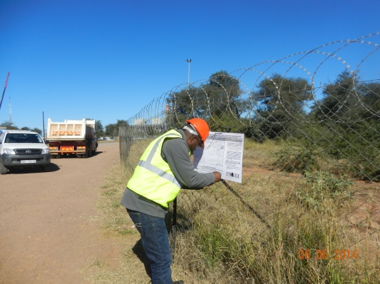Site Notices were erected at Medupi Power Stations (public entrance road) as per EIA Regulation 54(2)(a)(i) (Appendix E) (Figure 3).

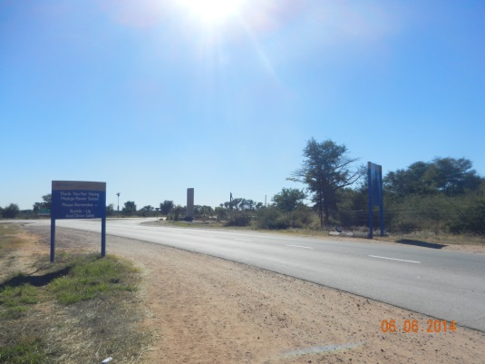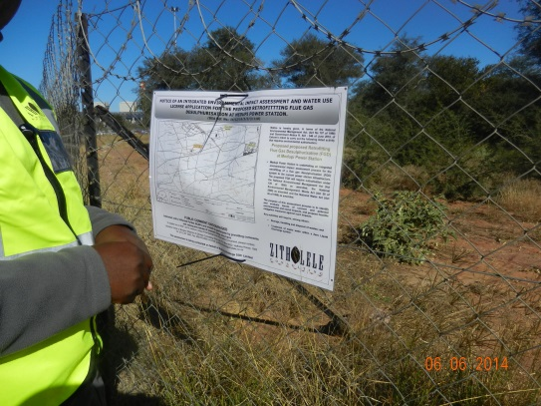

Figure 3: Site Notice at main road entrance to Medupi Power Station (Road XXX)

* Distribution of a letter of invitation to become involved, addressed to I&APs and organisations, accompanied by a Background Information Document (BID) containing details of the proposed project, and a registration sheet were done in June 2014 by e-mail, fax & post (Appendix E).

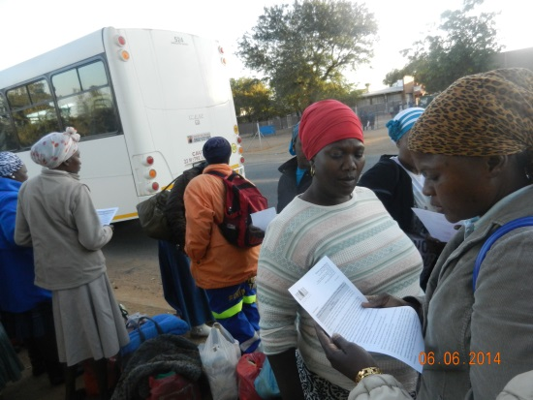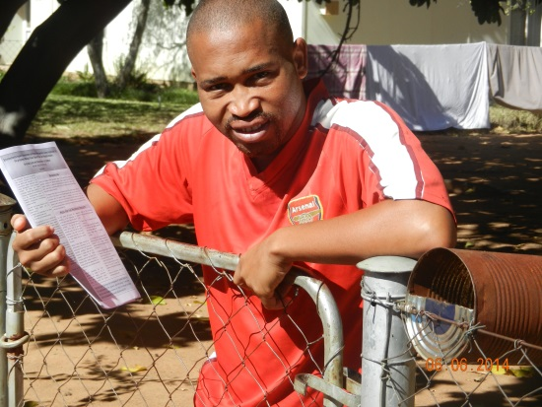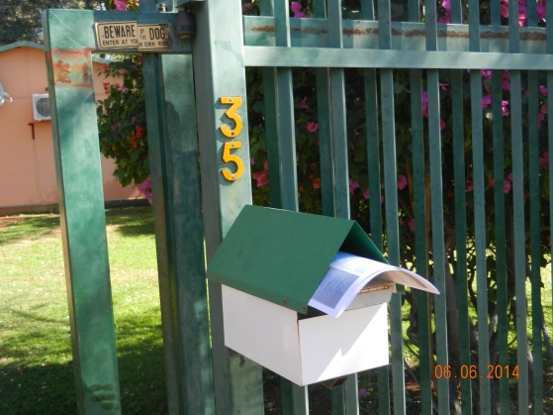The BID was also distributed in the study area at residential houses, bus stops etc. (Appendix E) (Figure 4).

Figure 4: Distribution of Background Information Document in surrounding

* The announcement of the EIA process was announced in the Mogol Post, the local community newspaper (Appendix E).
* 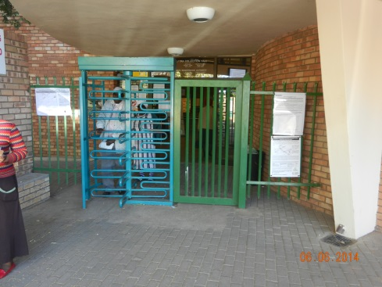EIA process notices (A3 site notices) were placed at conspicuous and prominently public places, invite stakeholders to participation in the EIA process.

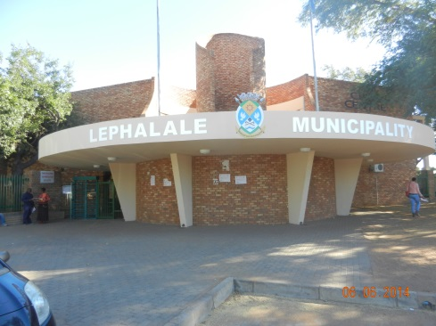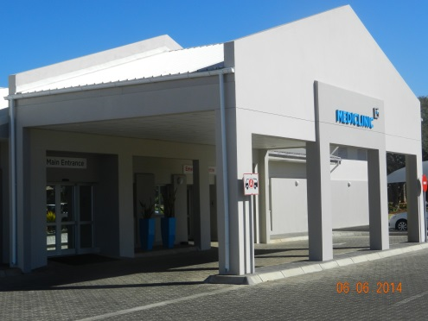Figure 5: EIA Process Notices put up in prominent public places

### Obtaining comment and contributions

The following opportunities are available during the Scoping phase for I&APs to contribute to the finalisation of the Scoping Report:

* Completing and returning the registration/comment sheets on which space was provided for comment.
* Providing comment telephonically or by email to the public participation office.
* Attending meetings that will be advertised in the Mogol Post, flyers will be distributed in the neighbouring community and posters will be erected in Lephalale at prominent public places i.e. public library, Lephalale Local Municipal Office, etc.

The minutes of the meetings to be held will be attached to the FSR and the comments / concerns / issues raised at these meeting will be included in the Comments and Response Report (CRR).

### Comments and Response Report

Issues / comments / concerns raised in the announcement and scoping phase of the project, were captured in an Comments and Response Report (CRR) Version 1 and appended to this DSR (Appendix E). The issues / comments / concerns raised during the public review period of the DSR will be added to the Final Scoping Report (FSR) as Version 2 of the CRR. The contributions made by I&APs were and will be acknowledged in writing.

### Draft Scoping Report

The purpose of the PPP in the DSR is to enable I&APs to verify that their contributions have been captured, understood and correctly interpreted, and to raise further issues. At the end of Scoping, the issues identified by the I&APs and by the environmental technical specialists, will be used to define the Terms of Reference for the Specialist Studies that will be conducted during the Impact Assessment Phase of the EIA. A period 40 days will be made available for public review of the DSR (from Wednesday 10 September to Tuesday 04 November 2014).

In addition to the newspaper advertisement and site notices that announced the opportunity to participate in the EIA, the opportunity for public review of the DSR will be announced as follows:

* Advertisement in the Mogol Post.
* In a letter to all registered I&APs on the project database, which will be e-mailed to those with e-mail addresses, fax to those without e-mail addresses and post to those without an e-mail address or fax number.

The DSR, including the CRR (Version 2), will be distributed for review and comment as follows:

* Left in public venues such as libraries within the vicinity of the project area (these are listed in Table 5 below);
* Courier to identified / relevant Organs of State (Commenting Authorities)
* Electronic copies to key stakeholders
* Electronic copy to those I&APs who requested the DSR
* A copy will be available at the meetings to be held

I&APs can comment on the DSR in various ways, such as completing the comment sheet accompanying the DSR, submitting individual comments, in writing, by post or e-mail.

Table 5: List of public places where the Draft Scoping Report will be made available

|  |  |  |
| --- | --- | --- |
| VENUE | ADDRESS | CONTACT |
| **Printed Copies** | | |
| Lephalale Local Municipality Public Library | Cnr Joe Slovo Street & Douwater Avenue, Lephalale |  |
| Marapong Community Library | 1456 Setlhora Street, Morapong |  |
| Agri SA: Lephalale | Albert Street, Lephalale |  |
| Medupi Power Station | Main Entrance Reception, Road XXX |  |
| **Electronic Copies** | | |
| Zitholele Consulting Website | http://www.zitholele.co.za/eia-for-medupi-fgd | |
| Tricia Njapha / Leoni Lubbe | publicprocess@zitholele.co.za | |

### Final Scoping Report

The Final Scoping Report (FSR) will be updated with the additional issues raised by I&APs and may contain new information. The FSR will be submitted to the Competent Authority (the Department of Environmental Affairs (DEA)), identified Organs of State, key stakeholders, and to those individuals who specifically request a copy. I&APs will be notified of the availability of the FSR.

In the Impact Assessment Phase of the EIA Specialist Studies will be conducted to assess the potential positive and negative impacts of the proposed project, and to recommend appropriate measures to enhance positive impacts and avoid or reduce negative ones. I&APs will be kept informed of progress with these studies.

### Public participation during the Impact Assessment

Public participation during the impact assessment phase of the EIA will mainly involve a review of the findings of the EIA, presented in a Draft Environmental Impact Report (DEIR), the Draft Environmental Management Programme (EMPr) and the volumes of Specialist Studies.

An EIA Newsletter will be distributed to all registered I&APs on the project database providing information such as:

* DEA’s acceptance of the FSR and approval of the Plan of Study for EIA;
* Envisaged timeframes of the various specialists’ studies to be undertaken;
* Envisaged timeframes of the impact phase; and
* Envisaged timeframes of the Public Participation activities.

I&APs will be advised in good time of the availability of these reports and how to access them. The dates and venues of public and other meetings will be provided to all registered I&APs.

## Reporting

The Draft Scoping Report was compiled during mid-2014, with the aim of providing an overview of the receiving environment and the proposed project. Site investigation, desktop studies and review of available literature informed the compilation of the Draft Scoping Report. Comments received from stakeholders during the public notification period have been reviewed and discussed with the client for consideration in the Draft Scoping Report content.

The Draft Scoping Report will be reviewed internally by the consultant, Zitholele Consulting, as well as by the client prior to making this document available for public comment. It is envisaged at this stage of the processes, that the public comment period will run from about mid-September to early November 2014. Once public comment has been received, this will be considered for purposes of the Final Scoping Report, which will be submitted to commenting and decision-making authorities before the end of the year.

The purpose of the Final Scoping Report is to provide the authorities with information around the receiving environment and the proposed project activities. The Scoping Report also provides a Plan of Study for the Impact Phase. The authorities may then request additional information for the Scoping Phase, or accept the FSR, and provide input to the Impact Assessment Phase.

# issues identified

Due to the fact that the construction and installation of infrastructure for the FGD retrofit will take place within the already impacted Medupi Power Station footprint, there are limited impacts of significance that will be generated on the receiving environment.

At the Scoping Phase it has been noted that the following issues will need to be unpacked and assessed during the EIA Phase of the process:

* Waste handling and disposal;
* Air emissions;
* Water usage;
* Social economic spin offs.

These issues have been identified through stakeholder engagement, site investigation and review of existing and appropriate reports and documentation.

## Waste handling and disposal

The Medupi Wet FGD technology will generate three key waste streams. These are gypsum, sludge and salts. The handling and disposal of these wastes may generate a potentially significant impact to soil, groundwater and surface water. For this reason, the waste handling and disposal activities will be investigated more rigorously within the Impact Assessment Phase.

The expected rate of gypsum generation during operational phase of the Wet FGD technology is between 1.67 and 1.69 million tonnes per year. It is anticipated that approximately 20% of the produce gypsum will be of commercial-grade. However, the client has not yet identified a market for this gypsum.

The alternatives of waste disposal on-site and off-site will be further assessed and investigated in the Impact Assessment Phase.

## Air quality

The Wet FGD technology retrofit is expected to reduce SO2 emissions by approximately 94%. This will align the Medupi Power Station to the National Environmental Management: Air Quality Act (Act 39 of 2004) minimum emissions standards for SO2. This will indicate a significant positive air emissions impact generated by the FGD retrofit. Zitholele will have the specialist air quality assessment, carried out in 2005 by Airshed Professionals, updated by the same consultants, in order to confirm this technology specification.

## Water Usage

The Wet FGD technology requires a significant amount of water for operation, as per Table 6 below, which was provided by Eskom engineer on request.

Table 6: Water usage volumes for Wet FGD technology

|  |  |
| --- | --- |
| Water Usage | Estimated water volumes m3/hour |
| Process Water | 1 118.4 |
| Sealing Water | 14.4 |
| Closed Cycle cooling makeup water | 29 |
| Backwash for pre-treatment filters | 17.7 |
| **Total** | **1 179.5** |

The Wet FGD technology water utilisation requires that the Impact Assessment Phase investigate how the FGD retrofit at Medupi Power Station will:

* Reduce water utilisation as far as practical;
* Reuse water in a responsible manner;
* Impact on other water users within the catchment;
* Source water for the project; and
* Investigate alternative water sources as a contingency.

It is understood that the Medupi Power Station water allocation from the MCWAP scheme will be increased during the subsequent phases of this scheme. The Water Use License Application process for the Medupi MCWAP water allocation is being carried out as an independent and strategic process.

# receiving environment

Appendix D provides the full original Medupi Power Station Scoping Report (Bohlweki; 2005). Refer to Chapter 5: “General description of Study Area” (Bohlweki, 2005) for a description of the receiving environment prior to the Medupi Power Station construction. This chapter provides a basis for the discussion around the receiving environment for the FGD retrofit within the Medupi Power Station footprint. In Section 7 of this report the receiving environment is discussed broadly and it must be noted that the FGD retrofit activities will occur predominantly within an impacted footprint.

## Climate

The climatic regime of the Lephalale area is characterised by hot, moist summers and mild, dry winters. The long-term annual average rainfall is 485 mm, of which 420 mm falls between October and March. The area experiences high temperatures, especially in the summer months, where daily maxima of >40°C are common. The annual evaporation in the area is approximately 2 281mm. Frost is rare (Airshed Professionals; 2005).

## Air quality

According to the Airshed Professionals Air Quality Report (2005), the following sources of atmospheric emissions are currently impacting on air quality and are located within the Lephapale Local Municipality areas:

* Matimba Power Station;
* Grootegeluk coal mine
* Veld fires;
* Sewage works on the farm Nelsonkop;
* Windblown dust from unvegetated areas and due to agricultural activities;
* Household fuel combustion;
* Vehicle exhaust emissions; and
* Medupi Power Station will also be contributing to atmospheric emissions once operational.

The Lephapale Municipality IDP 2014 to 2016 shows that more than 95% of the Waterberg District Municipality’s industrial emissions are generated within the Lephalale Municipality. Similarly, more than 95% of the SO2 emissions for the District Municipality are generated within the Lephalale area.

Lephalale has been identified as a priority area for atmospheric emissions (DEA; 2012). The DEA has identified the Lephalale Municipality as exceeding ambient air quality standards, resulting in significant impact to air quality and human health. The ambient air quality is therefore poor and requires specific and focused mitigation.

## Ecology

The Medupi Power Station footprint occurs within the Savanna Biome. Vegetation types, as discussed within the Medupi Scoping Report (2005), that occur in the study area include the following:

* Mixed Bushveld - the vegetation varies from a dense bushveld to open tree savanna.
* Sweet Bushveld - vegetation is dominated by Acacia species that increase to dense thickets, at the expense of the grass layer, when under pressure.
* Waterberg Moist Mountain Bushveld - the high proportion of unpalatable grasses within this vegetation type has resulted in the common term ‘sour bushveld’.

However, there is presently no indigenous habitat remaining within the Medupi footprint. The pre-construction phase for the Power Station included the removal of all vegetation and topsoil from the site in preparation for construction. Therefore the receiving environment for the FGD retrofit is heavily impacted and there are not expected to be any Red Data Species or habitats of conservation remaining within the Medupi Power Station footprint. Figure 6 below provides visual evidence of the extent of impact that has been generated on site by the Medupi Power Station construction phase.

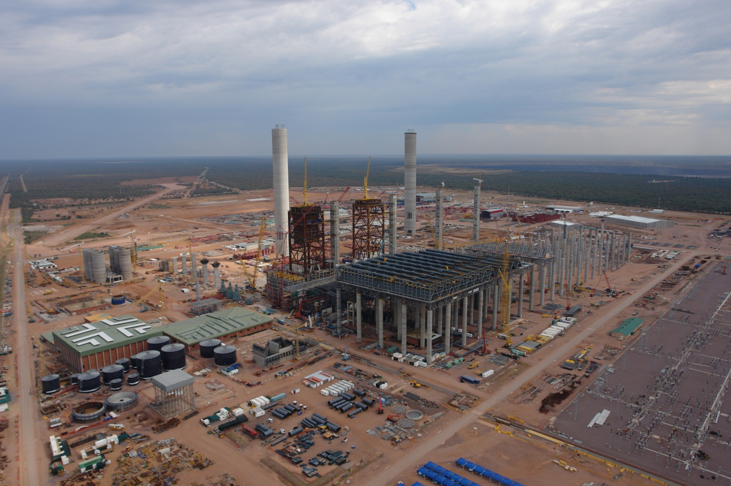

Figure 6: Photograph of the current condition of the receiving ecology

## Geology

The geological description below is taken directly from the specialist geology report (Bohlweki; 2005) used for the Medupi Power Station Scoping Report.

The Waterberg Coalfield comprises a graben structure with the Eenzaamheid fault forming the southern boundary and the northern boundary being delineated by the Zoetfontein fault. Archaean granite rocks outcrop to the north of the Zoetfontein fault and sediments of the Waterberg Group outcrop to the south of the Eenzaamheid fault.

The study area is further subdivided by the Daarby fault, a major northeast, then northwest, trending fault. The Daarby fault has a down throw of 360m to the north, at an angle of 50° to 60°. The down throw of 360 m to the north serves to bring the Grootegeluk Formation rocks to the south in contact with the younger Clarens Formation sandstone and Letaba Formation basalts in the north. Thus the fault divides the coalfield into a shallow (opencast) coal area to the south of the Daarby Fault, and a deep north coal area.

The Eenzaamheid fault has a throw of 250 m to the north and the fault is near vertical. The fault brings the upthrown Waterberg Group sediments on the south side of the fault in contact with shallow coal on the northern side of the fault.

The risk of the FGD retrofit impacting significantly on geology is very low. The infrastructure is all above surface and foundations will not impact on geology of more than ???m below surface. Figure 7 below provides an overview of the underlying geology of the receiving environment.

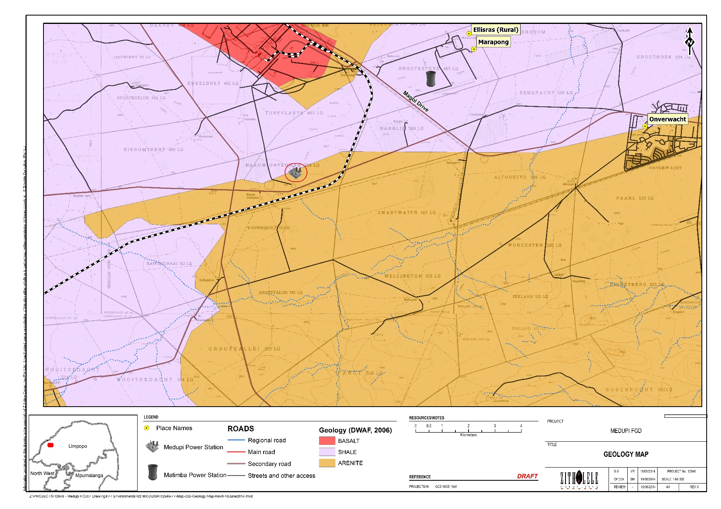

Figure 7 : Underlying geology in the Lephalale area

## Groundwater

The groundwater description is taken directly from the specialist groundwater report carried out for the Medupi Power Station Scoping Report (Bohlweki; 2005).

The groundwater potential of the formations located in the study area are limited in their pristine state due to low permeability, storage, and transmissivity. There are no artesian boreholes located within the study area. No large-scale groundwater abstraction occurs in the study area, even along the numerous faults.

The geological structures can enhance the groundwater potential in the area by increasing the permeability and transmissivity of the host rock. Secondary processes, such as faulting and fracturing, can create secondary fractured rock aquifers. Groundwater occurs within the joints, bedding planes, and along dolerite contacts within the Waterberg Group sediments

The groundwater potential of the fractured transitional zones between weathered and unweathered crystalline Letaba basalt rocks is good. Deeper fractures within the basalt, associated with faulting, have good groundwater potential. Fractured fault zone, especially if related to tensional stresses, are potentially rich targets for groundwater development. The graben structures are associated with tensional stresses, thus the Eenzaamheid fault could be an area of increased groundwater potential.

Groundwater will be important in terms of the potential impacts of disposal alternatives on site.

## Surface Water

The general description of the surface water within the area is taken directly from the Surface Water Specialist Study conducted for the Medupi Power Station Scoping Report (Bohlweki; 2005).

The study area falls within the Mogol River Catchment, which drains into the Limpopo River to the north (Figure 8). The Mokolo River catchment covers an area of 8 387 km2. The catchment stretches from the Waterberg Mountains though the upper reaches of the Sand River, and includes the Mokolo Dam and a number of small tributaries that join the main Mokolo River up to its confluence with the Limpopo River. The topography of the area is flat, varying between 900 and 922 mamsl1. The general topographical drainage system is poorly developed and drains in an easterly direction towards the Mogol River (810 mamsl).

There are no surface water bodies within the Medupi Power Station footprint. Therefore, no surface water resources will be directly affected by the FGD retrofit. The Lephalale area is predominantly dry, with evaporation significantly exceeding precipitation. Figure 8 provides a visual indication of the surface hydrology associated with the study area.

Figure 8 : Surface Water for the Lephalale study area

## Water Uses

The water use within the catchment is predominantly agriculture (87%) and industry (13%) related.

Currently water availability and water use in the catchment are in balance. However, within the provisions of the National Water Act (Act 39 of 1998 as amended) as stipulated in the National Water Resources Strategy, there is a need to meet the water requirements of the Reserve (Basic Human needs and Ecological) in terms of water quantity and quality. Taking the requirements into account, there is insufficient water to maintain the current balance. Added to this, it is anticipated that water demand will increase with new developments proposed in the Mokolo Catchment, such as new or expanded mining activities and new power stations (Bohlweki; 2005).

The McWAP scheme has been initiated in order to provide adequate water to supply the current and planned water users with allocations of water from the Mokolo Dam. Medupi Power Station already has an allocation for water from the McWAP phase 1 scheme. There is currently a Water Use License Application in process for additional water allocation to Medupi in order to supply for the planned FGD technology operation. This Water Use License is been applied for at a strategic level.

The Limpopo Province, and in particular, the Lephalale area, is a water stressed area with evaporation significantly higher than precipitation. Agriculture and industry in the municipal area are water intensive.

It is anticipated that water utilisation by the Medupi FGD technology retrofit will be an issue of contention and needs to be addressed more rigorously within the Impact Assessment Phase.

## Land Use

Principle land uses in the study area were identified during the original Medupi Power Station Scoping Phase (Bohlweki; 2005) as:

* Agricultural land devoted mainly to game and cattle farming.
* Residential and industrial areas – i.e. Onverwacht, the town of Lephalale; and
* Grootegeluk Mine, which is owned by Kumba Resources Pty Ltd;
* The Matimba Power Station;
* Game farms and lodges including the Ferroland Private Game Reserve; and
* Sewage works on the farms Zongezien and Nelsonskop.

In addition to these primary land users, Medupi Power Station will become one of the larger industries within the Lephapale Municipality. The FGD retrofit will not require additional land, as all infrastructure will be installed and constructed within the existing Medupi Power Station footprint.

The IDP (2014-2016) indicates that the primary corridor within the Lephalale Municipality is the national road N11 connecting to Mokopane in the north west.

## Socio-economic

The socio-economic description is taken, to a large degree, from the Medupi Scoping Report for the authorisation of the power station (Bohlweki; 2005). The study area is situated approximately 15km west of Lephalale in the Limpopo Province. The study area is positioned in the area under the jurisdiction of Lephalale Local Municipality, which forms part of the Waterberg District Municipality. The Lephalale Local Municipality covers an area of 19 605km2, and consists of 11 wards.

The IDP for the Lephalale area (2014-2016) indicates that there has been a 35.8% population increase within the Lephapale Municipality between 2001 and 2011. The IDP also indicates focal areas for the Minicipality to be job creation, improved infrastructure and a transition to a low carbon economy. This aligns with the Medupi FGD project as the operation of the Medupi Power Station (with FGD) will contribute to these initiatives.

One of the most important issue for address as highlighted within the 2014-2016 IDP is future water use and allocation. This is important in terms of supply to mining, agriculture and industry as well as to the growing domestic water use demand. Other issues within Lephalale Municipality relate to unemployment, low literacy rates and services to rural communities.

# Potential environmental and social impacts

Considering that the FGD retrofit activities will occur within the already impacted Medupi Power Station footprint, the potential environmental and social impacts are expected to be focused around waste management, air quality, water utilisation and socio-economic aspects.

## Waste Management

The handling and disposal of wastes generated by the Medupi FGD technology retrofit will have a potentially significant impact on soils, groundwater and surface water. The proposed alternatives for disposal of the various waste streams will be a focal area for address during the Impact Assessment Phase. A waste classification specialist report is being commissioned for the purpose of:

* Classifying the wastes into Types, according to the Waste Norms and Standards for disposal;
* Identifying and describing the requirements for the appropriate Class of disposal barrier system;
* Informing the assessment of alternatives for waste disposal.

The waste classification specialist study will be carried out between August and November 2014.

## Air quality

The aim of the Medupi FGD retrofit is to reduce SO2 emissions and, similarly, the Power Station’s impact on air quality. Therefore it is expected that the proposed project will have a positive impact of high significance to air quality. This impact will be assessed by a specialist consultant and the Impact Assessment Phase will provide a rating for the impact generated by the FGD retrofit.

## Water utilisation

The Lephalale Municipal area is highly water stressed and relies on the import of water from outside sources to supply water users in the area. Water users are predominantly agriculture and industrial operations. Due to the fact that the proposed Wet FGD technology requires a significant volume of water for operation, it is anticipated that the approval of the Wet FGD retrofit to Medupi Power Station will have a significant impact on water utilisation in the area.

## Socio-economic

The FGD retrofit proposed for Medupi Power Station will have an socio-economic impact to the local and national population in terms of, but not limited to:

* Possible employment of semi and highly skilled job seekers for construction phase;
* Ensuring compliance to the conditions of the World Bank loan, thereby assuring that the Medupi Power Station is funded and comes on line to supplement the South African electricity generation network;
* Reducing the potential health implications to local communities by decreasing the SO2 emissions, which have been scientifically linked to chronic lung conditions and heart disease.

Socio-economic impacts will be assessed as a focus of the Impact Assessment Phase.

# Plan of study for eia

## Introduction

In terms of Chapter 5 of the NEMA EIA regulations, EIA refers to the process of collecting, organising, analysing, interpreting and communicating information that is relevant to the consideration of the application. This includes an assessment of the nature, extent, duration, probability and significance of the identified potential environmental, social and cultural impacts of the proposed development as well as the cumulative impacts thereof. Mitigation measures for each significant impact are to be determined. Alternative land uses or developments, their impacts and their cumulative impacts will also be considered and compared with those of the proposed development. Details of the Public Participation Process (PPP) followed during the course of the assessment will be provided and it will be indicated how issues raised by stakeholders have been addressed. Knowledge gaps will be identified and descriptions of the arrangements for monitoring and management of the environmental impacts will be given.

## Terms of Reference for Specialist Studies

The client appointed appropriate consultants to undertake the necessary specialist studies during the authorisation processes for the Power Station construction. Subsequent to the site investigation and based on the availability of these specialist studies for the receiving environment of the FGD retrofit, it is anticipated that the following original studies can be utilised for purposes of the FGD EIA process:

* Soils, land capability and agricultural potential;
* Geology and Geotechnical investigations (Phase 1 geotechnical investigations);
* Surface water resources (aquatic) and wetlands (including wetlands delineation);
* Groundwater resources.
* Noise pollution;
* Visual impact;
* Ecology (Terrestrial flora and fauna and Avifauna assessment);
* Heritage impact studies;
* Traffic impact studies; and
* Socio-economic investigations.

The specialist studies as above provide detailed descriptions of the receiving environment prior to the construction of the power station infrastructure. Therefore the FGD retrofit will have a modified receiving environment and this will be motivated by evidence obtained at the site visit of January 2014. These specialist studies will be made available as appendices to the EIA Report and will inform the impact ratings and assessment.

Specialist studies that will need to be carried out again for the FGD retrofit will include the waste classification and the air quality assessment.

### Waste Classification

Due to the additional waste streams generated by the FGD process, the waste classification will need to be undertaken to classify each waste stream independently and together. The objectives of this updated waste classification study will be to assess the Medupi Power Station Flue Gas Desulphurisation (FGD) Plant as per the minimum requirements for the Integrated Environmental Authorisation for Environmental Authorization and Waste Management License Application.

The scope of work includes the following activities:

* Classification of the Medupi Power Station coal derived Ash, as well as FGD by-products gypsum, salts and sludge;
* Waste sample chemical analyses by a (South African Norms and Standards) SANAS accredited laboratory, to generate a sludge, salts and gypsum waste based on their modelled chemical composition;
* Total chemical composition analysis for inorganic and organic compounds;
* Waste classification report with recommendations on the type of landfill barrier system, etc.
* Inputs to the trade-off assessment based on the results from the synthetically generated wastes, classify the ash, salts gypsum and ash-gypsum-sludge mixture in terms of the SANAS.
* Compile a waste classification report that can be used by Zitholele and/or the client for licensing and barrier design purposes.

The waste classification will have significant input towards the preferred alternative for waste disposal as well as the conceptual design of the required disposal facilities.

### Air Quality Assessment

The scope of work for the air quality assessment will include the following:

* A review of the existing air quality assessment for Medupi Power Station;
* A description of the FGD process and how it will affect emissions from the Power Station;
* A study of relevant requirements;
* A study of the receiving environment in terms of sensitive receptors:
* The identification of sensitive receptors;
* Atmospheric dispersion potential of the area;
* Analysis of all available ambient air quality information to determine pre-operational phase ambient pollutant levels;
* The compilation of a comprehensive emissions inventory for the Power Station’s operational phase, including:
* Particulate Matter emissions from the operational phase activities;
* Boiler combustion emissions (PM, NOx, SO2);
* Atmospheric dispersion modelling to simulate PM, NOx and SO2 concentrations and the change therein as a result of the FGD retrofit. Modelling to include meteorological and dispersion modelling through the use of the approved US EPA CALPUFF modelling suite;
* An assessment to determine compliance of PM, NOx and SO2 NMES and NAAQS;
* An impact assessment as per the methodology provided by Zitholele Consulting;
* The compilation of a comprehensive air quality specialist report with input into the Environmental Management Programme.

## Impact Assessment Methodology

The impacts will be ranked according to the methodology described below. Where possible, mitigation measures will be provided to manage impacts. In order to ensure uniformity, a standard impact assessment methodology will be utilised so that a wide range of impacts can be compared with each other. The impact assessment methodology makes provision for the assessment of impacts against the following criteria:

* Significance;
* Spatial scale;
* Temporal scale;
* Probability; and
* Degree of certainty.

A combined quantitative and qualitative methodology was used to describe impacts for each of the aforementioned assessment criteria. A summary of each of the qualitative descriptors along with the equivalent quantitative rating scale for each of the aforementioned criteria is given in Table 7**: Quantitative rating and equivalent descriptors for the impact assessment criteria**.

Table 7**: Quantitative rating and equivalent descriptors for the impact assessment criteria**

|  |  |  |  |
| --- | --- | --- | --- |
| Rating | Significance | Extent Scale | Temporal Scale |
| 1 | VERY LOW | *Proposed site* | Incidental |
| 2 | LOW | *Study area* | Short-term |
| 3 | MODERATE | *Local* | Medium-term |
| 4 | HIGH | *Regional / Provincial* | Long-term |
| 5 | VERY HIGH | *Global / National* | Permanent |

A more detailed description of each of the assessment criteria is given in the following sections.

### Significance Assessment

Significance rating (importance) of the associated impacts embraces the notion of extent and magnitude, but does not always clearly define these since their importance in the rating scale is very relative. For example, the magnitude (i.e. the size) of area affected by atmospheric pollution may be extremely large (1 000 km2) but the significance of this effect is dependent on the concentration or level of pollution. If the concentration is great, the significance of the impact would be HIGH or VERY HIGH, but if it is diluted it would be VERY LOW or LOW. Similarly, if 60 ha of a grassland type are destroyed the impact would be VERY HIGH if only 100 ha of that grassland type were known. The impact would be VERY LOW if the grassland type was common. A more detailed description of the impact significance rating scale is given in Table 8 below.

Table 8**: Description of the significance rating scale**

| Rating | | Description |
| --- | --- | --- |
| 5 | Very high | Of the highest order possible within the bounds of impacts which could occur. In the case of adverse impacts: there is no possible mitigation and/or remedial activity which could offset the impact. In the case of beneficial impacts, there is no real alternative to achieving this benefit. |
| 4 | High | Impact is of substantial order within the bounds of impacts, which could occur. In the case of adverse impacts: mitigation and/or remedial activity is feasible but difficult, expensive, time-consuming or some combination of these. In the case of beneficial impacts, other means of achieving this benefit are feasible but they are more difficult, expensive, time-consuming or some combination of these. |
| 3 | Moderate | Impact is real but not substantial in relation to other impacts, which might take effect within the bounds of those which could occur. In the case of adverse impacts: mitigation and/or remedial activity are both feasible and fairly easily possible. In the case of beneficial impacts: other means of achieving this benefit are about equal in time, cost, effort, etc. |
| 2 | Low | Impact is of a low order and therefore likely to have little real effect. In the case of adverse impacts: mitigation and/or remedial activity is either easily achieved or little will be required, or both. In the case of beneficial impacts, alternative means for achieving this benefit are likely to be easier, cheaper, more effective, less time consuming, or some combination of these. |
| 1 | Very low | Impact is negligible within the bounds of impacts which could occur. In the case of adverse impacts, almost no mitigation and/or remedial activity are needed, and any minor steps which might be needed are easy, cheap, and simple. In the case of beneficial impacts, alternative means are almost all likely to be better, in one or a number of ways, than this means of achieving the benefit. Three additional categories must also be used where relevant. They are in addition to the category represented on the scale, and if used, will replace the scale. |
| 0 | No impact | There is no impact at all - not even a very low impact on a party or system. |

### Spatial Scale

The spatial scale refers to the extent of the impact i.e. will the impact be felt at the local, regional, or global scale. The spatial assessment scale is described in more detail in Table 9**.**

Table 9**: Description of the significance rating scale**

| Rating | | Description |
| --- | --- | --- |
| 5 | Global/National | The maximum extent of any impact. |
| 4 | Regional/Provincial | The spatial scale is moderate within the bounds of impacts possible, and will be felt at a regional scale (District Municipality to Provincial Level). |
| 3 | Local | The impact will affect an area up to 10 km from the proposed site. |
| 2 | Study Site | The impact will affect an area not exceeding the Eskom property. |
| 1 | Proposed site | The impact will affect an area no bigger than the ash disposal site. |

### Duration Scale

In order to accurately describe the impact it is necessary to understand the duration and persistence of an impact in the environment. The temporal scale is rated according to criteria set out in Table 10.

Table 10**: Description of the temporal rating scale**

|  |  |  |
| --- | --- | --- |
| Rating | | Description |
| 1 | Incidental | The impact will be limited to isolated incidences that are expected to occur very sporadically. |
| 2 | Short-term | The environmental impact identified will operate for the duration of the construction phase or a period of less than 5 years, whichever is the greater. |
| 3 | Medium term | The environmental impact identified will operate for the duration of life of facility. |
| 4 | Long term | The environmental impact identified will operate beyond the life of operation. |
| 5 | Permanent | The environmental impact will be permanent. |

### Degree of Probability

Probability or likelihood of an impact occurring will be described as shown in Table 11below.

Table 11**: Description of the degree of probability of an impact occurring**

|  |  |
| --- | --- |
| Rating | Description |
| 1 | Practically impossible |
| 2 | Unlikely |
| 3 | Could happen |
| 4 | Very Likely |
| 5 | It’s going to happen / has occurred |

### Degree of Certainty

As with all studies it is not possible to be 100% certain of all facts, and for this reason a standard “degree of certainty” scale is used as discussed in Table 12. The level of detail for specialist studies is determined according to the degree of certainty required for decision-making. The impacts are discussed in terms of affected parties or environmental components.

Table 12**: Description of the degree of certainty rating scale**

| Rating | Description |
| --- | --- |
| Definite | More than 90% sure of a particular fact. |
| Probable | Between 70 and 90% sure of a particular fact, or of the likelihood of that impact occurring. |
| Possible | Between 40 and 70% sure of a particular fact or of the likelihood of an impact occurring. |
| Unsure | Less than 40% sure of a particular fact or the likelihood of an impact occurring. |
| Can’t know | The consultant believes an assessment is not possible even with additional research. |
| Don’t know | The consultant cannot, or is unwilling, to make an assessment given available information. |

### Quantitative Description of Impacts

To allow for impacts to be described in a quantitative manner in addition to the qualitative description given above, a rating scale of between 1 and 5 was used for each of the assessment criteria. Thus the total value of the impact is described as the function of significance, spatial and temporal scale as described below:

***Impact Risk*** = (SIGNIFICANCE **+** *Spatial* **+** Temporal)/3 X Probability/5

An example of how this rating scale is applied is shown below:

Table 13**: Example of Rating Scale**

|  |  |  |  |  |  |
| --- | --- | --- | --- | --- | --- |
| Impact | Significance | Spatial Scale | Temporal Scale | Probability | Rating |
|  | LOW | *Local* | Medium-term | *Could Happen* |  |
| Impact to air | **2** | ***3*** | **3** | **3** | **1.6** |

Note: The significance, spatial and temporal scales are added to give a total of 8, that is divided by 3 to give a criteria rating of 2,67. The probability (3) is divided by 5 to give a probability rating of 0,6. The criteria rating of 2,67 is then multiplied by the probability rating (0,6) to give the final rating of 1,6.

The impact risk is classified according to five classes as described in the Table 14 below.

Table 14**: Impact Risk Classes**

|  |  |  |
| --- | --- | --- |
| Rating | Impact Class | Description |
| 0.1 – 1.0 | **1** | **Very Low** |
| 1.1 – 2.0 | **2** | **Low** |
| 2.1 – 3.0 | **3** | **Moderate** |
| 3.1 – 4.0 | **4** | **High** |
| 4.1 – 5.0 | **5** | **Very High** |

Therefore with reference to the example used for air quality above, an impact rating of 1.6 will fall in the Impact Class 2, which will be considered to be a low impact.

### Cumulative Impacts

It is a requirement that the impact assessments take cognisance of cumulative impacts. In fulfilment of this requirement the impact assessment will take cognisance of any existing impact sustained by the operations, any mitigation measures already in place, any additional impact to environment through continued and proposed future activities, and the residual impact after mitigation measures.

It is important to note that cumulative impacts at the national or provincial level will not be considered in this assessment, as the total quantification of external companies on resources is not possible at the project level due to the lack of information and research documenting the effects of existing activities. Such cumulative impacts that may occur across industry boundaries can also only be effectively addressed at Provincial and National Government levels.

Using the criteria as described above an example of how the cumulative impact assessment will be done is shown below:

Table 15 **- Example of cumulative impact assessment**

| Impact | Significance | Spatial Scale | Temporal Scale | Probability | Rating |
| --- | --- | --- | --- | --- | --- |
| Initial / Existing Impact (I-IA) | **2** | **2** | **2** | *1* | 0.4 |
| Additional Impact (A-IA) | **1** | ***2*** | **1** | *1* | 0.3 |
| Cumulative Impact (C-IA) | **3** | ***4*** | **2** | *1* | 0.6 |
| Residual Impact after mitigation (R-IA) | **2** | ***1*** | **2** | *1* | 0.3 |

As indicated in the example above the Additional Impact Assessment (A-IA) is the amount that the impact assessment for each criterion will increase. Thus if the initial impact will not increase, as shown for temporal scale in the example above the A-IA will be 0, however, where the impact will increase by two orders of magnitude from 2 to 4 as in the spatial scale the A-IA is 2. The Cumulative Impact Assessment (C-IA) is thus the sum of the Initial Impact Assessment (I-IA) and the A-IA for each of the assessment criteria.

In both cases the I-IA and A-IA are assessed without taking into account any form of mitigation measures. As such the C-IA is also a worst case scenario assessment where no mitigation measures have been implemented. Thus a Residual Impact Assessment (R-IA) is also made which takes into account the C-IA with mitigation measures. The latter is the most probable case scenario, and for the purpose of this report is considered to be the final state Impact Assessment.

### Notation of Impacts

In order to make the report easier to read the following notation format is used to highlight the various components of the assessment:

* Significance or magnitude- IN CAPITALS
* Temporal Scale – in underline
* Probability – in *italics and underlined*
* Degree of certainty - in **bold**
* Spatial Extent Scale – in *italics*

Please note that the impact rating system may change slightly to accommodate ease of use. However, the basic principle of the rating system will remain the same.

## Environmental Impact Report

Once the Scoping Report and the Plan of Study for the EIA is accepted by the DEA, Zitholele will begin the Environmental Impact Report.

The Environmental Impact Report will include the activity description; site assessments; public participation; a description of the issues and assessment of the site. The specialist studies results will be summarised and integrated into the Environmental Impact Report.

The WMLA Report will include all the technical information generated by the Design of the Facility, the Site Survey and the Operating Plan. In addition all the documents required by DEA for the waste license will also be included. These include the emergency and response plan, the closure and rehabilitation plan and the waste hierarchy implementation plan.

## Environmental Management Programme

An Environmental Management Programme (EMPr), in the context of the Regulations, is a tool that takes a project from a high level consideration of issues impacts down to detailed workable mitigation measures that can be implemented in a cohesive and controlled manner. The objectives of an EMP are to minimise disturbance to the environment, present mitigation measures for identified impacts, maximise potential environmental benefits, assign responsibility for actions to ensure that the pre-determined aims are met, and to act as a “cradle to grave” document. The EMPr will be drafted according to the findings in the Scoping Report and EIR.

## Public Participation during the EIA Phase

The purpose of public participation during the Impact Assessment Phase is to present the findings of the EIA phase and to avail the Draft EIR to the public for comments. I&APs will be afforded an opportunity to verify that their issues have been considered either by the EIA specialist studies, or elsewhere. Also, I&APs will comment on the findings of the Draft EIR, including the measures that have been proposed to enhance positive impacts and reduce or avoid negative ones. Once the review is completed, the authority may decide to request additional information on matters that may not be clear from the report, authorise the application with certain conditions to be complied with by the applicant or reject the application. An EA reflecting the decision of the authority as well as any conditions that may apply will be issued to the applicant.

I&APs will be advised in good time of the availability of these reports, how to obtain them, and the dates and venues of public and other meetings where the contents of the reports will be presented for comment.

The public participation process for the EIAs will involve the following proposed steps:

* Announcement of the availability and public review of the Draft EIR;
* Host a public meeting for the stakeholders to review the Draft EIR;
* Announcement of the availability of the Final EIR;
* Notification of the authorities’ decision with regard to EAs

### Announcing the availability of the Draft EIR and the EMPr

A letter will be circulated to all I&APs, informing them in terms of progress made with the study and that the Draft EIR and EMPr are available for comment. The report will be distributed to public places and also presented at a stakeholder meeting. Advertisements will be placed in the same newspapers used in the scoping phase to announce the public review period of the Draft EIR.

### Public review of Draft EIR and EMPr

The EIA Guidelines specify that stakeholders must have the opportunity to verify that their issues have been captured and assessed before the EIA Report will be approved. The findings of the specialist assessment will be integrated into the Draft EIR. The report will be written in a way accessible to stakeholders in terms of language level and general coherence. The Draft EIR will have a comprehensive project description, motivation and also the findings of the assessment and recommended mitigation measures. It will further include the Issues and Responses Report, which will list every issue raised with an indication of where the issue was dealt with in the EIR. The findings of the assessment and recommended mitigation measures will also be incorporated into the EIR.

As part of the process to review the Draft EIR and EMPr, one stakeholder workshop with an open house component will be arranged to afford stakeholders the opportunity to obtain first-hand information from the project team members and also to discuss their issues and concerns. Contributions at this meeting will be considered in the Final EIR.

### Announcing the availability of the Final EIR and EMPr

A letter will be circulated to all I&APs, informing them in terms of progress made with the study and that the Final EIR and EMP are available for comment. The reports will be distributed to the same public places (See Chapter 5 with the venues) as the previous reports for I&APs to review.

### Progress feedback

After comments from I&APs have been incorporated, all stakeholders on the database will receive a personalised letter to report on the status of the process, to thank those who commented to date and to inform them that the Final EIR and EMPr have been submitted to the lead authority for consideration. I & APs will be advised on the next steps in the process.

### Announce authorities’ decision

Registered I&APs will be notified by individual letters of the results from the authorities. Should it be a requirement from the authorities an advertisement will be placed in the same newspapers which were used during the scoping and impact assessment phases.

## Submission of Final EIR and Decision Making

Using the comments generated by the PPP the Draft EIR will be updated and finalised. All comments received will be added to the CRR and attached to the Final EIR as an appendix.

The Final EIR once updated with additional issues raised by I&APs may contain new information. The Final EIR will be submitted to the DEA for decision making, and will be distributed to those I&APs who specifically request a copy. I&APs will be notified of the availability of the report by letters, advertisements and emails.

## Overall EIA Project Schedule

Table 16**: Primary milestones of the Project**

| Milestones | Date |
| --- | --- |
| Final Scoping Report | July to November 2014 |
| Undertake Specialist Studies | February to March 2015 |
| Draft EIR and EMP | June 2015 |
| Stakeholder Engagement on EIR / EMP | July to September 2015 |
| Finalise EIR and EMP | September to October 2015 |
| Submission to Relevant Authorities | October 2015 |
| Environmental Authorisation | January 2016 |
| Appeal Period | To be confirmed in the Impact Assessment Phase |

# Conclusion and WAY FORWARD

Eskom appointed Zitholele Consulting to undertake the EIA, WML and WUL application for the proposed Medupi Power Station FGD technology retrofit. This Scoping study is being undertaken with the aim of identifying potential aspects of concern (both positive and negative) on the biophysical environment and identifying issues, concerns and queries from I&APs. This DSR documents the process followed, the findings and recommendations of the Scoping study, and the proposed Plan of Study for the EIA Phase to follow.

This DSR will be submitted to the public for comment. During the comment period meetings will be held with key stakeholders, focus groups and the public to discuss the Scoping Report and the way forward into the Impact Assessment Phase.

Following public review and comment, the Scoping Report will be finalised to address comments, and will be submitted to the authorities for acceptance. Once the FSR and plan of study for EIA has been accepted, the project will move into the Impact Assessment Phase.

This report provides accurate information as provided by the client, appropriate literature and EAP investigation.

**ZITHOLELE CONSULTING (PTY) LTD**

Sharon Meyer-Douglas Mathys Vosloo

**Project Manager Project Associate**

C:\USERS\SHARONM.ZITHOLELE\DESKTOP\MEDUPI\12949-46-REP-001-DSR-DRAFT8.DOCX

# references

Bohlweki Environmental, 2005. Scoping Report for the Establishment of a New Coal-fired Power Station in the Lephalale area, Limpopo. Bohlweki Environmental. Midrand.

COP17 Fact Sheet; 2014; http:// [www.eskom.co.za/](http://www.eskom.co.za/) aboutelectricity/ factsfigures/ kusile_and_medupi.pdf

Department of Environmental Affairs, 2012. Government Gazette No 35436, Notice 495 of 2012, Declaration of the Waterberg National Priority Area. Department of Environmental Affairs. Pretoria.

Eskom Holdings (SOC) Ltd, 2014. World Bank and African Development Bank Project Progress Report 3. Eskom Holdings (SOC) Ltd. Midrand.

Eskom website; 2014; http://www.eskom.co.za/whatweredoing/newbuild.html

Harris, D., 2013. FGD solids conveying and storage (HTP). Black & Veatch. Midrand.

Harris, D., 2014. Medupi FGD Retrofit Conceptual Design Report. Black & Veatch. Midrand.

Harris, D., 2014. Medupi Technology Selection Study Report. Black and Veatch. Midrand.

Lephalale Municipality, 2013. Lephalale Municipality Intergrated Development Plan, 2014-2016. Lephalale Municipality. Limpopo Province.

United States Environmental Protection Agency (US EPA) website; 2014. www://www.epa.gov/airquality/sulphurdioxide/health.htm

DEAT (2004) Criteria for determining Alternatives in EIA, Integrated Environmental Management, Information Series 11, Department of Environmental Affairs and Tourism (DEAT), Pretoria

DEAT (2004) Cumulative Effects Assessment, Integrated Environmental Management, Information Series 7, Department of Environmental Affairs and Tourism (DEAT), Pretoria

Department of Environmental Affairs, 2011. A user friendly guide to the National Environmental Management: Waste Act, 2008. South Africa. Pretoria.

Department of Water Affairs & Forestry, 1998. Waste Management Series. Minimum Requirements for the Handling, Classification and Disposal of Hazardous Waste.

National Environmental Management Act, 1998 (Act 107 of 1998) Implementation Guidelines Sector Guidelines for Environmental Impact Assessment Regulations Government Notice 654 of 2010, published in Government Gazette 3333, dated 29 June 2010.

National Environmental Management Act, 1998 (Act 107 of 1998) Publication of Need and Desirability Guideline in terms of the Environmental Impact Assessment Regulations, 2010, Government Notice 792 of 2012, Government Gazette 35746, dated 05 October 2012.

South Africa. 1973. Hazardous Substance Act 15 of 1973

South Africa. 1983. Conservation of Agricultural Resources Act 43 of 1983

South Africa. 1993. Occupational Health and Safety Act 85 of 1993

South Africa. 1998. National Environmental Management Act 107 of 1998

South Africa. 1998. National Water Act 36 of 1998

South Africa. 1999. National Water Act Regulations on use of water for mining and related activities aimed at the protection of water resources, 1999. (Notice 704). *Government gazette* 20119, 4 June.

South Africa. 1999. National Heritage Resources Act 25 of 1999

South Africa. 1999. National Water Act, 1998 (Act No. 36 of 1998) Regulations on use of water for mining and related activities aimed at the protection of water resources, 1999. Government gazette Vol. 408 No. 20119, 4 June

South Africa. 2004. National Environmental Management: Air Quality Act 39 of 2004

South Africa. 2004. National Environmental Management: Biodiversity Act 10 of 2004

South Africa. 2008. National Environmental Management Act 59 of 2008

South Africa. 2010. National Environmental Management Act (Act 107 of 1998) Implementation Guidelines, Sector Guidelines for Environmental Impact Assessment Regulations, 2010 (Notice 654). Government gazette 33333, 29 June

South Africa. 2010. National Environmental Management Act, 1998 (Act No. 107 of 1998) Listing Notice 1: List of Activities and Competent Authorities Identified in terms of Sections 24(2) and 24D, 2010. (Notice 544). *Government gazette* 33306:80, 18 June

South Africa. 2010. National Environmental Management Act, 1998 (Act No. 107 of 1998) Listing Notice 2: List of Activities and Competent Authorities Identified in terms of Sections 24(2) and 24D, 2010. (Notice 545). *Government gazette* 33306:105, 18 June

South Africa. 2010. National Environmental Management Act, 1998 (Act No. 107 of 1998) Listing Notice 3: List of Activities and Competent Authorities Identified in terms of Sections 24(2) and 24D, 2010. (Notice 546). *Government gazette* 33306:116, 18 June

South Africa. 2013. National Environmental Management: Waste Act, 2008 (Act No.59 of 2008) List of Waste Management Activities that have, or are likely to have, a detrimental effect on the environment, 2013. (Notice 921). Government gazette 37083:3, 29 Nov.

South Africa. 2013. National Environmental Management: Waste Act, 2008 (Act No.59 of 2008) National Norms and Standards for the Assessment of Waste for Landfill Disposal, 2013. (Notice 635). Government gazette 36784:22, 23 Aug.

South Africa. 2013. National Environmental Management: Waste Act, 2008 (Act No. 59 of 2008) List of Waste Management Activities that have, or are likely to have, a detrimental effect on the environment, 2013. Government gazette 37083:3, 29 Nov

APPENDIX A : Project Management Schedule

APPENDIX B : Curriculum Vitae of EAP and project team

APPENDIX C : Medupi FGD Retrofit Technology Selection Study Report

APPENDIX D : Process Flow Diagrams

APPENDIX E : Public Participation Supporting Documents